- What is the advantage of using a “reverse proxy server”?
A reverse proxy server is a type of proxy server that typically sits behind the firewall in a private network and directs client requests to the appropriate backend server. A reverse proxy provides an additional level of abstraction and control to ensure the smooth flow of network traffic between clients and servers.
Advantages
- Avoid the expense of installing another web server. A reverse proxy server increases the capacity of existing servers.
- Serve more requests for static content and thus free up bandwidth to serve more dynamic content.
- Reduce operating expense by increasing bandwidth.
- Provide a single point of control over who can access HTTP servers, and which servers can be accessed.
- Decrease response time of web pages and accelerate download time, enhancing the experience of web site users.
- Provide another layer of protection by hiding the internal IP address.
- Why and where Nginx is a better choice than apache.
- NGINX serves static content much faster than Apache. If you need to serve a lot of static content at high concurrency levels, NGINX should be used.
- NGINX code base is smaller by several orders of magnitude compared to Apache, so that is definitely a big plus from a forward-thinking security perspective.
- High-traffic website owners that need to serve a lot of static content and/or media streams will probably prefer NGINX.
- NGINX stands out because of some of its more advanced features (media streaming, reverse proxying for non-HTTP protocols), along with its commercial support and training.

- What are worker nodes and worker connections? How to calculate the max server capacity using the above two?
A worker process is a single-threaded process.
(If Nginx is doing CPU-intensive work such as SSL or gzipping and you have 2 or more CPUs/cores, then you may set worker_processes to be equal to the number of CPUs or cores.If you are serving a lot of static files and the total size of the files is bigger than the available memory, then you may increase worker_processes to fully utilize disk bandwidth.)
Worker nodes are used to enable connections.

The worker_connections and worker_processes allows us to calculate max clients we can handle:
max clients = worker_processes * worker_connections

- From what directory will NGINX automatically load server (virtual host) configurations when using the default /etc/nginx/nginx.conf configuration?
from /etc/nginx/sites-enabled
- How to configure different log_format for different “location” block/directive?
log_format myFormat '$remote_addr - $remote_user [$time_local]'"';
combined

- Host a site ABC.COM

  - Create an index page and a fail-safe page. If a page for URI is not available, the fail-safe page is served.
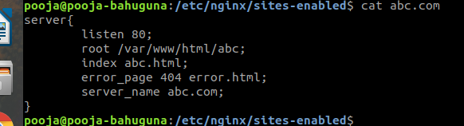
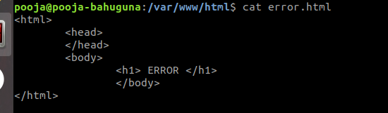
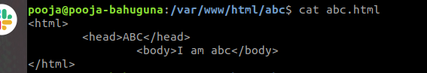

  - proxy pass to a website xyz.com on a particular URI.
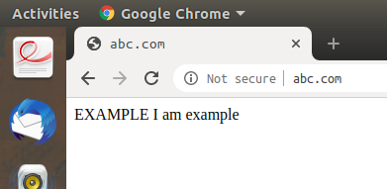
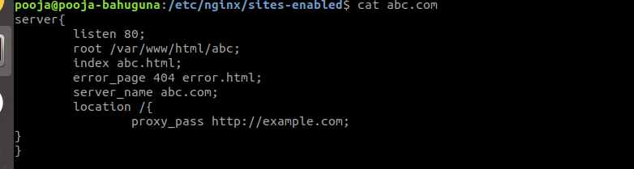
  - redirect to above URI on /redirect/
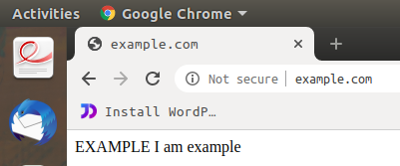
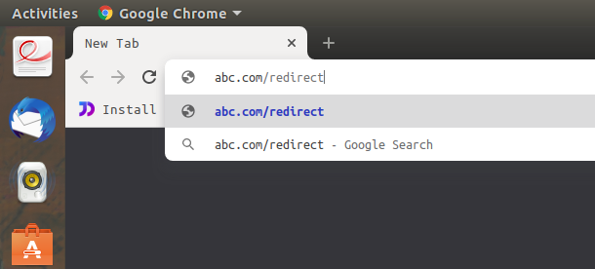
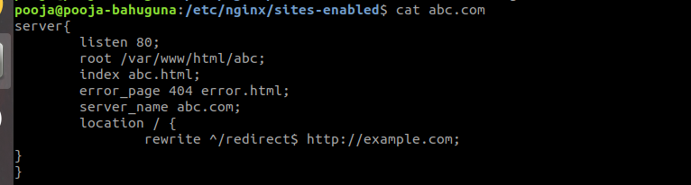

  - perform an HTTP to HTTPS redirection including non-www to www redirection.
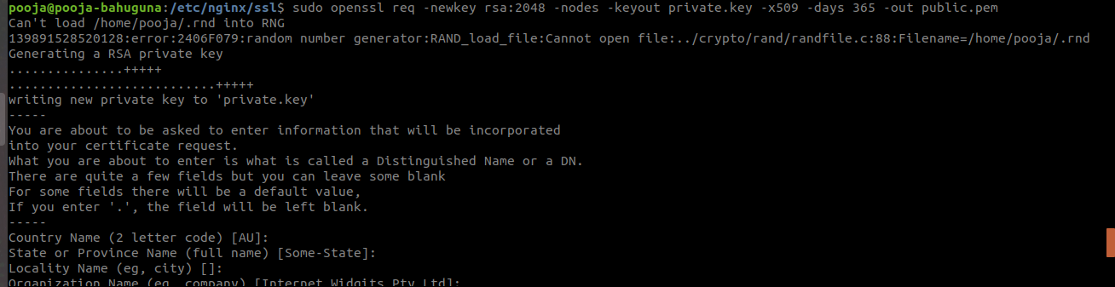
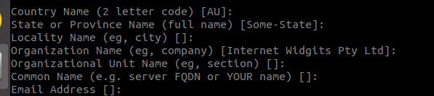
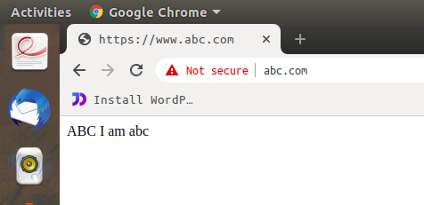
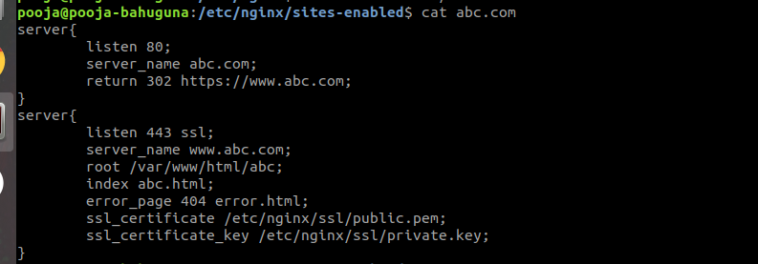
  - Allow access to a set of particular IPs on a location block and return 405 to other IPs no matter if the page in that location exists.
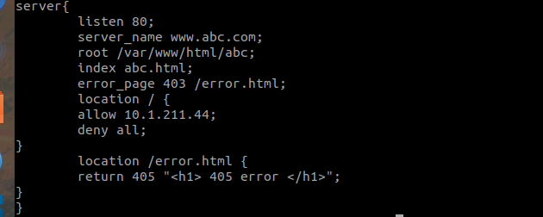

  - Place your images at /var/www/html/images. Only accept jpg/png/jpeg. Discard rest.
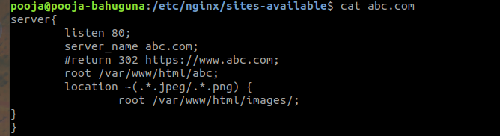
- Create a load balancer with 5 backends. Explain different types of load balancing methods.
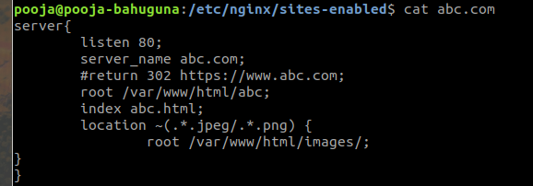
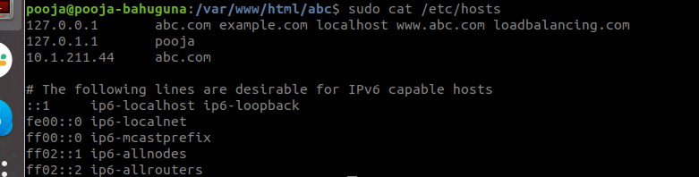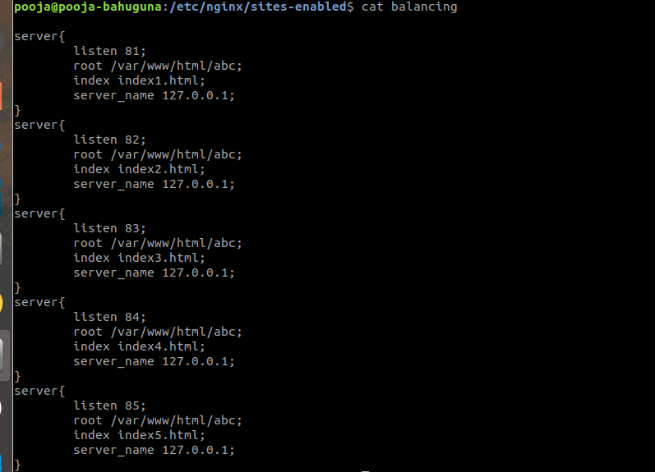

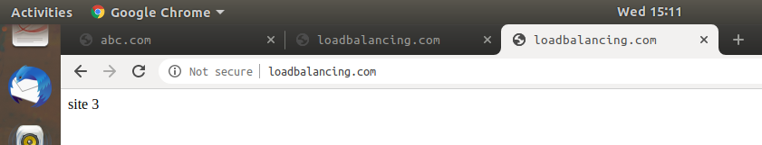
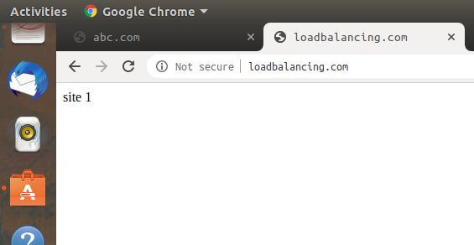


- Setup Basic Auth (Popup asking for username and password) in a particular location block. (The Basic Auth should not be asked for TTN IP)
