To add roles in the database dynamically

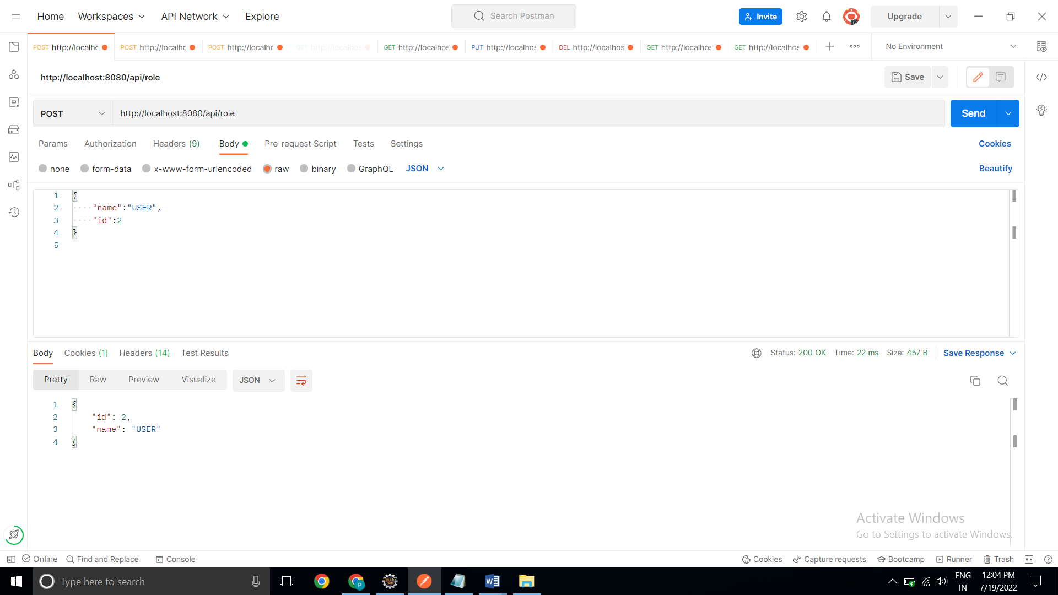

To add Users in the db which can be used for authentication purposes.

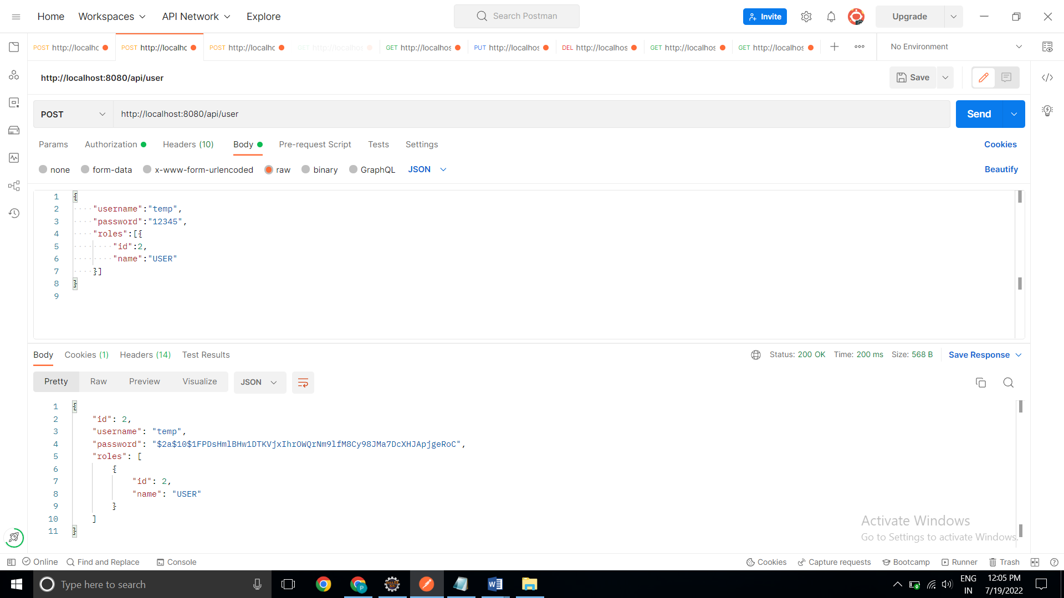

To add employees data in the database if and only if the authenticated user is **ADMIN** [Pooja is admin here and hence able to add new employee]

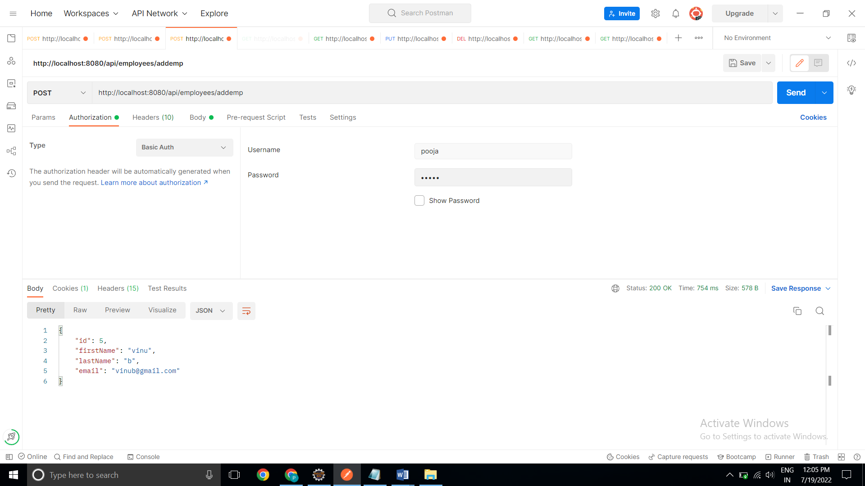

To list all the employees stored in the database.

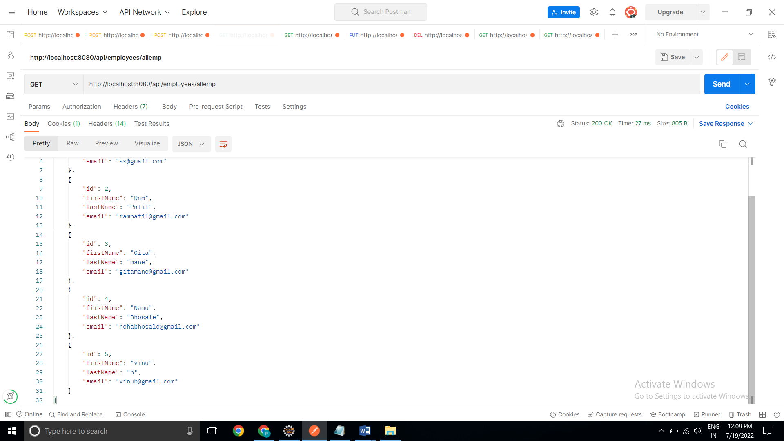

To fetch or get an employee record specifically based on the id of that employee

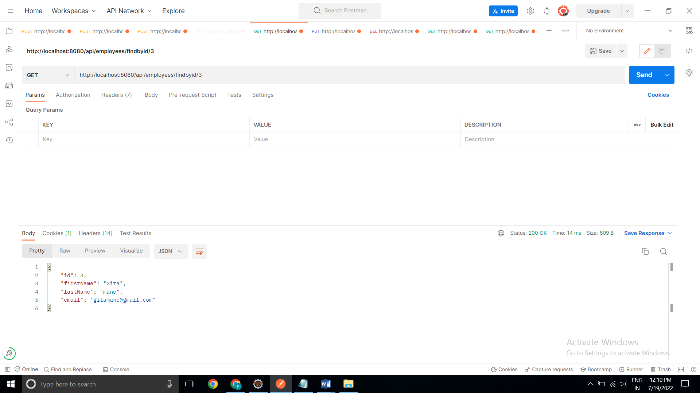

To update an existing employee record with the given updated json object

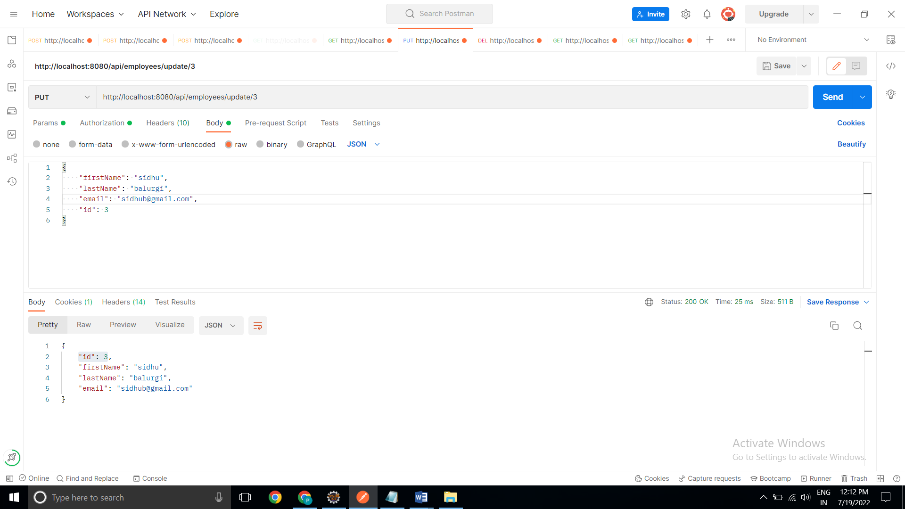

To delete an existing employee record based on id of the employee

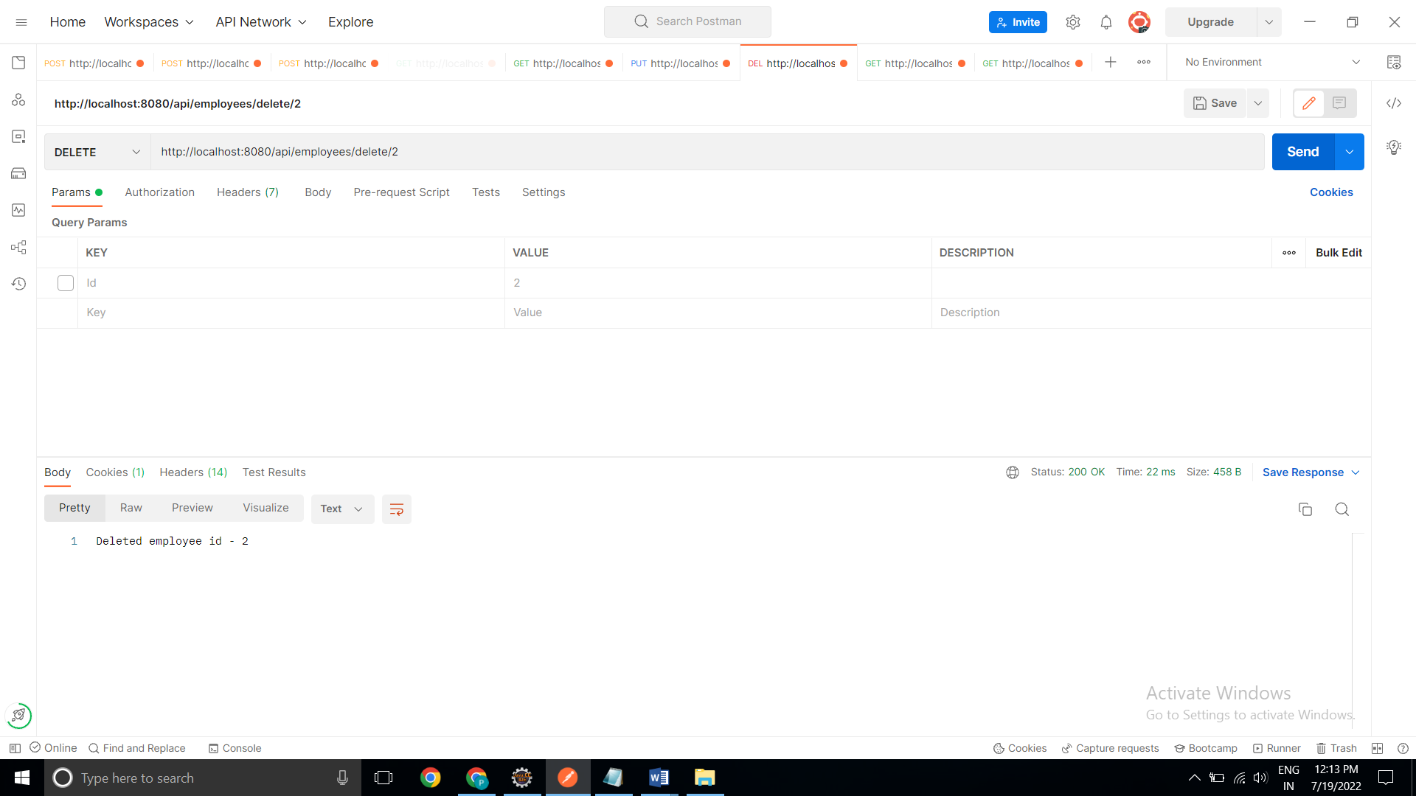

To fetch an employee by his/her first name and if found more than one record then list them all.

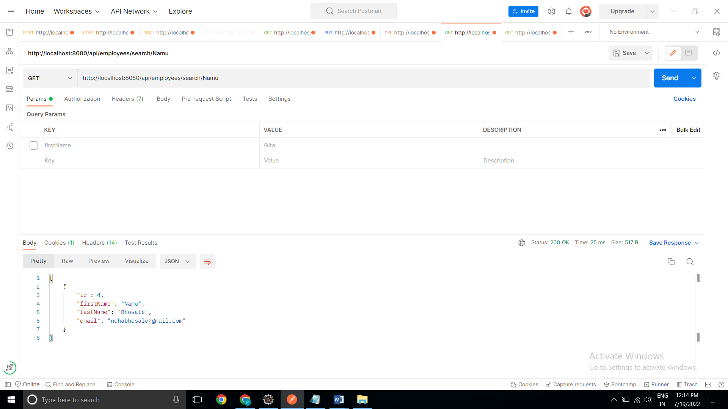

To list all employee records sorted on their first name in either ascending order or descending order. [ASC]

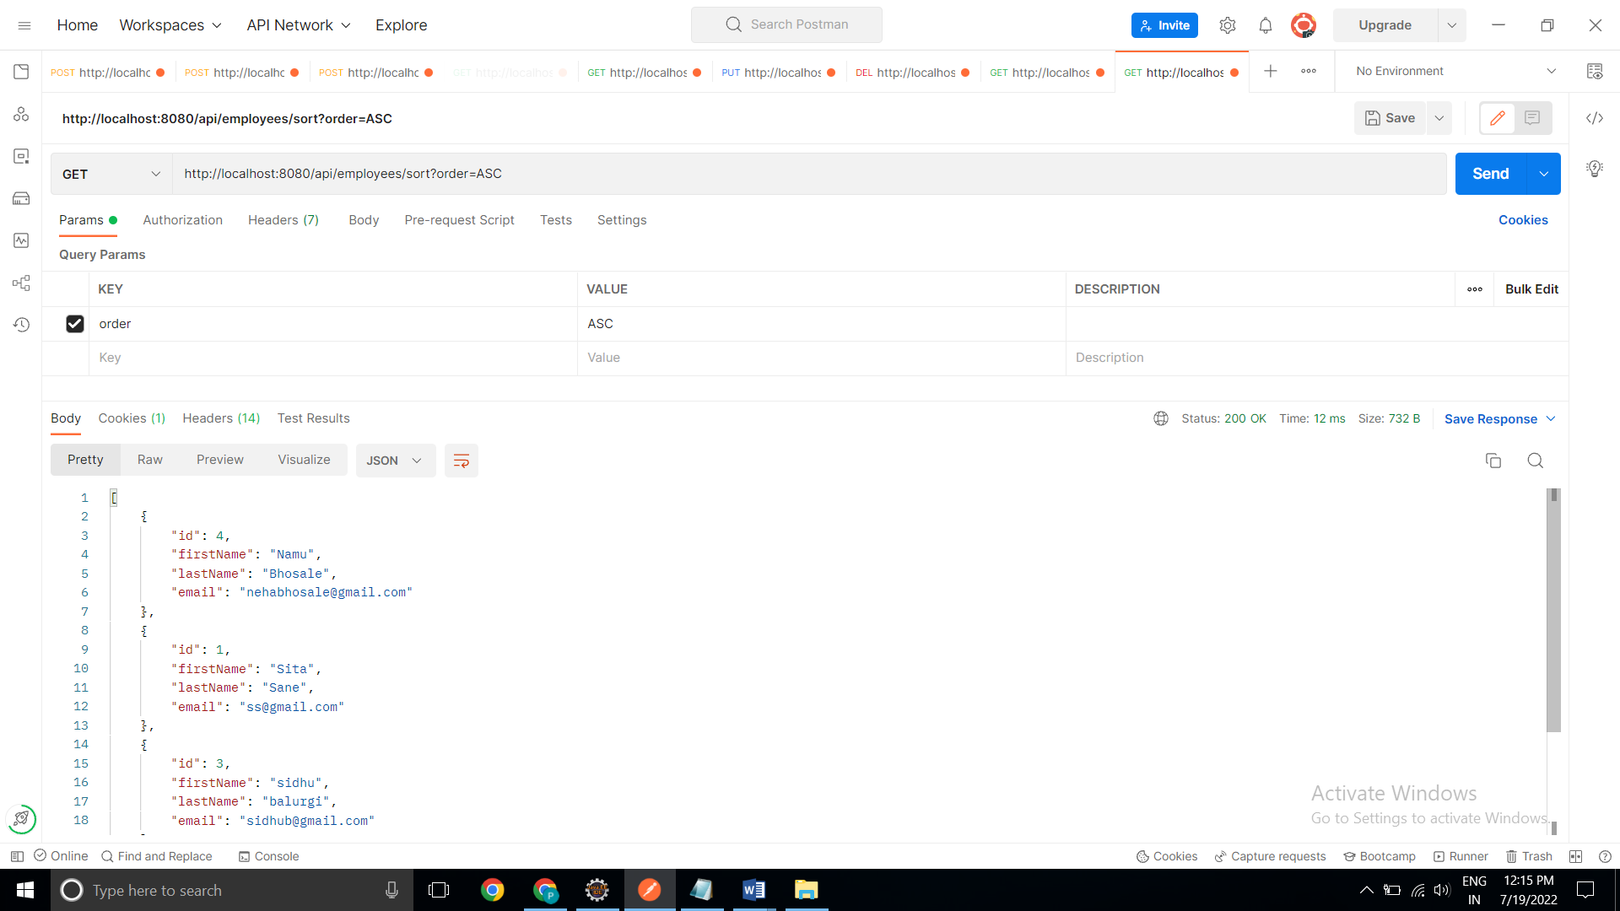

[DESC]

