|  |
| --- |
| Pooja Bhansali - gs6262  **BAN 632 – Big Data Technology and Applications** |
| **Take Home Project** |

Question 1: What is the output of the user-defined counter?

Total count = 18 days

Aquaman = 11 days

Deadpool 2 = 7 days

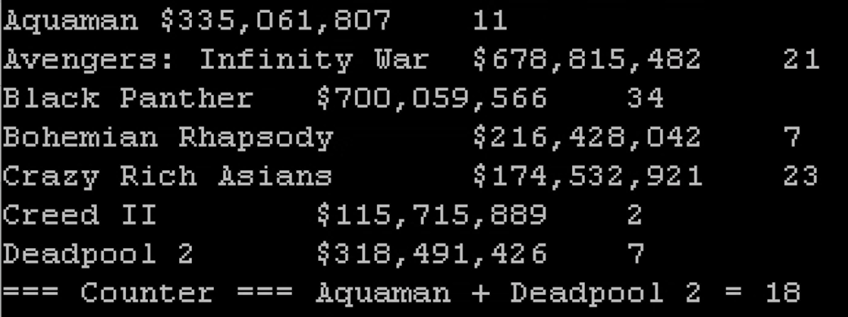

Question 2: Did you increment the counter in the mapper or in the reducer? Why?

Answer:

I increment the counter in reducer as that is where I will have everything reduced after all the mapping, mappers could be operating independently and can lead to inconsistent count.