**Code summary :**

This chatbot is using tf-idf and cosine similarity concepts to match the words in user’s questions with the words in dataset to give appropriate answers. For the gui part, we have made use of python’s tkinter library.

**Screenshot of the Chatbot:**

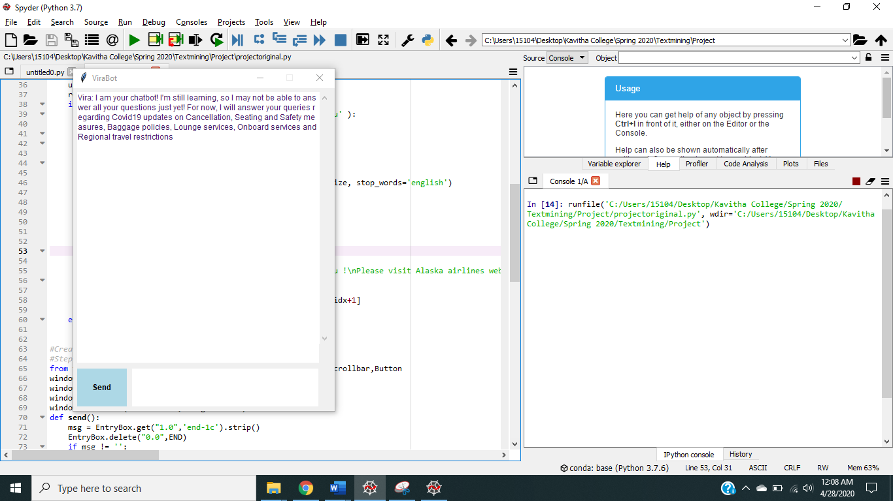

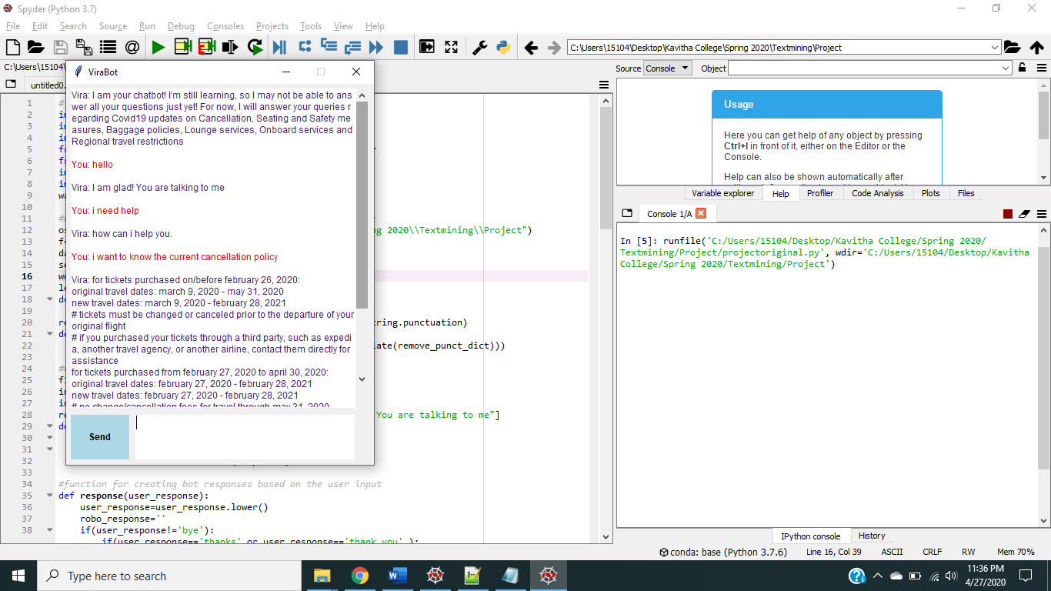

**Screenshots of Chatbot’s response for few sample questions:**

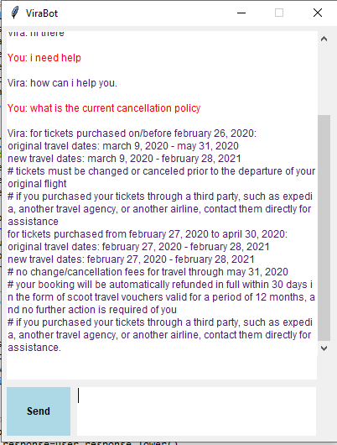 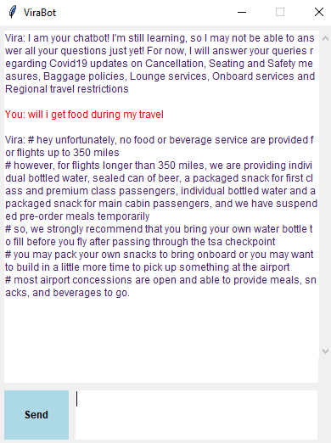

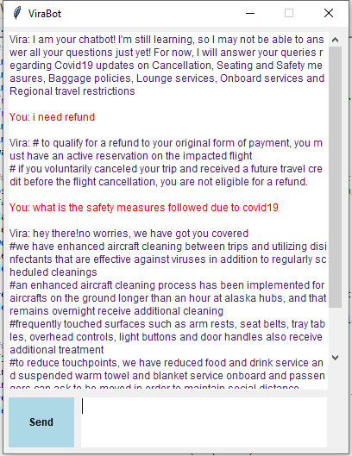 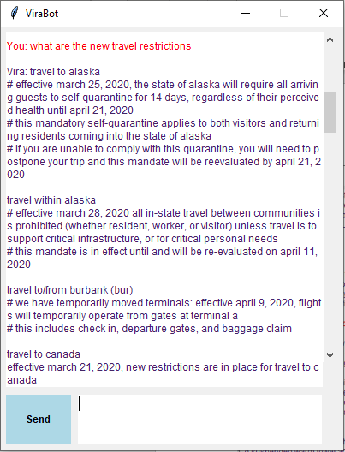

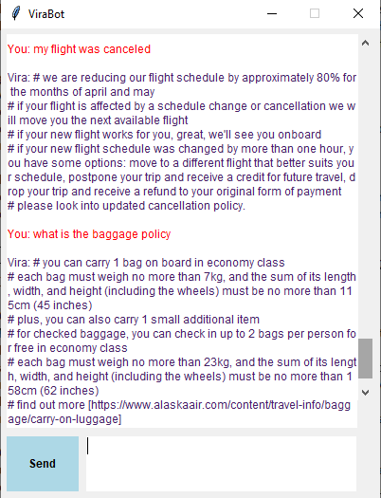 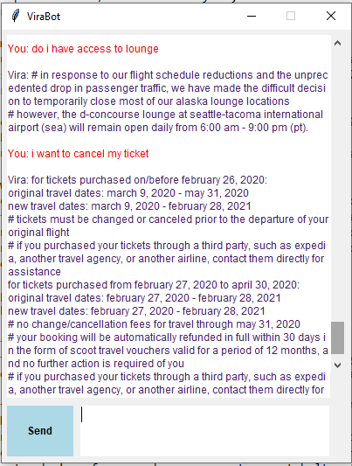

**Screenshots for the Summary statistics:**

1. Word cloud of the dataset we have considered

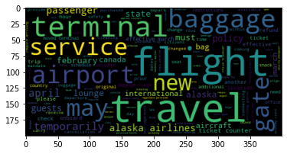

1. Lexical dispersion of most frequent words

One example shown below:

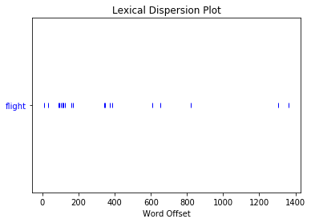

1. Accuracy Calculation: Here we are trying to calculate the accuracy manually.

Accuracy = Number of questions for which chatbot replied accurately / Total # of questions asked to chatbot

As of now, accuracy = 42/50 = 0.84 i.e. 84% accurate