TEAM 4

LEADERSHIP-PERFORMANCE

ANALYSIS

OF

NURSING HOME EMPLOYEES

Pooja Bhansali - gs6262

PonMalar

Prashanth Ravula - rj6383

Jayaprakash Reddy - bq8773

Table of the Content

|  |  |  |
| --- | --- | --- |
| No. | Title | Page |
| 1 | Introduction |  |
| 2 | Summary |  |
| 3 | Research and Methodology |  |
| 4 | Review of Survey Instruments |  |
| 5 | Factor Analysis of Leadership and Performance |  |
| 6 | Effect of Leadership on performance of Employees |  |
| 7 | Conclusions and Suggestions |  |
| 8 | References |  |

**INTRODUCTION**

As one of the most vital positions in the HR world, human resource analysts are given the duty of ensuring that all employees and managers are informed on the status of queries, issues, and concerns by compiling information relevant to the company. Using human resource information system programs like HRIS to manage their data more accurately, HR analysts gather statistics on salaries for specific job openings or analyze results from personality tests to select ideal job candidates. Those involved in improving employee training programs may also conduct surveys to gain information on job satisfaction before analyzing the data and recommending solutions to company managers to boost labor relations.

Creating work environments for nurses that are most conducive to patient safety will require fundamental changes throughout many health care organizations—in the ways work is designed and personnel are deployed, and how the very culture of the organization understands and acts on the science of safety. These changes require leadership capable of transforming not just a physical environment, but also the beliefs and practices of nurses and other health care workers providing care in that environment and those in the HCO who establish the policies and practices that shape the environment—the individuals who constitute the management of the organization.

Strong leadership is critical if the vision of a transformed health care system is to be realized. Yet not all nurses begin their career with thoughts of becoming a leader. The nursing profession must produce leaders throughout the Nursing Home system, from the bedside to the boardroom, who can serve as full partners with other health professionals and be accountable for their own contributions to delivering high-quality care while working collaboratively with leaders from other health professions.

Nursing homes should employ sufficient nursing staff to provide employee performance based on quality of care, controlling the cost of care and resources and reached to productivity target, taking care of employees additional responsibilities, nursing home also measuring generate high level of revenue from each unit, also providing ideas for new patient services, reducing medical errors, such as infection rates and medication errors and delivering high quality of medical care of patients and patient satisfaction, patient concerns and patient loyalty and building trust is key and important goals for nursing homes, HR analytics also like to measure the participation in organizations sponsored community outreach activities.

**SUMMARY**

People analytics can help organizations improve the effectiveness of nursing home workforce performance and leadership return on their HR investments. The functions of human capital management are all encompassing from hire to retire, offering Nursing home employees the opportunity to grow and develop is beneficial for both employees and them. Forward thinking nursing home leaders can capitalize on employee related opportunities resulting from industry consolidation and shifting workforce patterns by using people analytics. People analytics helps leaders refocus their nursing home workforce planning lens from a qualitative one, enabling them to scientifically unlock and measure the value of people of their organizations. People analytics can help Nursing home organizations maximize their return on workforce investments. But success requires a strategic approach that leverages leadership support and performance skilled team of analytics professionals.

Qualitative studies of the nursing home workers environment have long suggested that such attributes as leadership and communication may be related to nursing home performance, including home outcomes. However, empirical studies examining these relationships have been adequate.

**OBJECTIVES:**

This study is designed to: develop an instrument for measuring nursing home workers environment and perceived work effectiveness; test the reliability and validity of the instrument; and identify individual and facility-level factors associated with better facility performance.

**Research Design and Methods**

The analysis was based on survey responses provided by employees are 164 throughout Nursing Home. Exploratory factor analysis, analysis of variance, and regression models were used to assess instrument reliability and validity. Multivariate regression models, with fixed facility effects, were used to examine factors associated with work effectiveness based on employees performance and leadership.

**Results**

The reliability and validity of the survey instrument for measuring work environment and perceived work effectiveness has been demonstrated. Several individual (front line employee and manager) and facility characteristics (evaluation of employee performance and thoughts about unit leadership) that are significant predictors of perceived work effectiveness were identified.

**Conclusions**

The organizational performance model used in this study recognizes the multidimensionality of the work environment in nursing homes. Our findings suggest that efforts at improving performance must also be multifaceted. Empirical findings from such a line of research may provide insights for improving the quality of the work environment and ultimately the quality of residents' care.

A supervisor has a great quality of leadership to maintain the financial stability and enhance the efficiency of employees in Nursing home. Employees seeking to appreciations and satisfied with employees productivity from supervisors and increase retention should adopt practices that enhance worker satisfaction, starting with enhance patient satisfaction, quality of care enhance unit revenue that better identify the most promising candidates for work in long-term care and continuing enhanced training to enhance their ability to better manage a diverse workforce.

**RESEARCH AND METHODOLOGY**

Data is collected from employees of Nursing home to study the effects of Leadership on Performance of employees

Variables used – Demographic variables, Performance and Leadership

Methodology used – Survey

**MEASURES:**

Measures are the items in a research study to which the participant responds. Research measures include survey questions, interview questions, or constructed situations. When constructing interviews and surveys, it is important that the questions directly relate to the research questions.

All the measures are reasonable and appropriate for research purpose. Variable labels appeared in the given data is reasonable based on their operational measures except for the Tenure variable. Here in the given data every variable is categorized. Tenure variable gives employees Years Expected to Stay in this Nursing Home . There are a lot of missing values because respondents are asked to directly enter the years. To reduce the missing values and make it more suitable for analysis we suggest dividing the tenure into categories.

|  |  |
| --- | --- |
| **Reliability Statistics for Performance** | |
| Cronbach's Alpha | N of Items |
| 0.925 | 13 |

|  |  |
| --- | --- |
| **Reliability Statistics for Leadership** | |
| Cronbach's Alpha | N of Items |
| 0.833 | 14 |

**Performance Correlations:**

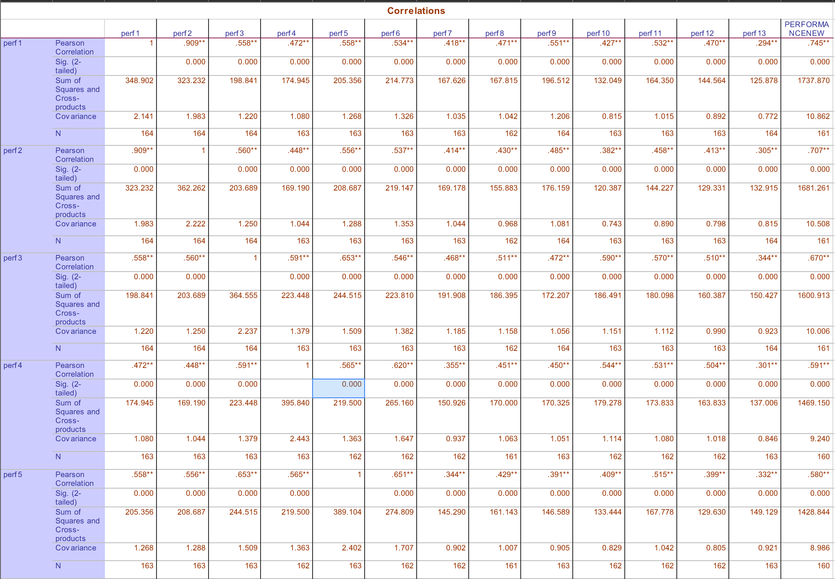

**Leadership Correlations:**

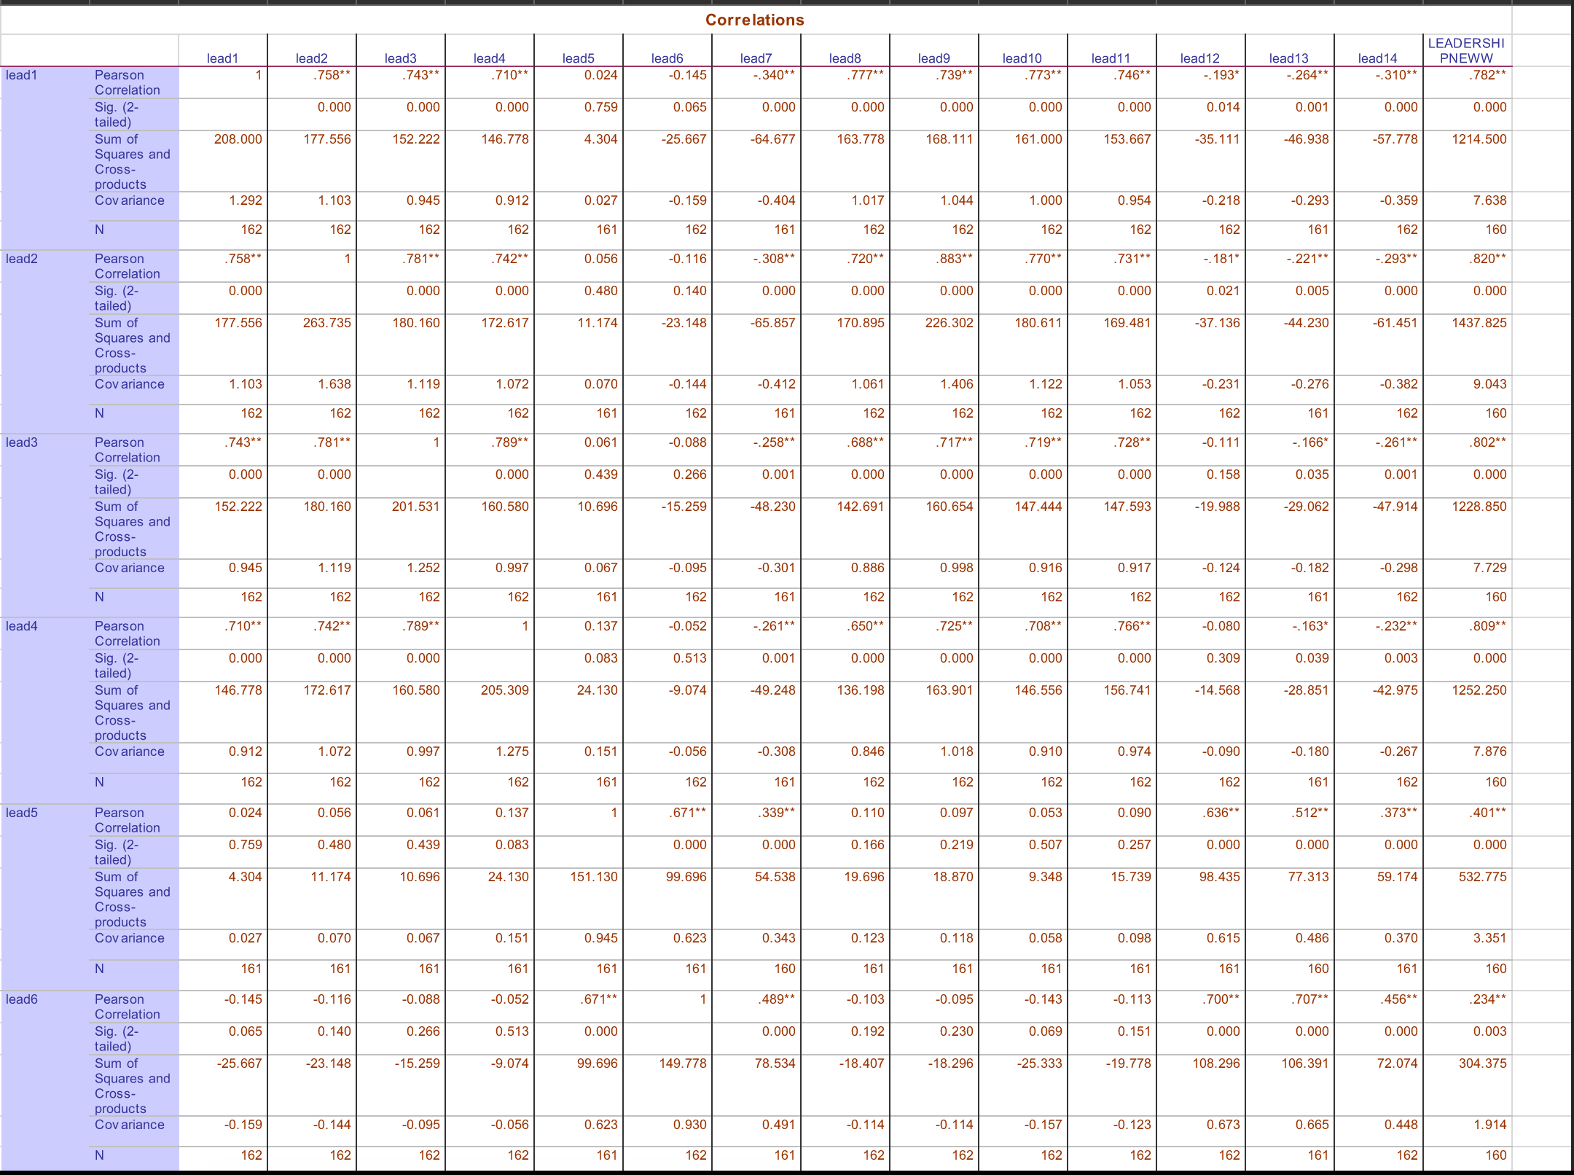

Measures are the items in a research study to which the participant responds and in our study it denotes the survey questions perf1 to 13 and Lead1 to Lead14. And these items have been evaluated by doing reliability & validity tests and are found to be appropriate for our study.

We used Cronbach’s alpha test for verifying the reliability and Pearson product moment correlation for verifying the validity of our items used in the survey.

**Review of Survey Instrument:**

Survey Variable labels appears reasonable however Tenure variable should be categorized which would in turn reduce the missing values.

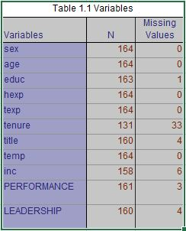

Measures have been evaluated by doing reliability & validity tests and are found to be appropriate for our study.

In the report, there are two types of Employee Identifier: Front Line as 1 and Identifier 2.

|  |  |  |
| --- | --- | --- |
| Level of Employees Identifier |  | Total |
|  |  |  |
| 1 as Front Line |  | 144 |
| 2 as Manager |  | 16 |
|  |  |  |
| Total |  | 160 |

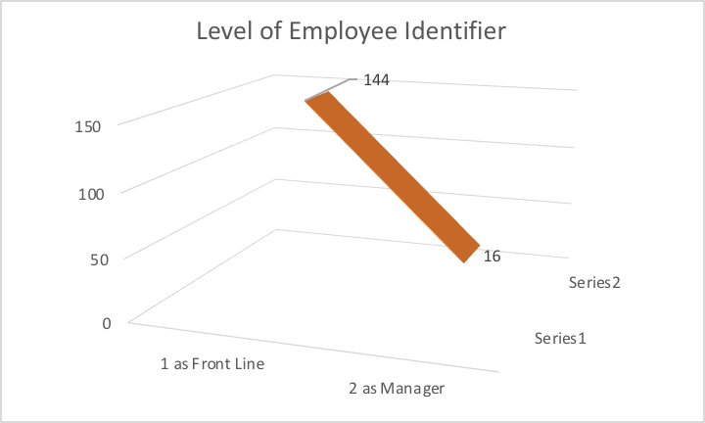

In Survey Evaluations: Employee performance identifier based on 13 unique questions asked by HR analytics:

**Employee Survey Gender Ratio:**

|  |  |
| --- | --- |
| Sex Ratio in Employee Survey |  |
| sex | Total |
| 1 as Male | 22 |
| 2 as Female | 142 |
| (blank) |  |
| Grand Total | 164 |

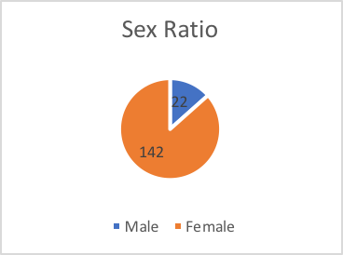

**Employee Survey Age:**

|  |  |
| --- | --- |
| Total of age |  |
| age | Total |
| 1 as < 25 years | 13 |
| 2 as 25-35 years | 60 |
| 3 as 36–45 years | 42 |
| 4 as 46–55 years | 39 |
| 5 as 56–65 years | 8 |
| 6 as 66 > years | 2 |
|  |  |
| Grand Total | 164 |

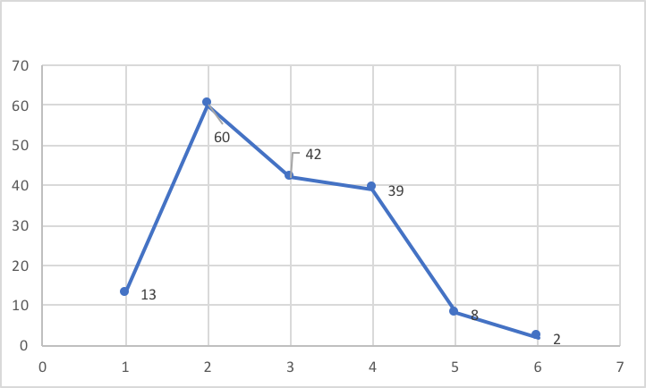

**Employee Education Survey:**

|  |  |
| --- | --- |
| Education of Employee Survey |  |
| Education | Total |
| 1 as High School/ GED | 2 |
| 2 as Technical Certification | 13 |
| 3 as Associated Degree | 63 |
| 4 Some College | 14 |
| 5 College Degree | 51 |
| 6 Graduate Degree | 20 |
|  |  |
| Grand Total | 164 |

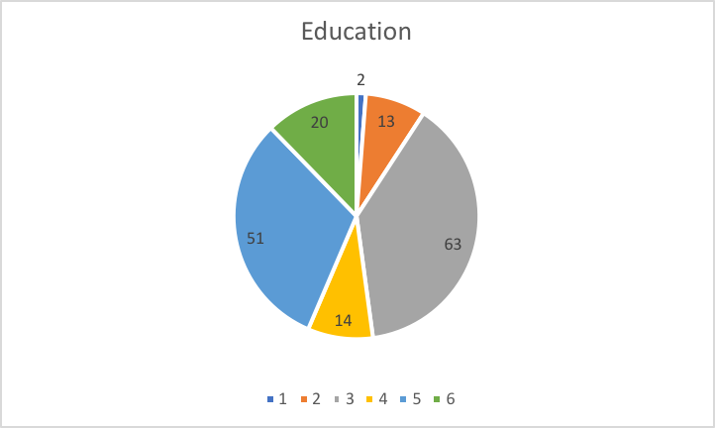

**Employee Years Survey:**

|  |  |
| --- | --- |
| Years Employed in this Nursing Home |  |
| Experience | Total |
| 1 as Less than 2 years | 19 |
| 2 as 2-5 Years | 53 |
| 3 as 6-10 Years | 22 |
| 4 as 11 – 15 Years | 24 |
| 5 as 16-20 Years | 14 |
| 6 as Greater than 20 Years | 32 |
|  |  |
| Grand Total | 164 |

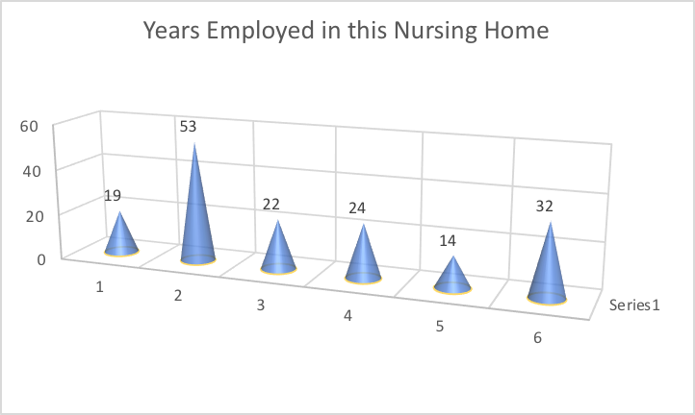

**Employee Total Experience of any Nursing Home:**

|  |  |
| --- | --- |
| Total Years of Experience in any Nursing Home |  |
| Experience | Total |
| 1 as Less than 2 years | 12 |
| 2 as 2-5 Years | 36 |
| 3 as 6-10 Years | 31 |
| 4 as 11 – 15 Years | 27 |
| 5 as 16-20 Years | 21 |
| 6 as Greater than 20 Years | 37 |
|  |  |
| Grand Total | 164 |

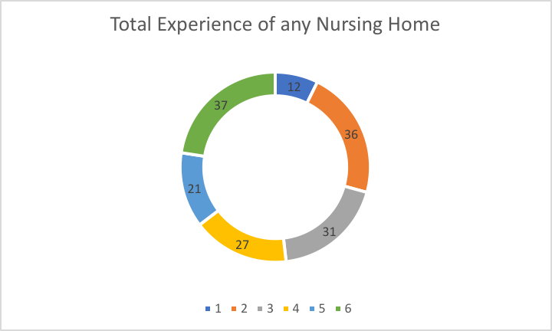

**Employee Present Job Title:**

|  |  |
| --- | --- |
| Title | Total |
| 1 as Clerk/Secretary | 5 |
| 2 as LPN | 7 |
| 3 as Nursing Assistant | 4 |
| 4 as RN | 48 |
| 5 as Social Worker | 4 |
| 6 as Technologist | 28 |
| 7 as Therapist | 39 |
| 8 as Supervisors | 11 |
| 9 Middle/Upper Management | 3 |
| 10 as Other | 11 |
| Grand Total | 164 |

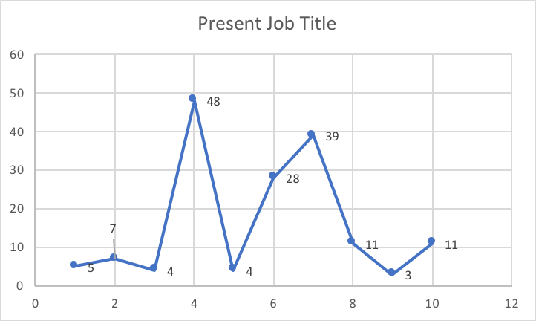

**Type of Employee Survey**

|  |  |
| --- | --- |
| Type of Employee |  |
| Temporary | Frequency |
| 1 as Full Time Employee | 107 |
| 2 as Part Time Employee | 41 |
| 3 as Casual Employee | 16 |
|  |  |
| Total | 164 |

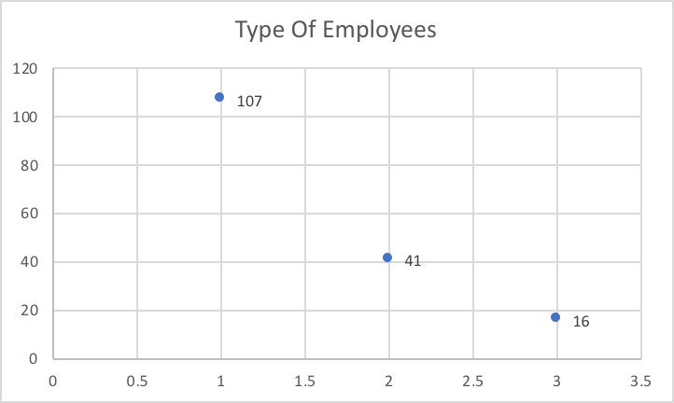

**Employee Income Survey:**

|  |  |
| --- | --- |
| Survey Employee Income |  |
| Income | Total |
| 1 as < 10,000 | 10 |
| 2 as 10,000 – 29,000 | 36 |
| 3 as 30,000 – 49,000 | 79 |
| 4 as 50,000 – 69,000 | 29 |
| 5 as 70,000 – 89,000 | 3 |
| 6 as 90,000 > | 1 |
|  |  |
| Grand Total | 164 |

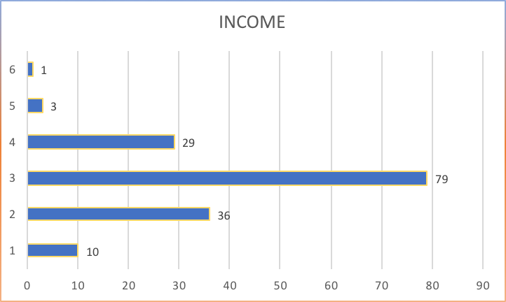

**Employee Quality Code Survey:**

|  |  |
| --- | --- |
| Quality Code |  |
| code | Total |
| 0 as High Quality no detected | 130 |
| 1 as No more than 10 omitted items with a majority (> 5) in the demographics section | 7 |
| 2 as Most or all of one section omitted | 4 |
| 3 as More than one section omitted | 9 |
| 4 as Lack of variation (checked the same category for all items in asection) | 11 |
| 5 as Major quality problems | 3 |
| Grand Total | 164 |

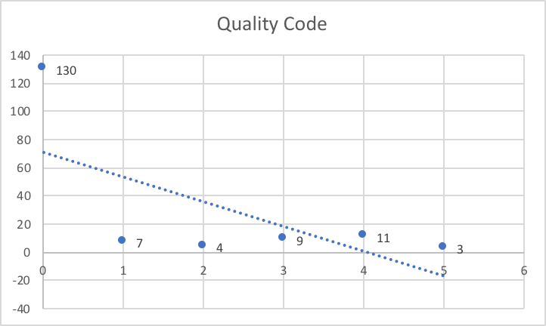

Based on the demographic variables measured, we can safely conclude it increases the confidence in the data as we happen to find majority of the people who are working in this field.

**Performance to Leadership:**

Performance as referred to in this presentation is a methodology for managing and aligning leadership behavior, strategy and results, three critical elements for achieving organizations, teams and individuals performance.

**PERFORMANCE STATISTICS:**

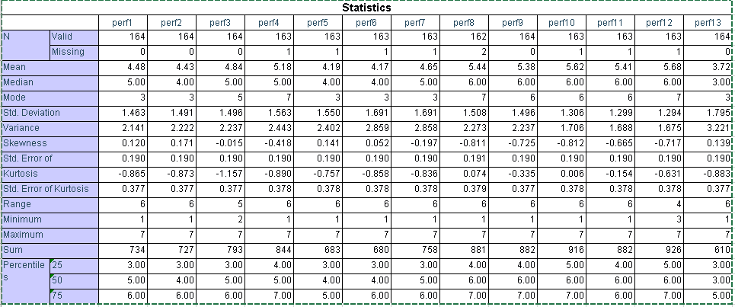

LEADERSHIP STATISTICS:

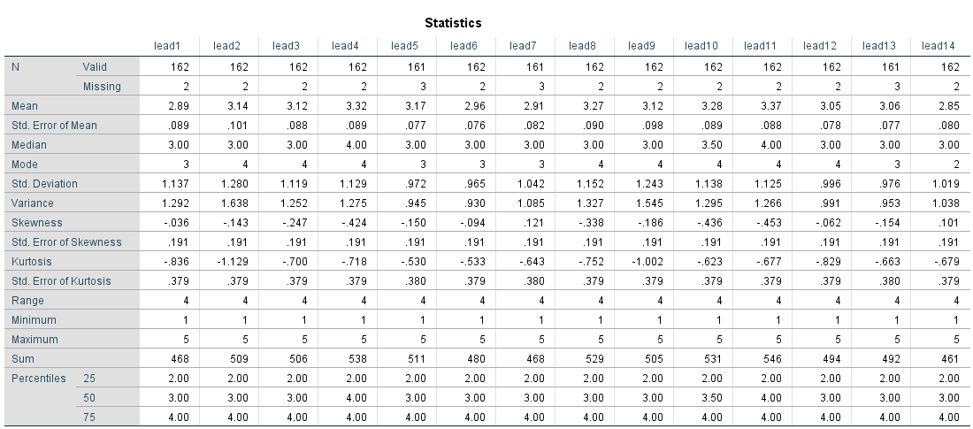

**Factor Analysis of**

**Leadership and Performance**

The analyst conceptualizes that there are two distinct leadership “factors” (items 1-14), and two distinct “performance” factors (items 1-13) that nursing home workers encounter in their work. According to the conceptualization, leadership factors are inherently different from performance factors and the absence of one does not imply the presence of others. However in our research we are analyzing the conceptual distinctions are consistent with workplace perceptions of nursing home employees. We also analyze the test for this conceptual-empirical consistency and test the convergent and discriminant validity of leadership-performance distinction also using a combination of exploratory and confirmatory factor analysis analyzes these issues.

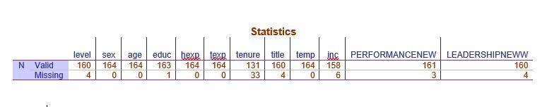

**Our Data met following criteria, hence they are suitable for factor analysis:**

No outliers, Adequate sample size, No perfect multicollinearity: Factor analysis is an interdependency technique.  There should not be perfect multicollinearity between the variables. Linearity: Factor analysis is also based on linearity assumption.  Non-linear variables can also be used.  After transfer, however, it changes into linear variable, Interval Data, All frequency distributions look plausible. We don't see anything weird in our data. All variables are positively coded: higher values always indicate more positive sentiments.All variables have some system missing values too but the extent of missingness isn't too bad.

Factor analysis provides information about reliability, item quality, and construct validity. General goal is to understand whether and to what extent items from a scale may reflect an underlying hypothetical construct or constructs, known as factors. An analytic method with high sensitivity to identify problematic items and assess the number of factors. Patterns of high inter-item correlations among subsets of items suggest more than one factor because the items tend to “cluster” together Any number of factors might underlie a set of items, up to the total number of items which would imply no common factor.

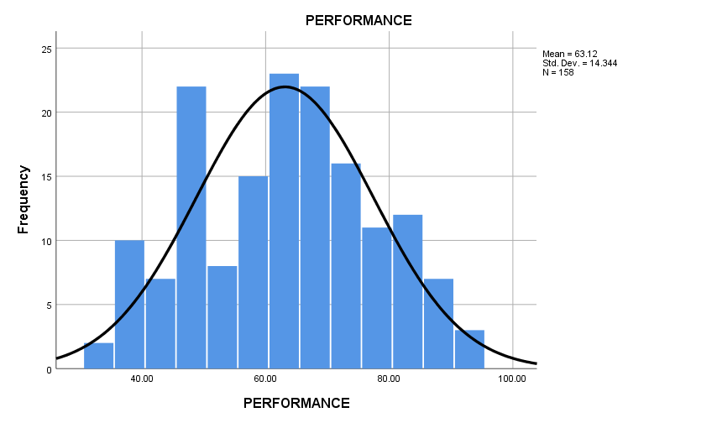

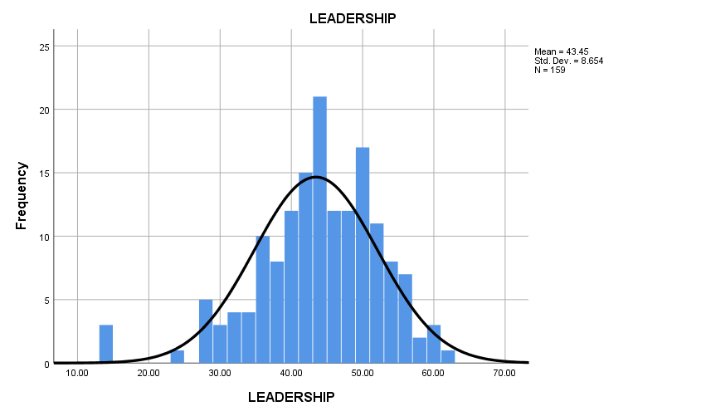

Exploratory factor analysis is if you don’t have any idea about what structure your data is or how many dimensions are in a set of variables.Confirmatory Factor Analysis is used for verification if you have a specific idea about what structure your data is or how many dimensions are in a set of variables. Exploratory data analysis helps to find patterns while confirmatory data analysis does statistical hypothesis testing on proposed models. In our Factor analysis, we are not sure at the start how many factors can be found. Hence, we have employed EFA to eliminate some factors that are not relevant. Once we are done with the preliminary elimination and arrived at possible factors, we can use Confirmatory factor analysis to test whether our chosen factors are significant.

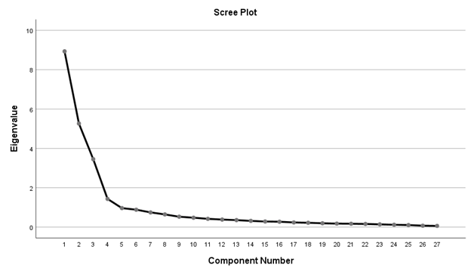

Leadership and Performance can be analyzed simultaneously combined or individually. A scree plot visualizes the Eigenvalues. In below scree plot, we see there are four factors that has Eigenvalues over 1 and these factors can be considered as “strong factors”. From 5th component and onwards the Eigenvalues drop off dramatically. The sharp drop between components 1-4 and components 5-27 strongly suggests that 4 factors underlie our Performance-Leadership analysis. Leadership and Performance each have two subdimensions. We have cross verified these by doing factor analysis for leadership and performance individually which also accounts for two subdimensions each. Since they are fetching us the same results we have analyzed them simultaneously.

**Convergent Validity**

Convergent validity is demonstrated by showing that the items or survey questions used to measure a factor, is appropriate and measures the perceptual or “latent” variable that it is intended to measure.

In our research, we used multiple rotation and extraction methods and checked item loadings. In general, item loadings above 0.70 are considered good items and indicate convergent validity of the factors.

**Discriminant Validity**

Discriminant validity is demonstrated by the distinctiveness of the “variables” or “factors” you create by adding the items. The distinctiveness of the factors used in a model can be studied by comparing the average variance shared between factors with the average variance extracted by each factor.

The criterion for discriminant validity that variance extracted for each construct should be higher than the variance shared with any other construct

Average Variance Extracted by both factors of Leadership 0.87 and 0.82 > Average variance shared between them, 0.16 . Hence there is evidence of discriminant validity

Average Variance Extracted by both factors of Performance 0.73 and 0.93 > Average variance shared between them, 0.27 . Hence there is evidence of discriminant validity .

**Name of the factors used for further analysis:**

Leadership Factors

1. Open to Change

Factors identified under open to change share common leadership attributes like, the leaders are not afraid of new changes , open to new change and motivates employees to perform efficiently by adapting these changes. They also perceived by employees that they give more freedom/autonomy to try new things that might help them improve their quality of work.

1. Resistance to Change

Factors named as Resistance to change share common leadership attributes like, the leaders are not very welcoming when it comes to new changes , employees think the leadership follows ‘stick to your guns’ approach.

Performance Factors

1. Patient Benefits/Satisfaction

Factors identified under Patients Benefits/Satisfaction commonly asks employees to evaluattheir performance relative to their coworkers on achieving patient satisfaction, how their service benefits patients by providing quality medical service and building trust.

1. Cost Saving

Factors identified under Cost saving are aimed at employees evaluating performance relative to their coworkers on cost saving and resource utilization aspects.

These factors can be used for further analysis by studying the relationship between them and how strongly one impacts the other.

Conclusions drawn based on the results for managers, CEOs, nursing home workers and public policy officials employees:

We can safely conclude based on our analysis that employees evaluate their performance based on achieving cost saving and resource utilization , providing quality medical service and achieving patient satisfaction. And employees perceives/identified there are two types of leadership existing in system that may or may not help much with improving their performance. One being more open to change and motivating, the other sticks to old belief system and doesn’t give much freedom to employees to incorporate new changes.

The leadership and performance of nursing home employees have critical outputs that have to be jointly maximized in any organizational setting. Many times, different factors influence performance differently so that some leadership factors might enhance employee performance more than others. Thus, the researcher conceptualizes that the leadership factors would influence employee performance differentially. In our analysis we run a regression analysis to tests for these hypotheses.

Null hypothesis – Leadership that is open to change and highly motivating is believed to improve performance of employees than the one that resists new changes.

Alternative Hypothesis- Leadership that resist new changes improves performance of employees.

Leadership ‘Resistance to change’ is Statistically Not significant since it is greater than 0.05 hence it’s the least/not significant in improving performance of employees.

We can safely conclude, Leadership that is ‘Open to change’ is most significant as the unstandardized coefficient value is 0.294 is higher than its counterpart 0.026, hence we can conclude Leadership that is open to change and highly motivating is believed to improve performance of employees than the one that resists new changes.

Direct effects of leadership factors on nursing home employee performance:

Effect of ‘Open to change and Motivating’ leadership on Nursing Home employee performance.

Based on our regression test results, leadership factor ‘Open to change’ has a positive coefficient 0.294 which means it has a positive effect on nursing home employee performance. Below scatter plot helps us to understand our conclusion visually. We can see there is an upward trend line.

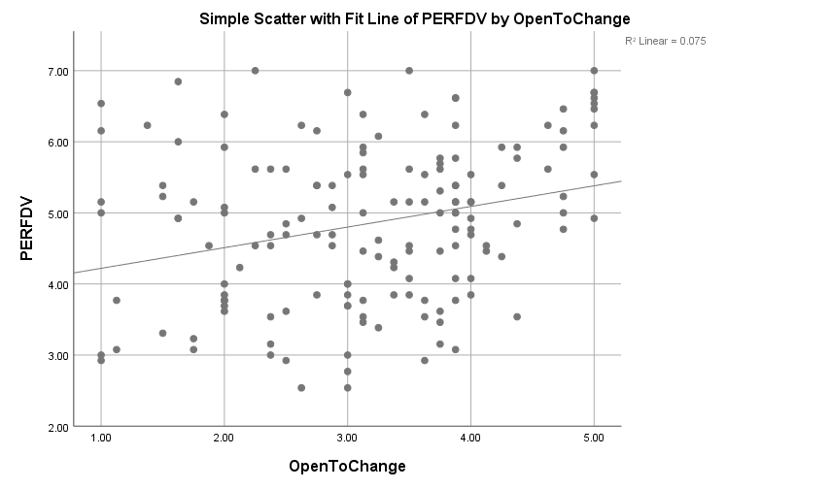

Effect of ‘Resistance to change’ leadership on Nursing Home employee performance.

Based on our regression test results, leadership factor ‘Resistance to change’ has coefficient of 0.02 which means it has zero to none effect on nursing home employee performance. Below scatter plot helps us to understand our conclusion visually. We can see there is a downward trend line.

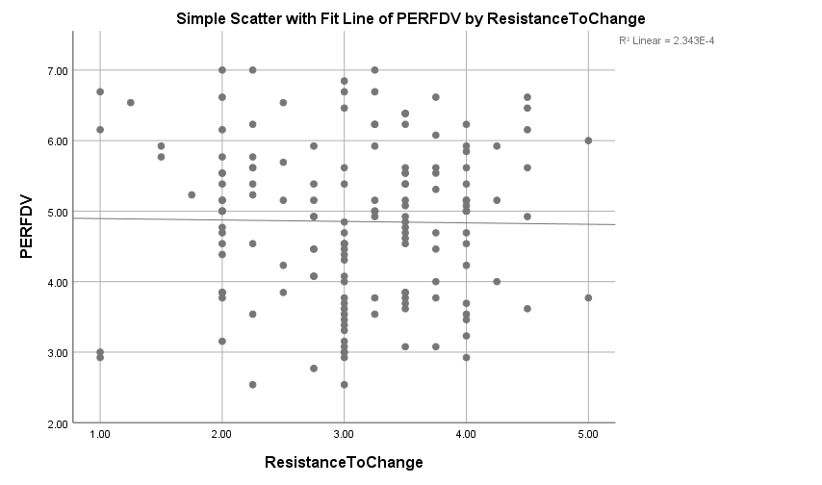

**CONCLUSIONS**

Conclusion drawn from the results for managers, CEOs, nursing home workers and public policy officials:

Based on our statistical test results, Leadership that is open to changes and motivating makes a positive impact on performance of employees. It encourages them to try new strategies that make them more enthusiastic about their work, help them to deliver high quality medical service and make them feel empowered.

Whereas Leadership that resist new changes and stick to old core system doesn’t have any impact on employee performance.

We can safely conclude organization should consider adapting leadership that is open to change which would in turn motivates employees and help them improve their performance by giving them more autonomy or power to try new things in their work system. When employees feel more empowered, they perform better and help the nursing home on whole to achieve higher patient satisfaction and retention.