1. **DATABASE CREATION & DATA CREATION:**
2. **Student Info table:**

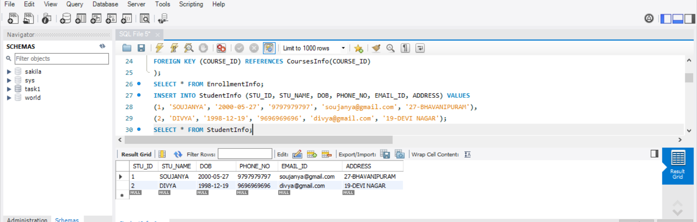

1. **Courses Info Table:**

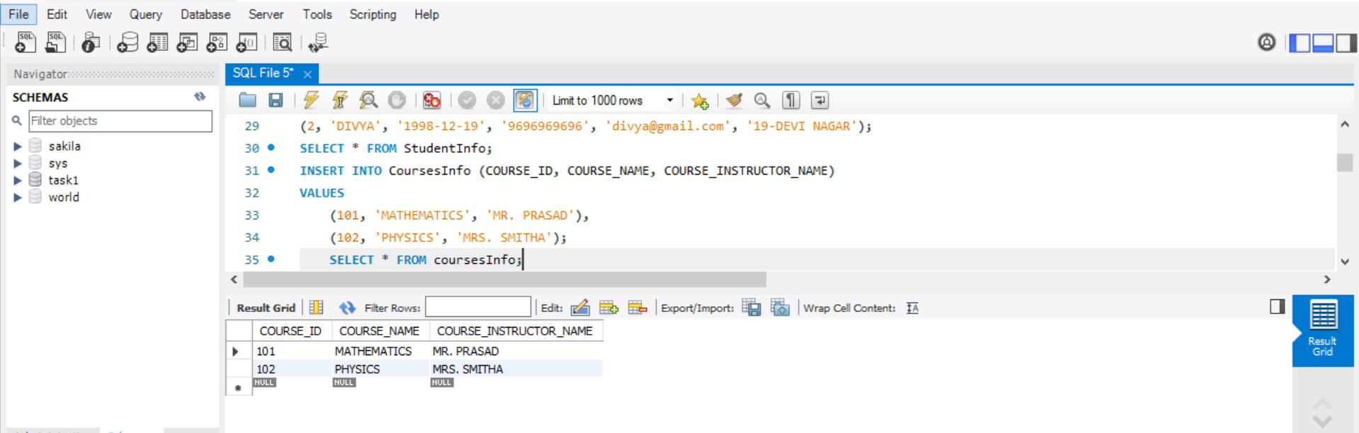

1. **Enrollment Info Table:**

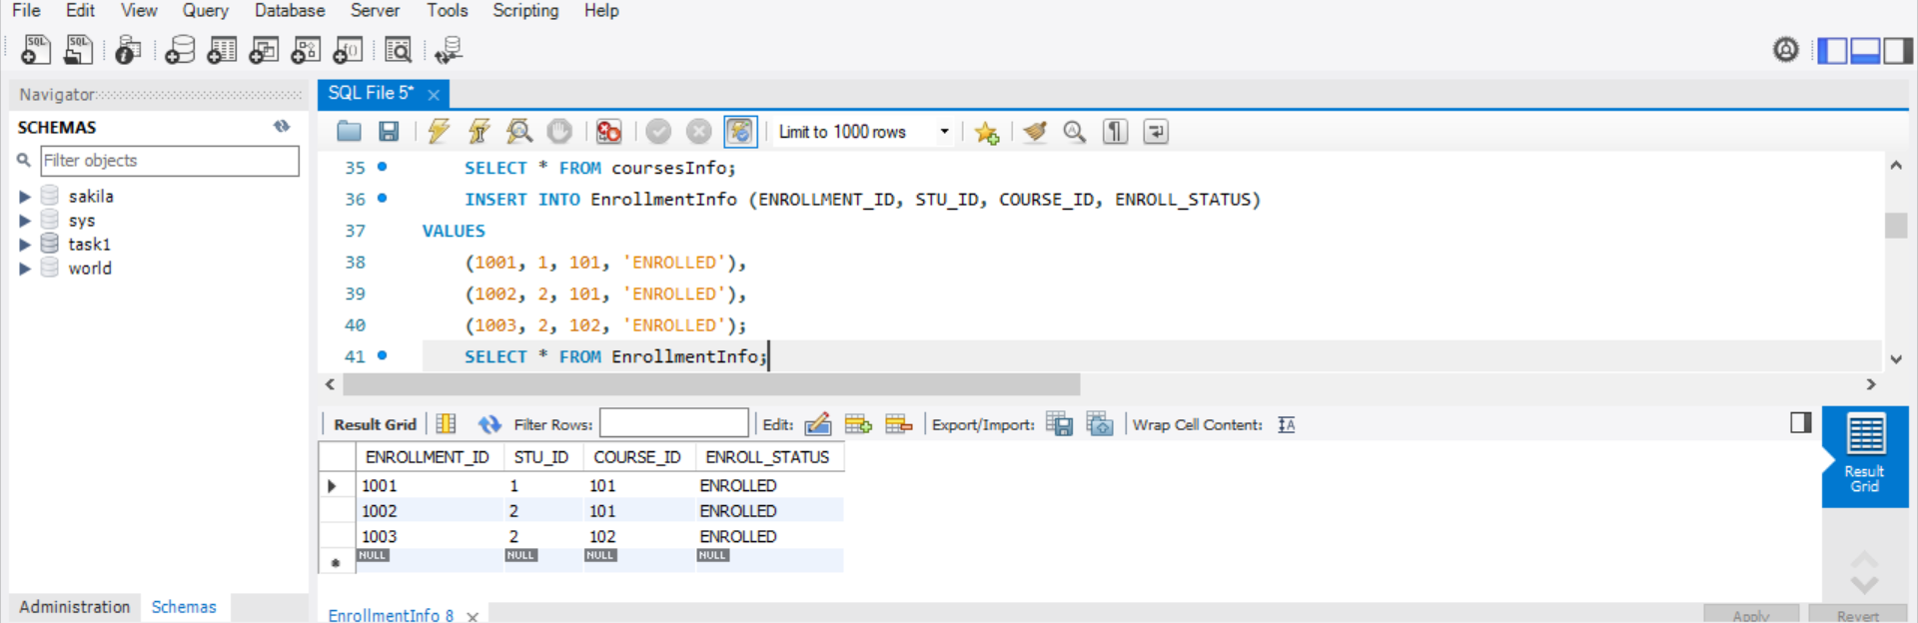

**RETRIEVE THE STUDENT INFORMATION**

1. **To retrieve student details, including their name, contact information, and enrollment status**

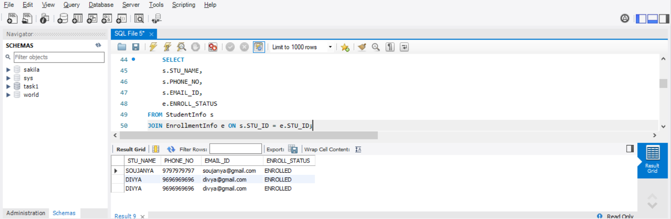

1. **To retrieve a list of courses in which a specific student is enrolled(let’s say with STU_ID = 2)**

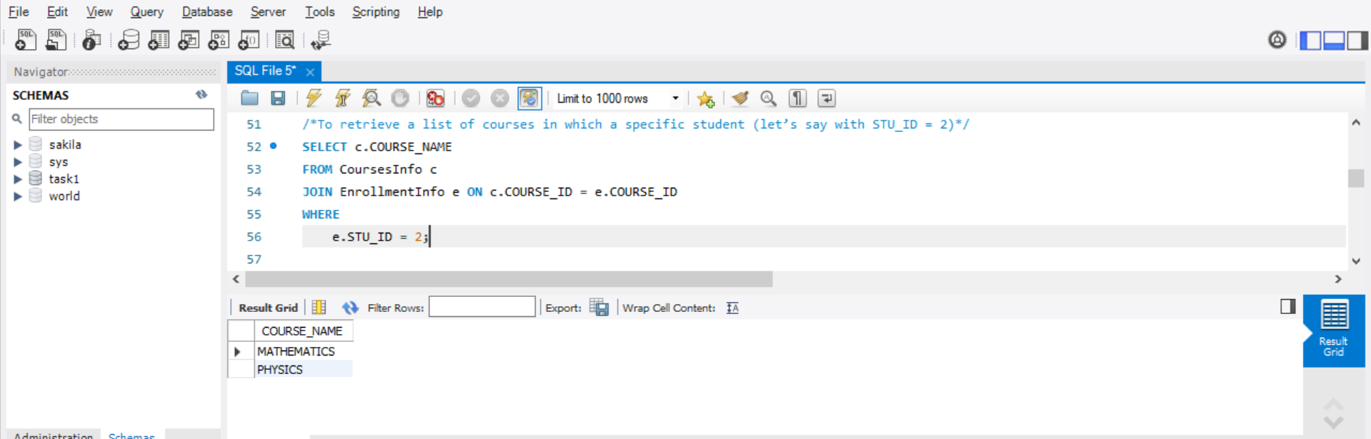

1. **To retrieve course information, including course name and instructor details**

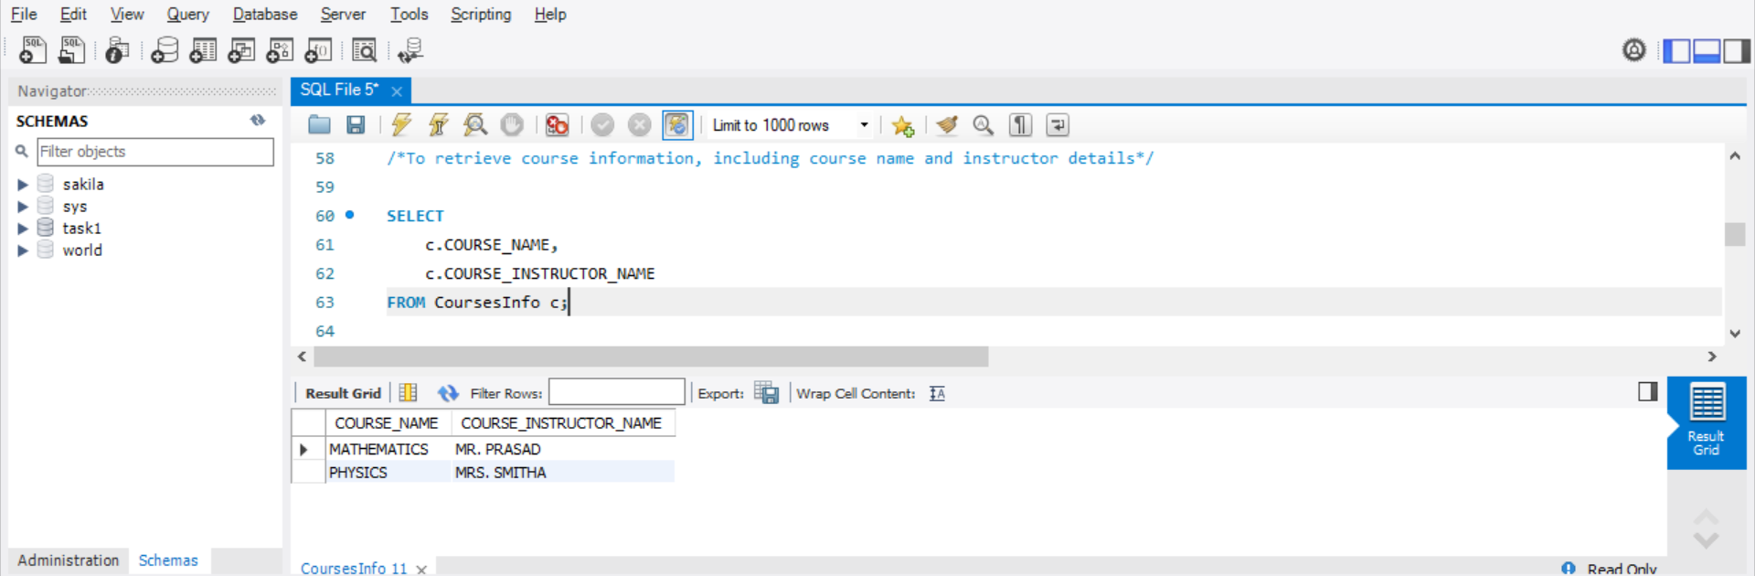

1. **To retrieve course information for a specific course (let’s say with COURSE_ID = 102)**

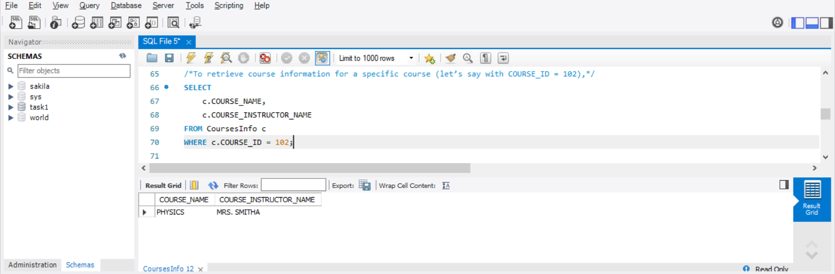

1. **To retrieve information for multiple courses (let’s say with course IDs 101, 102)**

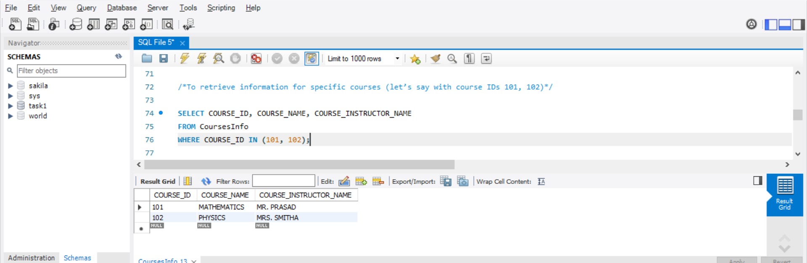

1. **Test the queries to ensure accurate retrieval of student information. (execute the queries and verify the results against the expected output.)**

The Screenshots were already added in the above for the queries of retrieval of student information**.**

**Reporting and Analytics (Using joining queries)**

1. **To retrieve the number of students enrolled in each course**

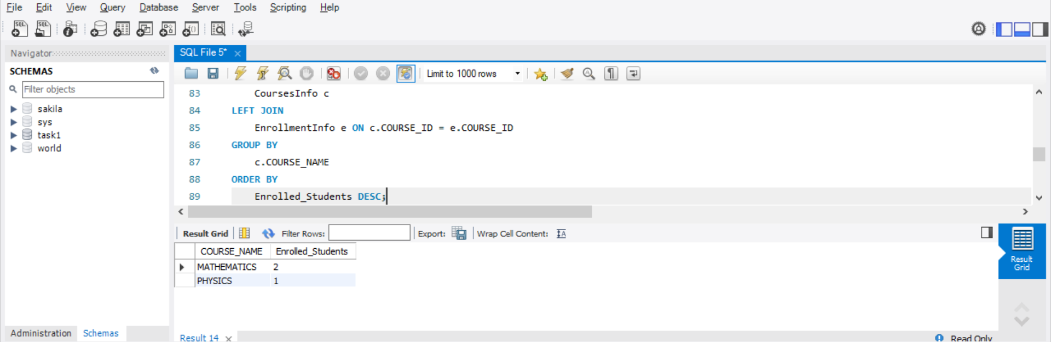

1. **To retrieve the list of students enrolled in a specific course (let’s say with COURSE_ID = 101)**

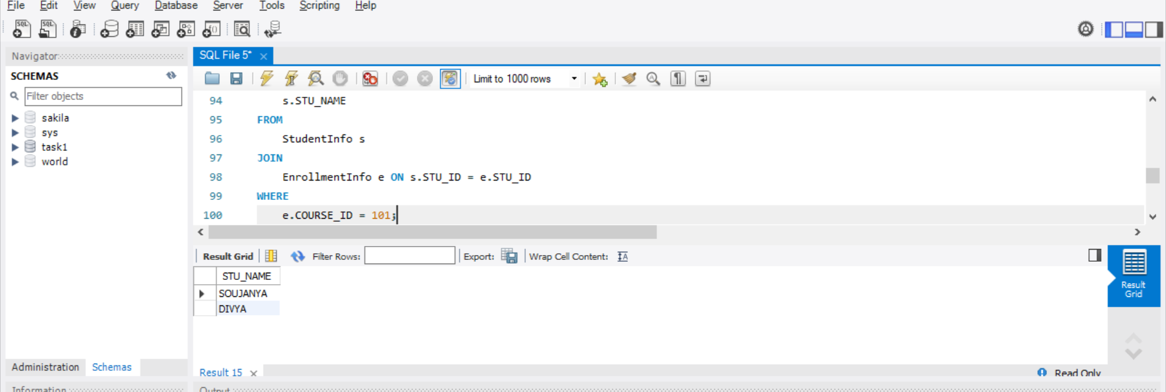

1. **To retrieve the count of enrolled students for each instructor**

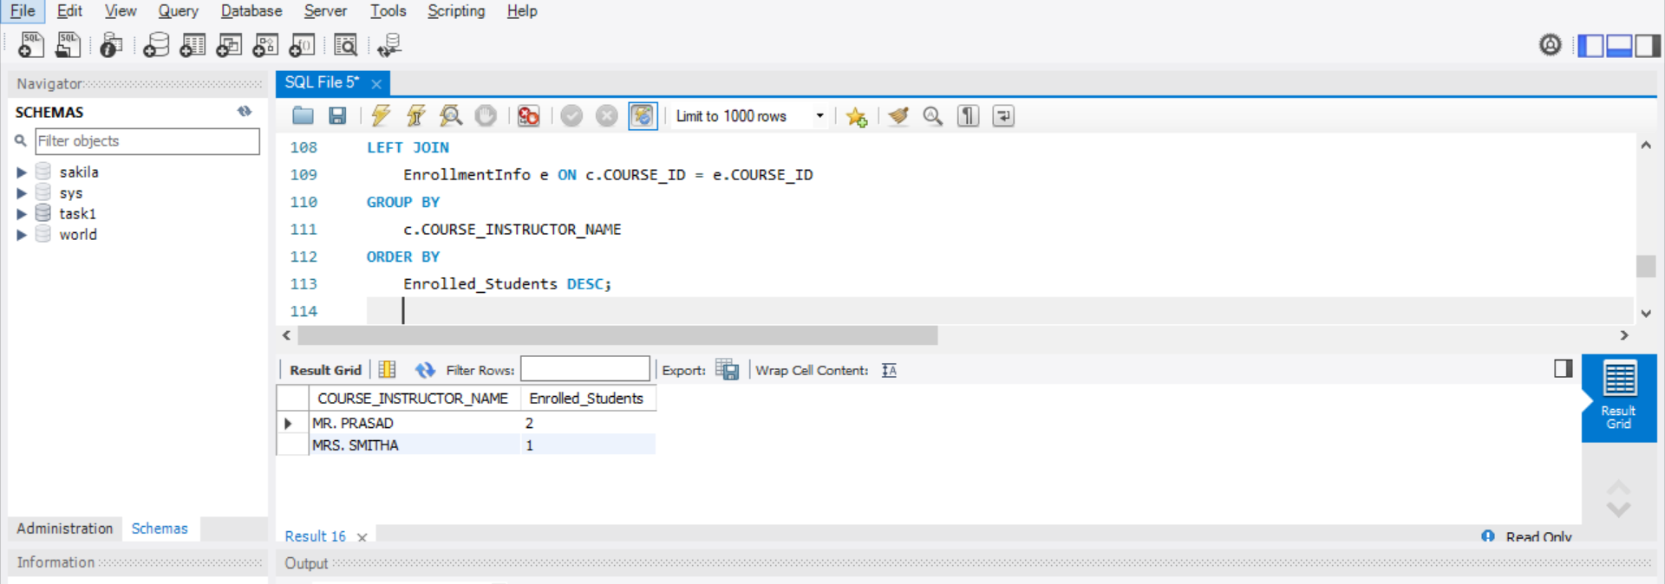

1. **To retrieve the list of students who are enrolled in multiple courses**

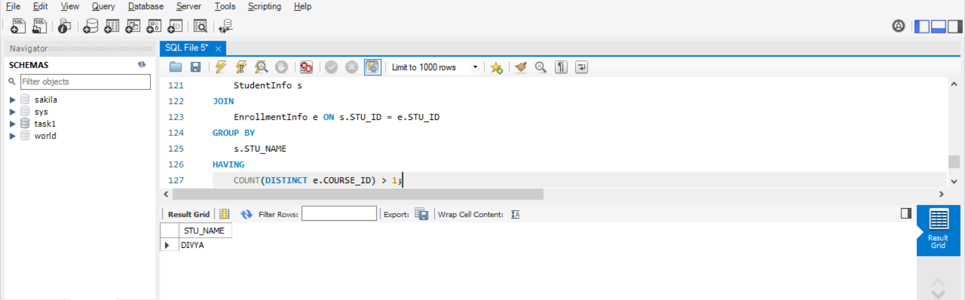

1. **To retrieve the courses with the highest number of enrolled students (arranged from highest to lowest)**

