1. **Database Creation (PostgreSQL)**

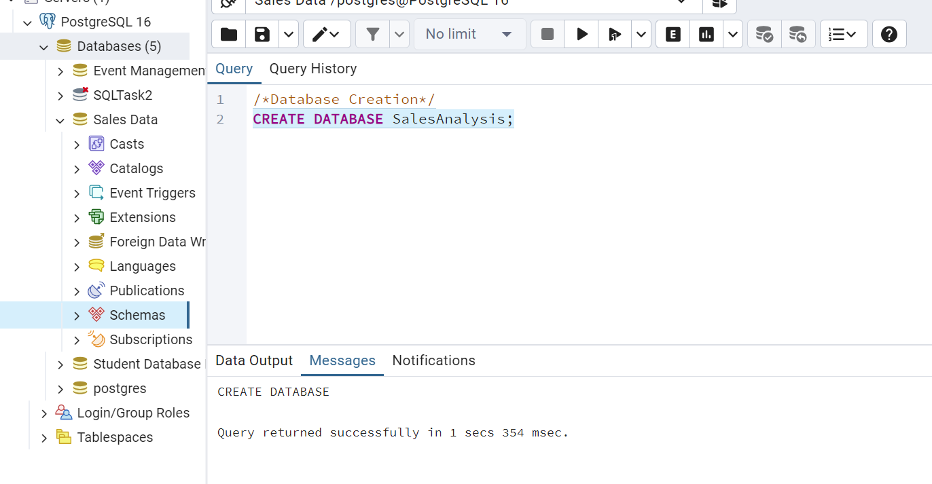

Create a table named "sales_sample" with the specified columns

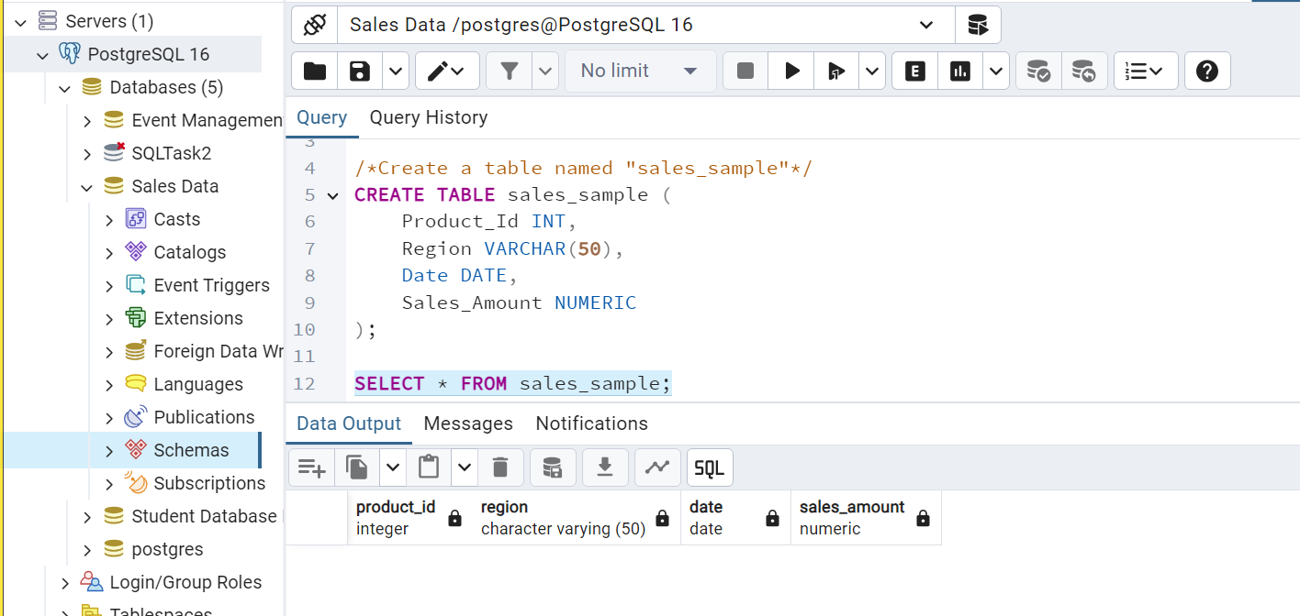

**Data Creation**

Insert 10 sample records into the "sales_sample" table, representing sales data

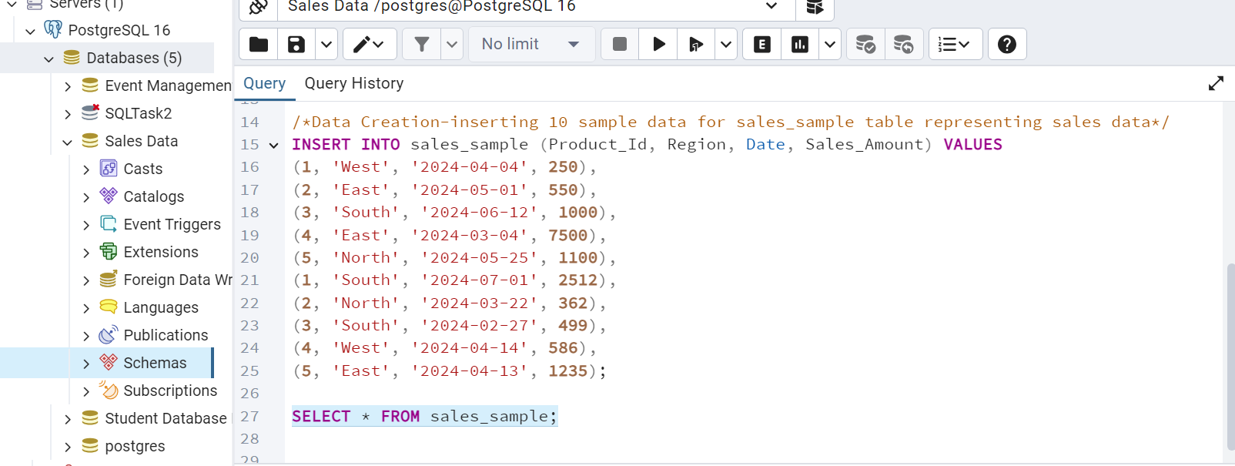

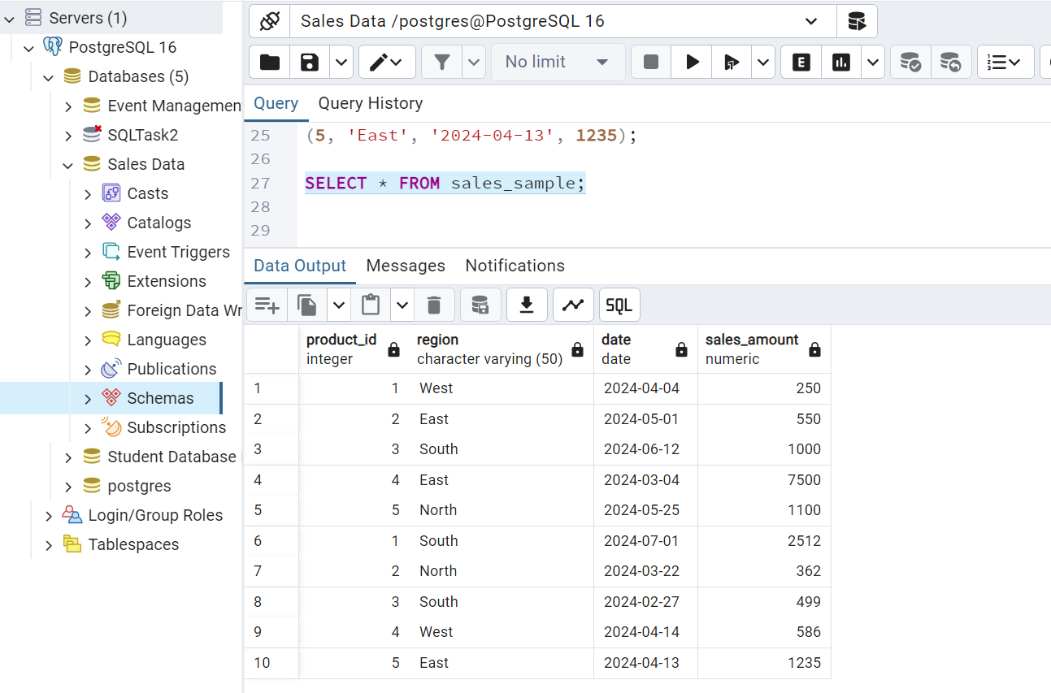

1. **Perform OLAP operations**

**a)** **Drill** **Down** - Analyze sales data at a more detailed level. Write a query to perform drill down

from region to product level to understand sales performance

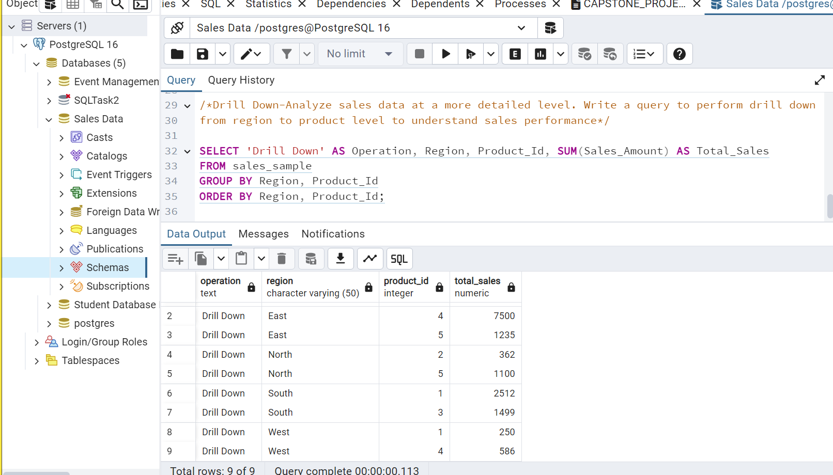

**b)** **Rollup** - To summarize sales data at different levels of granularity. Write a query to perform

roll up from product to region level to view total sales by region

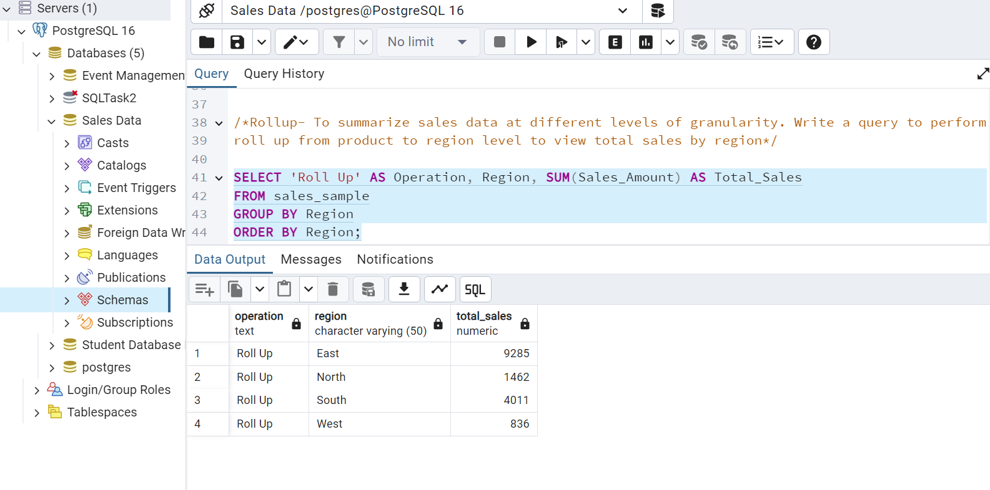

**c) Cube** - To analyze sales data from multiple dimensions simultaneously. Write a query to

Explore sales data from different perspectives, such as product, region, and date.

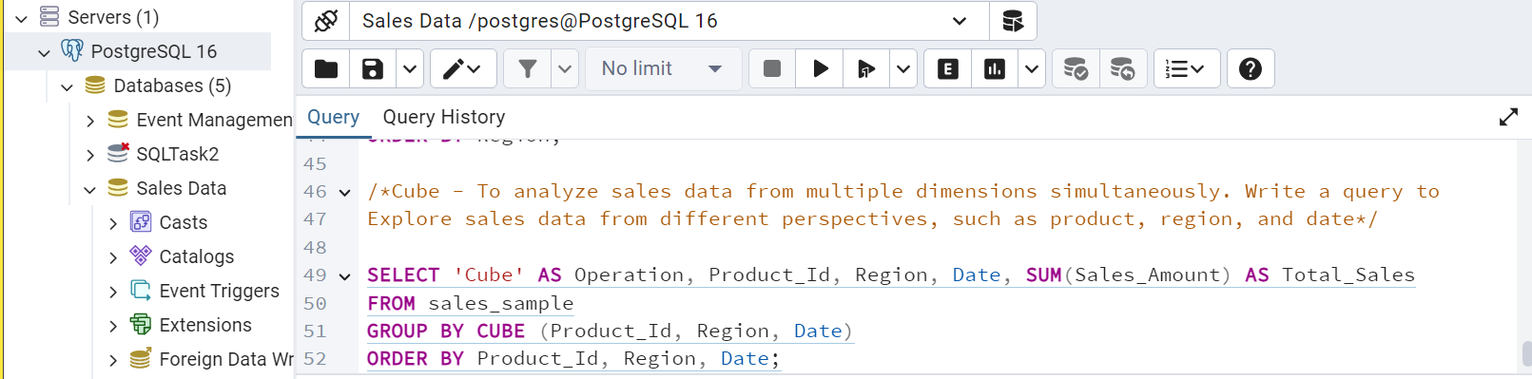

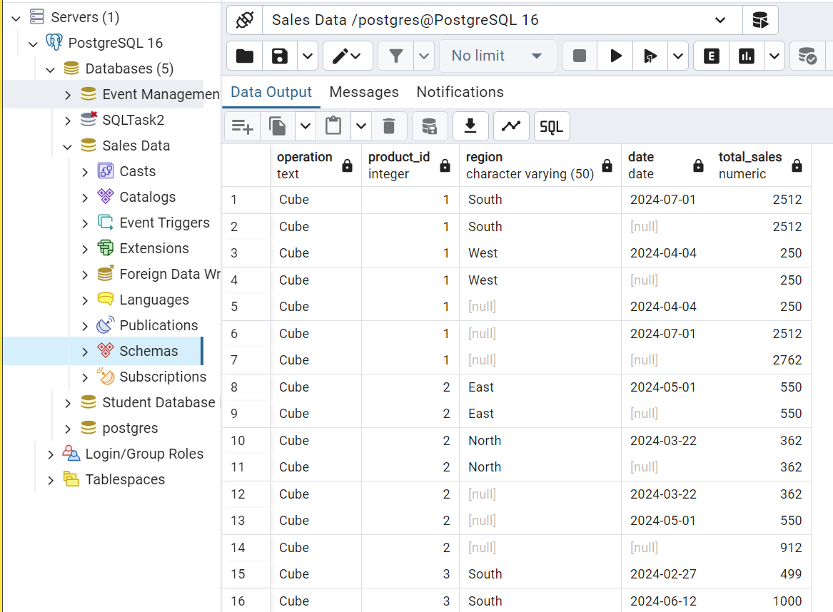

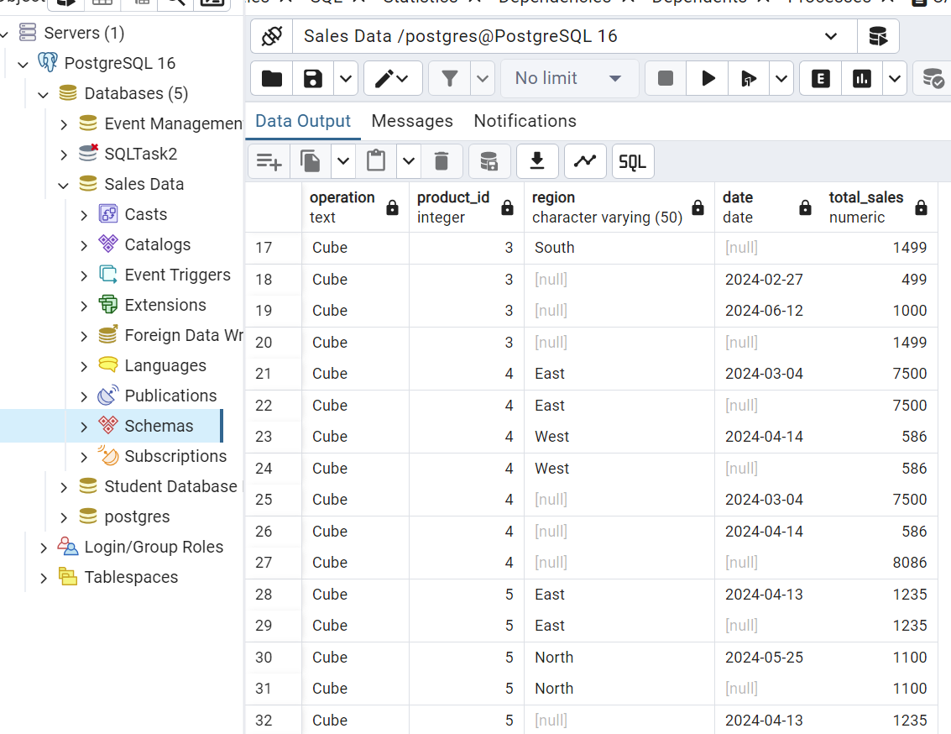

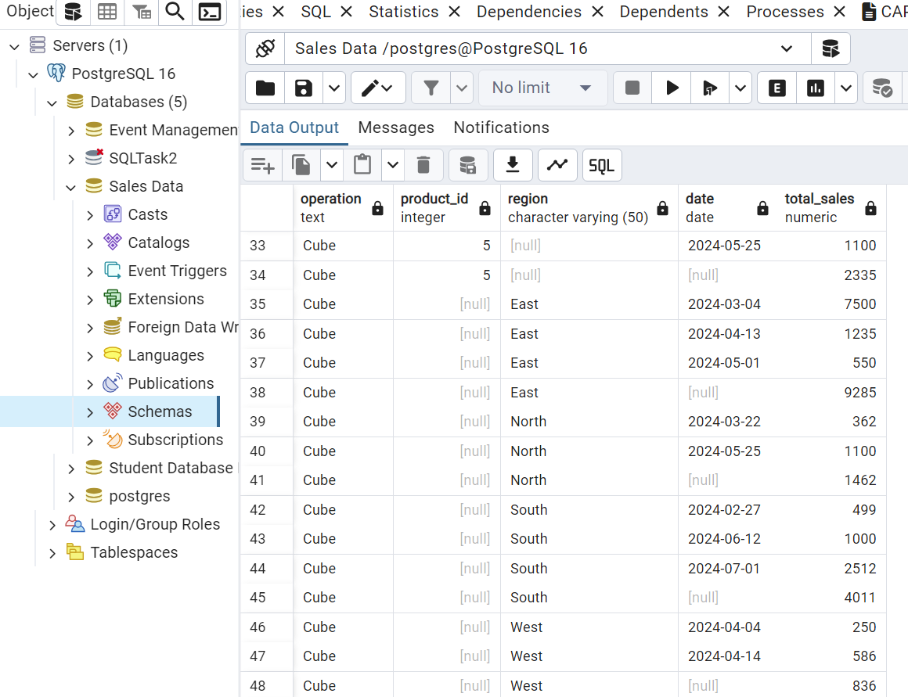

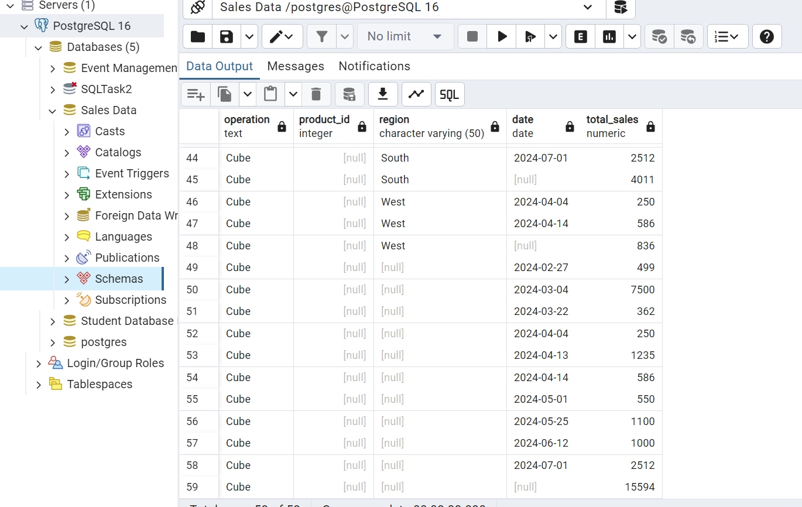

**d) Slice** - To extract a subset of data based on specific criteria. Write a query to slice the data to

view sales for a particular region or date range

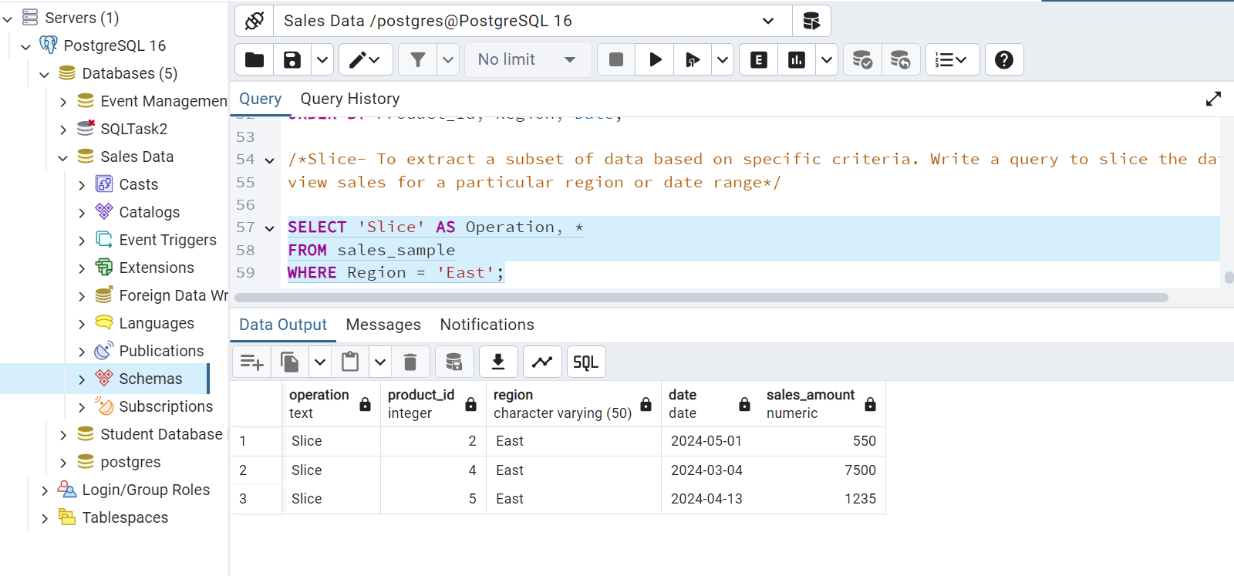

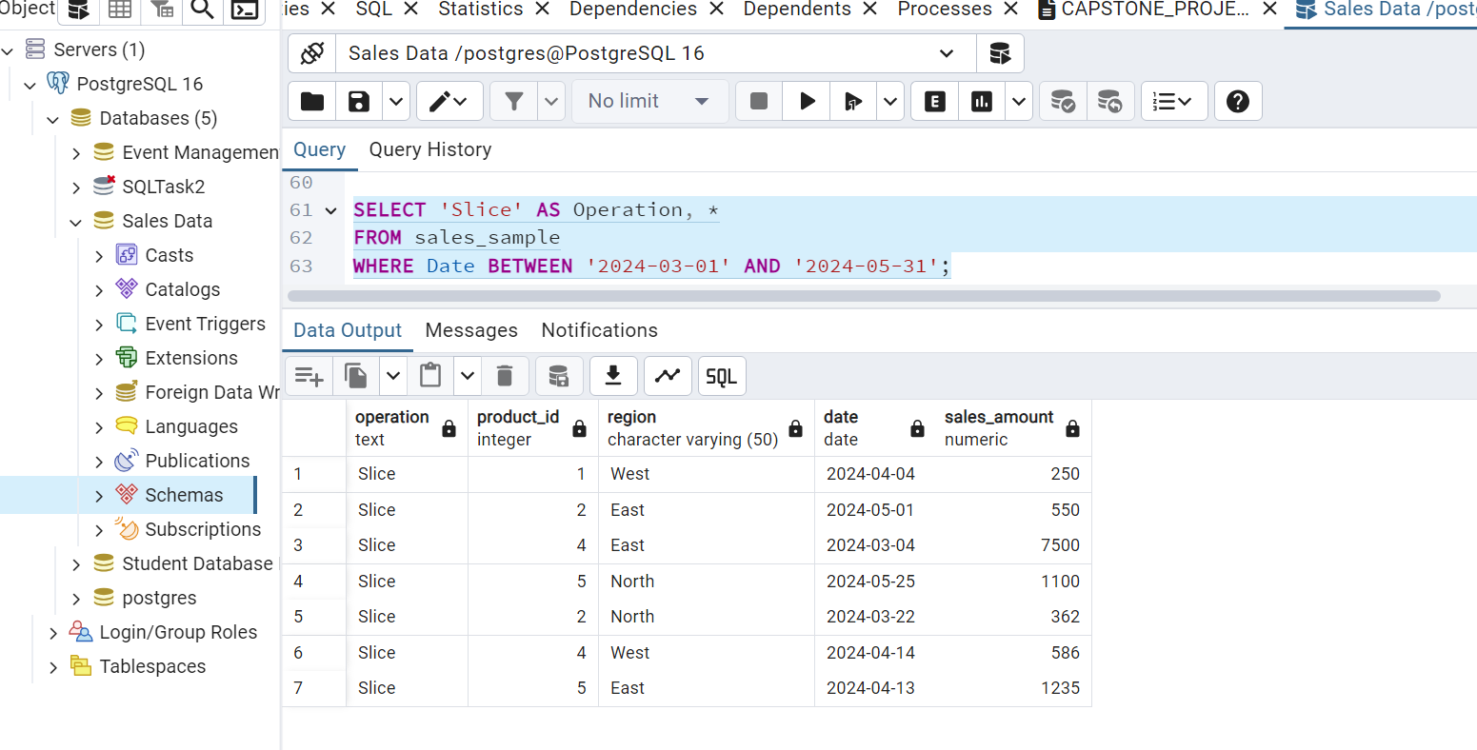

**e) Dice** - To extract data based on multiple criteria. Write a query to view sales for specific

combinations of product, region, and date

