**import** sqlite3

*# Create database connection*conn **=** sqlite3**.**connect("sales_data.db")cursor **=** conn**.**cursor()

*# Create sales table*cursor**.**execute("""CREATE TABLE IF NOT EXISTS sales ( id INTEGER PRIMARY KEY AUTOINCREMENT, product TEXT, quantity INTEGER, price REAL)""")

*# Insert sample data*data **=** [

("Laptop", 5, 60000),

("Mobile", 10, 20000),

("Tablet", 7, 15000),

("Headphones", 15, 3000),

("Smartwatch", 8, 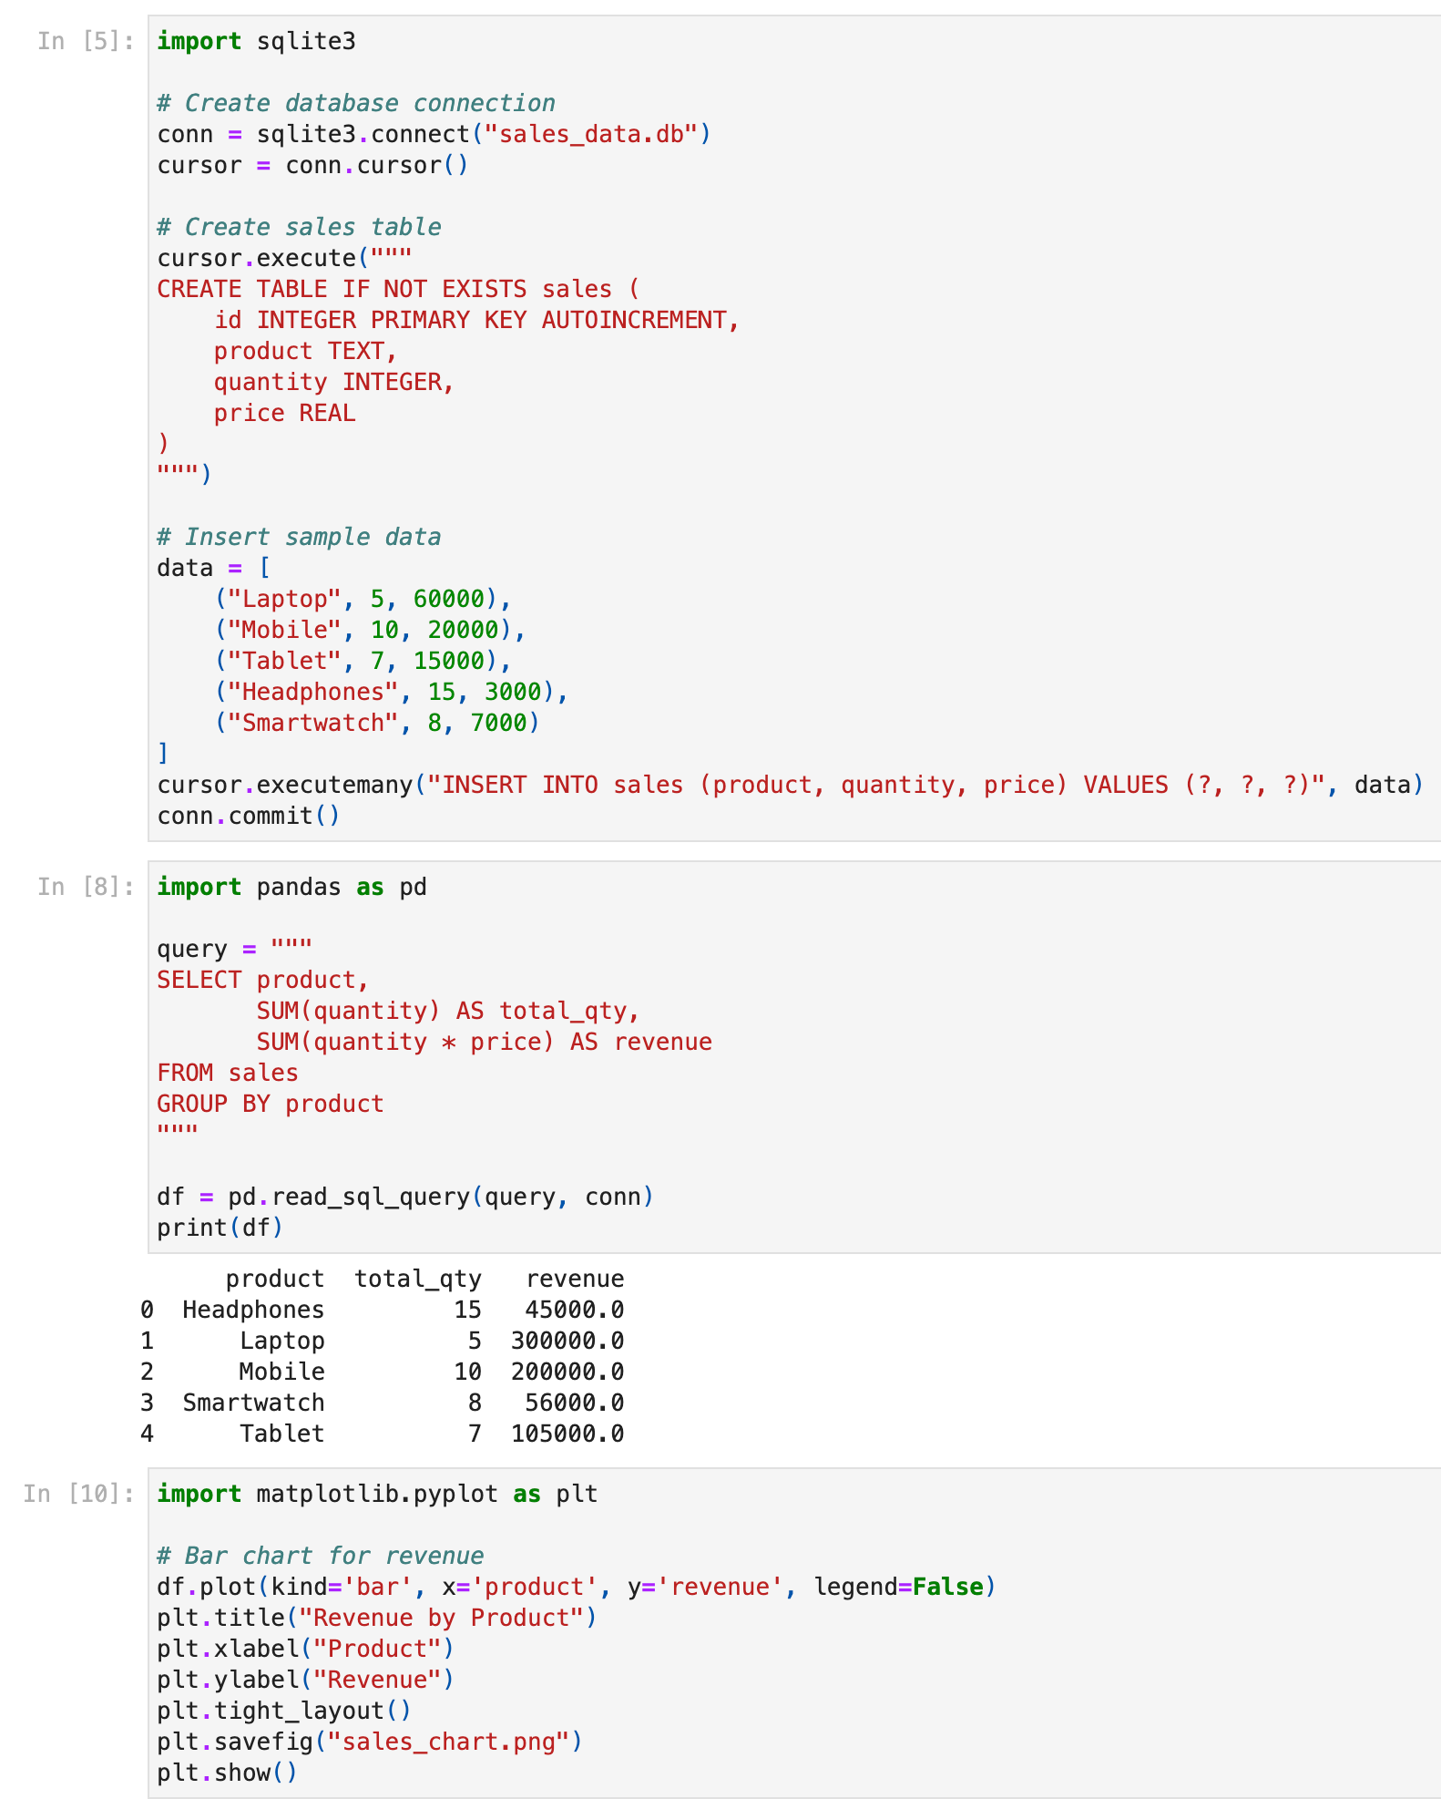quantity, price) VALUES (?, ?, ?)", data)conn**.**commit()

