In Python, the ZoneInfo module is a built-in library that provides a way to work with time zones. Time zones are crucial in computing as it helps in handling time differences and conversions between different regions of the world. In this article, we will explore the ZoneInfo module in Python and learn how to use it in our programs.

What is ZoneInfo?

The ZoneInfo module is a part of the standard library introduced in Python 3.9. It provides access to the IANA Time Zone database, which is a comprehensive database of all time zones worldwide. The IANA Time Zone database is the most widely used time zone database in the world and is maintained by the Internet Assigned Numbers Authority (IANA).

Using the ZoneInfo module, we can retrieve information about a specific time zone, including the time zone name, offset from Coordinated Universal Time (UTC), and daylight-saving time rules. It also provides us with the ability to convert a given datetime object to a different time zone, allowing us to work with times in different regions of the world easily.

How to Use ZoneInfo in Python?

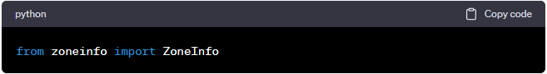Once we have imported the ZoneInfo module, we can create a datetime object and associate it with a specific time zone using the **zoneinfo** method. Here's an example:

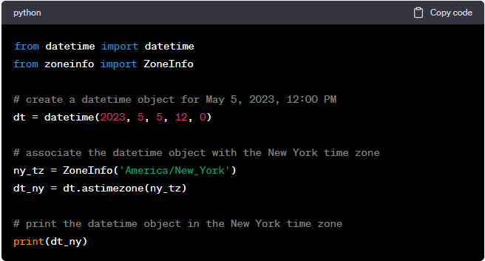In the above example, we created a datetime object for May 5, 2023, 12:00 PM, and associated it with the New York time zone using the **ZoneInfo** method. We then converted the datetime object to the New York time zone using the **astimezone** method and printed the result. The output will be the datetime object converted to the New York time zone.

We can also retrieve information about a specific time zone using the **ZoneInfo** method. Here's an example:

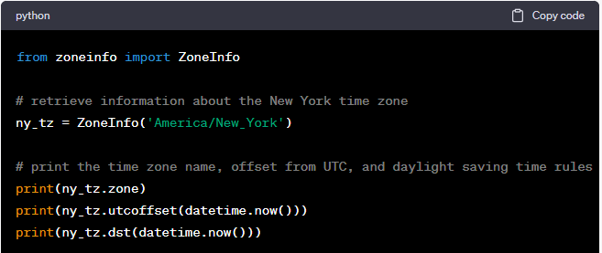

In the above example, we retrieved information about the New York time zone using the ZoneInfo method. We printed the time zone name using the zone attribute, the offset from UTC using the utcoffset method, and the daylight-saving time rules using the dst method.

Conclusion

The ZoneInfo module in Python provides a convenient and easy-to-use way to work with time zones. It allows us to retrieve information about a specific time zone and convert datetime objects to different time zones. This makes it easy to work with time-sensitive data and handle time differences between different regions of the world. If you need to work with time zones in your Python program, the ZoneInfo module is an excellent place to start.