**COURSE02MODULE05**

1. Data Source Excel spreadsheet

Checking the following constraints is done:

* Null or not (via Filter Rows)
* Data types (via Data Validator)
* Foreign Key References (via Sort and Merge at each step)

Filter Rows screenshot:

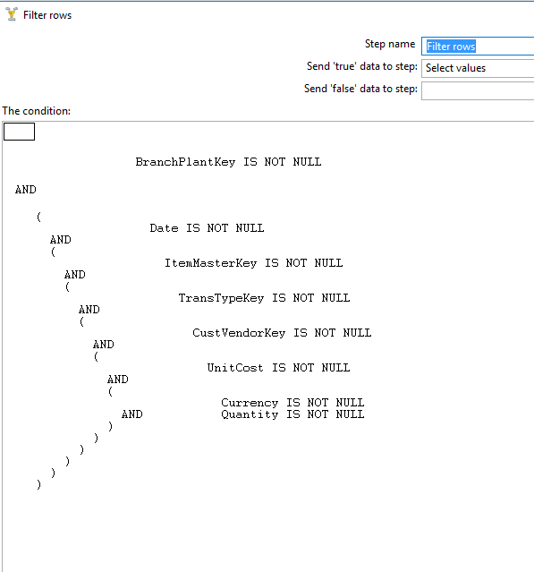

DataValidator (Data Type Validation)

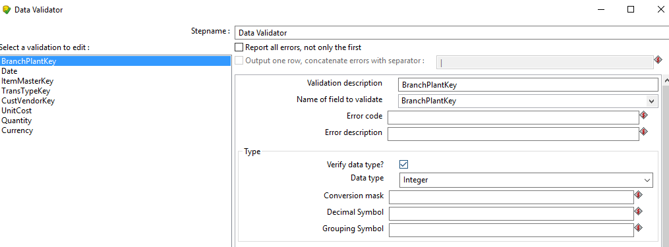

Transformation Screenshot:

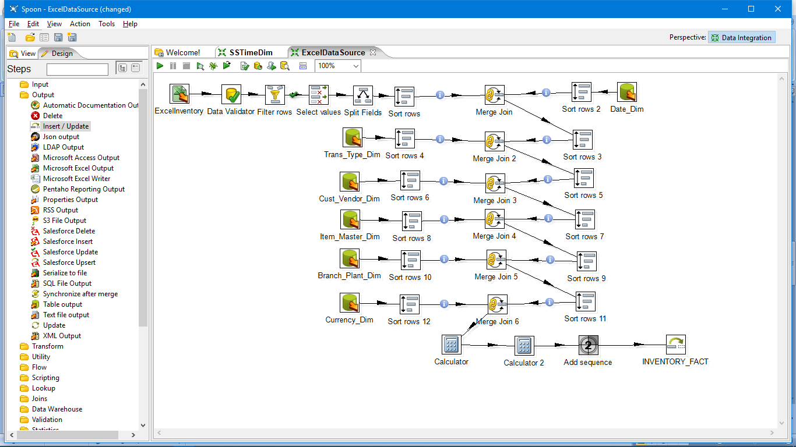

Execution of above transformation results in insertion of 10 new rows shown below as sql developer output

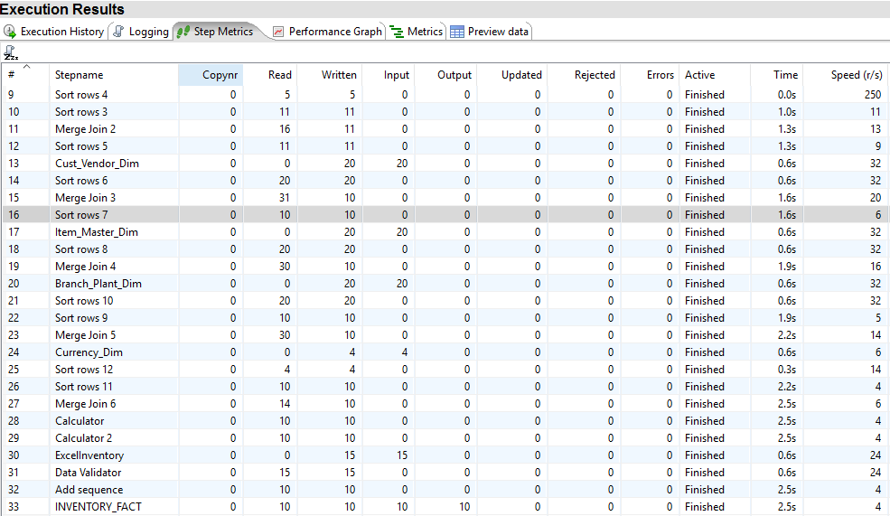

Sql Screenshot:

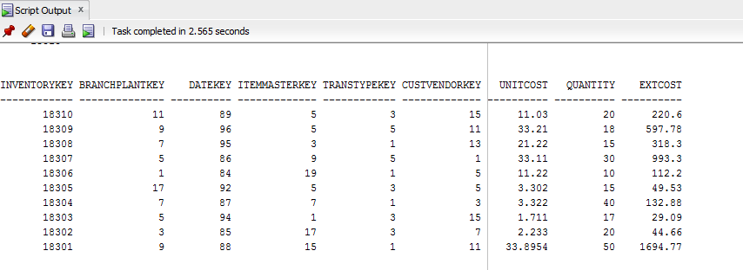

1. **Data source as Access**

Checking the following constraints is done:

* Null or not fields (via Filter Rows)
* Data types (via Data Validator)
* Foreign Key References (via Sort and Merge at each step)

Filter Rows screenshot:



DataValidator (Data Type Validation)



Transformation Screenshot:

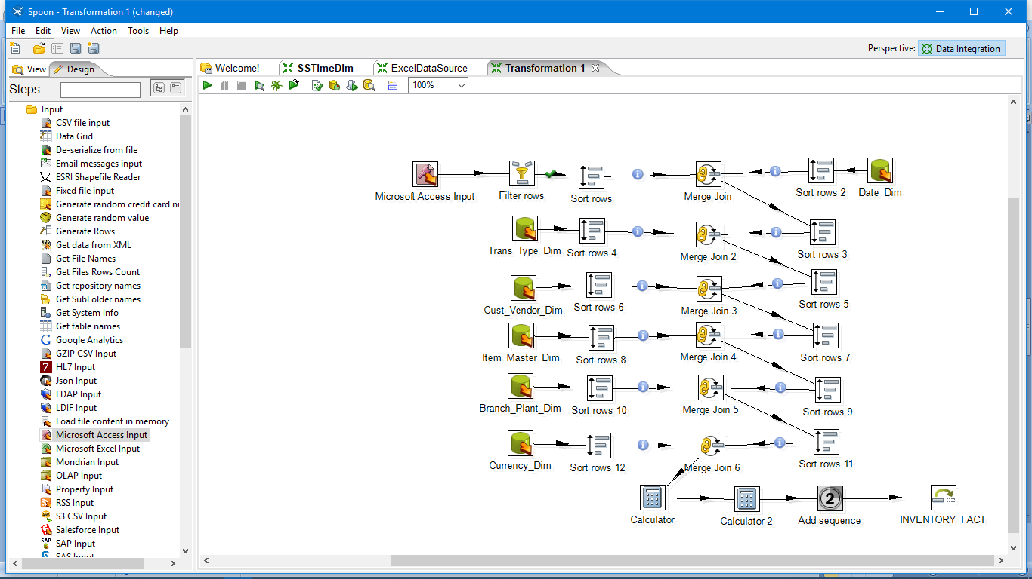

Execution of above transformation results in insertion of 11 new rows shown below as sql developer output

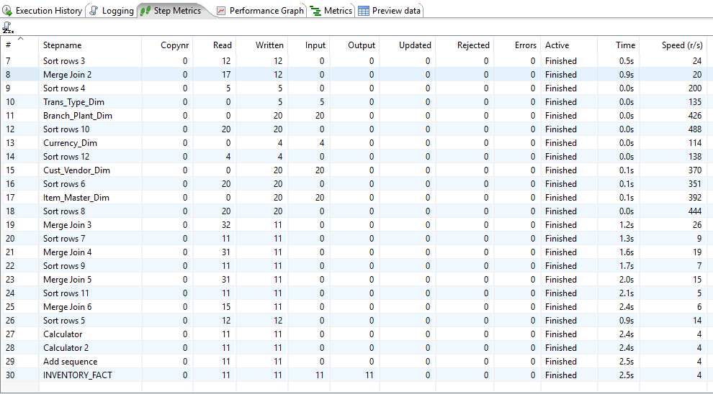

Sql Screenshot:

