**Course2_Module3_Assignment_Solutions**

**1)**

|  |  |  |  |
| --- | --- | --- | --- |
| **Dimensions** | | **Dimensions Data Source** | **Dimension Hierarchy** |
| **Member** | * MemId * MemName | ERD and Worksheet | - |
| * MemZip | ERD | - |
| * MemEmail | ERD | top level domain ->second level domain -> local part |
| * MemType | ERD | - |
| **Service** | * Sid * SName * SType | ERD and Special Events Worksheet |  |
| **Franchise** | * FranchId | ERD | - |
| * FranchRegion | ERD | Country->FranchRegion |
| * FranchPostalCode * FranchModelType | ERD | - |
| **Merchandise** | * MerchId * MerchName * MerchType | ERD | - |
| **Calendar** | * MemDate * ServPuchDate * SaleDate | ERD | year ->month ->day |
| * Eventdate | Worksheet |

**2)**

The measures are mostly from the

1. Sale table
2. Contains table for Merchandise Sales
3. ServPuchase Table for service purchases.
4. Some parts of Special Events Worksheet.

* Qty: additive measure from Contains table in ERD.
* Fact Table will record the price of Each Service Purchased derived measure from Service : ServCatPrice (ServiceCategory tablefrom ERD) non-additive measure(Because service price depends on the time of purchase)
* SpecialEvents: (Amount field from Worksheet): non-additive measure.
* MemberShip Price: MemTypePrice from MemberType Table(ERD).
* Merchandise : Unit Price of Merchandise (MerchPrice) ,Non additive and snapshot measure.
* TotalMerchsales : In fact table : additive measure(qty*unitprice)

**3)**

Calculation of grain size is as follows:

**Dimensions Calculation:**

* Franchise Rows = 350 and Franchise Postal codes = 200(given) so total =350
* 20 ServiceCategory Row and 1row for special Event so total = 21
* Days per year: 365 so total = 365
* 500 Merchandise Rows, Total= 500
* 50000 Member Rows, 150 Member Rows*200 Franchises(for special events) , 10 MemberType ,500 Member Zip Codes Rows so total = 50000 + 150*200 = 80000

**Fact Table size Calculation:**

* 100,000 Service Purchase Rows,(300*200) Special Events Purchase rows and 450,000 Contains table Rows so the fact table size = 1000000 + 60000 + 450000 = 610000

**Sparsity Calculation:**

* Formula : 1 - (fact table size / product of dimensions)
* 1 – (610000 / 350*21*365*500*80000) = 0.99
* The data cube has less than 1% of non zero cells

**4)**

1. Star schemais selected to support the sales analysis with 1 fact table and 5 dimension tables
2. Fact table named as SalesFactTable is introduced with the following attributes:

* SFTId(primary key)
* SFTQty(To determine sales quantity)
* SFTUnitPrice(Merchandise and Service Price)
* SFTTotalsales(Total sales amount)
* SFTPurchaseType(M:merchandise And S:service)

Dimension Tables are as follows:

Member

MemId(Primary key)

MemName

MemZip

MemEmail

MemDate(membership date)

MemType(Guest / Customer)

Service

Sid(primary key)

SName

SType(Special event, service, merchandise)

Merchandise

MerchId (Primary Key)

MerchName

MerchType

Franchise

FranchId (primary key)

FranchRegion

FranchPostalCode

FranchModelType

Calender

CId (primary key)

CDay

CMonth

CYear

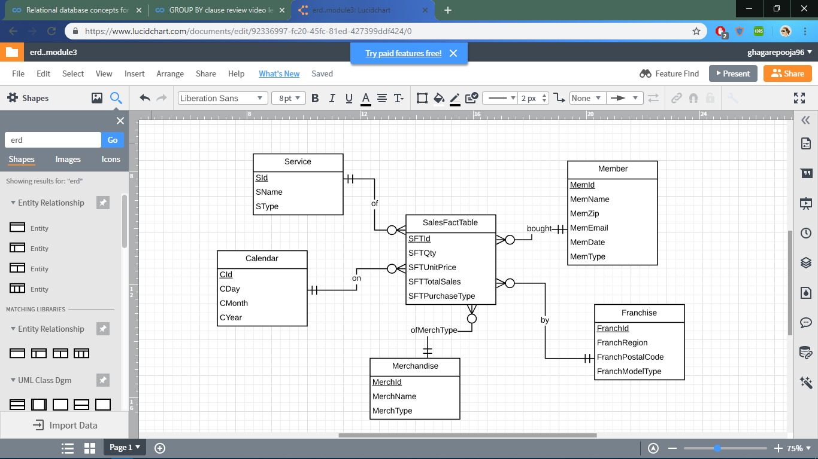

**5)**

**Summarizability Problems:**

1. MemDate in the Member Table is only provided for the members in the member table as it is absent for the Guest Members and Corporate Customers in the special events worksheet.
2. MemName is again provided for the members in member tabl and the Corporate Customers name is to be derived from the combined attribute “*Corporate Customer Name And Location”* in the special events worksheet.
3. Each Record does not have Franchise Name.

Incomplete Dimension-Fact Relationship are identified as no franchise name for special events are given and null values are not allowed. Franchise name can be obtained from the owner of spreadsheet.

1. MemType should be Guest for Guest Customers,Corporate for Special Event Customers, and Others given in ERD .
2. SalesUnitPrice for Merchandise,Service,Special Events is given, for Membership it has to be derived from MemberType Table from ERD
3. SFTPurchaseType(M/S) this should be determined to identify the type of purchase
4. SalesFactTable table will have Null values for merchandise as there will be no SId and for Service as there will be no MerchId.

**6) Sample Records In Tables:**

**Franchise Table:**

|  |  |  |  |
| --- | --- | --- | --- |
| **Franchise** | | | |
| *FranchId* | *FranchRegion* | *FranchPostalCode* | *FranchModelType* |
| F1 | Northwest | 98011 | Full |
| F2 | Mountain | 80111 | Medium |
| F3 | Central | 45236 | Limited |

**Member Table:**

|  |  |  |  |  |  |
| --- | --- | --- | --- | --- | --- |
| **Member** | | | | | |
| *MemId* | *MemName* | *MemDate* | *MemEmail* | *MemType* | *MemZip* |
| 3333 | Sue | 3-Mar-2011 | [sue@serv3.com](mailto:sue@serv3.com) | M3 | 45327 |
| 4444 | George |  | george@serv4.com | G | 45236 |
| 5555 | Frist Data |  |  | C | 80113 |

**Service Table:**

|  |  |  |
| --- | --- | --- |
| ***Service*** | | |
| *SId* | *SName* | *SType* |
| *M1* | *Gold* | *Membership* |
| *M2* | *Platinum* | *Membership* |
| *M3* | *value* | *Membership* |
| PSC1 | Ball machine | Service |
| PSC4 | Child class | Service |
| PS3 | Team practice | Special Event |

**Merchandise Table:**

|  |  |  |
| --- | --- | --- |
| ***Merchandise*** | | |
| *MerchId* | *MerchName* | *MerchType* |
| MC1 | Wilson balls | Balls |
| MC2 | Wilson racket | Racket |
| MC3 | Adidas shoes | Shoes |
| MC4 | Racket stringing | Racket |

**Calendar Table:**

|  |  |  |  |
| --- | --- | --- | --- |
| ***Calendar*** | | | |
| *CalId* | *CalDay* | *CalMonth* | *CalYear* |
| C1 | 10 | 2 | 2013 |
| C2 | 11 | 2 | 2013 |
| C3 | 12 | 2 | 2013 |
| C4 | 16 | 2 | 2013 |
| C5 | 18 | 2 | 2013 |
| C6 | 20 | 2 | 2013 |
| C7 | 21 | 2 | 2013 |
| C8 | 21 | 2 | 2013 |

**SalesFactTable:**

|  |  |  |  |  |  |  |  |  |  |
| --- | --- | --- | --- | --- | --- | --- | --- | --- | --- |
| *SFTId* | *SFTPurchaseType* | *MerchId* | *MemId* | *CallId* | *SId* | *FranchId* | *SFTQty* | *SFTUnitPrice($)* | *SFTTotalSales($)* |
| 1 | M | MC1 | 1111 | C1 | NULL | F1 | 2 | 3 | 6 |
| 2 | M | MC2 | 1111 | C1 | NULL | F1 | 1 | 200 | 200 |
| 3 | M | MC4 | 2222 | C3 | NULL | F2 | 1 | 40 | 40 |
| 4 | M | MC3 | 3333 | C3 | NULL | F3 | 1 | 100 | 100 |
| 5 | M | MC4 | 4444 | C4 | NULL | F1 | 1 | 40 | 40 |
| 6 | S | NULL | 1111 | C3 | PSC1 | F2 | 1 | 15 | 15 |
| 7 | S | NULL | 2222 | C4 | PSC4 | F3 | 1 | 75 | 75 |
| 8 | S | NULL | 4444 | C5 | PSC4 | F1 | 1 | 150 | 150 |
| 9 | S | NULL | 5555 | C3 | PSC1 | F2 | 1 | 1000 | 1000 |
| 10 | S | NULL | 6666 | C4 | PS3 | F3 | 1 | 500 | 500 |