**COURSE03MODULE03_ASSIGNMENT_SOLUTIONS**

1)

SELECT Name, SUM(ExtCost) AS CostSum,

RANK() OVER (ORDER BY SUM(ExtCost) DESC) AS SumCostRank

FROM Inventory_fact,cust_vendor_dim

WHERE Inventory_fact.CustVendorKey = cust_vendor_dim.CustVendorKey AND Inventory_fact.TransTypeKey = 5

GROUP BY Name;

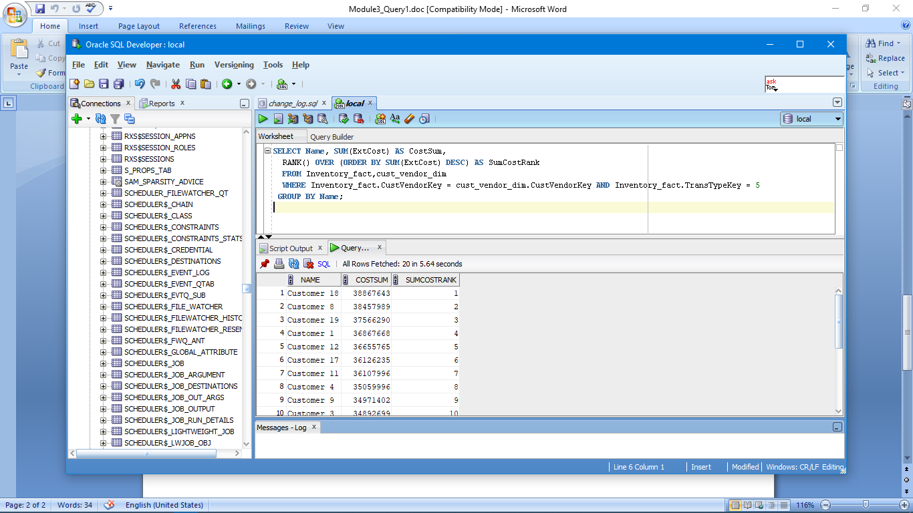

2)

SELECT State,Name, SUM(ExtCost) AS CostSum,

RANK() OVER (PARTITION BY State ORDER BY SUM(ExtCost) DESC) AS SumCostRank

FROM Inventory_fact,cust_vendor_dim

WHERE Inventory_fact.CustVendorKey = cust_vendor_dim.CustVendorKey AND Inventory_fact.TransTypeKey = 5

GROUP BY State,Name

ORDER BY State;

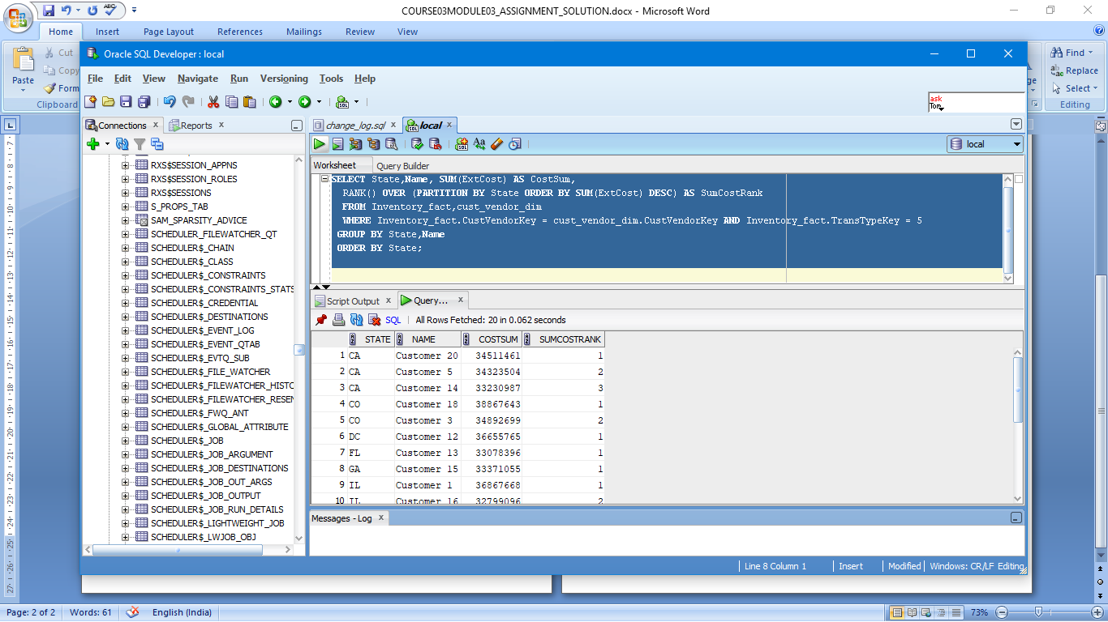

3)

SELECT Name, COUNT(*) AS TransCount,

RANK() OVER (ORDER BY COUNT(*) DESC) AS RankCount,

DENSE_RANK() OVER (ORDER BY COUNT(*) DESC) AS DenseRankCount

FROM Inventory_fact,cust_vendor_dim

WHERE Inventory_fact.CustVendorKey = cust_vendor_dim.CustVendorKey AND Inventory_fact.TransTypeKey = 5

GROUP BY Name;

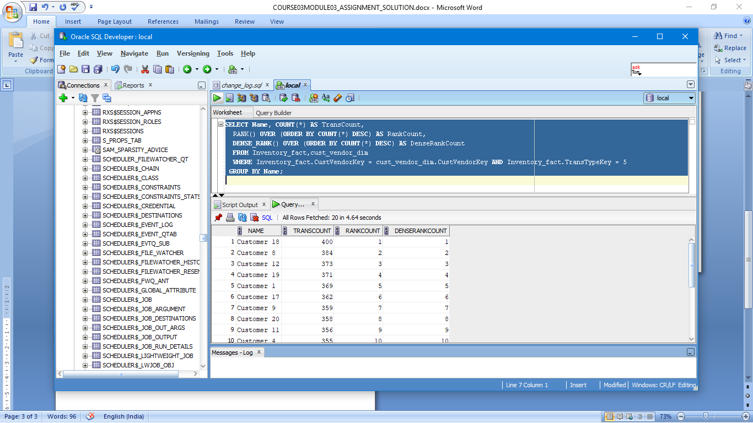

4)

SELECT Zip,CalYear,CalMonth, SUM(ExtCost) AS SumCost,

SUM(SUM(ExtCost)) OVER (

ORDER BY Zip,CalYear,CalMonth

ROWS UNBOUNDED PRECEDING ) AS CumSumCost

FROM Inventory_fact,cust_vendor_dim,date_dim

WHERE Inventory_fact.CustVendorKey = cust_vendor_dim.CustVendorKey AND Inventory_fact.DateKey = date_dim.DateKey

AND Inventory_fact.TransTypeKey = 5

GROUP BY Zip,CalYear,CalMonth;

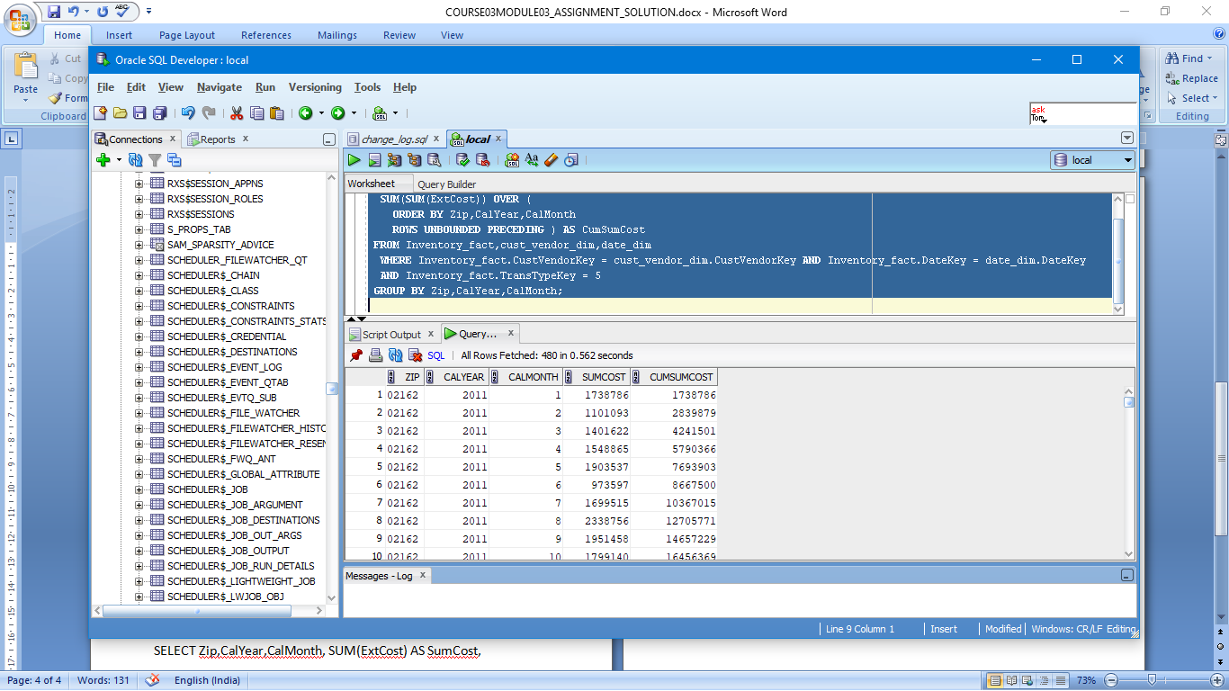

5)

SELECT Zip,CalYear,CalMonth, SUM(ExtCost) AS SumCost,

SUM(SUM(ExtCost)) OVER (PARTITION BY Zip,CalYear

ORDER BY Zip,CalYear,CalMonth

ROWS UNBOUNDED PRECEDING ) AS CumSumCost

FROM Inventory_fact,cust_vendor_dim,date_dim

WHERE Inventory_fact.CustVendorKey = cust_vendor_dim.CustVendorKey AND Inventory_fact.DateKey = date_dim.DateKey

AND Inventory_fact.TransTypeKey = 5

GROUP BY Zip,CalYear,CalMonth

ORDER BY Zip,CalYear;

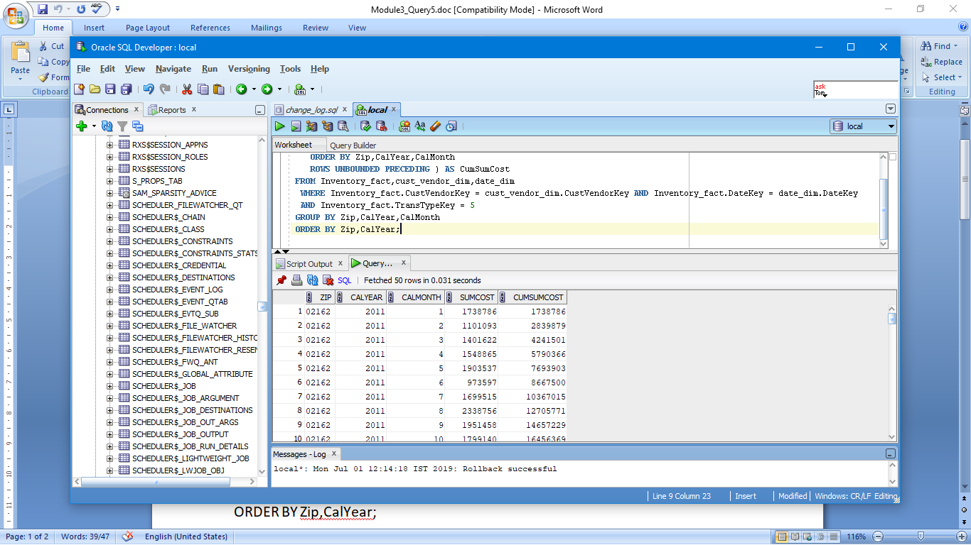

6)

SELECT SecondItemId,SUM(ExtCost) AS CostSum,RATIO_TO_REPORT(SUM(ExtCost))

OVER () AS SumCostRatio

FROM Inventory_fact,Item_master_dim

WHERE Inventory_fact.ItemMasterKey = Item_master_dim.ItemMasterKey AND Inventory_fact.TransTypeKey = 1

GROUP BY SecondItemId

ORDER BY SUM(ExtCost) DESC;

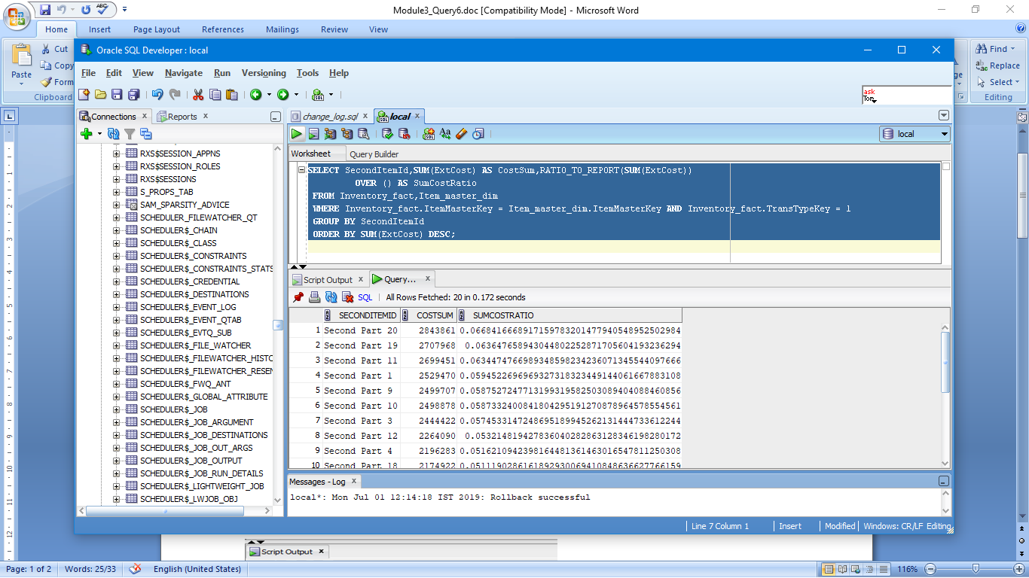

7)

SELECT CalYear,SecondItemId,SUM(ExtCost) AS CostSum,RATIO_TO_REPORT(SUM(ExtCost))

OVER (PARTITION BY CalYear) AS SumCostRatio

FROM Inventory_fact,Item_master_dim,date_dim

WHERE Inventory_fact.ItemMasterKey = Item_master_dim.ItemMasterKey AND Inventory_fact.DateKey = date_dim.DateKey AND Inventory_fact.TransTypeKey = 1

GROUP BY CalYear,SecondItemId

ORDER BY CalYear,SUM(ExtCost) DESC;

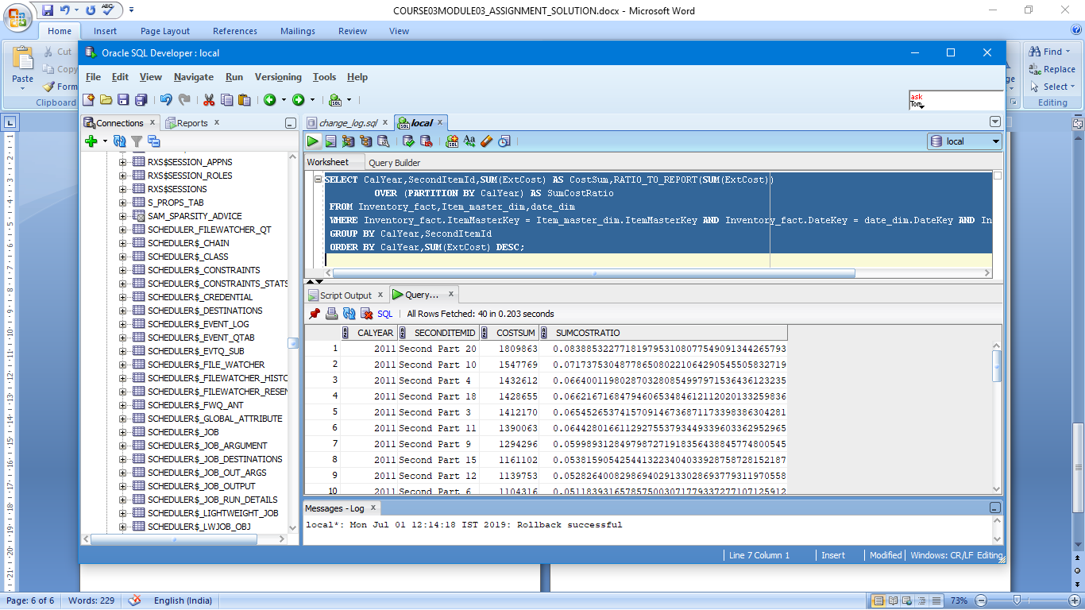

8)

SELECT BPName,CompanyKey,CarryingCost,

RANK()

OVER (ORDER BY CarryingCost) As RankCarryingCost,

PERCENT_RANK()

OVER (ORDER BY CarryingCost) As PercentRankCarryingCost,

CUME_DIST()

OVER (ORDER BY CarryingCost) As CumDistCarryingCost

FROM branch_plant_dim;

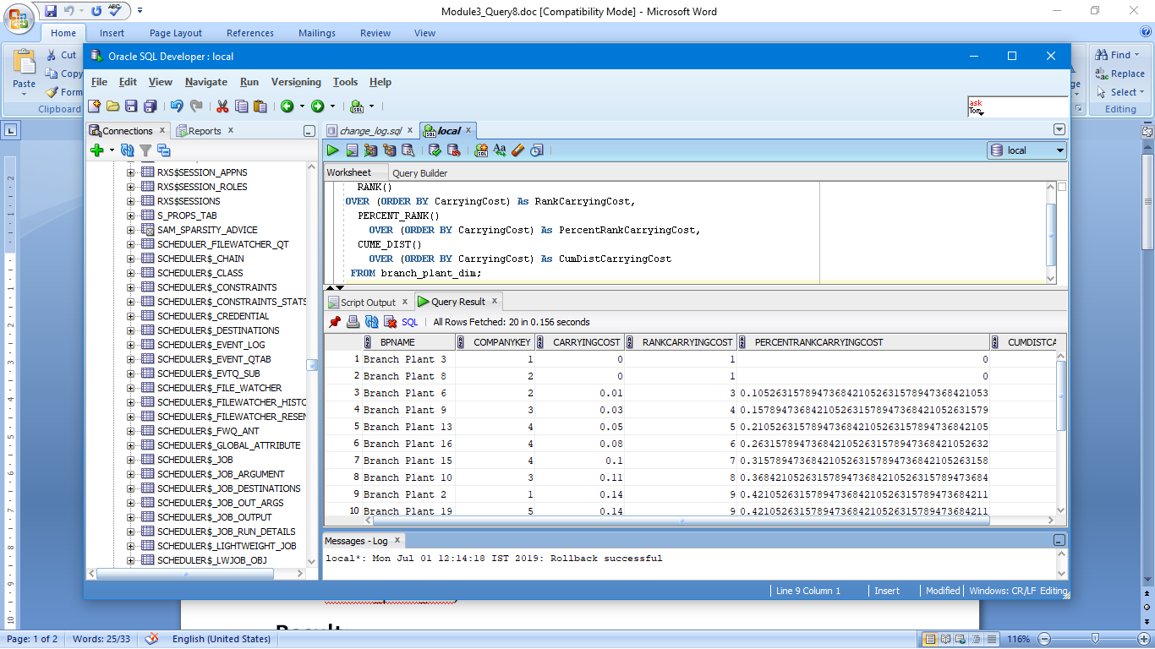

9)

SELECT BPName,CompanyKey,CarryingCost,CumDistCarryingCost

FROM

(SELECT BPName,CompanyKey,CarryingCost,

CUME_DIST()

OVER (ORDER BY CarryingCost DESC) As CumDistCarryingCost

FROM branch_plant_dim)

WHERE CumDistCarryingCost <= 0.15;

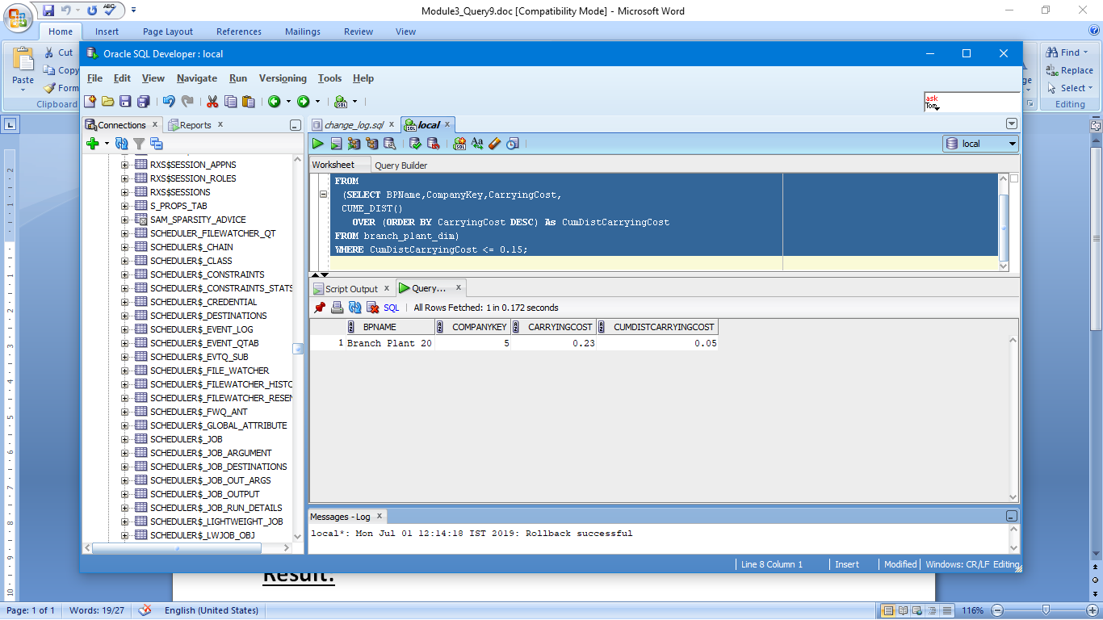

10)

SELECT DISTINCT ExtCost,

CUME_DIST()

OVER (ORDER BY ExtCost) As CumDistCarryingCost

FROM Inventory_fact,cust_vendor_dim

WHERE Inventory_fact.CustVendorKey = cust_vendor_dim.CustVendorKey AND State = 'CO'

ORDER BY ExtCost;

