**COURSE03MODULE04_ASSIGNMENT_SOLUTIONS**

1)

CREATE MATERIALIZED VIEW SalesByVendorDateKeyMV2011 AS

SELECT Inventory_fact.CustVendorKey,date_dim.DateKey, SUM(ExtCost) AS TotalCost,

SUM(Quantity) AS TotalQty , Count(*) AS TotalCount

FROM Inventory_fact,date_dim

WHERE Inventory_fact.DateKey = date_dim.DateKey

AND Inventory_fact.TransTypeKey = 5

AND date_dim.CalYear = 2011

GROUP BY Inventory_fact.CustVendorKey,date_dim.DateKey;

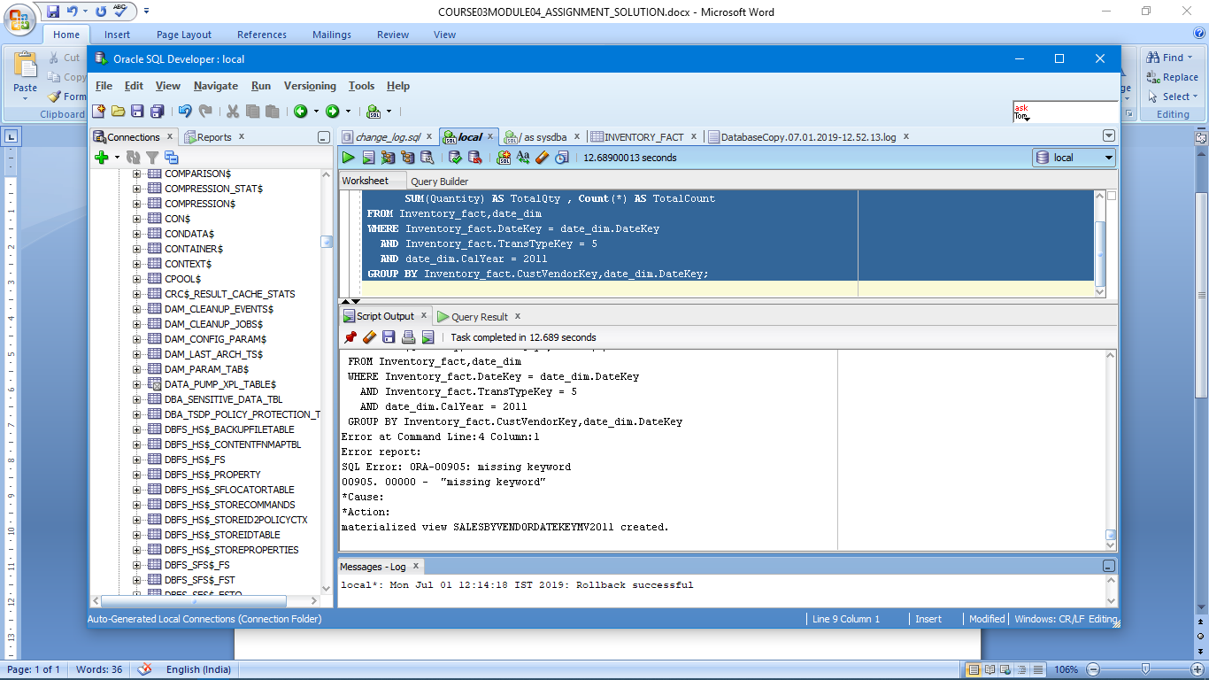

2)

CREATE MATERIALIZED VIEW SalesByVendorDateKeyMV2012 AS

SELECT Inventory_fact.CustVendorKey,date_dim.DateKey, SUM(ExtCost) AS TotalCost,

SUM(Quantity) AS TotalQty , Count(*) AS TotalCount

FROM Inventory_fact,date_dim

WHERE Inventory_fact.DateKey = date_dim.DateKey

AND Inventory_fact.TransTypeKey = 5

AND date_dim.CalYear = 2012

GROUP BY Inventory_fact.CustVendorKey,date_dim.DateKey;

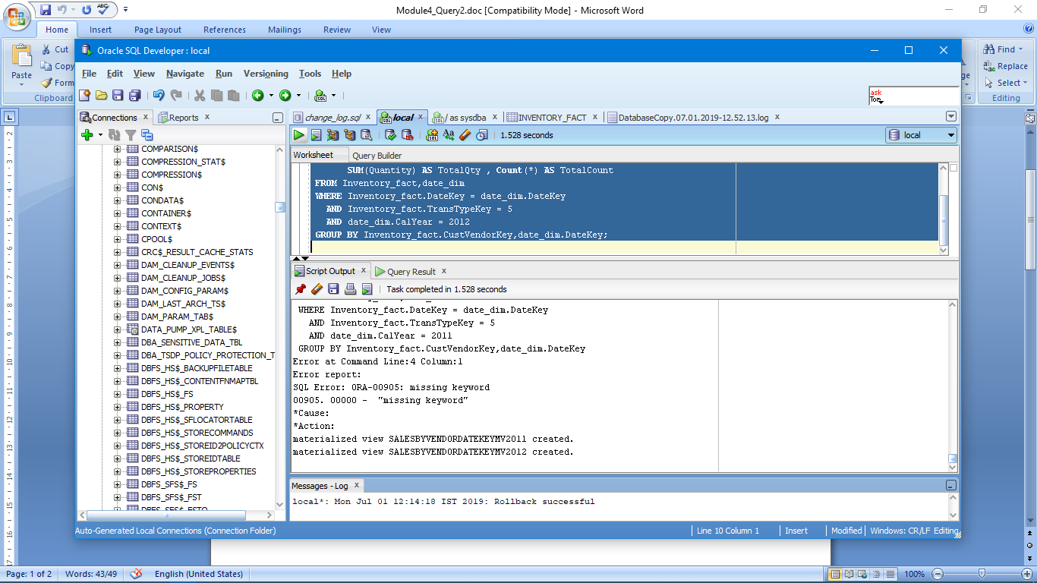

3)

SELECT date_dim.CalMonth,cust_vendor_dim.AddrCatCode1,SUM(MV1.TotalCost),SUM(MV1.TotalQty)

FROM SALESBYVENDORDATEKEYMV2011 MV1,cust_vendor_dim,date_dim

WHERE MV1.CustVendorKey = cust_vendor_dim.CustVendorKey AND MV1.DateKey = date_dim.DateKey

GROUP BY CUBE(date_dim.CalMonth,cust_vendor_dim.AddrCatCode1)

ORDER BY date_dim.CalMonth,cust_vendor_dim.AddrCatCode1;

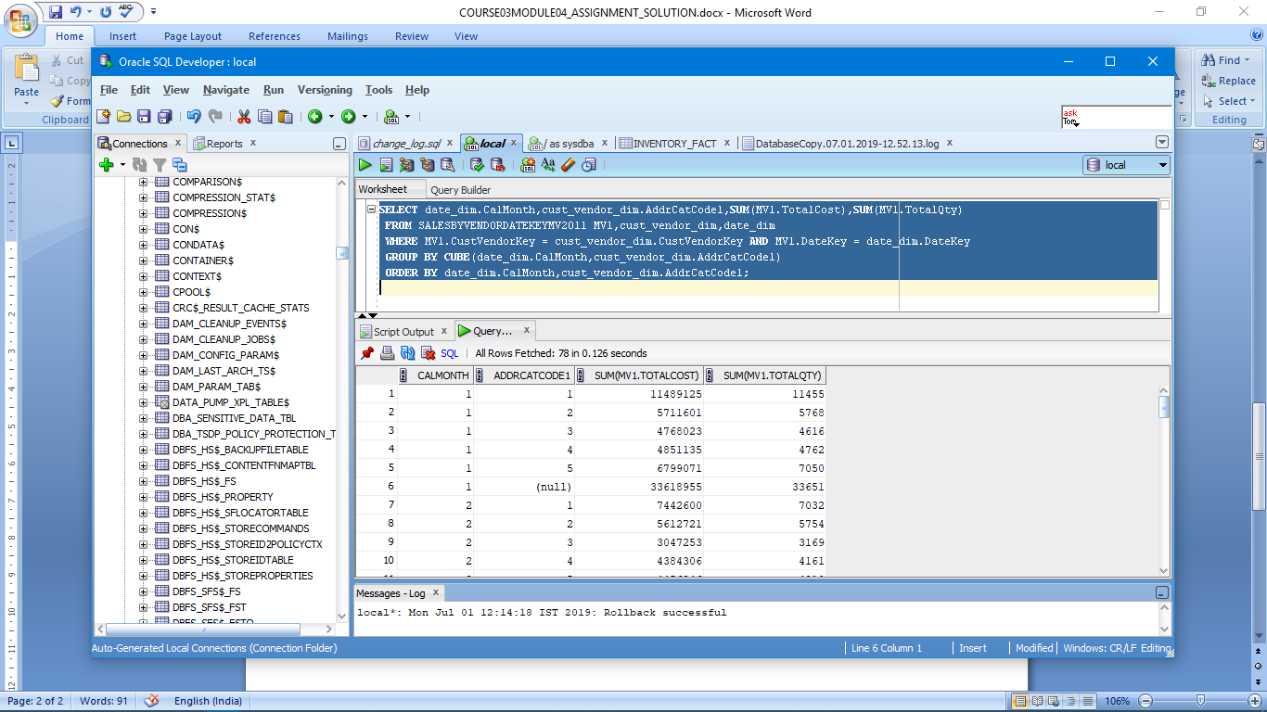

4)

SELECT CalQuarter,Zip,Name,SUM(TotalCost) AS NetSum,SUM(TotalCount) AS NetCount

FROM(

SELECT CalQuarter,Zip,Name,MV1.TotalCost AS TotalCost,MV1.TotalCount AS TotalCount

FROM SALESBYVENDORDATEKEYMV2011 MV1,date_dim,cust_vendor_dim

WHERE MV1.CustVendorKey = cust_vendor_dim.CustVendorKey AND MV1.DateKey = date_dim.DateKey

UNION

SELECT CalQuarter,Zip,Name,MV2.TotalCost AS TotalCost,MV2.TotalCount AS TotalCount

FROM SALESBYVENDORDATEKEYMV2012 MV2,date_dim,cust_vendor_dim

WHERE MV2.CustVendorKey = cust_vendor_dim.CustVendorKey AND MV2.DateKey = date_dim.DateKey )

GROUP BY CUBE(CalQuarter,Zip,Name)

ORDER BY CalQuarter,Zip,Name;

