**Assignment 1 – Calculator Application**

Developed an android calculator application of this UI:

The Application is tested on Model No LG Stylo 4 , screen size of 5.5in.

All the buttons are implemented .

Special touch effect is provided on button click.

The implementation screenshots are as follows:

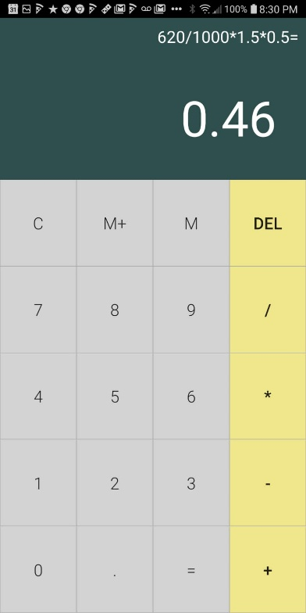 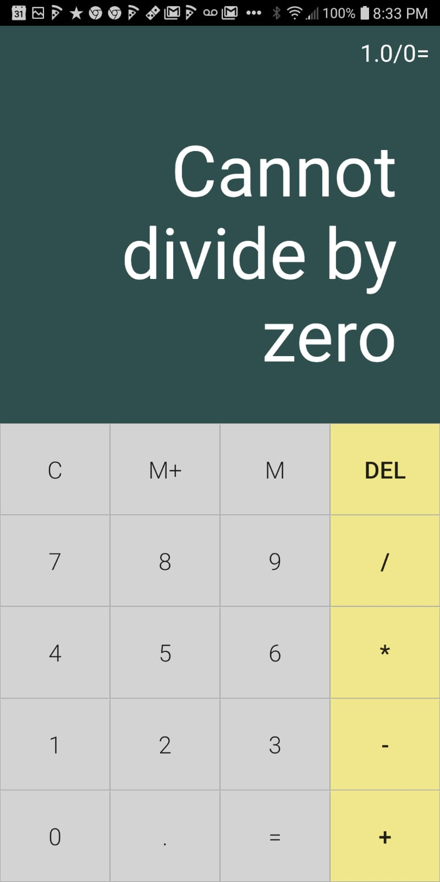

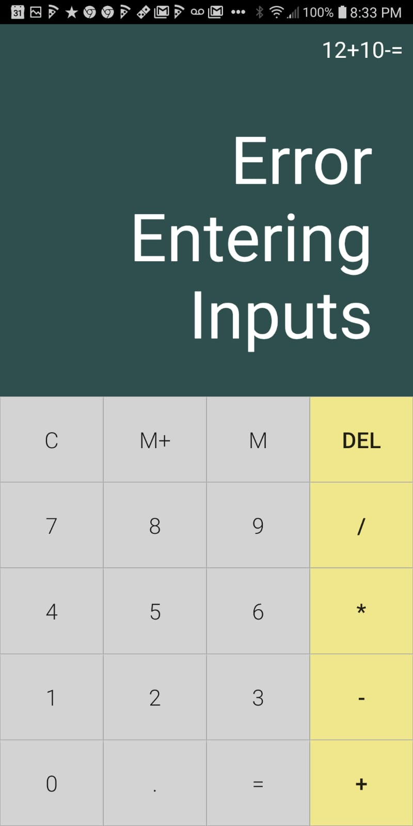

There is a M+ button which when clicked after equal sign stores the result , so on storing the result upon each calculation and you can recall the stored memory value using M button.