**POOJA GOEL**

**22210029**

**Assignment 1**

**CS 612 - Computer Systems**

**Question:**

**Word-count:**

**Using Lists to Count Words:**

Step 1:

Defining PINTOS_LIST in word_count_l.c file

#define PINTOS_LIST

Step2: complete functions in word_count_l.c file

void init_words(word_count_list_t* wclist) { /* TODO */

list_init (wclist);

}

size_t len_words(word_count_list_t* wclist) {

  /* TODO */

return list_size(wclist);

}

word_count_t* find_word(word_count_list_t* wclist, char* word) {

  /* TODO */

   struct list_elem *a;

   for(a= list_begin(wclist); a!=list_end(wclist);a=list_next(a))

   {

    struct word_count* b=list_entry(a,struct word_count,elem);

    if(strcmp(b->word,word)==0)

    return(b);

   };

  return NULL;

}

word_count_t* add_word(word_count_list_t* wclist, char* word) {

  /* TODO */

 word_count_t *a;

a=find_word(wclist,word);

if(a!=NULL)

{

  a->count=a->count+1;

  return a;

}

else{

  struct word_count *new =(struct word_count *)malloc(sizeof(struct word_count));

  new->count=1;

  new->word=word;

  list_push_back(wclist, &(new->elem));

  return new;

}

  return NULL;

}

void fprint_words(word_count_list_t* wclist, FILE* outfile) { /* TODO */

struct list_elem *a;

for(a= list_begin(wclist); a!=list_end(wclist);a=list_next(a))

   {

    struct word_count* b=list_entry(a,struct word_count,elem);

    fprintf(outfile,"%6d %6s\n", b->count,b->word);

}

}

static bool less_list(const struct list_elem* ewc1, const struct list_elem* ewc2, void* aux) {

  /* TODO */

struct word_count* a=list_entry(ewc1,struct word_count,elem);

struct word_count* b=list_entry(ewc2,struct word_count,elem);

if(less_count(a,b)|| (!less_count(a,b)&& !less_count(b,a)&& less_word(a,b)))

//if(a->count<b->count)

return true;

  return false;

}

void wordcount_sort(word_count_list_t* wclist,bool less(const word_count_t*, const word_count_t*)) {

list_sort(&(wclist->lst), less_list, less);

list_sort(wclist, less_list, less);

}

Step3:

Compiling the code:

root@DESKTOP-TN1I17B:/mnt/f/Semester 1/Assignment1/assignment1/word-count# make

gcc -g3 -Wall -std=gnu99 -c word_count_multithread.c -o word_count_multithread.o

gcc -pthread word_count_multithread.o word_helpers.o -o word_count_m

root@DESKTOP-TN1I17B:/mnt/f/Semester 1/Assignment1/assignment1/word-count# ./lwords gutenberg/alice.txt gutenberg/peter.txt

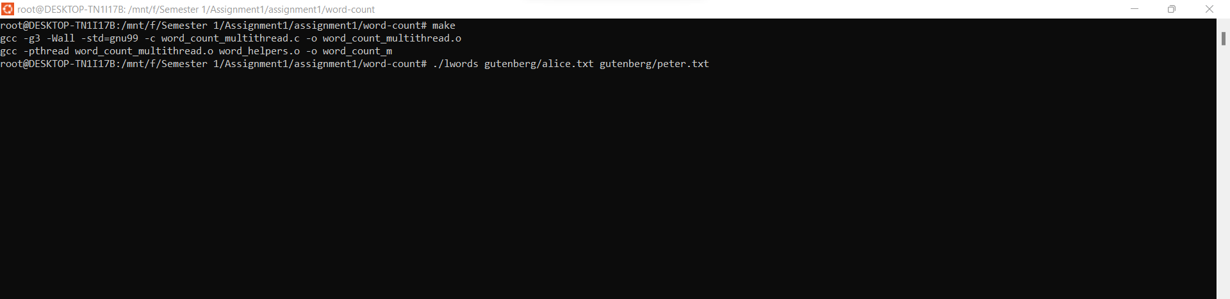

Count list is displaying is shown below:

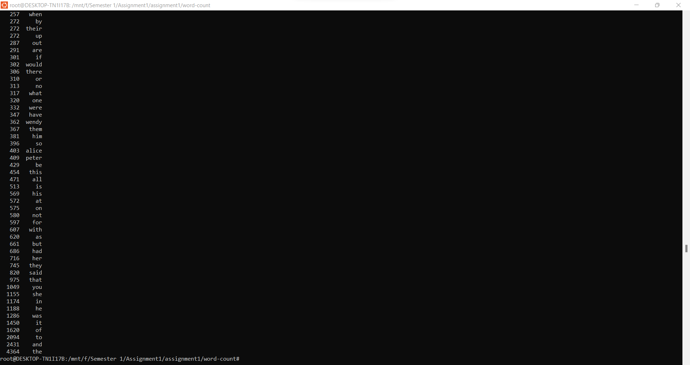

**Using Multiple Threads to Count Words**

**Creating a new c file :- word_count_multithread.c**

**File uses pthreads and creates multiple threads to read files.**

/*this file is creating multiple threads to read file and updating shared word_count_list_t* w*/

#define PINTOS_LIST

#define PTHREADS

#include<pthread.h>

#include "word_count.h"

#include "word_helpers.h"

#include "list.c"

#include "debug.c"

#include "word_count_l.c"

word_count_list_t* w; // defining global word_count_list_t

pthread_t thread[10]; //creating thread array globally

void* threadWordCount(void* arg)

{

    FILE* f = fopen((char *) arg, "r");

    count_words(w, f);

    fclose(f);

    return NULL;

}

int main(int argc, char *argv[]){

    w = (word_count_list_t*)malloc(sizeof(word_count_list_t));

    init_words(w);

    pthread_mutex_init(&w->lock, NULL);  // initializing mutex

    for(int i=0; i<argc; ++i){

      pthread_create(&thread[i], NULL, threadWordCount, argv[i]);

    }

    for(int i=0; i<argc; ++i){

      pthread_join(thread[i], NULL);

    }

    wordcount_sort(w,NULL); // sorting updated w list

    fprint_words(w, stdout);

    exit(0);

}

**Step:**

**Updating all functions in word_count_l.c**

#define PINTOS_LIST

#ifndef PINTOS_LIST

//#error "PINTOS_LIST must be #define'd when compiling word_count_l.c"

//#define PINTOS_LIST // defining PINTOS_LIST for the compilation

#define PINTOS_LIST

//#define PTHREADS

#endif

#include "word_count.h"

#include "list.h"

#include "word_helpers.h"

void init_words(word_count_list_t* wclist) { /* TODO */

#ifdef PINTOS_LIST

#ifdef PTHREADS

   list_init (&wclist->lst);

#else

list_init (wclist);

#endif

#endif

}

size_t len_words(word_count_list_t* wclist) {

  /* TODO */

#ifdef PINTOS_LIST

#ifdef PTHREADS

  return list_size(&(wclist->lst));

#else

return list_size(wclist);

#endif

#endif

}

word_count_t* find_word(word_count_list_t* wclist, char* word) {

  /* TODO */

   #ifdef PINTOS_LIST

   #ifdef PTHREADS

   struct list_elem *a;

   for(a= list_begin(&(wclist->lst)); a!=list_end(&(wclist->lst));a=list_next(a))

   {

    struct word_count* b=list_entry(a,struct word_count,elem);

    if(strcmp(b->word,word)==0)

    return(b);

   };

   return NULL;

  #else

   struct list_elem *a;

   for(a= list_begin(wclist); a!=list_end(wclist);a=list_next(a))

   {

    struct word_count* b=list_entry(a,struct word_count,elem);

    if(strcmp(b->word,word)==0)

    return(b);

   };

  return NULL;

  #endif

  #endif

}

word_count_t* add_word(word_count_list_t* wclist, char* word) {

  /* TODO */

 word_count_t *a;

  #ifdef PINTOS_LIST

  #ifdef PTHREADS

  a=find_word(wclist,word);

if(a!=NULL)

{ pthread_mutex_lock(&(wclist->lock));

  a->count=a->count+1;

  pthread_mutex_unlock(&(wclist->lock));

  return a;

}

else{

  struct word_count *new =(struct word_count *)malloc(sizeof(struct word_count));

  new->count=1;

  new->word=word;

  pthread_mutex_lock(&(wclist->lock));

  list_push_back(&(wclist->lst),&(new->elem));

  pthread_mutex_unlock(&(wclist->lock));

  return new;

}

  return NULL;

#else

a=find_word(wclist,word);

if(a!=NULL)

{

  a->count=a->count+1;

  return a;

}

else{

  struct word_count *new =(struct word_count *)malloc(sizeof(struct word_count));

  new->count=1;

  new->word=word;

  list_push_back(wclist, &(new->elem));

  return new;

}

  return NULL;

  #endif

  #endif

}

void fprint_words(word_count_list_t* wclist, FILE* outfile) { /* TODO */

struct list_elem *a;

#ifdef PINTOS_LIST

#ifdef PTHREADS

   for(a= list_begin(&(wclist->lst)); a!=list_end(&(wclist->lst));a=list_next(a))

   {

    struct word_count* b=list_entry(a,struct word_count,elem);

    fprintf(outfile,"%6d %20s\n", b->count,b->word);

}

#else

for(a= list_begin(wclist); a!=list_end(wclist);a=list_next(a))

   {

    struct word_count* b=list_entry(a,struct word_count,elem);

    fprintf(outfile,"%6d %6s\n", b->count,b->word);

}

#endif

#endif

}

static bool less_list(const struct list_elem* ewc1, const struct list_elem* ewc2, void* aux) {

  /* TODO */

struct word_count* a=list_entry(ewc1,struct word_count,elem);

struct word_count* b=list_entry(ewc2,struct word_count,elem);

if(less_count(a,b)|| (!less_count(a,b)&& !less_count(b,a)&& less_word(a,b)))

//if(a->count<b->count)

return true;

  return false;

}

void wordcount_sort(word_count_list_t* wclist,bool less(const word_count_t*, const word_count_t*)) {

#ifdef PINTOS_LIST

#ifdef PTHREADS

list_sort(&(wclist->lst), less_list, less);

#else

list_sort(wclist, less_list, less);

#endif

#endif

}

**Step:**

**Perform changes in make file accordingly**

**Step:**

**Compiling file**

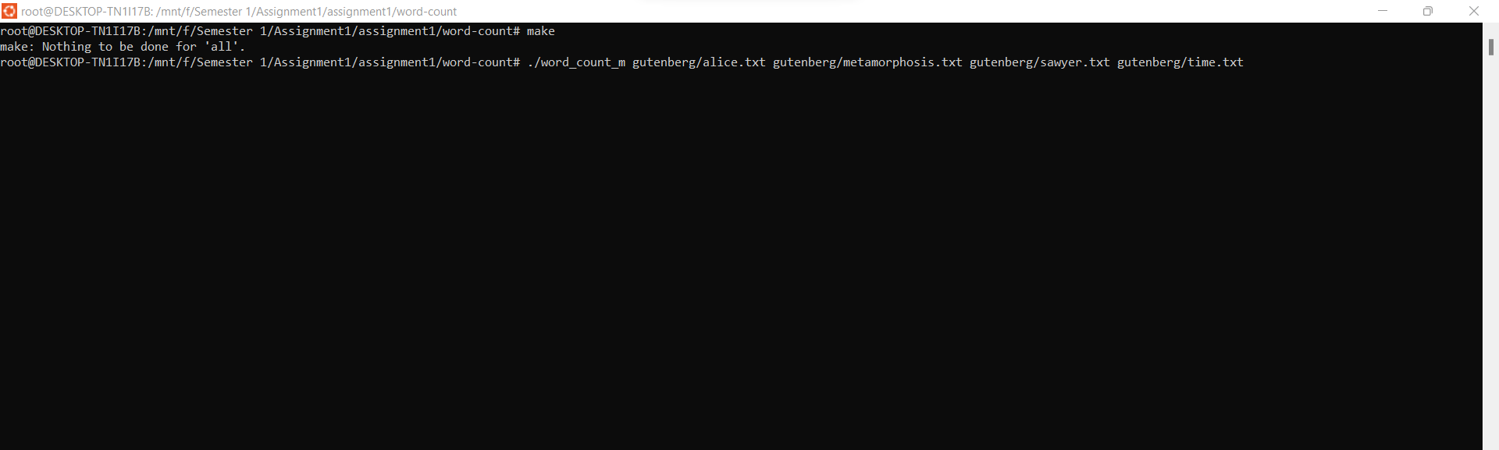

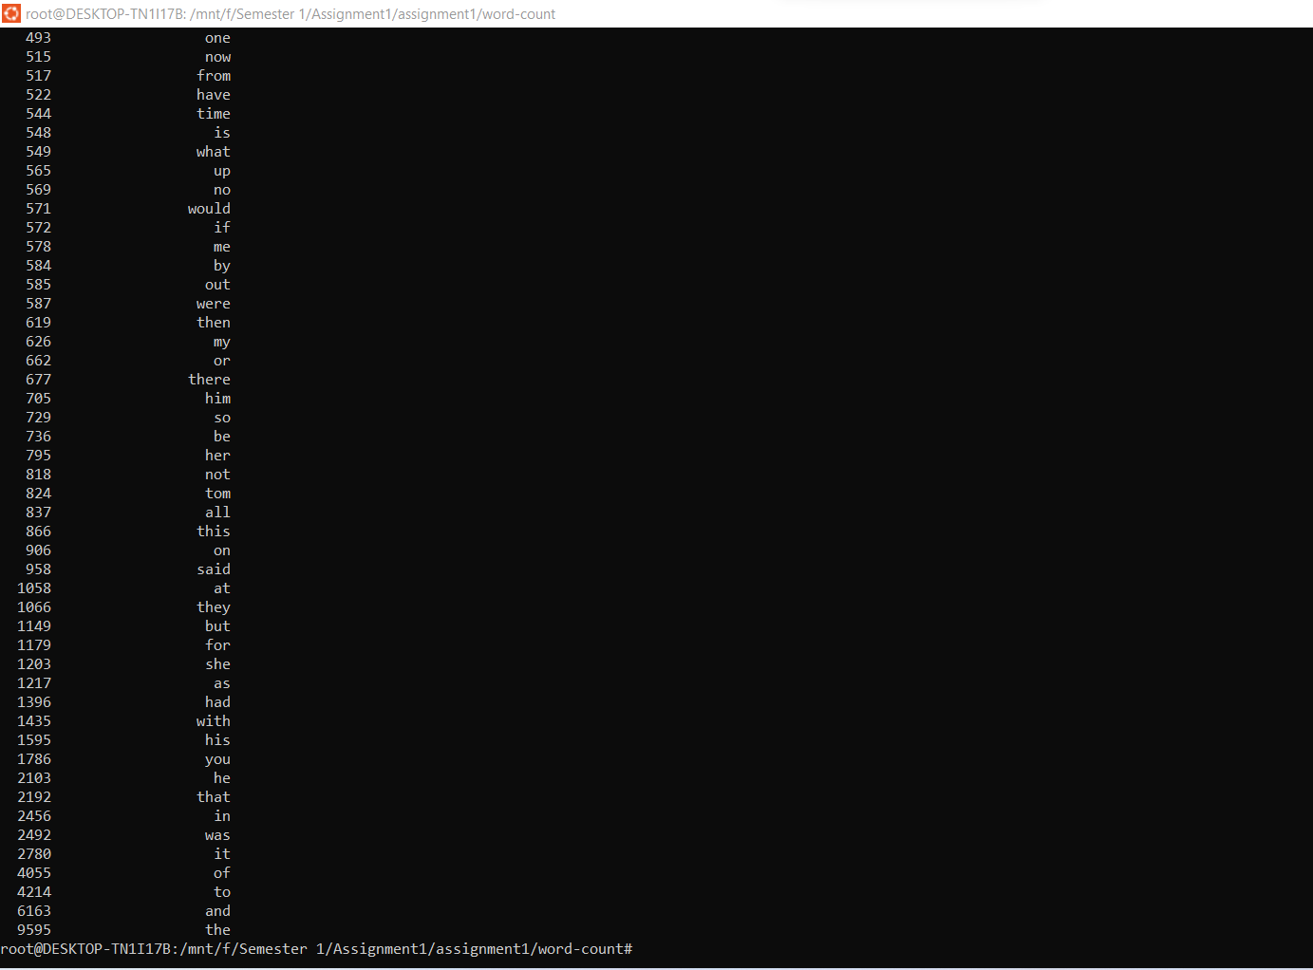

**Question:**

**Shell**

int cmd_cwd(struct tokens* tokens); //defining cmd_cwd function

int cmd_cd(struct tokens* tokens);// defining cmd_cwd function

{cmd_cwd, "cwd", "prints the current working directory to standard output,"},

    {cmd_cd, "cd", "takes one argument, a directory path, and changes the current working directory to that directory."}

int cmd_cd(unused struct tokens* tokens)

{

  char*filename; //defining charater pointer

  filename=tokens_get_token(tokens,1);

  if(filename==NULL)

  {

fprintf(stderr,"please specify a directory.\n");

  }

else if(chdir(filename)!=0)

fprintf(stderr,"%s not found.\n",filename);

return 1;

}

int cmd_cwd(unused struct tokens* tokens) // cmd_cwd function uses getcwd function to read

{

  char cwd[PATH_MAX];

   if (getcwd(cwd, sizeof(cwd)) != NULL) {

       printf("Current working directory: %s\n", cwd);

   } else {

       perror("getcwd() error");

       return 1;

   }

   return 0;

}

**Step:**

**Compiling**

