**Implementation of the Jajodia-Mutchler voting algorithm.**

Initially, the version number (VN), replicas update (RU) and distinguished site (DS) values for X at all servers are 1, 8, and A.

1. When the request is sent to component that consist of the servers ABCDEFGH.

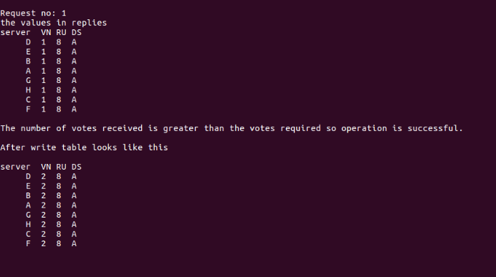

1. When the request is sent to component that consist of the servers ABCD.

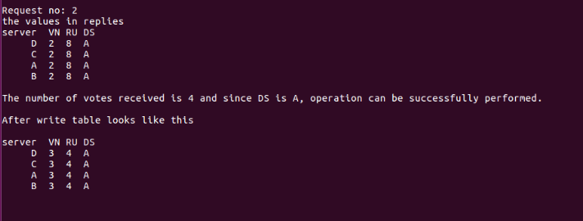

1. The request is sent to component that consist of the servers EFGH.

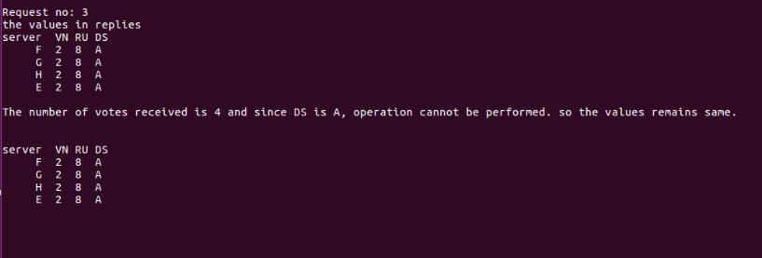

1. The request is sent to component that consist of the server A.

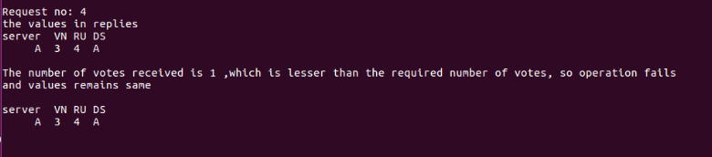

1. The request is sent to the component that consist of the servers BCD.

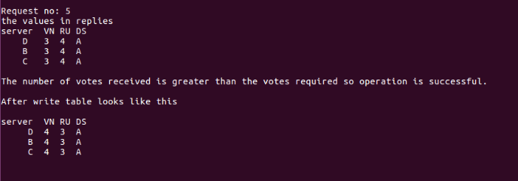

1. The request is sent to the component that consist of the servers EFG.

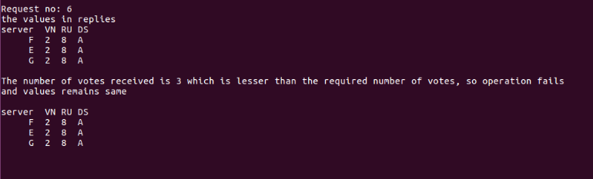

1. The request is sent to the component that consist of the server H.

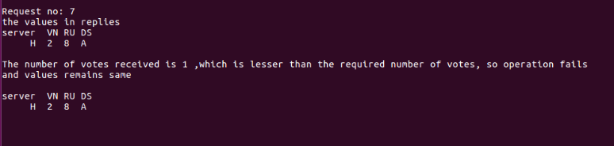

1. The request is sent to the component that consist of the server BCDEFG.

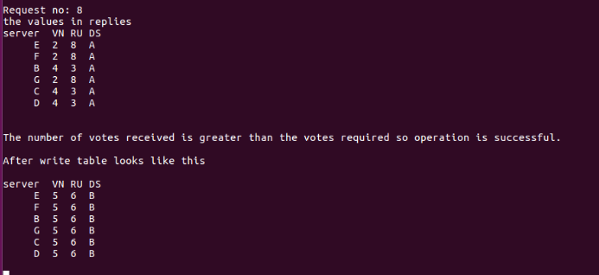

After 2nd iteration, request no 16 looks like below:

