Kafka producer-consumer Snapshot

1.Producer produced message in String Format
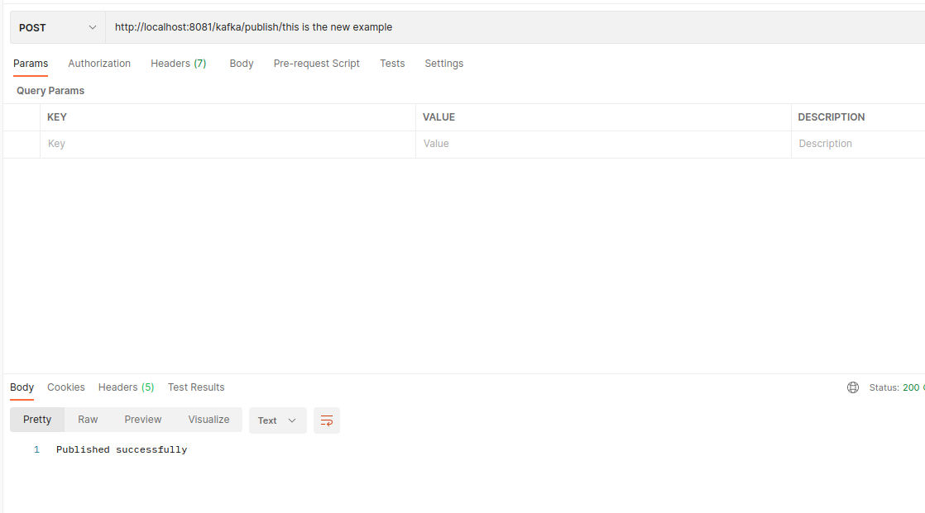
2.Consumer consumed message in String Format

3.Producer produced message in Json Format

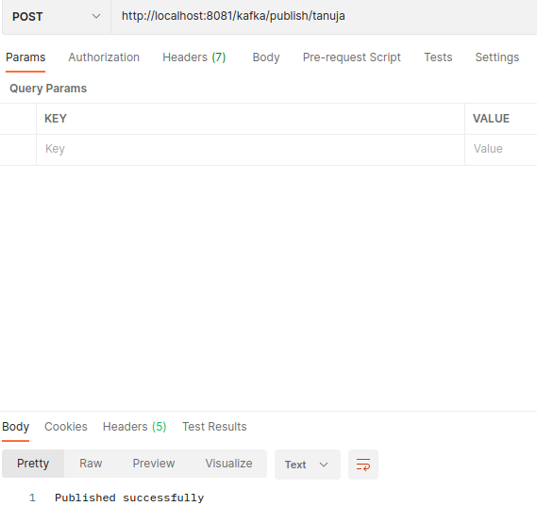
4.Consumer consumed message in Json Format

