sudo mkdir docker-workspace && cd docker-workspace 🡪

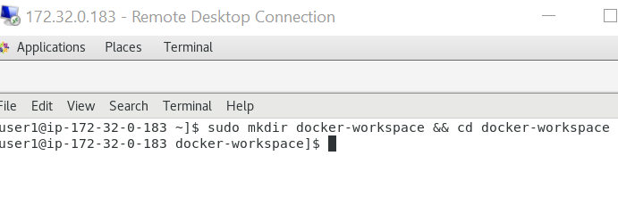

sudo yum install -y yum-utils device-mapper-persistent-data lvm2 vim 🡪

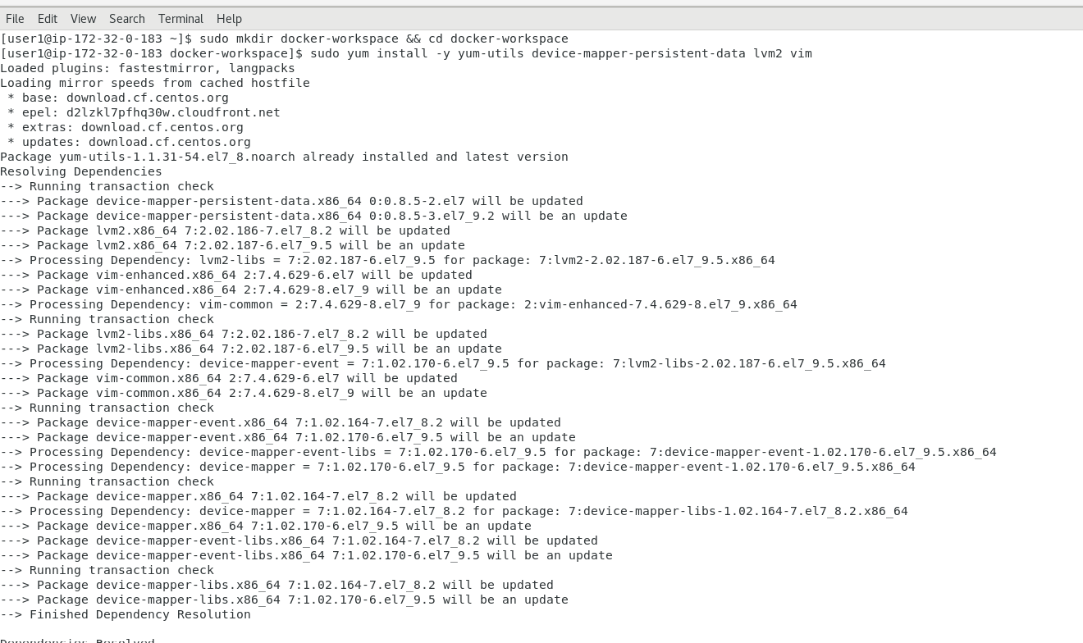

sudo yum-config-manager --add-repo <https://download.docker.com/linux/centos/docker-ce.repo> -->

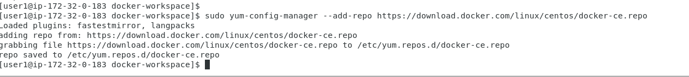

sudo yum update 🡪

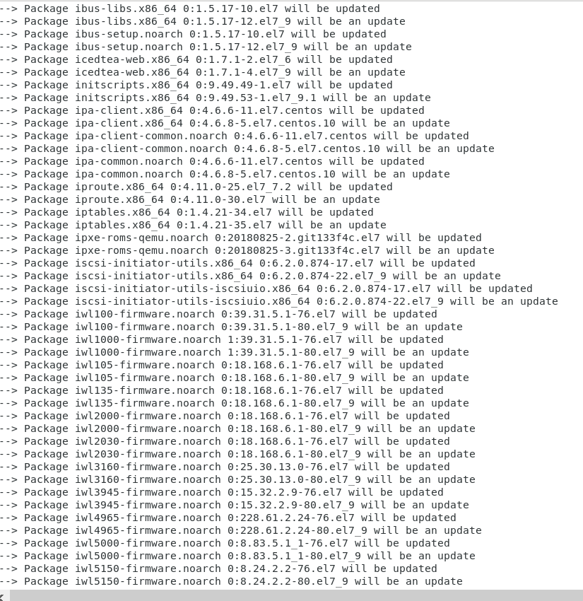

sudo yum install -y docker-ce docker-ce-cli containerd.io 🡪

sudo mkdir /etc/docker

sudo su -

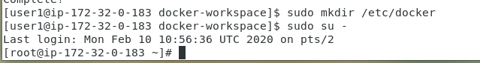

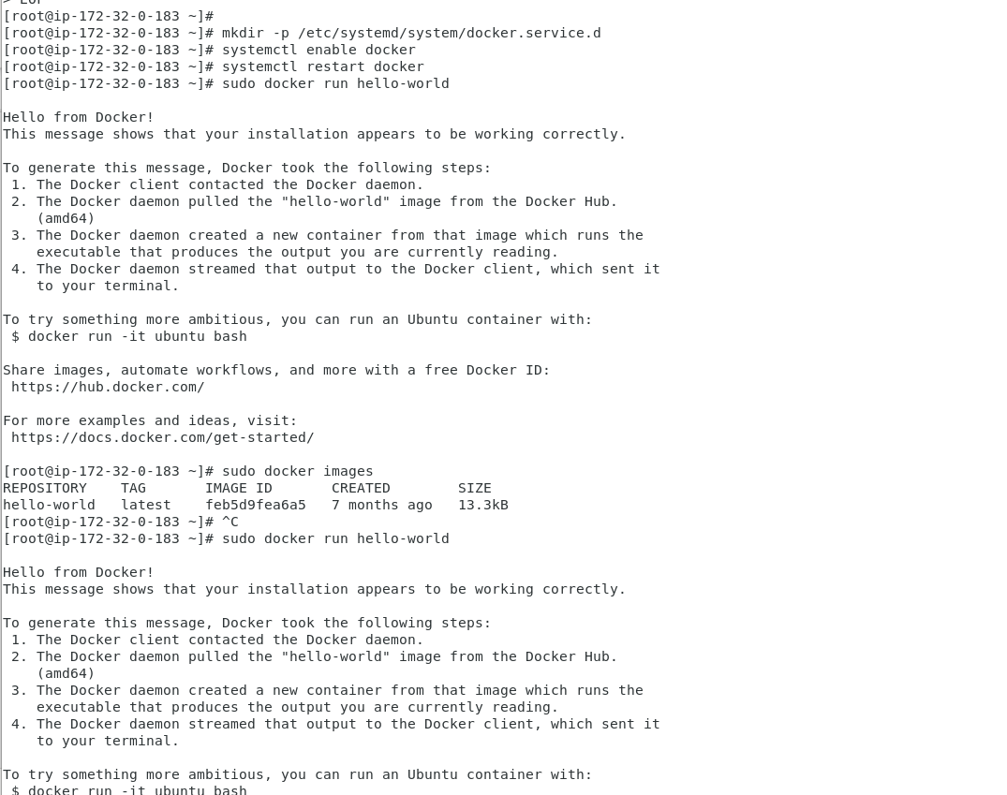

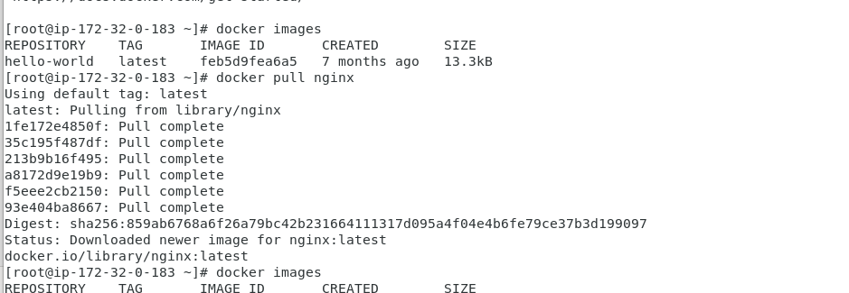

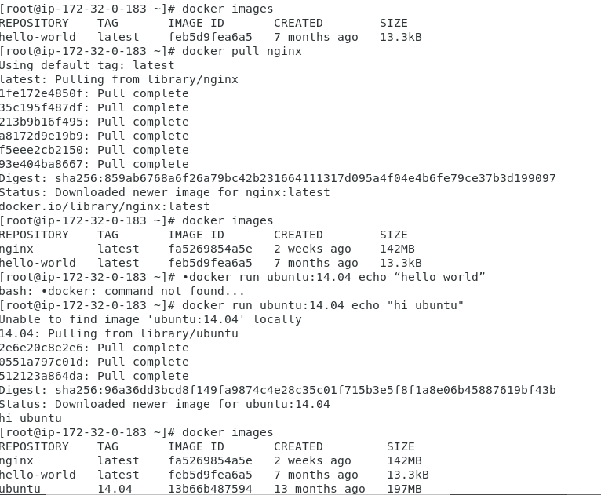

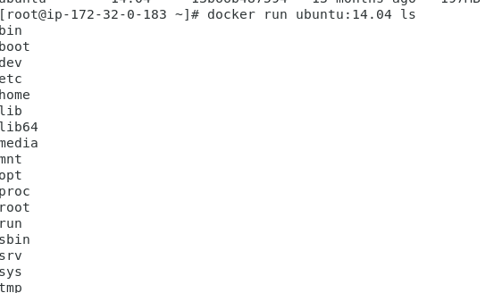

Docker ps -ef command

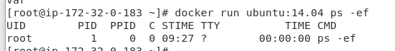

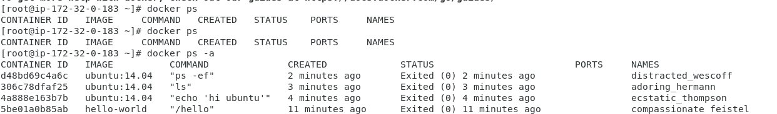

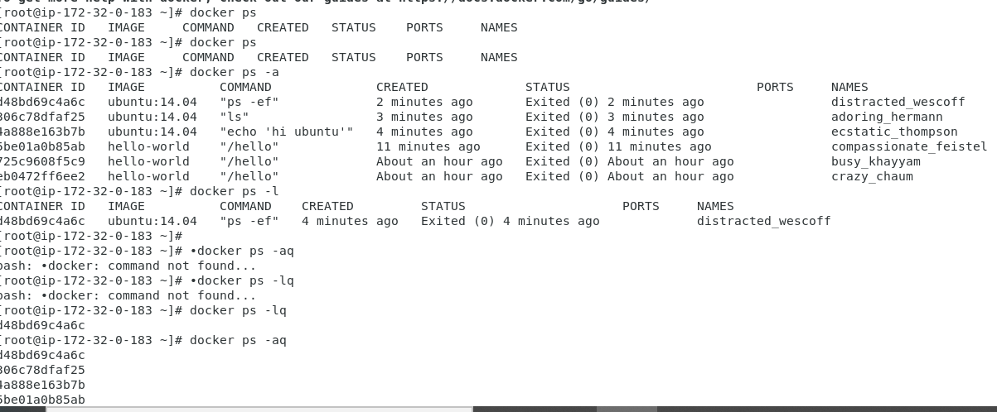

CICD:

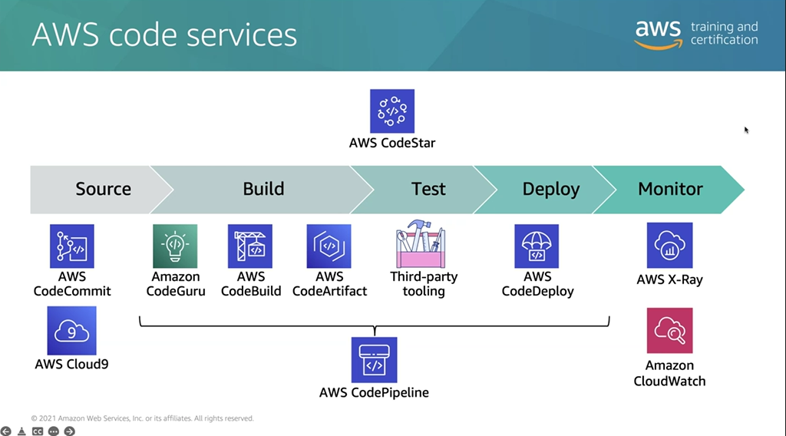

Code commit is not exact same to github bt its equivalent to it

