MAC ADDRESS TABLE

TECHNICAL CODETHAN REPORT
SUBMITTED TO

RAMAIAH INSTITUTE OF TECHNOLOGY
(Autonomous Institute, Affiliated to VTU)

Bangalore – 560054

SUBMITTED BY
Name: Patil Vineet | USN: 1MS17CS079
Name: Pooja Kumari  Name: Ashwini T  Name: Sahana LM  Name: Adit Agrawal | USN: 1MS17CS081  USN: 1MS18CS401  USN: 1MS18CS417  USN: 1MS17CV008
As part of the Course Data Structures– CS32

SUPERVISED BY
Faculty
Dr.Parkavi.A



DEPARTMENT OF COMPUTER SCIENCE AND ENGINEERING

RAMAIAH INSTITUTE OF TECHNOLOGY

Aug-Dec 2018

Department of Computer Science and Engineering

Ramaiah Institute of Technology
(Autonomous Institute, Affiliated to VTU)

Bangalore – 54

CERTIFICATE

This is to certify that Name: PATIL VINEET (USN: 1MS17CS079), Name: POOJA KUMARI (USN: 1MS17CS081), Name: ASHWINI T (USN: 1MS18CS401), Name: SAHANA LM (USN: 1MS18CS417), Name: ADIT AGRAWAL (USN: 1MS17CV008) have completed the “MAC ADDRESS TABLE” as part of Technical Codethan. We declare that the entire content embodied in this B.E. 3rd Semester report contents are not copied.

Submitted by Guided by
Name: Patil Vineet | USN:1MS17CS079
Name: Pooja Kumari | USN:1MS17CS081
Name: Ashwini T | USN:1MS18CS401
Name: Sahana LM | USN:1MS18CS417
Name: Adit Agrawal | USN:1MS17CV008
Dr. Parkavi.A
(Dept of CSE, RIT) (Assistant Professor, Dept. of CSE, RIT)

Department of Computer Science and Engineering

Ramaiah Institute of Technology
(Autonomous Institute, Affiliated to VTU)

Bangalore – 54

Evaluation Sheet

Sl. No | USN | Name | Research Content understanding  and Coding  (10) | Report, Video proofs and photo Proofs submission  (10) | Total Marks  (20)
1. | 1MS17CS079 | Patil Vineet
2. | 1MS17CS081 | Pooja Kumari
3. | 1MS18CS401 | Ashwini T
4. | 1MS18CS417 | Sahana LM
5. | 1MS17CV008 | Adit Agrawal

Evaluated By

Name: Parkavi.A
Designation: Assistant Professor
Department: Computer Science & Engineering, RIT
Signature:

HOD, CSE

 | Table of Contents
 |  | Page No
 | Abstract | 5
 | Introduction | 6
 | Literature Survey | 7
 | Abstract Data Type | 8
 | Implementation | 9-12
 | Results and Discussions | 13-14
 | Conclusion | 15
 | References | 16

ABSTRACT

A MAC address table, sometimes called a Content Addressable Memory (CAM) table, is used on Ethernet switches to determine where to forward traffic on a LAN. This MAC Address Table can be implemented using Hash Table. The user can access all the details related to the system using the same. Our project is a small prototype of the actual MAC address table which is currently being used in Computer Networking. If the user enters the MAC address (which currently we have given in the form of number) then the port number available for that system will be displayed. This can be further extended to give other details like OS kernel, OS build, IP address, etc.

INTRODUCTION

In computing, a hash table (hash map) is a data structure that implements an associative array abstract data type, a structure that can map keys to values. A hash table uses a hash function to compute an index into an array of buckets or slots, from which the desired value can be found. Therefore, to implement the MAC address table we are using the same concept.

In our project, the MAC address acts as the key. This is then hashed to give the index number of the array in which it is to be stored. The hashing is done using the algorithm designed by us and is used to index and retrieve items from the database, and it is faster to find the item using the same. The search mechanism would first look across the MAC addresses for matches until it finds the match (or ruled the other entries out).
Example:
MAC Address: 00-14-22-01-23-45
Port no: 4000

LITERATURE SURVEY

The project deals with Application of Data Structures and Algorithms in Networking. The objective
of the project is to understand the implementation of data structures in industry.
Network Industry is a vast industry and the scope for software development is huge. Several businesses like OEMs and Service providers come under this industry. We focus on networking devices software in this project.
There are basically two types of data structures used:
Linear data structures which include stacks, queues, and linked lists.
Non-Linear data structures which include trees (avl trees, splay trees, binary trees, lsm trees)
Hashing for MAC Table is used extensively when order isn’t important but lookup needs to be fast.
Algorithm is a process or a set of rules to be followed in problem solving operations. Algorithms in computer science are used to solve complex problems. Various data structures are used to reduce the algorithm length and reduce the run-time of the program. Searching and sorting techniques are implemented using algorithms.
There are various kinds of algorithms used to implement a code:
Shortest Path Algorithm: Common in networking
String Matching Algorithm: Used in debugging tools
Cryptographic Algorithm: Used for providing security in networking devices
Parallel Algorithm: Used to split a process to make it faster
Many more kinds of algorithms are used in the industry. Eg: Distributed Algorithms

Industry creates new protocols of which algorithms are a part. Industrial use of data structures requires selection and implementation of algorithms, use of libraries and debugging the code involving an algorithm:
Selecting an algorithm:
Should know how to make trade offs
Need to know when to use which algorithm
Code Tuning:
Use new data structures or algorithms
Porting of code
Analyzing existing code and improvising

Abstract Data Type (ADT)

Objects: It is a collection of pairs (key, value). Key is used to access the value, just as an array index is used to access the corresponding element in the array. Array indices have to be of type int. Here, the key is the MAC Address and value is the port number.
Structure {
MAC Address (key)
port Number (value)
}

Functions:

- int hashCode (int mac) ➔ This function takes a mac address and returns an index value after performing certain operations. This is hashing.

- DataItem *search (int mac) ➔ It searches if the entered key is present in the MAC address table or not. If present, it returns the values associated with that key.

- Insert (int mac, int port) ➔ This function inserts the mac address into the mac address list and assigns the port number to it.

- DataItem* delete(struct DataItem* item) ➔ This function is used to delete any column from the mac address table.

- display() ➔ The display function displays the MAC Address Table.

IMPLEMENTATION

#include <stdio.h>
#include <string.h>
#include <stdlib.h>

#define SIZE 20

struct DataItem {
int port;
int key;
};

struct DataItem* hashArray[SIZE];
struct DataItem* dummyItem;
struct DataItem* item;

int hashCode(int key) {
return key % SIZE;
}

struct DataItem *search(int key) {
//get the hash
int hashIndex = hashCode(key);

//move in array until an empty
while(hashArray[hashIndex] != NULL) {

if(hashArray[hashIndex]->key == key)
return hashArray[hashIndex];

//go to next cell
++hashIndex;

//wrap around the table
hashIndex %= SIZE;
}

return NULL;
}

void insert(int key,int port) {
int hashIndex;
struct DataItem *item = (struct DataItem*) malloc(sizeof(struct DataItem));
item->port = port;
item->key = key;

//get the hash
hashIndex = hashCode(key);

//move in array until an empty or deleted cell
while(hashArray[hashIndex] != NULL && hashArray[hashIndex]->key != -1) {
//go to next cell
++hashIndex;

//wrap around the table
hashIndex %= SIZE;
}

hashArray[hashIndex] = item;
}

struct DataItem* delete(struct DataItem* item) {
int key = item->key;

//get the hash
int hashIndex = hashCode(key);

//move in array until an empty
while(hashArray[hashIndex] != NULL) {

if(hashArray[hashIndex]->key == key) {
struct DataItem* temp = hashArray[hashIndex];

//assign a dummy item at deleted position
hashArray[hashIndex] = dummyItem;
return temp;
}

//go to next cell
++hashIndex;

//wrap around the table
hashIndex %= SIZE;
}

return NULL;
}

void display() {
int i = 0;

for(i = 0; i<SIZE; i++) {

if(hashArray[i] != NULL)
printf(" (%d,%d)\n",hashArray[i]->key,hashArray[i]->port);
else
printf("--\n");
}

printf("\n");
}

int main() {
int ch, key, count = 1, val;
dummyItem = (struct DataItem*) malloc(sizeof(struct DataItem));
dummyItem->port = -1;
dummyItem->key = -1;

insert(189751, 2760);
insert(146822, 4731);
insert(424782, 7963);
insert(487265, 7692);
insert(127552, 4590);
insert(147391, 2071);
insert(172843, 7000);
insert(134541, 4586);
insert(374452, 2001);

display();
while (count) {
printf("Enter 1: Insert 2. Search, 3: Delete, 4: Display, 5: Exit\n");
scanf("%d",&ch);
switch (ch) {
case 1: printf("Enter the mac address and port no.\n");
scanf("%d",&key);
scanf("%d", &val);
insert(key, val);
break;
case 2: printf("Enter the key to be searched\n");
scanf("%d",&key);
item = search(key);
if(item != NULL) {
printf("Element found and its portnumber is: %d\n", item->port);
} else {
printf("Element not found\n"); }
break;
case 3: printf("Enter the key to be deleted\n");
scanf("%d",&key);
item = search(key);
if(item != NULL) {
printf("Element with portnumber: %d is deleted\n", item->port);
} else {
printf("Element not found\n");
}
delete(item);
break;
case 4: display(); break;
case 5: count = 0; break;
}
}
return 0;
}

RESULTS AND DISCUSSIONS

Initial Appearance:

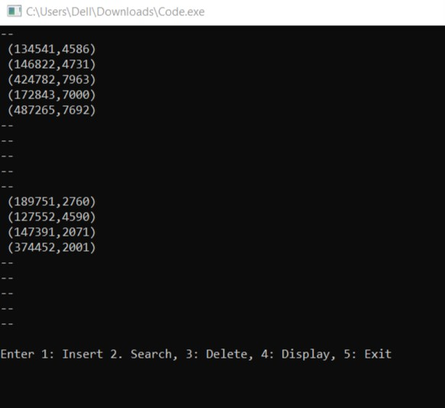

Inserting MAC Address:

Displaying MAC Addresses:

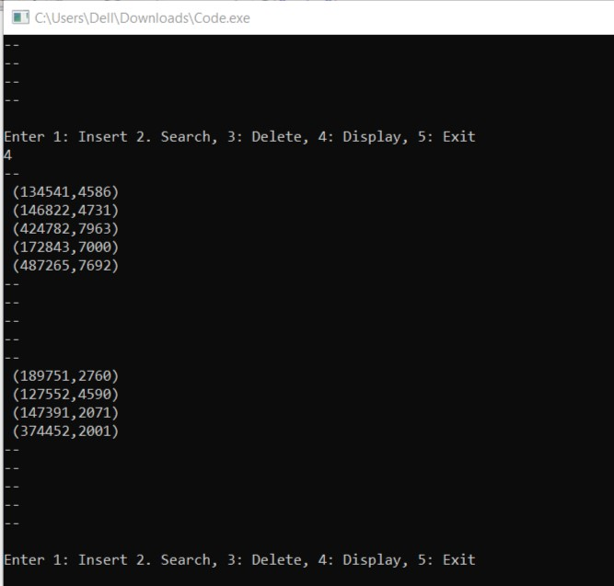

Deleting MAC Address:

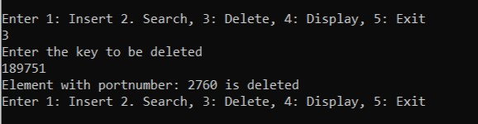

7.CONCLUSION

Our project is a small prototype for storing information linked to the MAC address, and its implementation was possible due to various concepts of data structures, algorithm and techniques. Since hashing is a one-way process it improved the speed of finding the information to a great extent. Also, it made it safer as there is no way to reverse engineer it. But the entire project could not have been completed without the basic structures, arrays and linked lists. Thus, we can conclude that data structures and algorithms is a basic building block for the implementation of all sorts of programs in software industry.
8.REFERENCES

- Fundamentals of Data Structures in C (Second Edition)
Author-Ellis Horowitz, Anderson-Freed, Sahni

- Application of Data Structures & Algorithms in Networking
By D T V Ramakrishna Rao
Senior technical architect
product engineering dept
Infosys ltd

- Basic Data Transmission in Networks: MAC Tables and ARP Tables
By Sean Wilkins

