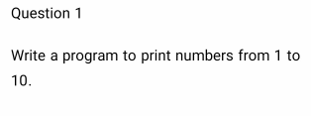

public class Num1

{

public static void main(String[] args)

{

int i;

for(i=1;i<=10;i++)

System.out.println(i);

}

}

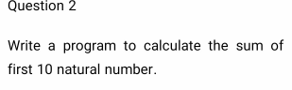

public class Num2

{

public static void main(String[] args)

{

int i,a=0;

for(i=1;i<=10;i++)

{

a=a+i;

}

System.out.print("sum=" +a);

}

}

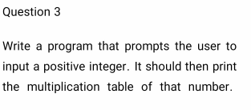

public class Multi3

{

static int mul;

public static void multiply(int n)

{

for(int i=0; i <=10; i++)

{

System.out.println(n+" \* "+i+" = "+n\*i);

}

}

public static void main(String[] args)

{

Multi3.multiply(5);

}

}

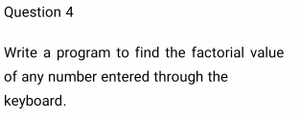

class Fact3

{

public static void main(String[] args) {

int i,fact=1;

int n=4;

for(i=1;i<=n;i++){

fact=fact\*i;

}

System.out.println("Factorial of "+n+" is: "+fact);

}

}

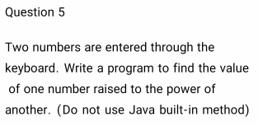

public class pow4

{

public static void main(String args[])

{

int base =50;

int expo=2;

int temp = base;

for (int i=1; i<expo; i++)

{

temp = temp\*temp;

}

System.out.println("Result of "+base+" power "+expo+" is "+temp);

}

}

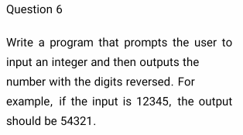

public class RevNum {

public static void main(String[] args)

{

int n=123455,rev=0;

int temp=n;

System.out.println("Original num"+temp);

while(n>0)

{

temp=n%10;

rev=rev\*10+temp;

n=n/10;

}

System.out.println("Reveresed num"+rev);

}

}

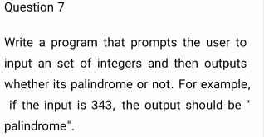public class Palindrome6 {

public static void main(String[] args)

{

int n=141,rev=0;

int temp=n;

System.out.println("Original num"+temp);

while(n>0)

{

temp=n%10;

rev=rev\*10+temp;

n=n/10;

}

System.out.println("Reveresed num"+rev);

if(temp==rev)

System.out.println("palindrome number ");

else

System.out.println("not palindrome");

}

}

//HAVE DOUBT

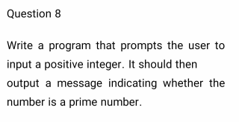

public class PrimeNum {

public static void main(String[] args) {

int i,flag=0,m=5,n=0;

if(m==1||m==0)

{

System.out.println(m+"is not a prime number...");

}

else

{

for(i=2;i<m;i++)

{

if(m%i==0)

{

flag=1;

break;

}

}

if(flag==1)

System.out.println(m+"is not a prime number...");

else

System.out.println(m+"is a prime number...");

}

}

}

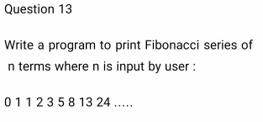

public class FibiNum

{

public static void main(String[] args)

{

int a=0,b=1,num=10,i;

System.out.print(a+" "+b);

for(i=2;i<num;i++)

{

int c=a+b;

System.out.print(" "+c);

a=b;

b=c;

}

}

}

15

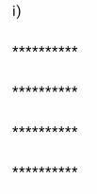

public class PatternClass

{

public static void main(String[] args)

{

for(int i=0;i<=5;i++)

{

for(int j=0;j<=5;j++)

{

System.out.print("\*");

}

System.out.println();

}

}

}

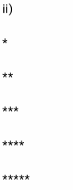

public class RightTri

{

public static void main(String[] args)

{

for(int i=0;i<=5;i++)

{

for(int j=0;j<=i;j++)

{

System.out.print("\*");

}

System.out.println();

}

}

}

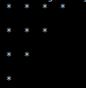

public class PyraMid

{

public static void main(String[] args)

{

int n=5;

for(int i=0;i<n;i++)

{

for(int j=n-i;j>1;j--)

{

System.out.print(" \* ");

}

//for( int j=0;j<=i;j++)

{

System.out.println(" ");

}

System.out.println(" ");

}

}

}

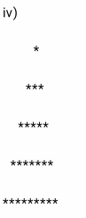

public class PyramidPattern

{

public static void main(String args[])

{

int i, j, row = 6;

for (i=0; i<row; i++)

{

for (j=row-i; j>1; j--)

{

System.out.print(" ");

}

for (j=0; j<=i; j++ )

{

System.out.print("\* ");

}

System.out.println();

}

}

}

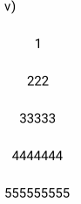

public class Pyra

{

public static void main(String args[])

{

int i, j, row = 6;

for (i=0; i<row; i++)

{

for (j=row-i; j>1; j--)

{

System.out.print(" ");

}

for (j=0; j<=i; j++ )

{

System.out.print(i);

}

System.out.println();

}

}

}

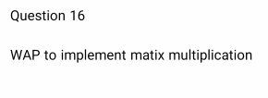

public class MatMul{

public static void main(String args[]){

int a[][]={{1,1,1},{2,2,2},{3,3,3}};

int b[][]={{1,1,1},{2,2,2},{3,3,3}};

int c[][]=new int[3][3];

for(int i=0;i<3;i++){

for(int j=0;j<3;j++){

c[i][j]=0;

for(int k=0;k<3;k++)

{

c[i][j]+=a[i][k]\*b[k][j];

}

System.out.print(c[i][j]+" ");

}

System.out.println();

}

}

}

public class SumOfArray {

public static void main(String[] args) {

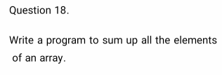

int [] arr = new int [] {1, 2, 3, 4, 5};

int sum = 0;

for (int i = 0; i < arr.length; i++) {

sum = sum + arr[i];

}

System.out.println("Sum of all the elements of an array: " + sum);

}

}