Assignment No. 2

Title: **Study of different operating systems for Raspberry-Pi board. Understanding the process of OS installation on Raspberry-Pi board.**

**Aim:** To understand various Operating Systems for Raspberry Pi Board and OS installation in It.

**Hardware Requirement**: SD Card (Minimum 8GB), Card Reader and Raspberry PI Board.

**Software Requirement:** Sdcard Formatter, Win32 Disk Imager for windows os.

**Theory:**

Raspberry-Pi is a complete mini-computer. It needs an operating system to work out. All the storage is provided from SD card. The Raspberry Pi itself doesn’t come with an operating system. For that, you need NOOBS, short for New Out of the Box Software. It’s an operating system manager that makes it easy to download, install, and set up your Raspberry Pi. When you first boot up NOOBS, you’ll get a selection of OS's to choose from. Which operating systems are available depends on which model of Raspberry Pi you are using. For this guide, we’ll stick to the most common OS's operating systems available on the newest models of the Raspberry Pi. Right now, that’s Raspbian, OSMC, OpenELEC, Windows IoT Core, and RISC OS.

On the first boot, NOOBS greets you with a selection of operating systems. You can install as many as you want that’ll fit on your SD card. Let’s dig into which of those choices is best for your particular plans for your Raspberry Pi.

Android Things  
Arch Linux ARM  
CentOS  
Debian  
Fedora  
FreeBSD  
Gentoo Linux  
Kali Linux  
Kano  
NetBSD  
Plan 9  
Raspbian  
RISC OS  
Slackware  
SUSE  
Ubuntu Core  
Ubuntu MATE  
Windows 10 IoT Core

### **1. Raspbian Is the Best All-Around Operating System**

Raspbian is the “official” operating system of the Raspberry Pi and because of that, it’s the one most people will want to start with.

Raspbian is a version of Linux built specifically for the Raspberry Pi. It comes packed with all the software you’ll need for every basic task with a computer. You’ll get LibreOffice as an office suite, a web browser, email program, and some tools to teach programming to kids and adults alike. Heck, it even includes a special (no longer in development) version of Minecraft. Raspbian is the backbone for pretty much every DIY project out there, so if you’re looking to make something, Raspbian is most likely where you want to start. Because it’s so widely used, it’s also easy to find guides and troubleshooting tips.

**2. OSMC Is the Best, Most Feature-Rich Media Center Software**

OSMC (Open Source Media Center) is media center software but it’s easier to set up and use. In fact, it doesn’t look like Kodi at all, and that’s a good thing. It’s probably the easiest to use media center software available on the Pi. If you’re new to media centers or you’re trying to set one up for non-techy people, OSMC is the one you want to use.

#### 3. Ubuntu MATE

Ubuntu MATE is a stable and simple OS, which brings a configurable yet still light-on-resources MATE desktop for its users. It is especially good for devices short on hardware specs, making it perfect for Raspberry Pi devices that can’t run a composite desktop. MATE desktop comes with essential apps like a file manager, text editor, image viewer, system monitor, document viewer and terminal.

Ubuntu MATE is original Ubuntu with an APT package manager and Ubuntu’s Software Center. It also works with remote workstation solutions like LTSP and X2Go, and comes with themes and artworks similar to Ubuntu. For loading its latest version, Ubuntu MATE 15.10 (Wily Werewolf) on Raspberry Pi, developers recommend 4GB or more high-speed SD card.

### 4. Windows 10 IoT Core Is for Developers Making Connected Devices

Windows 10 IoT is a special version of Windows built for the Raspberry Pi. It is not a full version of Windows. Instead, it’s meant as a development platform for coders and programmers to prototype internet connected devices using the Raspberry Pi and Windows 10. Windows 10 IoT is only compatible with Windows 10 and you cannot do anything with it unless you have another computer with Windows 10 installed.

**5. Android**

Amazingly, it’s also possible to run Android on a Raspberry Pi. Actually, that shouldn’t come as much of a surprise — Android seems to run on just about anything these days, from PCs to set-top boxes.

Various versions of Android are available for the Pi, with the current versions based on Android 7.0 Nougat. Some Android TV builds are also in development at the time of writing.

**6. RISC OS Pi**

If you are looking for something different than the traditional Operating Systems for Raspberry Pi 3, then go for the RISC OS Pi. It is not built on Linux and does not support the electronic prototype projects, but it is a whole new concept of OS which works on its own. So, if you are a curious type person and want to play around with your Pi, then you should try this Operating System.

**7. Retro Pi**

Anyone here who own a computer and do not have installed any game on it? I think the answer is negative because everyone loves games. Some are addicted to it while some play games just for having some relaxing time. No matter what, but if you want to play games on your Raspberry Pi, then the Retro Pi is the platform you will need to enjoy at full pace.

- Retro Pi is an all-in-one gaming platform which turns your Pi 3 into a high-class retro gaming machine.

**8. Arch Linux ARM**

Arch Linux ARM is a simple port of Arch Linux. It will give you full control over your Pi device. Its simple base structure will provide you with the access of shaping the system according to your needs.

* Targeted, simple, and user-centralized OS
* It gives you complete control over the system.

All these are different types of Operating Systems for Raspberry Pi, but here we are deeply studying with Raspbian OS. The step by step installation process is as follow:

**Installation process for Raspbian OS on Raspberry pi:**

**Step 1. Downloading NOOBS**

Using NOOBS is the easiest way to install Raspbian on your SD card. To get hold of a copy of NOOBS:

Visit [www.raspberrypi.org/downloads/](http://www.raspberrypi.org/downloads/)

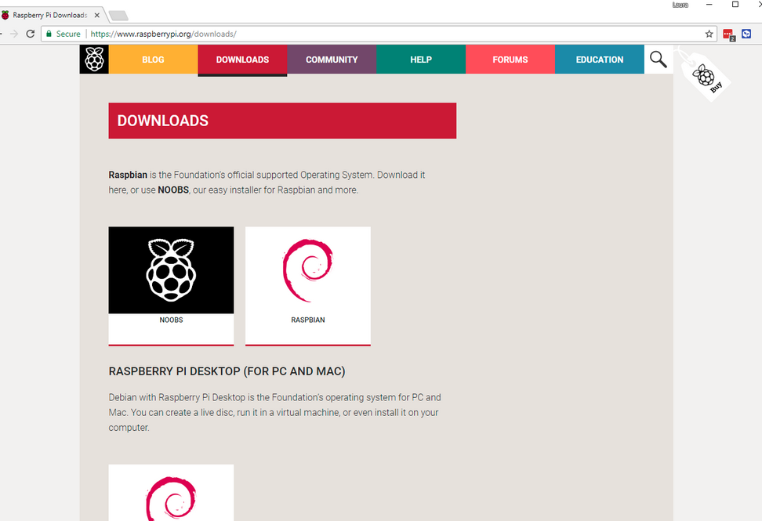

You should see a box with a link to the NOOBS files. Click on the link.

**Step 2.** **Formatting the SD Card**

If the SD card on which you wish to install Raspbian currently has an older version of Raspbian on it, you may wish to back up the files from the card first, as they will be overwritten during this process.

I) Visit the SD Association’s website and download SD Formatter 4.0 for Windows or Mac.

II) Insert your SD card into the computer or laptop’s SD card reader and make a note of the drive letter allocated to it, e.g. F:/.

III) In SD Formatter, select the drive letter for your SD card, and format it.

**Step 3.** **Extracting NOOBS from the zip archive**

Next, you will need to extract the files from the NOOBS zip archive you downloaded from the Raspberry Pi website.

I) Go to your Downloads folder and find the zip file you downloaded.

II) Extract the files and keep the resulting Explorer/Finder window open.

**Step 4.** **Copying the files**

Now open another Explorer/Finder window and navigate to the SD card. It’s best to position the two windows side by side.

I) Select all the files from the NOOBS folder and drag them onto the SD card.

II) Eject the SD card.

**Step 5.** **Booting from NOOBS**

Once the files have been copied over, insert the micro SD Card into your Raspberry Pi, and plug the Pi into a power source.

You will be offered a choice when the installer has loaded. You should check the box for Raspbian, and then click Install.

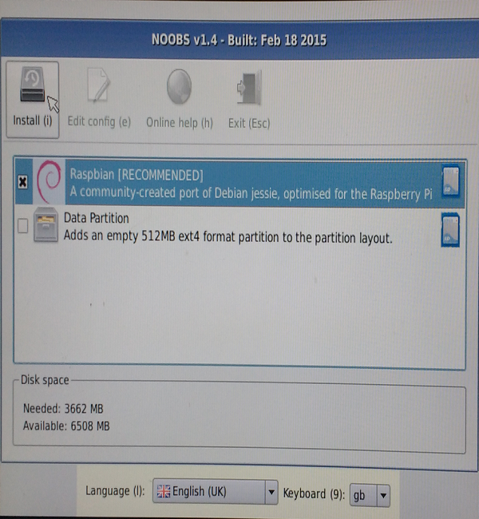

**Step 6. Relax:**

Click Yes at the warning dialog, and then sit back and relax. It will take a while, but Raspbian will install.

**Conclusion:**

In this way we have learned about various OS for Raspberry Pi and installation of Raspbian OS on Raspberry Pi Board.