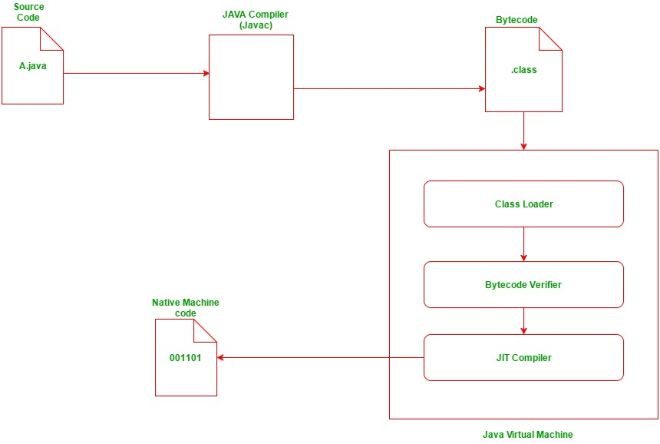  
this is how java code executes..  
JVM works independently but it is platform dependent but java is not  
in c++ there is no byte code  
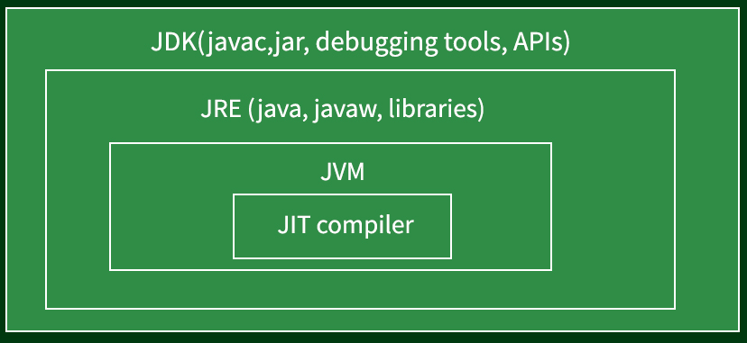  
  
Array initial elements are set 0 first.  
outside main=10^7 size of arrays  
inside main= 10^6

In interview pretend fake as we are thinking from scratch.   
An ArrayList is a dynamic array.  
Difference between stack and heap  
 **Stack**: Fast access, limited size, LIFO order, temporary aur structured data ke liye.  
 **Heap**: Flexible size, thoda slow access, koi order nahi, aur bade dynamic data ke liye.  
NEW  
This  
  
**2D Array** is like a flexible grid for storing different types of data.  
**Matrix** is a type of 2D array but only for numbers, with special rules for mathematical operations.  
when sorted array apply binary search  
In place sorting- in which no new data structure is taken.  
  
**ABSTRACT DATA TYPE-**  
Samajhne ke liye, ADT ko ek design blueprint ki tarah dekhiye jo kaam define karta hai, par implementation ki chinta nahi karta. Chahe Stack internally **array** se implement ho ya **linked list** se, iska interface wahi rahega. Yeh hi ADT ka concept hai.

HOW TO CALCULATE ADDRESS IN ARRAYS:  
2D ARRAY:  
LOC A[I][J]=B+W[N(I-L1)+(J-L2)]  
A[3:7 – 1:4] 3 is lower bound(l1)  
 7 is upper bound(u1)  
 1 is lower bound (l2)  
 4 is upper bound(u2)  
LOC A[I][J]=B+W[(I-L1)+M(J-L2)]  
  
3D ARRAY:  
a[m][n][p] m is row, n is column, p is height  
l1 l2 l3  
e1 e2 e3  
row major = B+W[(E1L2+E2)L3+E2]  
E=K1-L(E is effective address)  
A[I][J][K]: (K=i-L)  
Column major = B+W[(E2L2+E1)L1+E2]

PRECEDENCE OF OPEARTORS

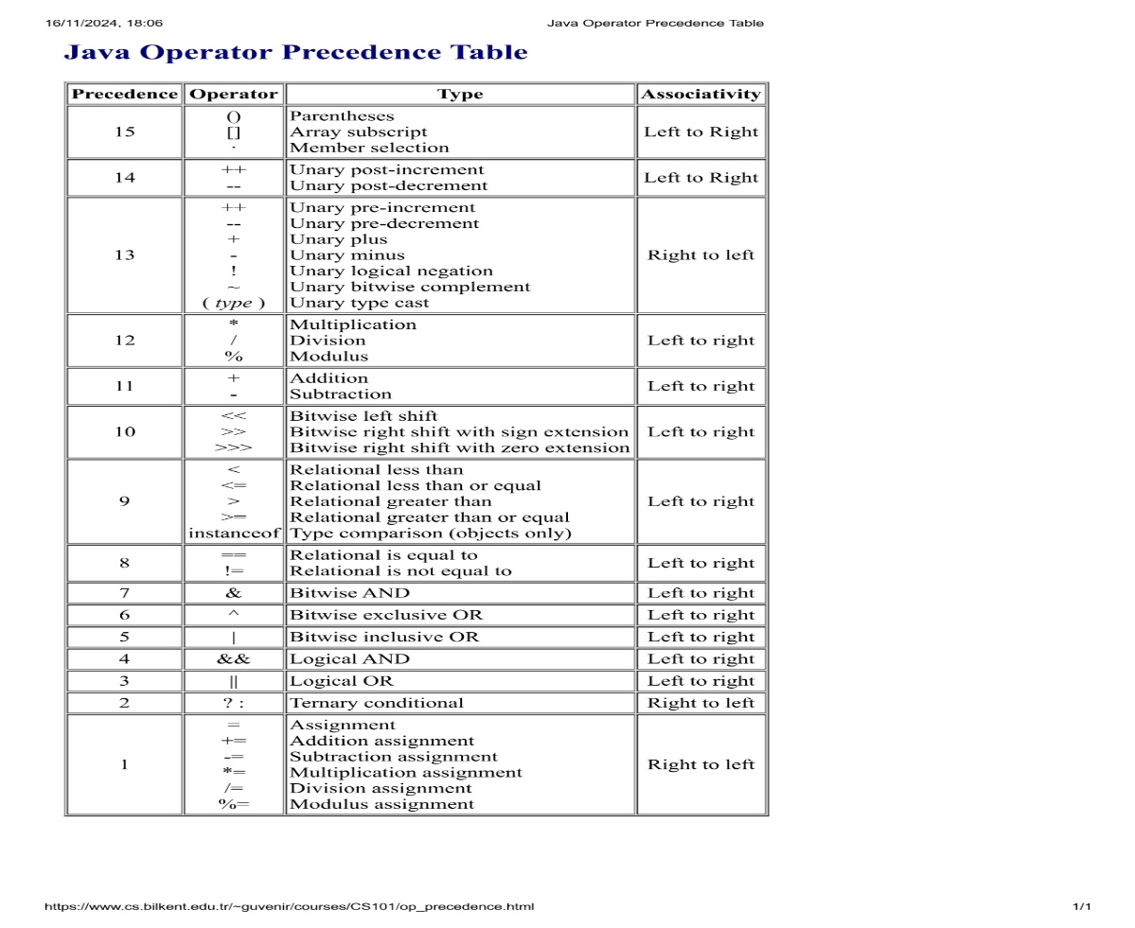

UTA-Unary, ternary, assignment uses right to left associativity.

INSERTION SORT-  
array is divided into two parts sorted and unsorted or unsorted array ke first element to sorted array ke sahi position mei lgate jate hai or last mei puri array sorted ho jatihai.

SELECTION SORT-  
array is divided into two parts right and left or left array ke first element ko sahi position mei lgate jate hai or last mei puri array sorted ho jatihai right mei.

BUBBLE SORT-  
Aga bgal sorting hoti hai.

PIVOT SORT-  
Ek pivot element lete hai or uske left mei sare use chhote or right mei sare use bde fir left ki sorted array mei bhi same cheez and right ke bhi last mei sbko add.

MERGE SORT-  
Array keeps on dividing into two parts