Study whole trees from quantum.  
Depth of a tree – no of edges (longest path from root to leaf)

Binary tree representation using array  
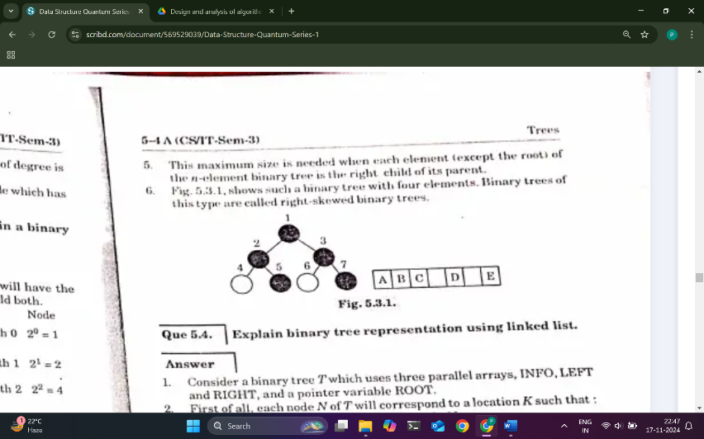

1   
 / \   
 2 3  
 / \  
4 5  
class Solution {  
public int maxDepth(TreeNode root) {  
if(root == null){  
 return 0;  
 }  
int left = maxDepth(root.left);  
 int right = maxDepth(root.right);  
 return Math.max(left,right)+1;  
 }  
}  
sbse pehle left sare(qki wo pehle likha hai) check hoge fir agr null to ek step back right krega check this is called backtracking fir jb dono ki value mil jayega to last mei check kr lege jb ek value ka left or right complete ho jayega.

QUEUE tb use krte hain jaha reverse wagarh kuch krna hota hai ek lekr chlte hai arrayList or ek jisme left or right store kra ske fir uske left right until null  
<https://www.geeksforgeeks.org/problems/reverse-level-order-traversal/1> see the logic