**Assignment**

1. Explain Green Computing with its advantages.

The term green computing refers to environmentally sustainable computing. it is also referred as green it (information technology).

This branch of computing deals with computers, servers, printers, monitors and associated networking and communication systems. it includes "design", "manufacturing", "use" and "disposal" of green it systems effectively and efficiently with minimum

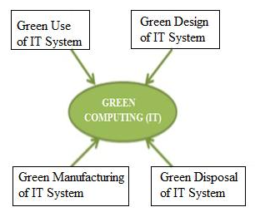

Advantages of Green Computing

Telecommuting technique help in increasing profit margin increases worker satisfaction and reduces Greenhouse gas emissions.

virtualization of it helps in running two or more computer systems on single set of physical hardware this reduces operating cost for energy and cooling this ultimately helps in saving money.

It reduces usage of paper and other consumable in IT industry green manufacturing makes use of bamboo for computers and peripherals moreover computers are constructed using recycle plastic and set will have less impact on the environment.

It minimizes equipment disposal requirements by adopting reuse, refurbish and recycle methods.

1. What is E-waste?What can be done to reduce the impact of E-waste.

E-waste also known as electronic waste is the world’s fastest-growing waste streams.

It includes a wide variety of products ranging from any household items with circuitry and electrical electronics component with power battery supply.

The main 3 constituents of e-waste are glass plastic and metal

Electronic waste and environmental hazardous on one hand and valuable on the other as they contain a substantial amount of precious and write the metal such as Copper, Gold, Silver, Nickel , indium and Palladium.

* donate or sell electronics
* consume less in order to reduce your e-waste
* recycle via a retailer
* buy energy star rated appliances

1. What are the benefits of going paperless.
2. labor savings

paper is extremely time-consuming to work with as it requires a great deal of time and labor to organize and retrieve. on average, office staff spend about one hour per month searching for and replacing files.

2.Printing Cost

 Printing hard copies of business documents requires the purchase of paper, toner, ink, the printers and their maintenance. In most organizations, going paperless can save more than $500 per person per year in these supplies.

3. Lost & Misfield Document

7% of all paper documents get lost or misfiled. A secure and backed up paperless environment, greatly minimizes the risk of losing or misplacing a digital document. And if a disaster should occur, digital documents can often be recovered, whereas paper documents could be gone permanently.

4. Email Management

Perhaps your staff is concerned that digital documents will just mean more emails. However, with simple email management strategies, there is no need for staff to spend tedious hours organizing, reviewing and deleting emails. Emails should be treated like any other type of electronic file and be immediately categorized into an appropriate folder.

5. Storage Costs

Paper files take up space and many organizations are forced give up their office space to file cabinets and boxes of documents. Paperless companies greatly minimize their need for storage space as a single hard drive, or the Cloud, can store millions of documents.

4.  What is Github? Give advantages of using Github.

GitHub is a code hosting platform for collaboration and version control. GitHub lets you (and others) work together on projects.

GitHub essentials are:

* Repositories
* Branches
* Commits
* Pull Requests
* Git (the version control software GitHub is built on)

Advantages of Github are :-

1. It makes it easy to contribute to your open source projects

• To be honest, nearly every open-source project uses GitHub to manage their project. Using GitHub is free if your project is open source and includes a wiki and issue tracker that makes it easy to include more in-depth documentation and get feedback about your project. If you want to contribute, you just fork a project, make your changes and then send them a pull request using GitHub web interface.

2.Documentation

By using GitHub, you make it easier to get excellent documentation. Their help section and guides have articles for nearly any topic related to git that you can think of.

3.Showcase your work

Are you a developer and wishes to attract recruiters? GitHub is the best tool you can rely on for this. Today, when searching for new recruits for their project, most companies look into the GitHub profiles. If your profile is available, you will have a higher chance of being recruited even if you are not from a great university or college.

4.GitHub is repository

This was already mentioned before, but it’s important to note, GitHub is a repository.

What this means that it allows your work to get out there in front of the public. Moreover, GitHub is one of the largest coding communities around right now, so it’s wide exposure for your project.

1. Write a program using PEP8 rules.

CODE : -

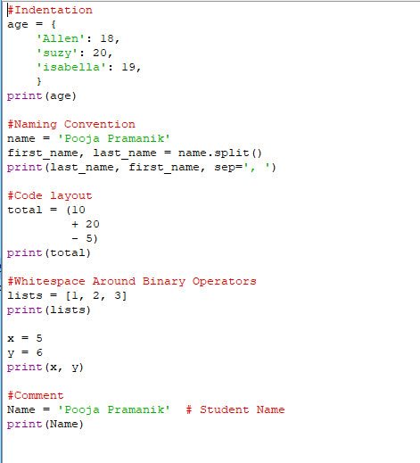

OUTPUT :-

