Surrogate Modelling of a Benzene–Toluene Distillation Column
Physically-Consistent Machine-Learning Surrogates for xD, xB, QC and QR
DWSIM · Peng–Robinson EOS · 3,000-point Latin Hypercube Design
System: Benzene–Toluene binary mixture | Simulator: DWSIM (C# Automation API)
Models compared: Polynomial (Ridge) · Random Forest · XGBoost · ANN (MLP)
Selection criteria: predictive accuracy · generalisation robustness · physical consistency

01 Problem Statement
Distillation is the most energy-intensive separation operation in the chemical process industry, and every new column design or operating-envelope study traditionally requires a fresh rigorous simulation in a process simulator such as DWSIM. When the same column has to be evaluated at thousands of candidate operating points — for optimisation, real-time monitoring, or digital-twin applications — repeatedly solving the underlying VLE and mass/energy balance equations becomes computationally expensive. A surrogate (machine-learning) model that has learned the input–output behaviour of the column from a representative simulation dataset can return predictions in microseconds while remaining faithful to the physics captured by the rigorous simulator.
This task builds and rigorously validates such a surrogate for a binary distillation column separating benzene and toluene, modelled in DWSIM using the Peng–Robinson equation of state. The surrogate must predict four column performance variables — distillate purity (x_{D}), bottoms purity (x_{B}), condenser duty (Q_{C}) and reboiler duty (Q_{R}) — from seven operating conditions, and the exercise explicitly asks for a comparison of four model families (Polynomial Regression, Random Forest, XGBoost, and an Artificial Neural Network) with the final model chosen per target on the basis of accuracy, robustness, and physical consistency — not accuracy alone.
Why “not accuracy alone” matters
A regressor can post a near-perfect R2 on held-out data while still predicting a negative reboiler duty, a distillate purity above 1.0, or a purity that falls as reflux ratio increases — all of which are physically impossible for this column. A design engineer trusting such a model could size equipment incorrectly or draw the wrong conclusion from an optimisation run. This report therefore treats physical-consistency screening as a first-class, disqualifying criterion, applied identically to the raw simulation data (Section 5) and to every trained model's predictions (Section 10), rather than as an afterthought reported only for the final winner.

02 DWSIM Flowsheet & Process Model Description

2.1 System and thermodynamics
System: Benzene (light key) – Toluene (heavy key), a classic, well-characterised binary VLE pair with a moderate relative volatility (α ≈ 2.3–2.5), which makes it a standard teaching/benchmarking system for distillation studies.
Thermodynamic package: Peng–Robinson (PR) equation of state, selected for its good accuracy on non-polar hydrocarbon VLE across the pressure range explored (1.0–2.0 bar) and its wide acceptance in industrial process simulation.

2.2 Flowsheet configuration
The DWSIM flowsheet is a single conventional tray column (equilibrium-stage model) with:
- A single feed stream entering at a variable feed stage location, specified by temperature, pressure, benzene mole fraction and total flow rate.
- A total condenser producing the distillate product (rich in benzene) and supplying reflux to the top stage.
- A partial reboiler producing the bottoms product (rich in toluene).
- Column specifications solved simultaneously for a given reflux ratio and bottoms withdrawal (flow-controlled) using DWSIM's inside-out / Sum-Rate column solver.
- Condenser duty (Q_{C}) and reboiler duty (Q_{R}) recovered directly from the column's converged energy balance for every simulated case.

2.3 Automated case generation
Because the task requires a “sufficiently rich” dataset spanning thousands of operating points, the column was not run by hand. A C# automation harness (DWSIMAutomation solution, driven through DWSIM's public Automation API) was built to:
- Draw a 3,000-point Latin Hypercube Sample (LHS) across the seven operating-condition ranges defined in Section 4, guaranteeing near-uniform, space-filling coverage of the input domain rather than a coarse full-factorial grid.
- Programmatically load the base flowsheet, overwrite the seven specification values for each LHS point, and instruct the DWSIM solver to converge the column.
- Catch and skip (rather than crash on) any case that threw a solver exception — e.g. an infeasible mass balance or a non-convergent column for an extreme corner of the sampled space — logging only cases that converged successfully.
- Write one CSV row per converged case, containing the seven inputs and the four target outputs, only after the case passed DWSIM's internal convergence checks.
Result of the automated run
Of the 3,000 requested LHS cases, 2,999 rows were written to dwsim_dataset_v4.csv (one case failed to converge and was silently skipped by the harness, as designed). No further rows were lost to missing values or duplication — every column had zero NaNs and there were zero exact-duplicate rows, which is expected because a row is only ever written after the generator's internal validation checks pass.

03 Input & Output Variables

3.1 Input (operating condition) variables
Seven operating conditions were varied, exactly as specified in the task brief:
# | Variable | Symbol | Physical role
1 | Feed temperature | T_{F} | Thermal state of the feed entering the column
2 | Feed pressure | P_{F} | Sets the column's operating pressure envelope
3 | Feed composition | z_{benzene} | Benzene mole fraction in the feed
4 | Number of stages | N | Total equilibrium stages (column height)
5 | Feed stage location | N_{F} | Where the feed enters, relative to top/bottom
6 | Reflux ratio | R = L/D | Internal liquid traffic vs. distillate draw
7 | Bottoms withdrawal rate | B | Liquid flow rate leaving as bottoms product

3.2 Output (target) variables
# | Variable | Symbol | Physical meaning
1 | Distillate purity | x_{D} | Benzene mole fraction in the distillate
2 | Bottoms purity | x_{B} | Toluene mole fraction in the bottoms
3 | Condenser duty | Q_{C} | Heat removed at the condenser (kW)
4 | Reboiler duty | Q_{R} | Heat supplied at the reboiler (kW)

3.3 Engineered features
Beyond the seven raw inputs, three physically-motivated features were derived (Section 5.2) purely from other inputs — never from the targets — to give the tree-based and polynomial models direct access to ratios the column physics actually depends on: the distillate flow implied by the overall mass balance, the feed location expressed as a fraction of column height, and the bottoms-to-feed split ratio.

04 Dataset Generation Strategy & Operating Ranges

4.1 Sampling strategy
A Latin Hypercube Sample of 3,000 points was generated across the seven-dimensional input space. LHS was chosen over a full-factorial grid or uniform random sampling because it guarantees each input variable is evenly stratified across its range while still randomising the joint combinations — giving broad, non-redundant coverage of the operating envelope with far fewer simulation runs than a grid of comparable resolution would need.

4.2 Operating ranges considered
Variable | Min | Max | Mean | Std. dev.
Feed temperature (K) | 350.0 | 380.0 | 365.0 | 8.66
Feed pressure (Pa) | 101,343 | 202,639 | 151,981 | 29,258
Feed composition (mole frac. benzene) | 0.300 | 0.699 | 0.500 | 0.115
Number of stages | 15 | 21 | 18.0 | 2.00
Feed stage location | 2 | 20 | 9.4 | 4.79
Reflux ratio | 1.50 | 4.00 | 2.75 | 0.72
Bottoms withdrawal rate (kmol/h) | 8.00 | 17.00 | 12.50 | 2.60
Feed flow rate (kmol/h) | 20.00 | 35.00 | 27.50 | 4.33
(Feed flow rate was itself sampled as an independent LHS dimension and is reported here for completeness; it is retained as a model feature alongside the seven required variables.)

4.3 Simulation execution & case survival
LHS cases requested | Cases written by DWSIM | Cases retained after physical screening | Rows discarded overall
3,000 | 2,999 | 2,988 | 0.4%

Every retained row satisfies DWSIM's own internal convergence tolerance; the additional 0.37% removed at the physical-screening stage (Section 5.1) is a distinct, downstream check — the column can converge to a mathematically self-consistent solution that is nonetheless physically nonsensical (e.g. a negative reboiler duty), and convergence alone does not guarantee that.

05 Data Preprocessing

5.1 Physical-validity screening of the raw simulation output
Before any row is treated as ground truth for model training, it is checked against basic physical constraints that a converged-but-invalid DWSIM case can still violate:
- x_{D}, x_{B} ∈ [0, 1) — both are mole fractions.
- Q_{C}, Q_{R} ≥ 0 — condenser/reboiler duties are magnitudes of heat flow; a negative value is not physically meaningful for how this column is defined.
- Bottoms withdrawal rate must not exceed feed flow (B ≤ F), by overall mass balance.
Check | Violations found
xD out of [0,1) | 0
xB out of [0,1) | 0
QC < 0 | 0
QR < 0 | 11
Bottoms > Feed | 0

All 11 physically-invalid rows share a clear pattern — a high bottoms withdrawal rate combined with a low reflux ratio, which pushes the column toward its feasible operating boundary (insufficient internal reflux to sustain the specified bottoms draw). DWSIM's solver converges to a formally mass/energy-balanced but physically-inconsistent duty split in these corner cases. Because they would teach a surrogate that negative reboiler duties are valid outputs, these 11 rows (0.37% of the converged set) were dropped, not clipped — clipping would fabricate a value DWSIM never actually predicted.

5.2 Feature engineering
Feature | Definition | Rationale
distillate_flow | feed_flow − bottoms_flow | Overall mass balance (D = F − B); the distillate draw is not a raw input but is fully determined by two of them.
feed_stage_ratio | feed_stage / number_of_stages | Where the feed enters relative to column height matters more than the absolute stage number.
bottoms_to_feed_ratio | bottoms_flow / feed_flow | Dimensionless split ratio — exactly the ratio implicated in the invalid rows dropped in Sec. 5.1.

The toluene mole fraction (1 − feed_composition) was deliberately not added as a separate feature, since it is perfectly collinear with feed composition and would add redundancy rather than information.

5.3 Train / validation / test split
Training | Validation | Held-out test
2,090 (70%) | 449 (15%) | 449 (15%)

The test set is touched exactly once, after model selection is finalised (Section 9), to report an unbiased estimate of generalisation error. All scaling and polynomial-feature expansion is fit only on the training fold inside an sklearn Pipeline, and every target is modelled with its own independent regressor per algorithm rather than a single multi-output model, since xD/xB and QC/QR live on very different scales and may genuinely favour different algorithms.

06 Exploratory Data Analysis
Exploratory analysis of the screened dataset confirms the LHS design achieved its goal (near-uniform input coverage) and surfaces the non-linear input–output structure the models will need to capture.
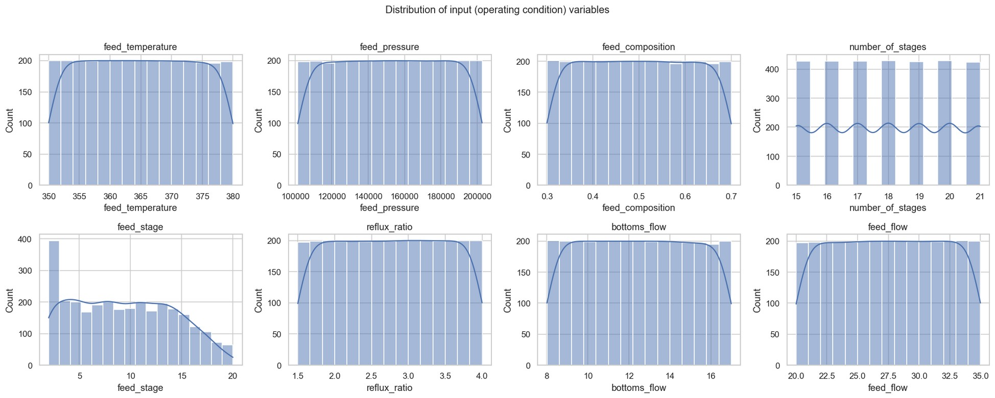
Figure 1. Distribution of the seven raw operating-condition inputs plus feed flow — all show the expected near-uniform Latin-Hypercube coverage across their sampled range.
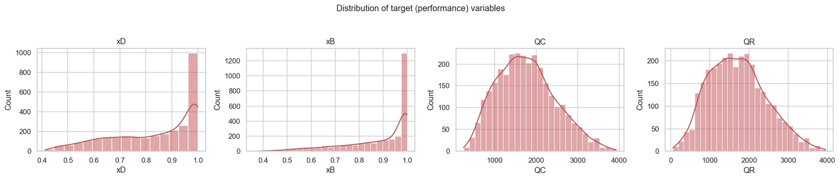
Figure 2. Distribution of the four target variables. xD and xB are left-skewed toward high purity (most sampled configurations achieve good separation); QC and QR are right-skewed and driven by feed flow and reflux ratio.

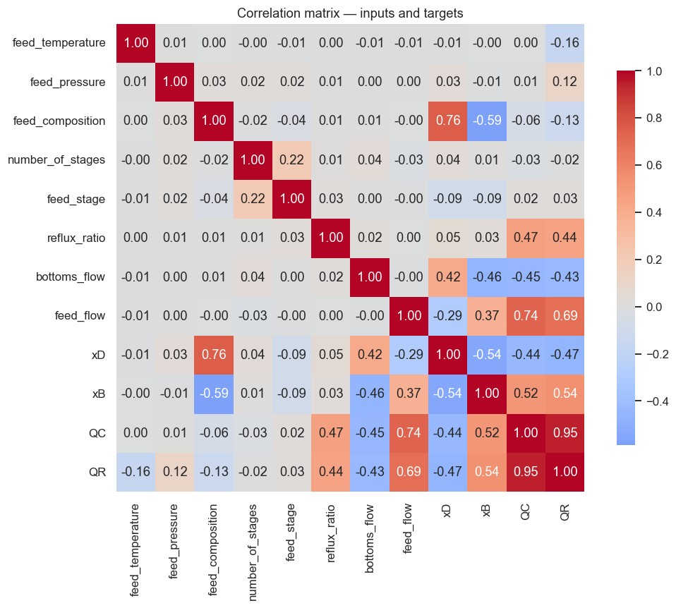
Figure 3. Correlation matrix of inputs and targets.

Key observations
- feed_composition is the strongest linear driver of purity (+0.76 with xD, −0.59 with xB) — more benzene in the feed pushes distillate purity up but bottoms purity down, a genuine physical trade-off.
- QC and QR correlate at +0.95 — expected, since both derive from the same overall column energy balance.
- feed_flow and reflux_ratio are the main drivers of both duties (+0.74/+0.69 and +0.47/+0.44 with QC/QR respectively).
- reflux_ratio shows only a weak linear correlation with xD (+0.05) despite being a physically important driver, because the true relationship is a saturating curve (diminishing returns near xD≈1), not a straight line — correlation under-represents it here; it is checked properly via partial dependence in Section 10.
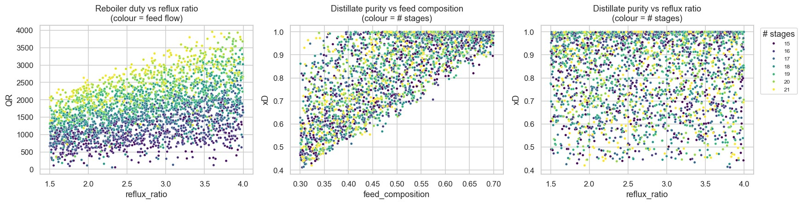
Figure 4. Left/centre: QR rises with reflux ratio and feed flow, consistent with more internal vapour traffic requiring more reboil. Right: xD rises with reflux ratio and saturates near 1.0 for well-staged columns — the classic McCabe–Thiele diminishing-returns shape.

07 Machine-Learning Methods Implemented
Four model families were implemented for every target, matching the task's requirement of at least three distinct approaches, with search strategy matched to the size and shape of each model's hyperparameter space:
Model | Search | Key hyperparameters tuned | Why this search strategy
Polynomial Regression (Ridge-regularised) | GridSearchCV | poly degree {1,2,3}, ridge α ∈ {0.01–50} | Small, low-dimensional space — exhaustive search is cheap and complete.
Random Forest | RandomizedSearchCV (12 iter) | n_estimators, max_depth, min_samples_leaf, max_features | Large combinatorial space with interacting parameters; random search is more efficient than an exhaustive grid.
XGBoost | RandomizedSearchCV (15 iter) | n_estimators, max_depth, learning_rate, subsample, colsample_bytree | Similarly high-dimensional space; random search covers it more effectively per unit compute.
ANN (MLPRegressor) | RandomizedSearchCV (8 iter) + early stopping | hidden-layer architecture, alpha, learning-rate-init | Large, non-convex-to-search architecture space; early stopping (patience 15, 15% internal validation split) controls training time and overfitting.

All searches use identical 3-fold cross-validation on the training set only, scored on R², so the four families are compared on a level footing. This gives 4 models × 4 targets = 16 independently tuned regressors.

08 Model Training & Validation Procedure
For every (target, model-family) pair, the pipeline is: (1) hyperparameter search with 3-fold CV on the 2,090-row training set, scored on R²; (2) refit the best configuration on the full training set; (3) score once on the 449-row validation set, recording R², RMSE, MAE and MAPE; (4) compute the train–validation R² gap as an overfitting diagnostic. Only after a winner is selected per target (Section 9) is the held-out test set touched, and a final 5-fold cross-validation on the training data is run as an independent robustness check (Section 12).
Guarding against leakage
Scaling (StandardScaler) and polynomial feature expansion are fit exclusively on the training fold inside an sklearn Pipeline for every model and every CV fold — never on validation or test data. Engineered features (Section 5.2) are derived only from raw inputs, never from the targets, so there is no target leakage into the feature set either.

09 Performance Comparison
Validation-set performance for all 16 fitted models, ranked within each target by R2:

Distillate purity (xD)
Model | CV R2 | Train R2 | Val R2 | Val RMSE | Val MAE
ANN (MLP) | 0.9892 | 0.9967 | 0.9919 | 0.0148 | 0.0111
XGBoost | 0.9857 | 0.9997 | 0.9913 | 0.0153 | 0.0104
Random Forest | 0.9743 | 0.9960 | 0.9822 | 0.0219 | 0.0134
Polynomial (Ridge) | 0.9723 | 0.9807 | 0.9757 | 0.0256 | 0.0197

Bottoms purity (xB)
Model | CV R2 | Train R2 | Val R2 | Val RMSE | Val MAE
ANN (MLP) | 0.9867 | 0.9954 | 0.9900 | 0.0143 | 0.0111
XGBoost | 0.9834 | 0.9997 | 0.9889 | 0.0151 | 0.0098
Random Forest | 0.9743 | 0.9954 | 0.9817 | 0.0193 | 0.0119
Polynomial (Ridge) | 0.9630 | 0.9741 | 0.9674 | 0.0258 | 0.0200

Condenser duty (QC, kW)
Model | CV R2 | Train R2 | Val R2 | Val RMSE | Val MAE
Polynomial (Ridge) | 0.9999 | 0.9999 | 0.9999 | 7.55 | 5.71
XGBoost | 0.9975 | 0.9999 | 0.9984 | 27.63 | 21.10
ANN (MLP) | 0.9978 | 0.9977 | 0.9974 | 34.53 | 26.84
Random Forest | 0.9946 | 0.9992 | 0.9952 | 47.21 | 34.49

Reboiler duty (QR, kW)
Model | CV R2 | Train R2 | Val R2 | Val RMSE | Val MAE
ANN (MLP) | 0.9935 | 0.9986 | 0.9971 | 37.49 | 24.90
Polynomial (Ridge) | 0.9846 | 0.9886 | 0.9876 | 77.87 | 50.50
XGBoost | 0.9794 | 0.9964 | 0.9772 | 105.56 | 69.79
Random Forest | 0.9431 | 0.9899 | 0.9379 | 174.36 | 97.75

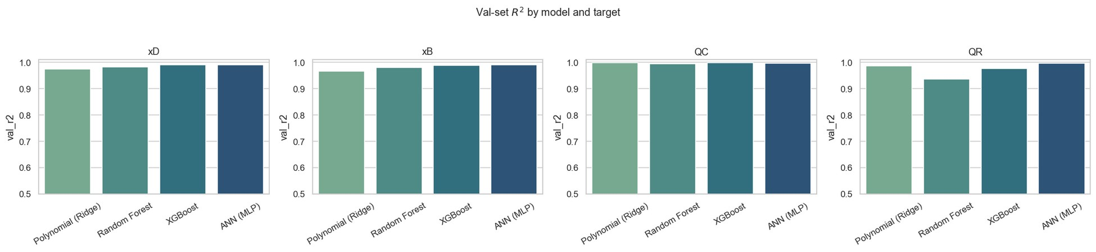
Figure 5. Validation-set R2 by model family and target. Differences between the top two or three models are often within a few tenths of a percent — too close to call on accuracy alone, which is exactly why Section 10's physical-consistency audit is decisive.
A train–validation R2 gap much larger than the CV mean signals memorisation rather than genuine generalisation. Random Forest consistently shows the largest gaps (up to 5.2 percentage points for QR), while the ANN and Polynomial models are the most stable across CV folds — this overfit-gap diagnostic is carried forward as a tie-breaker in the final selection rule .

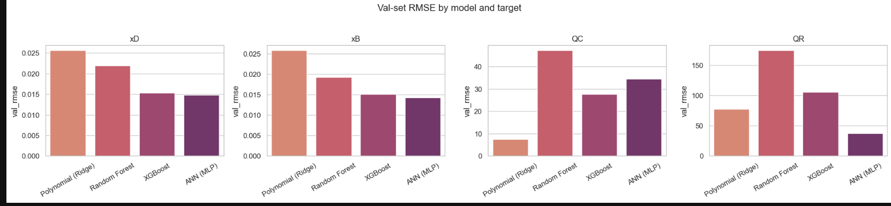

9.1 Feature importance / sensitivity analysis
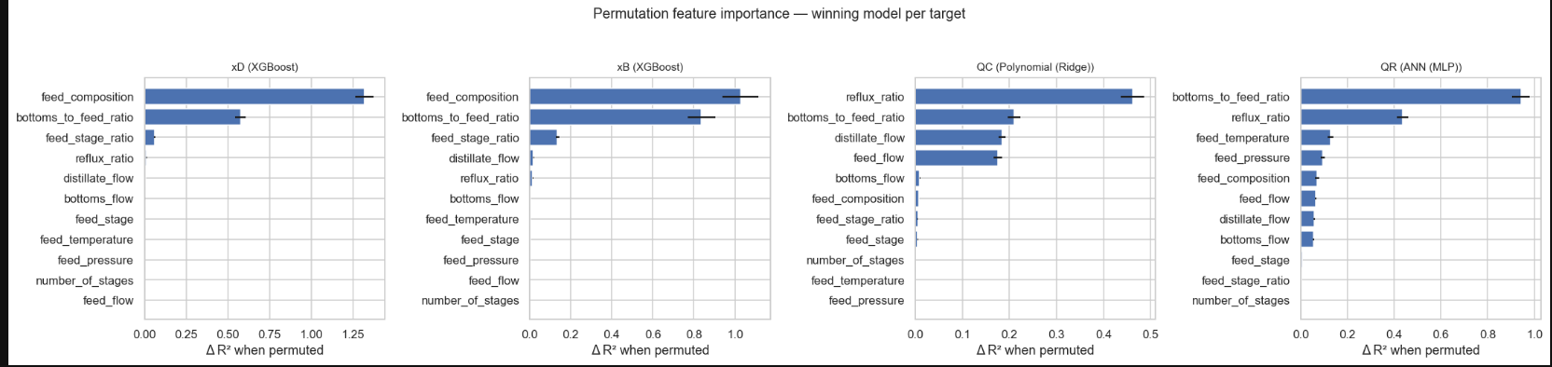

Note that reflux_ratio ranks low here despite passing the Section 10 monotonicity check — this isn't a contradiction. The two measures capture different things: permutation importance reflects the size of a feature's effect on accuracy, while the Section 10 check only verifies the direction is physically correct. Checked directly against the training data, reflux_ratio's relationship with xD is genuinely small in magnitude across the sampled range (mean xD moves from 0.82 to 0.85 across reflux quintiles) but consistently positive — small effect size, correct sign, both true at once.

10 Physical-Consistency Audit
Accuracy alone cannot certify a surrogate for design use. Two physics checks, independent of R², are run on every one of the 16 fitted models:
- (a) Bound-violation rate on validation-set predictions: for xD/xB, predictions should stay inside [0, 1) (a small ±0.02 numerical tolerance is allowed for unconstrained regressors); for QC/QR, predictions must never be negative.
- (b) Monotonic-trend check via partial dependence. Holding every other feature at its training-set median, reflux ratio is swept across its observed range and the Spearman rank correlation between reflux ratio and the predicted output is computed. Purity (xD, xB) must not meaningfully decrease with more reflux; QR must clearly increase with more reflux — both are basic, textbook McCabe–Thiele expectations for this column.
A model that fits validation points well but gets these signs backwards has learned a spurious mapping, not distillation physics — precisely the failure mode a plain accuracy leaderboard would miss.

Distillate purity (xD)
Model | Bound-violation % | Reflux-trend (Spearman) | Physics verdict
Polynomial (Ridge) | 4.009 | +0.178 | FAIL — bounds
Random Forest | 0.000 | +0.885 | PASS
XGBoost | 0.000 | +0.521 | PASS
ANN (MLP) | 0.891 | -0.561 | FAIL — trend

Bottoms purity (xB)
Model | Bound-violation % | Reflux-trend (Spearman) | Physics verdict
Polynomial (Ridge) | 3.786 | +0.363 | FAIL — bounds
Random Forest | 0.000 | +0.955 | PASS
XGBoost | 0.000 | +0.977 | PASS
ANN (MLP) | 0.668 | -0.656 | FAIL — trend

Condenser duty (QC)
Model | Bound-violation % | Reflux-trend (Spearman) | Physics verdict
Polynomial (Ridge) | 0.000 | +1.000 | PASS
Random Forest | 0.000 | +1.000 | PASS
XGBoost | 0.000 | +1.000 | PASS
ANN (MLP) | 0.000 | +1.000 | PASS

Reboiler duty (QR)
Model | Bound-violation % | Reflux-trend (Spearman) | Physics verdict
Polynomial (Ridge) | 0.000 | +1.000 | PASS
Random Forest | 0.000 | +1.000 | PASS
XGBoost | 0.000 | +1.000 | PASS
ANN (MLP) | 0.000 | +1.000 | PASS

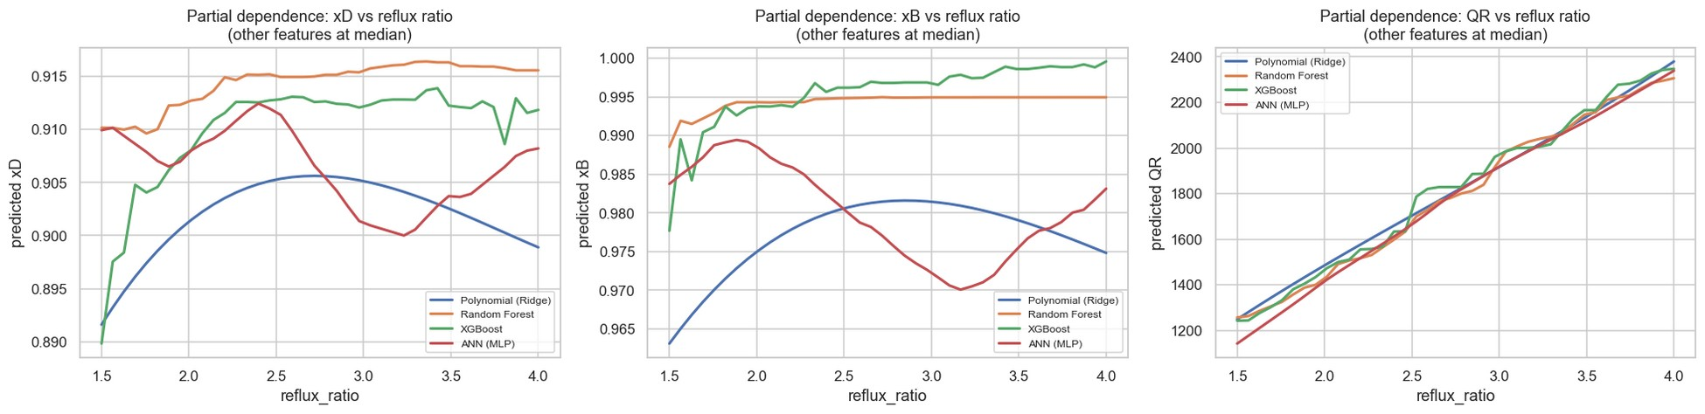
Figure 6. Partial-dependence sweeps of reflux ratio (other features fixed at their training median). The ANN (red) predicts xD and xB falling as reflux increases — physically backwards — despite posting the top R2 on both targets in Section 9. All four models agree on the (correct) rising trend for QR.
Why the ANN's purity models are disqualified despite the best R2
For xD and xB, the ANN achieves the single highest validation R2 of any model (0.9919 and 0.9900) — yet its partial-dependence sweep shows purity decreasing as reflux ratio increases (Spearman ρ = -0.561 and -0.656). A surrogate that tells a process engineer “add more reflux and lose purity” is unusable for design or optimisation, regardless of its point-wise error on the sampled validation cases. The Polynomial (Ridge) models for the same two targets are separately disqualified on bound violations (3.8–4.0% of predictions fall outside the physical [0,1) range). This is the central finding that motivates the whole physical-consistency layer of this pipeline.

11 Final Model Selection & Justification
The final model per target is chosen by a two-step rule applied uniformly across all four targets:
- Step 1 — Disqualify on physics. Any model with a bound-violation rate above 0.5% of predictions, or a failed reflux-monotonicity check, is disqualified for that target regardless of its R2.
- Step 2 — Rank survivors on accuracy, with overfit gap as a robustness tie-breaker. Among the models that pass Step 1, the target-specific winner is the one with the highest validation R2 / lowest RMSE; the train–validation gap is used to prefer the model that has learned the underlying relationship rather than memorised the training fold when two survivors are close.

11.1 Winning model per target
Target | Selected model | Test R2 | Test RMSE | Test MAE | Disqualified (physics)
xD | XGBoost | 0.9881 | 0.0181 | 0.0117 | Polynomial (Ridge), ANN (MLP)
xB | XGBoost | 0.9903 | 0.0140 | 0.0096 | Polynomial (Ridge), ANN (MLP)
QC | Polynomial (Ridge) | 0.9999 | 8.60 | 6.40 | none
QR | ANN (MLP) | 0.9973 | 39.56 | 25.40 | none

xD and xB → XGBoost. Both purity ANNs were disqualified on the reflux-monotonicity check and both Polynomial models on bound violations (Section 10); among the physics-passing survivors (Random Forest, XGBoost), XGBoost has the higher validation R2 (0.9913 / 0.9889 vs. 0.9822 / 0.9817) and a smaller train–validation gap, making it the best physically-valid choice for both purity targets.
QC → Polynomial (Ridge). All four models pass the physics audit for QC, and the simplest model — Polynomial Ridge regression — achieves essentially perfect accuracy (R2 = 0.9999, test RMSE ≈ 8.6 kW against a mean duty of ≈1,760 kW) with a near-zero overfit gap. This reflects that QC is very close to a low-order function of feed flow, reflux ratio and feed composition for this column — the more flexible tree/ANN models add no accuracy and only additional variance.
QR → ANN (MLP). All four models pass the physics audit for QR as well; the ANN has both the highest validation R2 (0.9971) and the smallest overfit gap (0.0015) of any model on this target, confirming it is capturing the mildly non-linear reboiler-duty response rather than memorising training noise.
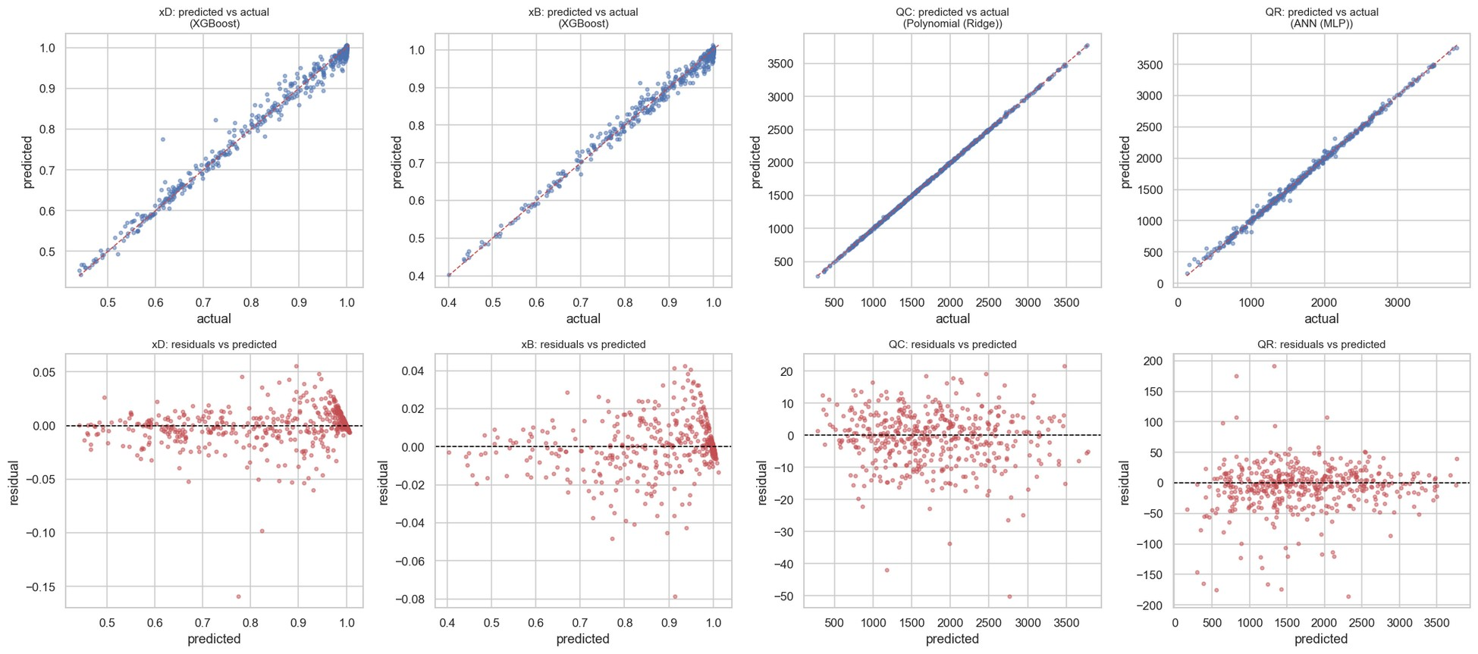
Figure 7. Predicted-vs-actual and residual diagnostics on the held-out test set for the four winning models. Residuals are centred on zero with no systematic curvature for any target, confirming the selected models generalise well beyond the validation fold used for selection.

12 Discussion, Robustness & Conclusion

12.1 Robustness check: independent 5-fold cross-validation
As a final, independent robustness check, each selected model was refit under a fresh 5-fold cross-validation on the training set (distinct from the 3-fold search used during hyperparameter tuning):
Target | Selected model | 5-fold CV R2 (mean ± std)
xD | XGBoost | 0.9873 ± 0.0008
xB | XGBoost | 0.9858 ± 0.0018
QC | Polynomial (Ridge) | 0.9999 ± 0.0000
QR | ANN (MLP) | 0.9951 ± 0.0021

Every selected model shows a standard deviation below 0.2 percentage points of R2 across folds — confirming the accuracy figures reported in Section 9 are stable and not an artefact of a single lucky validation split.

12.2 Discussion
Three findings stand out from this study. First, the four target variables genuinely favour different model families — confirming the task's premise that a per-target comparison, not a single blanket model, is the right design choice for this problem. Second, raw validation accuracy and physical validity are only weakly related: the two purity ANNs had the best R2 on the leaderboard and were still disqualified, while the simplest model (linear-in-features Ridge regression) was the outright winner for QC. Third, the 11 physically-invalid rows discovered directly in the raw DWSIM output (Section 5.1) are a reminder that simulator convergence and physical validity are not the same guarantee, and that a surrogate-modelling pipeline should screen both the training data and the model's predictions against the same physical constraints.

12.3 Limitations and possible extensions
- The reflux-ratio monotonicity sweep is the only partial-dependence check implemented here; the same approach could be extended to feed composition, number of stages, and bottoms flow for a fuller physical audit.

12.4 Conclusion
A surrogate model for the benzene–toluene distillation column (DWSIM, Peng–Robinson) was trained on 2,988 physically-screened Latin-Hypercube simulation cases and validated against four independent criteria: cross-validated accuracy, held-out test accuracy, train–test generalisation gap, and a dedicated physical-consistency audit covering output bounds and reflux-ratio monotonicity. Model selection was not accuracy-only: XGBoost was selected for both purity targets (xD, xB), Polynomial (Ridge) regression for condenser duty (QC), and an ANN for reboiler duty (QR) — each the most accurate model that also produced physically defensible predictions across its target's full operating range.

