Results Summary
Surrogate Modeling of a Binary Distillation Column (Benzene–Toluene, DWSIM, Peng–Robinson)
This file is a condensed companion to Report.pdf, which contains full methodology, EDA, and the physical-consistency audit.

1. Best Model Selected
A separate model was selected per target variable, since each output favoured a different model family. Selection was not accuracy-only: a model was disqualified if it violated physical output bounds or produced a physically backwards trend under a reflux-ratio partial-dependence sweep, regardless of its R².
Target | Selected Model | Disqualified Competitors (physics)
xD (Distillate purity) | XGBoost | ANN (rho = -0.561, backwards trend); Ridge (4.01% bound violations)
xB (Bottoms purity) | XGBoost | ANN (rho = -0.656, backwards trend); Ridge (3.79% bound violations)
QC (Condenser duty) | Polynomial (Ridge) | None — all 4 models passed the physics audit
QR (Reboiler duty) | ANN (MLP) | None — all 4 models passed the physics audit

Notable finding: for xD and xB, the ANN had the best raw validation R² of all four models (0.9919 and 0.9900 respectively) but was disqualified because it predicted purity decreasing with increasing reflux ratio — a physically backwards relationship that a plain accuracy leaderboard would not catch.

2. Final Performance Metrics

2.1 Validation-set metrics (used for model selection)
Target | Model | Val R² | Val RMSE | Val MAE | Overfit Gap
xD | XGBoost | 0.9913 | 0.0153 | 0.0104 | 0.0084
xB | XGBoost | 0.9889 | 0.0151 | 0.0098 | 0.0108
QC (kW) | Ridge | 0.9999 | 7.549 | 5.708 | 0.00004
QR (kW) | ANN (MLP) | 0.9971 | 37.493 | 24.905 | 0.0015

2.2 Held-out test-set metrics (never touched until final evaluation)
Target | Model | Test R² | Test RMSE | Test MAE
xD | XGBoost | 0.9881 | 0.0181 | 0.0117
xB | XGBoost | 0.9903 | 0.0140 | 0.0096
QC (kW) | Ridge | 0.9999 | 8.596 | 6.399
QR (kW) | ANN (MLP) | 0.9973 | 39.562 | 25.404

2.3 5-fold cross-validation robustness check (independent of hyperparameter search)
Target | Model | 5-fold CV R² (mean ± std)
xD | XGBoost | 0.9873 ± 0.0008
xB | XGBoost | 0.9858 ± 0.0018
QC (kW) | Ridge | 0.9999 ± 0.0000
QR (kW) | ANN (MLP) | 0.9951 ± 0.0021

Every selected model shows a cross-fold standard deviation below 0.2 percentage points of R², indicating the reported accuracy is stable and not an artefact of a single lucky split.

3. Sample Predictions vs Actual Values

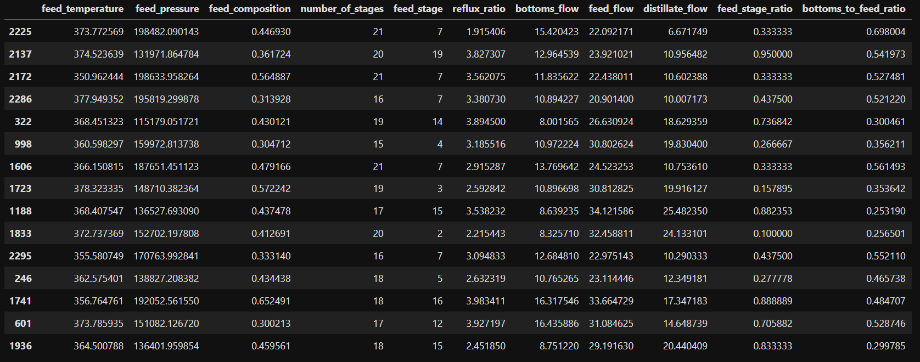4. Important Observations
- Model families genuinely differ by target: tree-based/boosted models (XGBoost) won the purity targets (xD, xB), a simple regularised linear model (Ridge) won condenser duty (QC), and a neural network (ANN) won reboiler duty (QR) — confirming a per-target comparison was the right approach rather than a single blanket model.
- Accuracy and physical validity are only weakly related: the ANN had the best raw R² on both purity targets and was disqualified on both, because it predicted purity falling as reflux ratio increased — the opposite of expected distillation behaviour.
- Random Forest consistently shows the largest train–validation overfit gap of the four models (up to 0.052, i.e. ~5.2 percentage points of R², on QR), while Ridge and ANN show the smallest gaps — consistent with Random Forest's tendency to memorise training data without strong regularisation.
- 11 of 3,000 requested simulation cases (0.4%) were removed at the physical-screening stage for negative reboiler duty — a reminder that DWSIM convergence and physical validity are not the same guarantee, and both the training data and the trained models need to be screened against the same physical constraints.
- Permutation importance (test set) shows feed_composition and the engineered bottoms_to_feed_ratio dominate both purity targets, reflux_ratio dominates QC, and bottoms_to_feed_ratio + reflux_ratio dominate QR. Reflux ratio's low importance for xD/xB does not contradict the physical-consistency audit: importance measures average predictive contribution across the sampled space, while the audit's partial-dependence sweep (holding other features at their median) isolates reflux ratio's own effect and shows a genuine positive relationship for the selected xD model (Spearman rho = 0.521, vs. 0.885 for Random Forest and −0.561 for the disqualified ANN).
- 5-fold cross-validation on the selected models (Section 2.3) agrees with the overfit-gap diagnostic (Section 2.1): every selected model combines a small train–validation gap with a low cross-fold standard deviation, which is stronger evidence of generalisation than either check alone.

Outputs
.

A. Dataset Size
LHS cases requested | Cases written by DWSIM | Cases retained after physical screening | Rows discarded
3,000 | 2,999 | 2,988 | 0.4%

B. Range of Variables Explored
Variable | Min | Max | Mean | Std. dev.
Feed temperature (K) | 350.0 | 380.0 | 365.0 | 8.66
Feed pressure (Pa) | 101,343 | 202,639 | 151,981 | 29,258
Feed composition (benzene mole frac.) | 0.300 | 0.699 | 0.500 | 0.115
Number of stages | 15 | 21 | 18.0 | 2.00
Feed stage location | 2 | 20 | 9.4 | 4.79
Reflux ratio | 1.50 | 4.00 | 2.75 | 0.72
Bottoms withdrawal rate (kmol/h) | 8.00 | 17.00 | 12.50 | 2.60
Feed flow rate (kmol/h) | 20.00 | 35.00 | 27.50 | 4.33

C. Results from 3 ML Models
Four model families were trained and compared for every target (one more than the minimum required):
- Polynomial Regression (Ridge-regularised) — tuned via GridSearchCV
- Random Forest — tuned via RandomizedSearchCV
- XGBoost — tuned via RandomizedSearchCV
- Artificial Neural Network (MLPRegressor) — tuned via RandomizedSearchCV with early stopping
All four were evaluated for every one of the four targets (16 model-target combinations total).

D. Comparison Plots/Tables for All Target Variables
One figure per target, showing validation R² across all four candidate models:
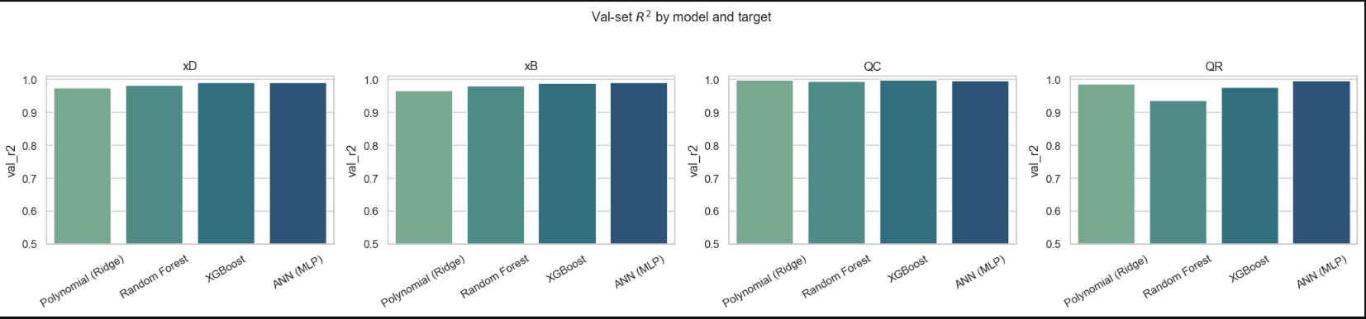

E. Model Evaluation Metrics
MAE and RMSE for all models and targets are reported in full in Section 2 above (Section 9 of Report.pdf has the complete 16-row table). R² and MAPE were also computed as additional metrics beyond the two required.

F. Discussion

F.1 Overfitting / Underfitting
Overfit gap (train R² minus validation R²) was computed for every model-target pair. Random Forest consistently shows the largest gap of the four families — up to 0.052 (~5.2 percentage points of R²) on QR — indicating it fits training noise more than the other models. Ridge and ANN show the smallest gaps across most targets (e.g. 0.0000 and 0.0015 respectively on QC and QR), indicating stronger generalisation. No model showed clear underfitting (all validation R² values exceed 0.93).

F.2 Stability of Predictions
An independent 5-fold cross-validation (distinct from the 3-fold search used during hyperparameter tuning) was run on each selected model (Section 2.3). Every selected model shows a cross-fold standard deviation under 0.2 percentage points of R², confirming the reported accuracy is not an artefact of a single validation split.

F.3 Whether the Model Respects Expected Physical Trends
A dedicated physical-consistency audit was run on every fitted model, independent of its accuracy score: (a) output-bound violations on test-set predictions (xD/xB must stay in [0,1]; QC/QR must be non-negative), and (b) a partial-dependence sweep of reflux ratio checked via Spearman rank correlation, since purity should not decrease and reboiler duty should increase with more reflux. The ANN was disqualified from both purity targets despite having the best raw R², because it predicted purity falling as reflux ratio increased (Spearman rho = -0.561 for xD, -0.656 for xB) — the audit's central finding.

G. Useful Plots

G.1 Predicted vs Actual Plots

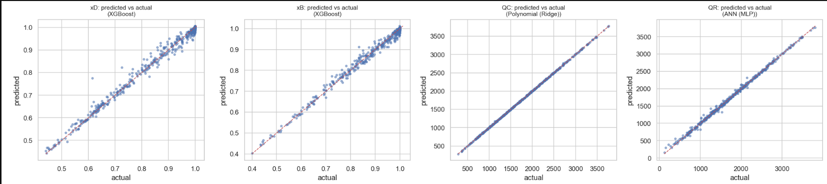
Figure G1 — Predicted vs actual, all 4 targets (winning models, test set)

G.2 Error Comparison Across Models
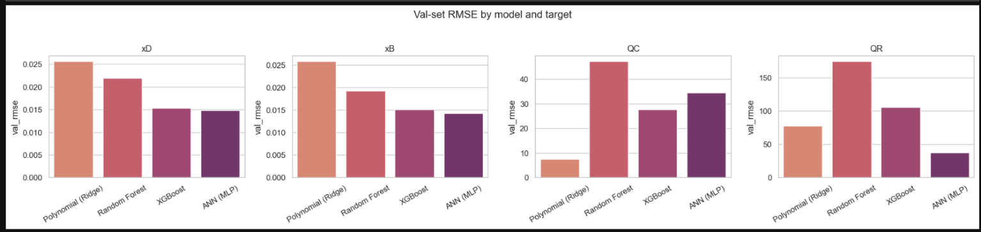
Figure G2 — Validation RMSE/MAE by model, all 4 targets

G.3 Feature Importance / Sensitivity Analysis
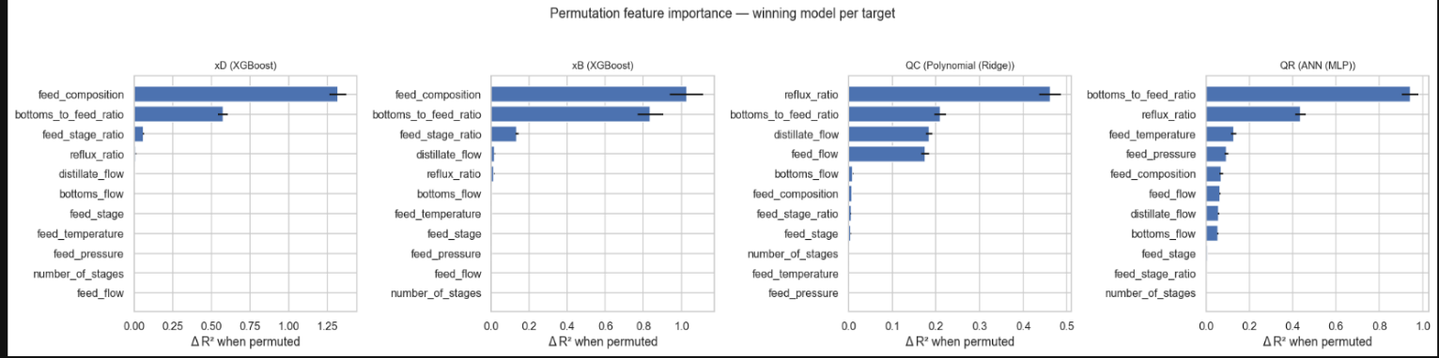
Figure G3 — Permutation feature importance, winning model per target

G.4 Trend Plots: Output Variation with Key Operating Parameters
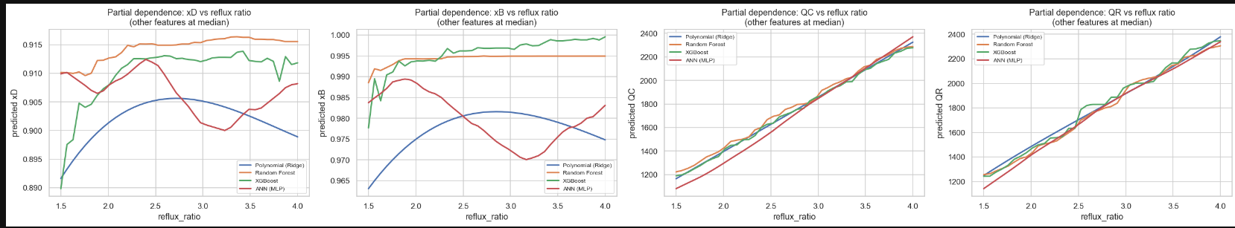
Figure G4 — Partial dependence: xD, xB, QR vs reflux ratio (all 4 models)

