Streamlit Dashboard to Analyze Network Traffic

Aim: To create a dashboard (using streamlit) to visualize the following from the 5 minutes captured traffic and also from live network traffic:
a. RTT (Color zones: red indicates high rtt, orange indicates medium rtt, etc.)
b. Jitter (Time vs. Jitter graph)
c. Packet reordering frequency
d. TCP slow start duration
e. Retransmission bursts (sign of duplicate ACKs)
f. Half-open connections (sign of ACK missing in a three way TCP handshake)
g. Throughput stability (Time vs. Throughput)
h. Flow map table (Source/Destination pair, protocol, latency, & traffic identification (private and public subnets)
The objective of the task is that the Dashboard should be able to display the behavior and causality of the network traffic (captured dataset and live data).

- Captured data (via wireshark)
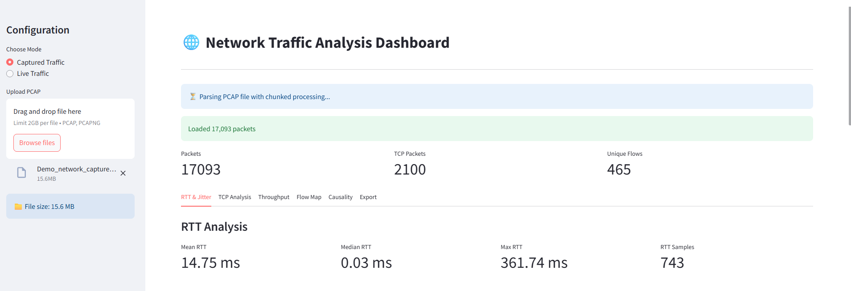

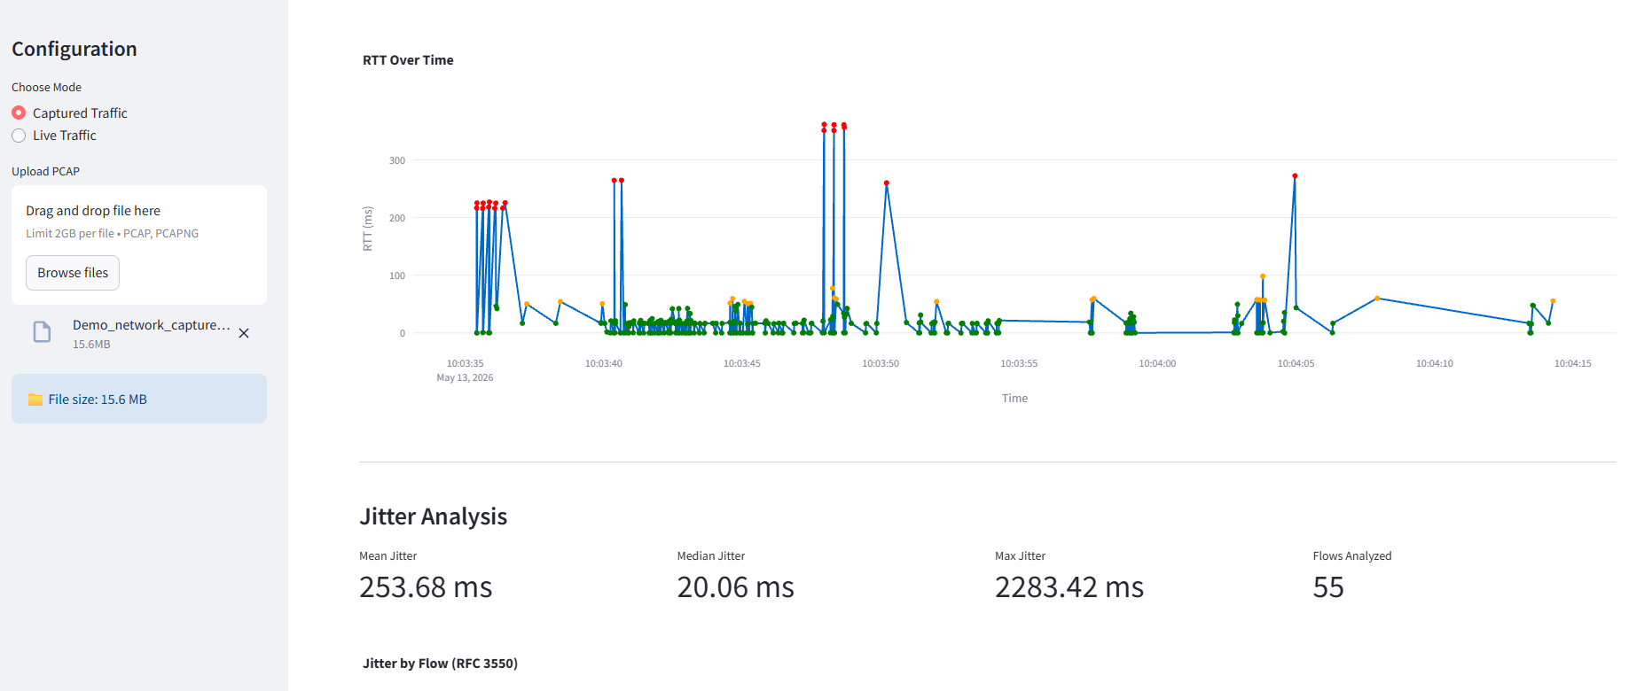

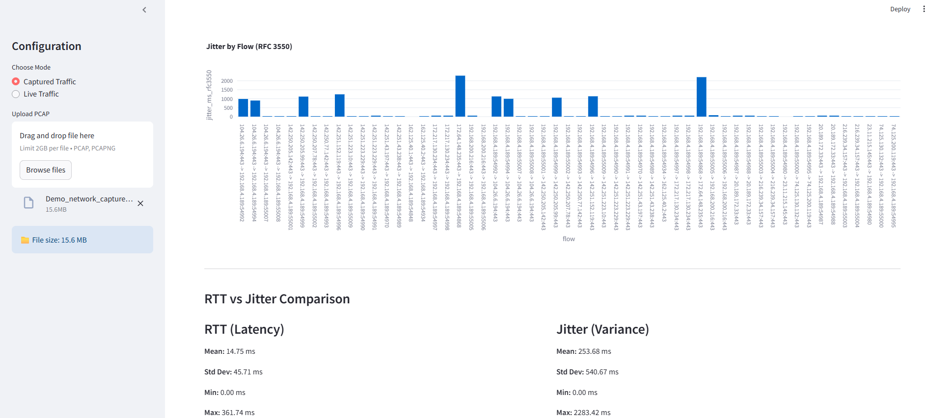

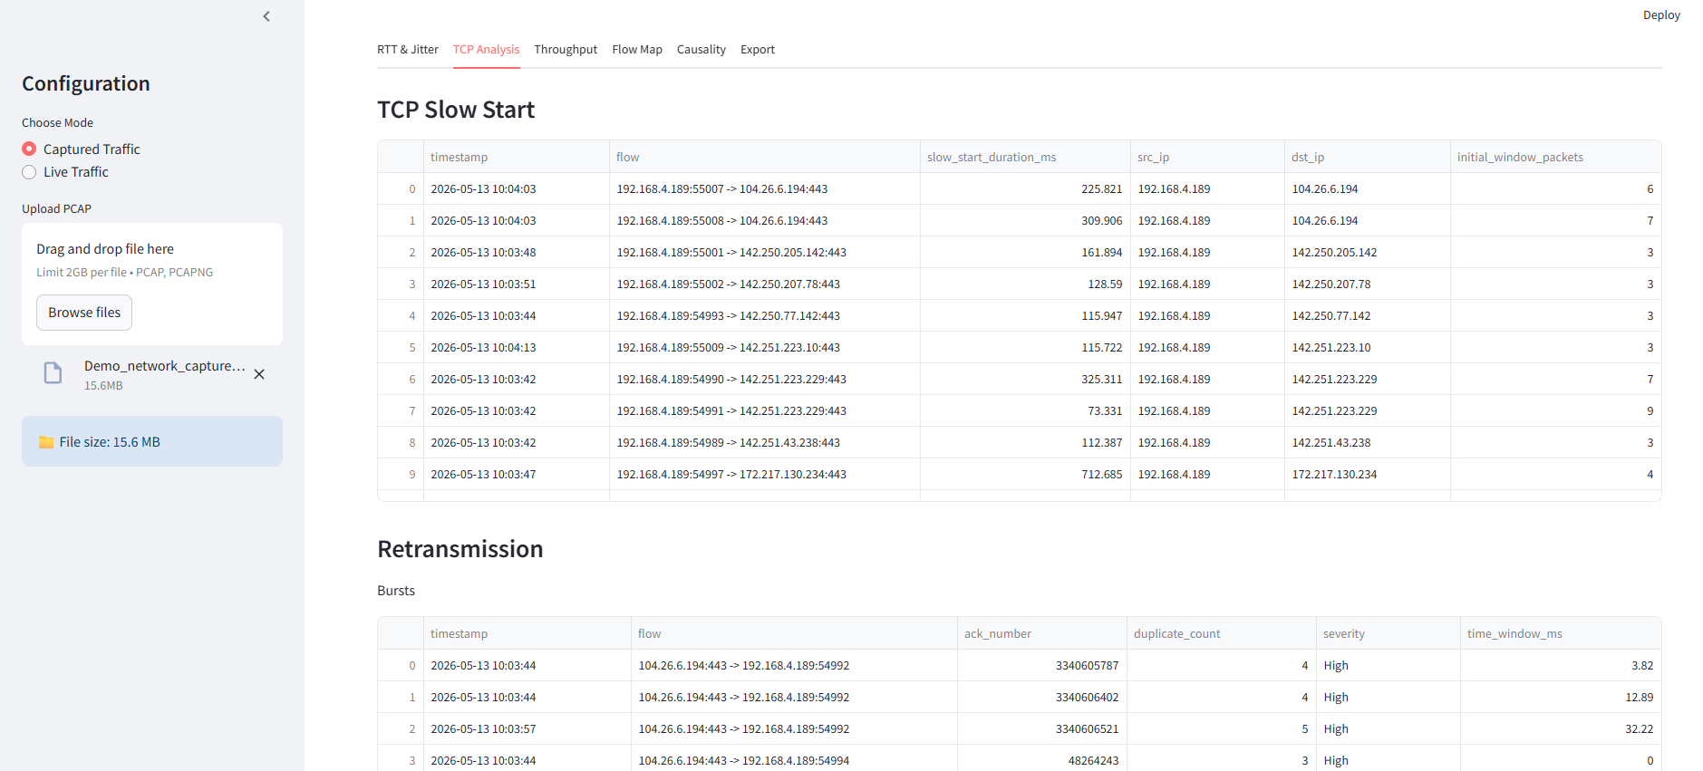

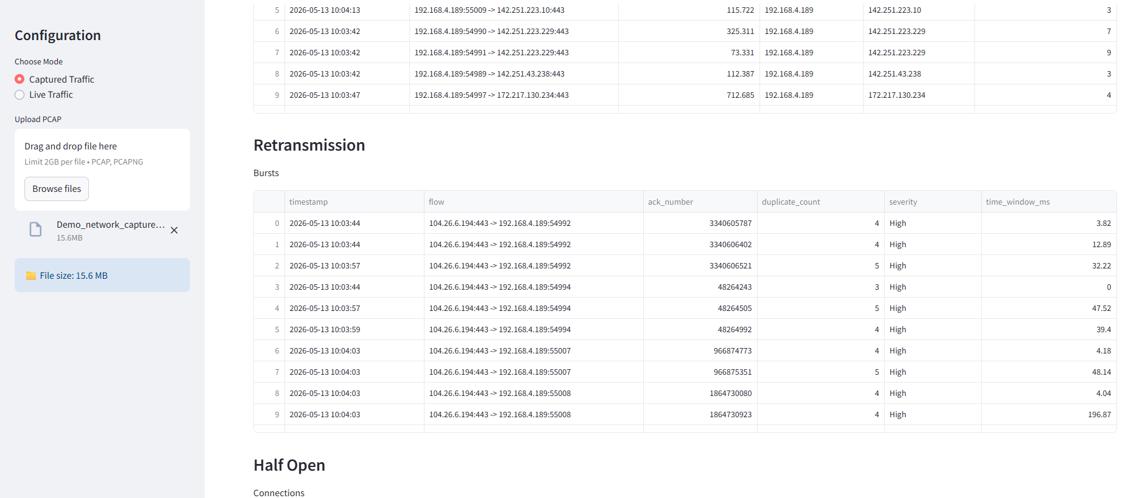

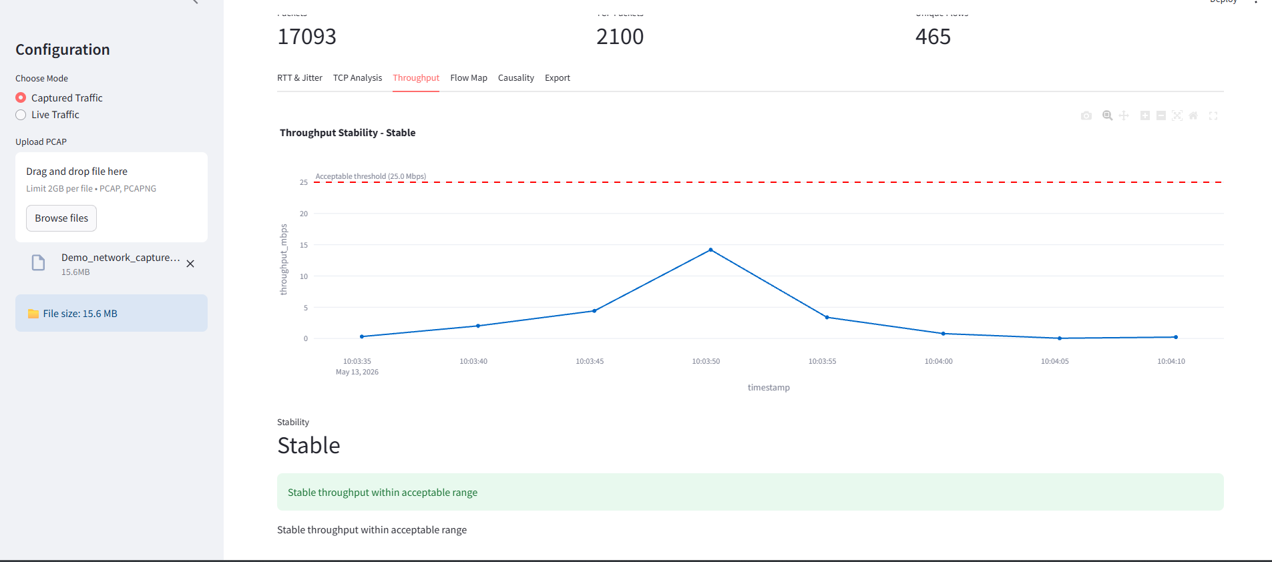

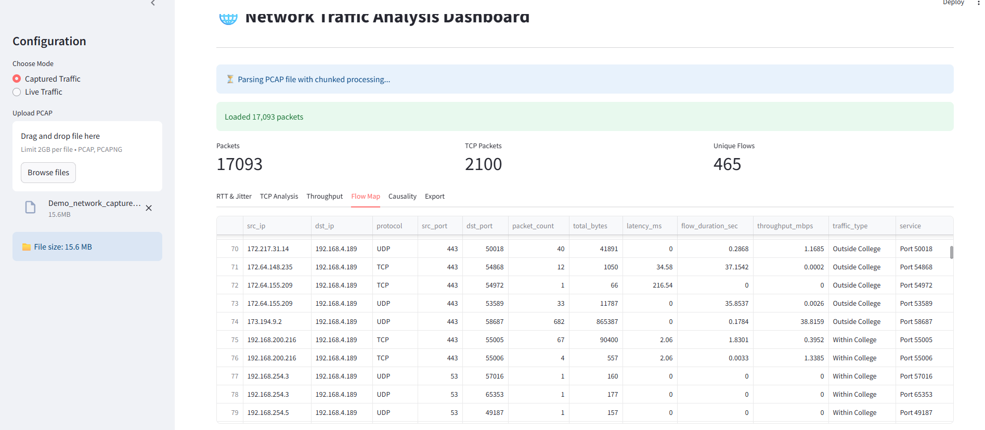

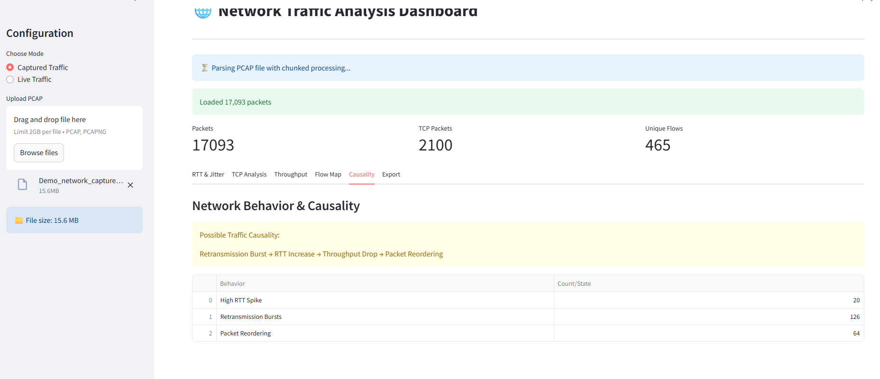

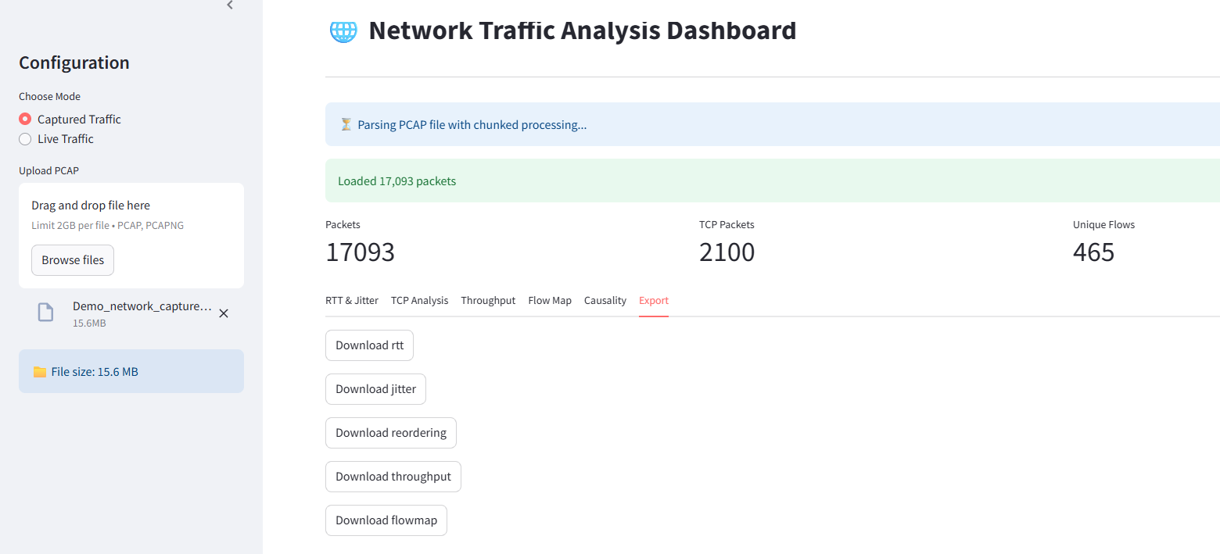

- Live Data Capture (via sniff())

