Last updated: 00/00/00 00:00 AM

COMP-SCI 5560 (SS16) - Knowledge Discovery and Management

**Class Project - Wisdom Restaurant Recommendation System**

Team 5: *Samaa Gazzaz (9), Pooja Shekhar (38), Chen Wang (44), Dayu Wang (45)*

**Application Setup Guide**

1. Install [**IntellIJ Ultimate**] **->** NOT the Community Version!
2. Install [Tomcat 8.5.4]  
   <**IMPORTANT**> The version of Tomcat matters!  
   Installation File in GitHub Repository: ./Application_Resources
3. When running IntellJ Ultimate for the first time, please install the following (see below).

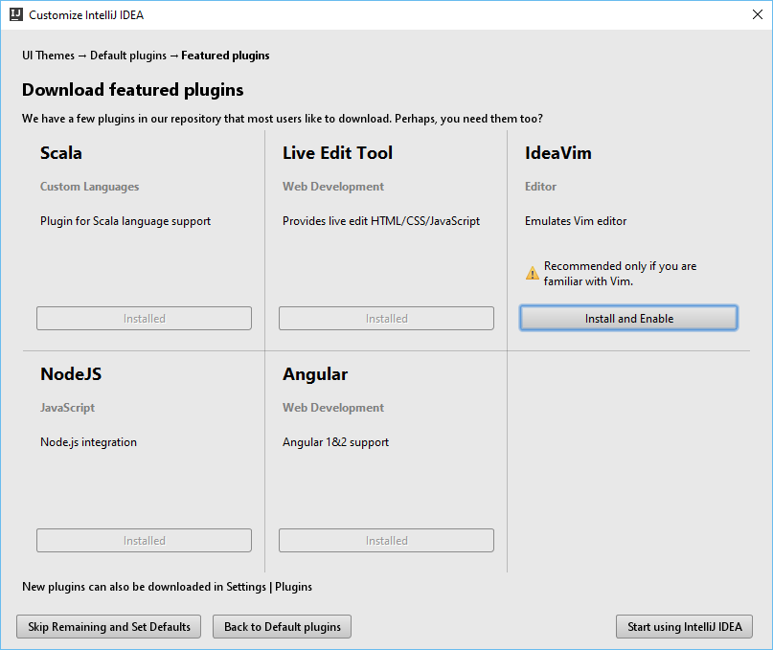

1. **Open** repository folder “W” in IntellIJ. -> **NOT “Import”!**
2. Setup Java JDK for the project.
3. Open “build.sbt” and click “refresh”.
4. **<IMPORTANT>** Update all the file directories (absolute paths).

Correlation.java line 40 line 80

Wisdom.java line 23 line 77

UserInput.java line 19

WebJson.java line 12

WebWriter.java line 12

WisdomServlet.java line 30

1. Setup Tomcat 8.5.4 in Run/Debug Configuration (see below).

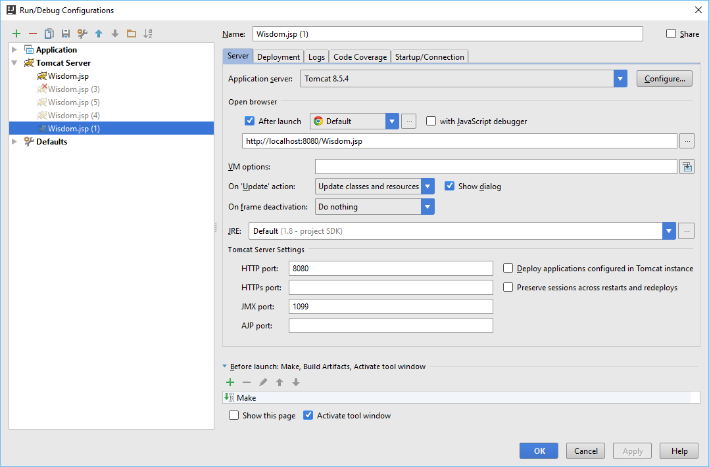

1. Right click “Wisdom.jsp” and choose “Run Wisdom.jsp”.
2. If everything was correctly setup, you should see the browser popped up and the application runs.