GOWTHAM T S

**CURRICULUM VITAE**

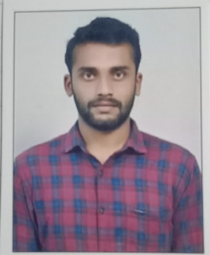

**MOBILE NUMBER: 7676705450**

**EMAIL ID :** [**gowthamsanju50@gmail.com**](mailto:gowthamsanju50@gmail.com)



**CARRIER OBJECTIVE**

Pursuing a position that is challenging, encouraging and offers a great deal of exposure to implement my knowledge and skills in the company that enables my professional growth while being dedicated, punctual, loyal and hard working.



**ACADEMIC CREDENTIALS**

|  |  |  |  |  |
| --- | --- | --- | --- | --- |
| **Course** | **Name of the Institution** | **Board/ University** | **Year of passing** | **Percentage/ Aggregate** |
| B.E | BGS institute of technology Nagamangala | ACU | 2022 | Awaiting final year results |
| Diploma | Govt polytechnic Arakere , Mandya | Board of  Technical  Examination  (BTE) | 2019 | 67% |
| SSLC | Bharathi education trust  Bharathi nagar , KM Doddi | Karnataka Secondary  Education. | 2016 | 84.96% |



**TECHNICAL SKILLS**

* Research skills
* Designing and creativity



**TECHNICAL PROFICIENCIES**

* + SolidEdge
  + Ansys
  + CATIA
  + MS Office Suite (Word, Excel, Power point)



**INTERNSHIP**

* During Diplamo: At Sujaya Industry
* Developed excellent Skills and completed all projects on time.



**PERSONAL PROFILE**

**Name :** Gowtham T S

**Father name :** Siddaraju

**Mother name :** Poornima

**Date of birth :** 30-07-1999

**Nationality :** Indian

**Religion :** Hindu

**Languages known :** English and Kannada



**DECLARATION**

I hereby declare that the above information given by me is correct and true to the best of my knowledge.

(Gowtham T S)