1. Overview insights

Average burnout risk by department
USE student_burnout_db;
SELECT
s.department,
ROUND(AVG(i.burnout_risk_score), 2) AS avg_burnout_risk
FROM fact_intelligence_scores i
JOIN dim_students s
ON i.student_id = s.student_id
GROUP BY s.department
ORDER BY avg_burnout_risk DESC;

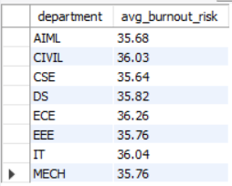

Average productivity by year of study
SELECT
s.year_of_study,
ROUND(AVG(i.productivity_score), 2) AS avg_productivity
FROM fact_intelligence_scores i
JOIN dim_students s
ON i.student_id = s.student_id
GROUP BY s.year_of_study
ORDER BY s.year_of_study;

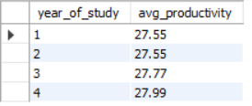

Burnout distribution
SELECT
burnout_category,
COUNT(*) AS record_count
FROM fact_intelligence_scores
GROUP BY burnout_category
ORDER BY record_count DESC;
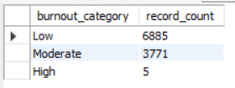

Detailed burnout distribution
SELECT
burnout_level_detailed,
COUNT(*) AS record_count
FROM fact_intelligence_scores
GROUP BY burnout_level_detailed
ORDER BY record_count DESC;

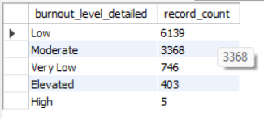

2. Risk detection queries

High and critical risk records
SELECT
i.student_id,
s.department,
s.year_of_study,
i.record_date,
ROUND(i.burnout_risk_score, 2) AS burnout_risk_score,
i.burnout_category,
i.burnout_level_detailed
FROM fact_intelligence_scores i
JOIN dim_students s
ON i.student_id = s.student_id
WHERE i.burnout_category = 'High'
ORDER BY i.burnout_risk_score DESC, i.record_date DESC;
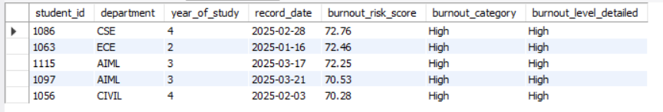

Early warning students: Elevated + High + Critical
SELECT
i.student_id,
s.department,
s.year_of_study,
i.record_date,
ROUND(i.burnout_risk_score, 2) AS burnout_risk_score,
i.burnout_level_detailed
FROM fact_intelligence_scores i
JOIN dim_students s
ON i.student_id = s.student_id
WHERE i.burnout_level_detailed IN ('Elevated', 'High', 'Critical')
ORDER BY i.burnout_risk_score DESC, i.record_date DESC;

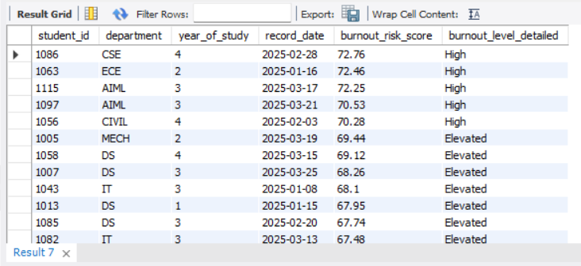
Students with low productivity but rising concern
SELECT
i.student_id,
s.department,
i.record_date,
ROUND(i.productivity_score, 2) AS productivity_score,
ROUND(i.burnout_risk_score, 2) AS burnout_risk_score,
i.burnout_level_detailed
FROM fact_intelligence_scores i
JOIN dim_students s
ON i.student_id = s.student_id
WHERE i.productivity_score < 35
AND i.burnout_level_detailed IN ('Elevated', 'High', 'Critical')
ORDER BY i.burnout_risk_score DESC, i.productivity_score ASC;

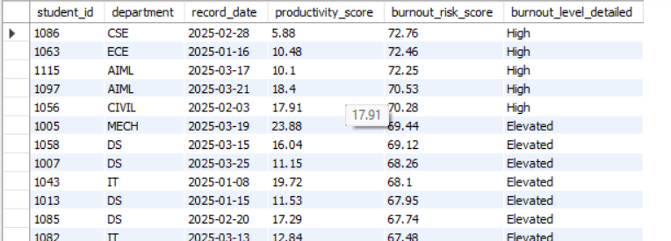

3. Behavioral analysis queries

Sleep vs burnout
SELECT
ROUND(m.sleep_hours, 1) AS sleep_hours,
ROUND(AVG(i.burnout_risk_score), 2) AS avg_burnout_risk
FROM fact_daily_metrics m
JOIN fact_intelligence_scores i
ON m.student_id = i.student_id
AND m.record_date = i.record_date
GROUP BY ROUND(m.sleep_hours, 1)
ORDER BY sleep_hours;

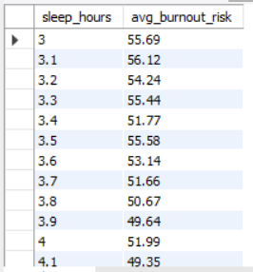

Workload vs productivity
SELECT
ROUND(i.workload_index, 1) AS workload_index,
ROUND(AVG(i.productivity_score), 2) AS avg_productivity
FROM fact_intelligence_scores i
GROUP BY ROUND(i.workload_index, 1)
ORDER BY workload_index;

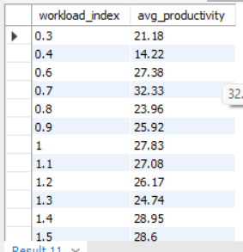

Department-wise workload and burnout
SELECT
s.department,
ROUND(AVG(i.workload_index), 2) AS avg_workload,
ROUND(AVG(i.burnout_risk_score), 2) AS avg_burnout
FROM fact_intelligence_scores i
JOIN dim_students s
ON i.student_id = s.student_id
GROUP BY s.department
ORDER BY avg_burnout DESC;

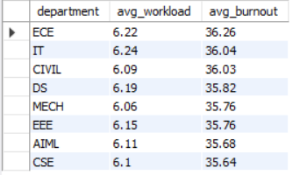

Residence type comparison
SELECT
s.residence_type,
ROUND(AVG(i.burnout_risk_score), 2) AS avg_burnout,
ROUND(AVG(i.productivity_score), 2) AS avg_productivity
FROM fact_intelligence_scores i
JOIN dim_students s
ON i.student_id = s.student_id
GROUP BY s.residence_type;

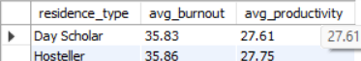

4. Weekly trend analysis

Weekly burnout trend
SELECT
YEAR(record_date) AS yr,
WEEK(record_date) AS wk,
ROUND(AVG(burnout_risk_score), 2) AS avg_weekly_burnout
FROM fact_intelligence_scores
GROUP BY YEAR(record_date), WEEK(record_date)
ORDER BY yr, wk;

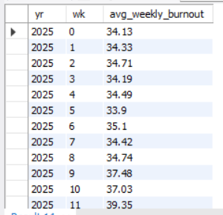
Weekly productivity trend
SELECT
YEAR(record_date) AS yr,
WEEK(record_date) AS wk,
ROUND(AVG(productivity_score), 2) AS avg_weekly_productivity
FROM fact_intelligence_scores
GROUP BY YEAR(record_date), WEEK(record_date)
ORDER BY yr, wk;

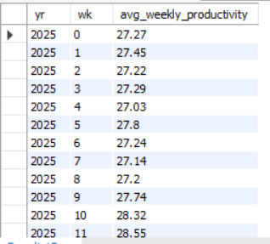
Weekly early-warning count
SELECT
YEAR(record_date) AS yr,
WEEK(record_date) AS wk,
COUNT(*) AS at_risk_records
FROM fact_intelligence_scores
WHERE burnout_level_detailed IN ('Elevated', 'High', 'Critical')
GROUP BY YEAR(record_date), WEEK(record_date)
ORDER BY yr, wk;
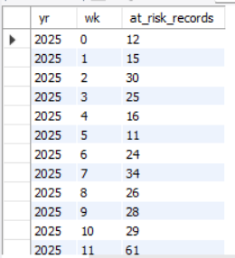

5. One standout query

Students with highest average burnout over the semester
SELECT
i.student_id,
s.department,
s.year_of_study,
ROUND(AVG(i.burnout_risk_score), 2) AS avg_burnout_risk,
ROUND(AVG(i.productivity_score), 2) AS avg_productivity
FROM fact_intelligence_scores i
JOIN dim_students s
ON i.student_id = s.student_id
GROUP BY i.student_id, s.department, s.year_of_study
ORDER BY avg_burnout_risk DESC
LIMIT 10;

