Shop Bridge Document

Time Consumed -

Coding – 4 hr
Test Cases – 3 hr

Language – Java (11.0.10)
IDE – Eclipse (4.13.0)
Database – MySQL (8.0.23)

Technology – Spring-boot with maven repository

How To Run Project :

- Database -

- Create schema with the name : shop-bridge
- Click on the apply button

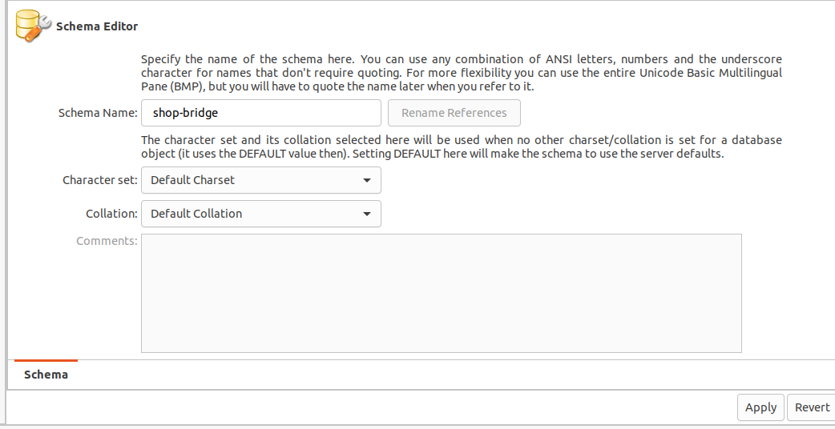

- Import SQL Script

- To import data from dump – Go to the Mysql Workbench , In the header select Server -> Data Import

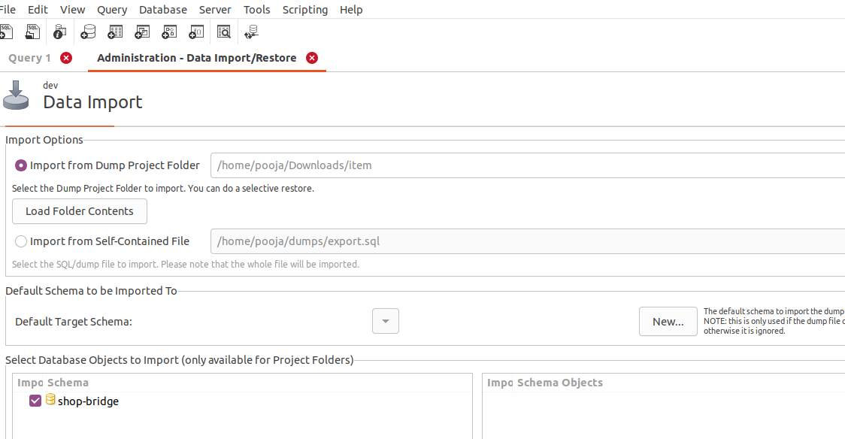
- When this window opens, browse for the directory where the dump has been stored (Note : I have added the dump in the folder struture).
- Click on the start import button.
- The tables are populated with the data

- Clone Project
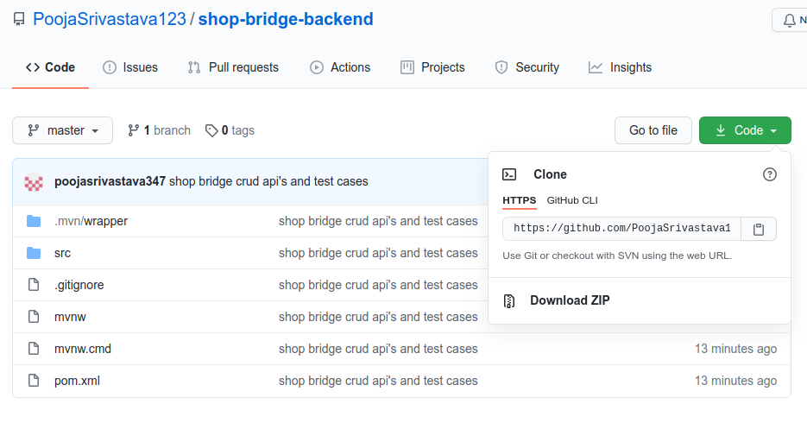

- Copy URL - https://github.com/PoojaSrivastava123/shop-bridge-backend.git
- Go to Folder where you want to save the the project and open terminal
- Run git clone https://github.com/PoojaSrivastava123/shop-bridge-backend.git

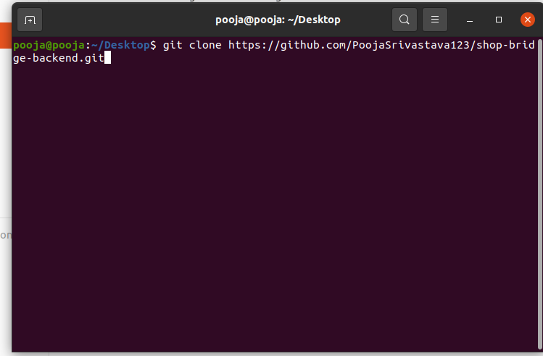

- Go inside the cloned folder and open terminal and run –
mvn spring-boot:run
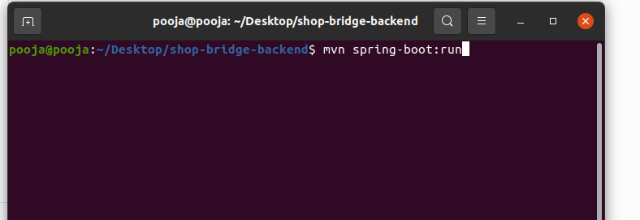

3. Code Coverage Visibility -

- Inside project folder run – mvn test
- Go to folder – target --> site --> jacoco
- Run index.html

