Shop Bridge Document

Time Consumed

UI Design – 4 hr
Api Integration – 4 hr

Technology – Angular (6.14.4)

How To Run Project :

- Clone Project

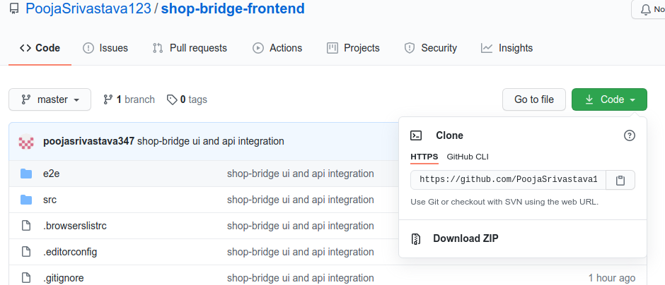

- Copy URL - https://github.com/PoojaSrivastava123/shop-bridge-frontend.git
- Go to Folder where you want to save the the project and open terminal
- Run git clone https://github.com/PoojaSrivastava123/shop-bridge-frontend.git

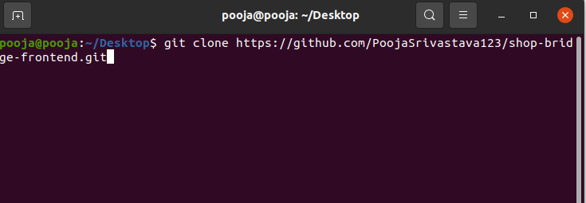

- Go inside the cloned project folder and open terminal and run - npm install
- Then run ng serve
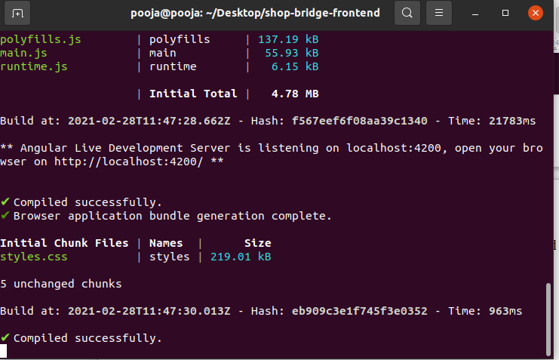

- When code is compiled successfully , Go the browser and type -
localhost:4200

