

SQL Project:-


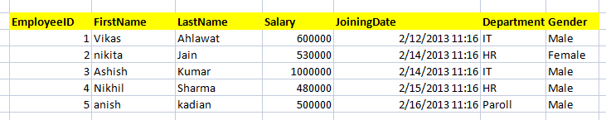

1) Write a query to get all employee detail from "EmployeeDetail" table

2) Write a query to get only "FirstName" column from "EmployeeDetail" table

3) Write a query to get FirstName in upper case as "First Name".

4) Write a query to get FirstName in upper case as "First Name".

5) Write a query for combine FirstName and LastName and display it as "Name" (also include white space between first name & last name)

- Select employee detail whose name is "Vikas

- Get all employee detail from EmployeeDetail table whose "FirstName" start with latter 'a'.

8) Get all employee detail from EmployeeDetail table whose "FirstName" start with latter 'a'.

- Get all employee details from EmployeeDetail table whose "FirstName" end with 'h'

- Get all employee detail from EmployeeDetail table whose "FirstName" start with any single character between 'a-p'

- Get all employee detail from EmployeeDetail table whose "FirstName" not start with any single character between 'a-p'

- Get all employee detail from EmployeeDetail table whose "Gender" end with 'le' and contain 4 letters. The Underscore(_) Wildcard Character represents any single character

- Get all employee detail from EmployeeDetail table whose "FirstName" start with 'A' and contain 5 letters

- Get all employee detail from EmployeeDetail table whose "FirstName" containing '%'. ex:-"Vik%as".

- Get all unique "Department" from EmployeeDetail table

- Get the highest "Salary" from EmployeeDetail table.

- Get the lowest "Salary" from EmployeeDetail table

- Show "JoiningDate" in "dd mmm yyyy" format, ex- "15 Feb 2013

- Show "JoiningDate" in "yyyy/mm/dd" format, ex- "2013/02/15"

- Show only time part of the "JoiningDate"

- Get only Year part of "JoiningDate"

- Get only Month part of "JoiningDate”

- Get system date

- Get UTC date.

  - Get the first name, current date, joiningdate and diff between current date and joining date in months.

- Get the first name, current date, joiningdate and diff between current date and joining date in days.

- Get all employee details from EmployeeDetail table whose joining year is 2013

- Get all employee details from EmployeeDetail table whose joining month is Jan(1)

- Get all employee details from EmployeeDetail table whose joining month is Jan(1)

- Get how many employee exist in "EmployeeDetail" table

- Select only one/top 1 record from "EmployeeDetail" table

- Select all employee detail with First name "Vikas","Ashish", and "Nikhil".

- Select all employee detail with First name not in "Vikas","Ashish", and "Nikhil"

- Select first name from "EmployeeDetail" table after removing white spaces from right side

- Select first name from "EmployeeDetail" table after removing white spaces from left side

- Display first name and Gender as M/F.(if male then M, if Female then F)

- Select first name from "EmployeeDetail" table prifixed with "Hello

- Get employee details from "EmployeeDetail" table whose Salary greater than 600000

- Get employee details from "EmployeeDetail" table whose Salary less than 700000

- Get employee details from "EmployeeDetail" table whose Salary between 500000 than 600000


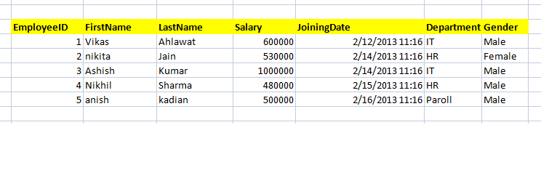

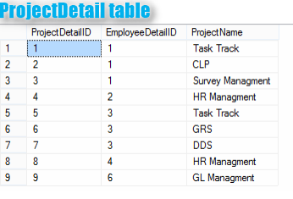

- Give records of ProjectDetail table

- Write the query to get the department and department wise total(sum) salary from "EmployeeDetail" table.

- Write the query to get the department and department wise total(sum) salary, display it in ascending order according to salary.

- Write the query to get the department and department wise total(sum) salary, display it in descending order according to salary

- Write the query to get the department, total no. of departments, total(sum) salary with respect to department from "EmployeeDetail" table.

- Get department wise average salary from "EmployeeDetail" table order by salary ascending

47 . Get department wise maximum salary from "EmployeeDetail" table order by salary ascending

48.Get department wise minimum salary from "EmployeeDetail" table order by salary ascending.

- Get department wise minimum salary from "EmployeeDetail" table order by salary ascending

- Join both the table that is Employee and ProjectDetail based on some common paramter

- Get employee name, project name order by firstname from "EmployeeDetail" and "ProjectDetail" for those employee which have assigned project already.

- Get employee name, project name order by firstname from "EmployeeDetail" and "ProjectDetail" for all employee even they have not assigned project.

- Get employee name, project name order by firstname from "EmployeeDetail" and "ProjectDetail" for all employee if project is not assigned then display "-No Project Assigned"

54.Get all project name even they have not matching any employeeid, in left table, order by firstname from "EmployeeDetail" and "ProjectDetail

- Get complete record (employeename, project name) from both tables ([EmployeeDetail],[ProjectDetail]), if no match found in any table then show NULL

- Get complete record (employeename, project name) from both tables ([EmployeeDetail],[ProjectDetail]), if no match found in any table then show NULL

57.Get complete record (employeename, project name) from both tables ([EmployeeDetail],[ProjectDetail]), if no match found in any table then show NULL

58.Write down the query to fetch EmployeeName & Project who has assign more than one project

- Write down the query to fetch ProjectName on which more than one employee are working along with EmployeeName

- Apply Cross Join in Both the tables

