
(University DataBase Management System)
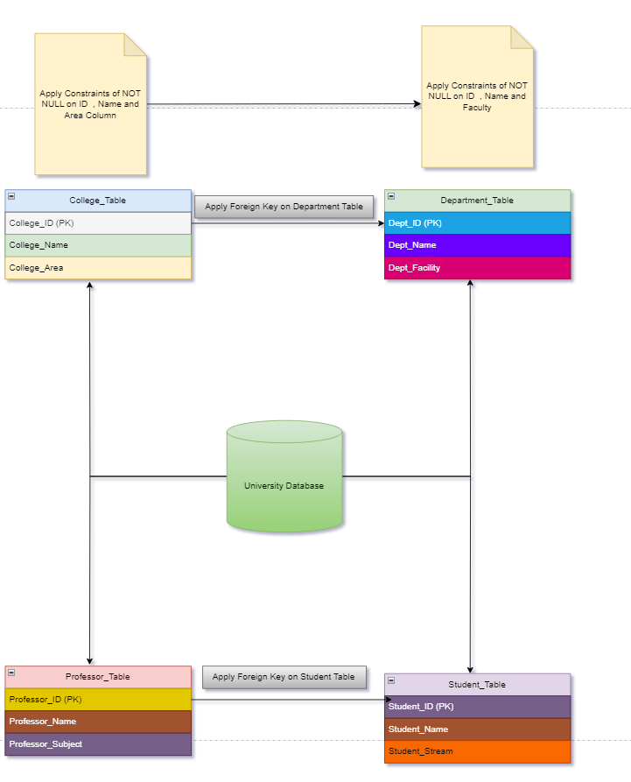
University Database Management System is one of the Fundamental and Intermediate level SQL project
Here in this Project you have to create an efficient DBMS for the any University .
Inorder to create this system Perform the following task:-

Task 1:-
1.Create University Database give any University name you want

2. Under this University Create four tables and each table should have following three Column named as:-
A. College_Table
College_ID(PK)
College_Name
College_Area

B. Department_Table
Dept_ID(PK)
Dept_Name
Dept_Facility

C. Professor_Table
Professor_ID(PK)
Professor_Name
Professor_Subject
D. Student_Table
Student_ID(PK)
Student_Name
Student_Stream

3. Apply foreign key on Department key from College_table
4. Apply foreign Key on Student_Table from Professor_Table
5. Insert atleast 10 Records in each table

Task 2:-
- Give the information of College_ID and College_name from College_Table
- Show Top 5 rows from Student table.
- What is the name of professor whose ID is 5
- Convert the name of the Professor into Upper case
- Show me the names of those students whose name is start with a
- Give the name of those colleges whose end with a
- Add one Salary Column in Professor_Table
- Add one Contact Column in Student_table
- Find the total Salary of Professor
- Change datatype of any one column of any one Table

Task 3:-
- Show first 5 records from Students table and Professor table Combine
- Apply Inner join on all 4 tables together
- Show Some null values from Department table and Professor table.
- Create a View from College Table and give those records whose college name starts with C
- Create Stored Procedure of Professor table whatever customer ID will be given by user it should show whole records of it.
- Rename the College_Table to College_Tables_Data .

