Funtion In Java

Java is one of the most popular programming languages in the world, and one of its key features is its ability to define and use functions. Functions in Java are blocks of code that perform a specific task, and they are used to organize code and make it more modular and reusable.

**Definition and Purpose**

**Function (Method):** A block of code that performs a specific task. Functions help in breaking the program into smaller, modular, and manageable pieces.

**Purpose:** To perform a specific operation and to avoid code redundancy by reusing the code.

**Syntax:**

returnType functionName(parameters) {

// function body

}

**Example:**

public class SimpleFunction {

public static int add(int a, int b) {

return a + b;

}

public static void main(String[] args) {

System.out.println("Sum: " + add(10, 20));

}

}

**Function Components**

**Access Modifiers:** Define the scope of the method (e.g., public, private, protected).

**Static vs. Instance Methods:**

Static Methods: Belong to the class and can be called without creating an instance of the class. Declared using the static keyword.

**Instance Methods:** Belong to an instance of the class. You need to create an object of the class to call these methods.

**Return Type:** Specifies the type of value the function returns. Use void if no value is returned.

**Method Name:** Should be descriptive and follow the camelCase convention.

**Parameters:** Inputs to the function, specified in parentheses. Can be zero or more parameters.

**Method Body:** Contains the code to be executed. Enclosed within {}.

Function Categories

* **Parameterized Functions:** These functions take parameters (inputs) to perform operations.

Example: public int add(int a, int b) {

return a + b; }

* **Non-Parameterized Functions:** These functions do not take any parameters. Example: public void printHello() {

System.out.println("Hello, World!"); }

* **Void Functions:** These functions do not return any value. They perform an action but do not provide any output.

Example: public void printMessage(String message) {

System.out.println(message); }

* **Non-Void Functions:** These functions return a value of a specified type. Example: public int add(int a, int b) {

return a + b }

Calling a Function

To execute a function, you call it from another part of your code. How you call a method depends on whether it is a static method or an instance method.

**Static Methods**

Static methods belong to the class itself rather than any instance of the class. They are called using the class name.

Syntax ClassName.methodName(arguments);

Example: public class MathUtils {

public static int add(int a, int b) {

return a + b; }

}

public class Main {

public static void main(String[] args) {

int result = MathUtils.add(5, 3);

System.out.println("Result: " + result);

}

}

**Instance Methods**

Instance methods belong to an instance (object) of the class. They are called using the object of the class.

Syntax: objectName.methodName(arguments);

Example: public class Calculator {

public int multiply(int a, int b) {

return a * b }

}

public class Main {

public static void main(String[] args) {

Calculator calc = new Calculator();

int result = calc.multiply(4, 7);

System.out.println("Result: " + result);

}

}

**Parameters and Arguments**

Parameters: Variables listed in the method declaration.

Arguments: Actual values passed to the method when it is called.

**Method Overloading**

Method overloading allows multiple methods with the same name but different parameter lists. The compiler determines which method to call based on the method signature (name and parameter list).

Example: public class OverloadExample {

public int add(int a, int b) {

return a + b: }

public double add(double a, double b) {

return a + b: }

public int add(int a, int b, int c) {

return a + b + c;

}

public static void main(String[] args) {

OverloadExample example = new OverloadExample();

System.out.println(example.add(1, 2));

System.out.println(example.add(1.0, 2.0)); System.out.println(example.add(1, 2, 3));

}

}

**Recursive Methods**

A recursive method calls itself to solve a smaller instance of the same problem. Recursive methods must have a base case to avoid infinite recursion.

Example: public class RecursionExample {

public int factorial(int n) {

if (n == 0) {

return 1;

} else {

return n * factorial(n - 1);

}

}

public static void main(String[] args) {

RecursionExample example = new RecursionExample();

int result = example.factorial(5);

System.out.println("Factorial of 5: " + result);

}

}

Flow of Execution of Function in java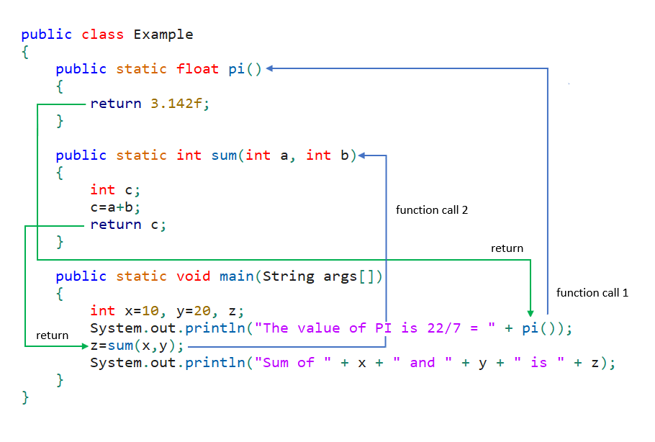

Formal and Actual Arguments

**Formal Arguments**

Formal arguments (also called formal parameters) are the parameters defined in the method declaration.They act as placeholders for the values that will be passed to the method when it is called. They exist only within the method where they are declared.

Example: public class Example {

// a and b are formal arguments

public void add(int a, int b) {

int result = a + b;

System.out.println("Sum: " + result);

}

}

**Actual Arguments**

Actual arguments (also called actual parameters) are the values or variables passed to the method when it is called. They provide the actual data that the method operates on.They exist in the calling method.

Example: spublic class Main {

public static void main(String[] args) {

Example example = new Example();

// 10 and 20 are actual arguments

example.add(10, 20);

}

}