- Top 10 states by total transaction amount
SELECT state, ROUND(SUM(amount), 2) AS total_amount
FROM aggregated_transaction
GROUP BY state
ORDER BY total_amount DESC
LIMIT 10;
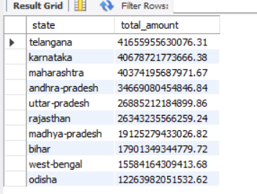
- Top 10 states by total transaction count
SELECT state, SUM(count) AS total_count
FROM aggregated_transaction
GROUP BY state
ORDER BY total_count DESC
LIMIT 10;

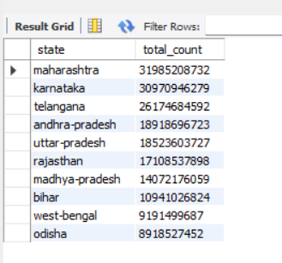

- Payment category distribution by total amount
SELECT transaction_type, ROUND(SUM(amount), 2) AS total_amount
FROM aggregated_transaction
GROUP BY transaction_type
ORDER BY total_amount DESC;
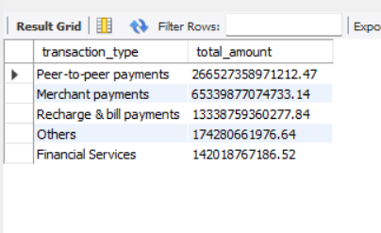

- Payment category distribution by total amount
SELECT transaction_type, SUM(count) AS total_count
FROM aggregated_transaction
GROUP BY transaction_type
ORDER BY total_count DESC;

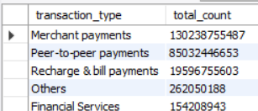

- Year-wise transaction trend
SELECT year, ROUND(SUM(amount), 2) AS total_amount, SUM(count) AS total_count
FROM aggregated_transaction
GROUP BY year
ORDER BY year;

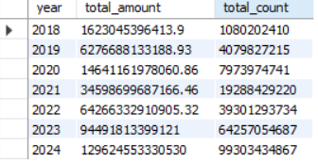

- Quarter-wise transaction trend
SELECT quarter, ROUND(SUM(amount), 2) AS total_amount, SUM(count) AS total_count
FROM aggregated_transaction
GROUP BY quarter
ORDER BY quarter;

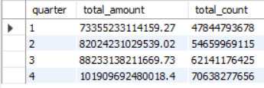

- State and year trend together
SELECT state, year, ROUND(SUM(amount), 2) AS total_amount
FROM aggregated_transaction
GROUP BY state, year
ORDER BY state, year;
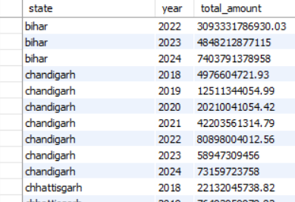

- Top payment category within each state
SELECT state, transaction_type, ROUND(SUM(amount), 2) AS total_amount
FROM aggregated_transaction
GROUP BY state, transaction_type
ORDER BY state, total_amount DESC;
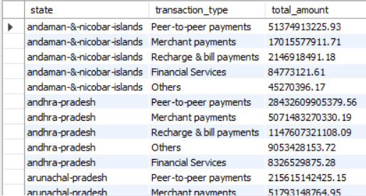
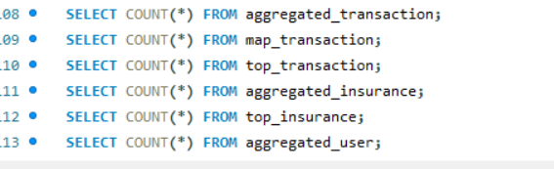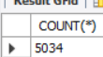
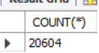
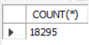

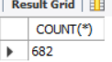
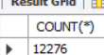
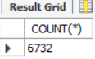

SELECT state, ROUND(SUM(amount), 2) AS total_amount
FROM aggregated_transaction
GROUP BY state
ORDER BY total_amount DESC
LIMIT 10;

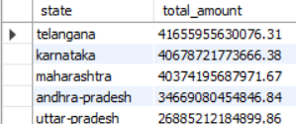

2.. Top 10 states by transaction count
SELECT state, SUM(count) AS total_count
FROM aggregated_transaction
GROUP BY state
ORDER BY total_count DESC
LIMIT 10;
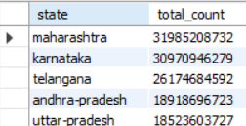
3. Payment category distribution by amount
SELECT transaction_type, ROUND(SUM(amount), 2) AS total_amount
FROM aggregated_transaction
GROUP BY transaction_type
ORDER BY total_amount DESC;
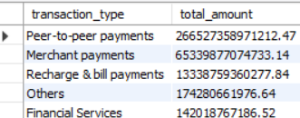

4.Payment category distribution by count
SELECT transaction_type, SUM(count) AS total_count
FROM aggregated_transaction
GROUP BY transaction_type
ORDER BY total_count DESC;
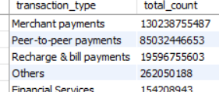
5. Year-wise transaction trend
SELECT year, ROUND(SUM(amount), 2) AS total_amount, SUM(count) AS total_count
FROM aggregated_transaction
GROUP BY year
ORDER BY year;
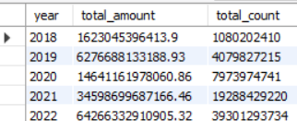

B. Geographic analysis
6. Top 10 districts by transaction amount
SELECT district, ROUND(SUM(amount), 2) AS total_amount
FROM map_transaction
GROUP BY district
ORDER BY total_amount DESC
LIMIT 10;
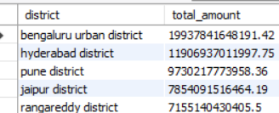
7. Top 10 districts by transaction count
SELECT district, SUM(count) AS total_count
FROM map_transaction
GROUP BY district
ORDER BY total_count DESC
LIMIT 10;
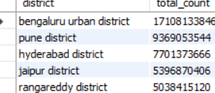

8.Top entities from top transaction data
SELECT entity_name, entity_type, ROUND(SUM(amount), 2) AS total_amount
FROM top_transaction
GROUP BY entity_name, entity_type
ORDER BY total_amount DESC
LIMIT 20;
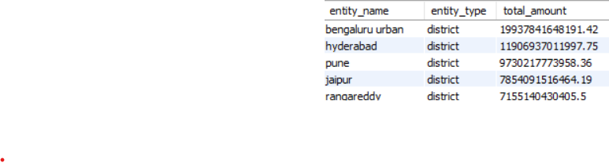
9. Top pincodes only
SELECT entity_name AS pincode, ROUND(SUM(amount), 2) AS total_amount
FROM top_transaction
WHERE entity_type = 'pincode'
GROUP BY entity_name
ORDER BY total_amount DESC
LIMIT 10;
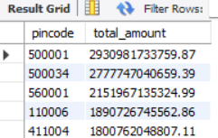
C. User analysis
10. Top mobile brands by user count
SELECT brand, SUM(count) AS total_users
FROM aggregated_user
GROUP BY brand
ORDER BY total_users DESC
LIMIT 10;
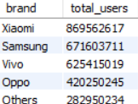
11. Brand-wise average percentage
SELECT brand, ROUND(AVG(percentage), 4) AS avg_percentage
FROM aggregated_user
GROUP BY brand
ORDER BY avg_percentage DESC
LIMIT 10;
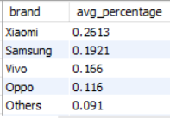
D. Insurance analysis
12. Top states by insurance amount
SELECT state, ROUND(SUM(amount), 2) AS total_amount
FROM aggregated_insurance
GROUP BY state
ORDER BY total_amount DESC
LIMIT 10;
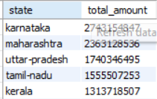
13. Top insurance entities
SELECT entity_name, entity_type, ROUND(SUM(amount), 2) AS total_amount
FROM top_insurance
GROUP BY entity_name, entity_type
ORDER BY total_amount DESC
LIMIT 20;
