

## DEPARTMENT OF COMPUTER ENGINEERING

**BRACT’S**

**VISHWAKARMA INSTITUTE OF INFORMATION TECHNOLOGY**

SURVEY NO. 3/4, KONDHWA (BUDRUK), PUNE – 411048, MAHARASHTRA (INDIA).

**BRACT’S**

**VISHWAKARMA INSTITUTE OF INFORMATION TECHNOLOGY, PUNE**

## 2023 -2024

**TY PROJECT-I REPORT ON**

**Music Generation using Machine Learning**

**TY.BACHELOR OF TECHNOLOGY (COMPUTER ENGINEERING)**

##### SUBMITTED BY

|  |  |  |
| --- | --- | --- |
| **STUDENT NAME** | **Gr. No.** | **Roll. No.** |
| Pooja Vishwakarma | 22110402 | 323064 |
| Ketan Choudhari | 22110060 | 323016 |
| Aniket Dhoke | 22110835 | 323018 |
| Ahliya Mote | 22110787 | 323046 |



**CERTIFICATE**

This is to certify that the project report entitles

**“**Breast Cancer Detection Using Machine Learning**”**

Submitted by

|  |  |  |
| --- | --- | --- |
| **STUDENT NAME** | **Gr. No.** | **Roll. No.** |
| Pooja Vishwakarma | 22110402 | 323064 |
| Ketan Choudhari | 22110060 | 323016 |
| Aniket Dhoke | 22110835 | 323018 |
| Ahliya Mote | 22110787 | 323046 |

is a bonafide student of this institute and the work has been carried out by him/her under the supervision of Prof. Nitin Sakhare Sir and it is approved for the partial fulfillment of the requirement of VISHWAKARMA INSTITUTE OF INFORMATION TECHNOLOGY, for the award of the degree of **Bachelor of Technology** (Computer Engineering).

**Prof. Nitin Sakhare Sir** **(Dr. S. R. Sakhare)**

Guide Head,

Department of Computer Engineering Department of Computer Engineering

Place : Pune

Date : 04-12-2023

**NAME OF THE STUDENTS**

Pooja Vishwakarma

Ketan Choudhari

Aniket Dhoke

Ahilya Mote

**ACKNOWLEDGEMENT**

I would like to express my gratitude towards Prof. Nitin Sakhare Sir who gave us the chance to work on our project. Their timely guidance inspired us to work on this project.

They gave many different ideas which proved to be very helpful for this project. Sir also inspected our work and made continuous evaluation of the project. I would like to thank them for their remarkable role in the completion of our project. Also I would like to thank my group members who made a lot of efforts for the completion of our project.

**ABSTRACT**

In this study, we delve into the pressing global health concern posed by breast cancer, directing our focus toward the integration of AI for early detection. The primary objective revolves around a meticulous evaluation of K-Nearest Neighbors (KNN), Support Vector Machine (SVM), and decision tree (DT) algorithms, specifically aimed at distinguishing between benign and malignant tumors. Notably, SVM emerges as the frontrunner, exhibiting superior accuracy, especially when confronted with larger datasets. Our research advances by integrating ensemble voting mechanisms and adaptive algorithms, bolstering the prospects of early-stage identification and offering a glimmer of hope for improved prognoses. Importantly, our findings transcend the realm of breast cancer, advocating for the deployment of robust diagnostic tools across various medical disciplines. This study underscores the proactive potential of amalgamating artificial intelligence with healthcare, with SVM's excellence serving as a beacon for innovative AI integration. Ultimately, this research illuminates a compelling path toward enhancing patient outcomes through timely and proactive intervention.

**TABLE OF CONTENTS**

|  |  |  |  |  |  |  |
| --- | --- | --- | --- | --- | --- | --- |
| **Sr. No.** | | | | **Title of Chapter** | | **Page No.** |
| **01** | | | | **Introduction** | | 6-7 |
|  | 1.1 | | | Overview | | 7 |
|  | 1.2 | | | Motivation | | 7 |
| **02** | | | | Literature Survey | | 8-9 |
| **03** | | | | Software Requirements Specification | | 10-16 |
|  | | 3.1 | | Project Scope | | 10-11 |
|  | | 3.2 | | Functional Requirement | | 11-13 |
|  | | 3.3 | | Non-functional Requirement | | 13-15 |
|  | |  | | 3.3.1 | Performance Requirements | 13-14 |
|  | |  | | 3.3.2 | Security Requirements | 14-15 |
|  | | 3.4 | | System Requirements | | 15-16 |
|  | |  | | 3.4.1 | Database Requirements | 15 |
|  | |  | | 3.4.2 | Software Requirements | 15 |
|  | |  | | 3.4.3 | Hardware Requirements | 16 |
| **04** | | | | System Design | | 17-18 |
|  | | 4.1 | | System Architecture | | 17 |
|  | | 4.2 | | Flow Chart | | 18 |
| **05** | | | | Other Specification | | 19-21 |
|  | | | 5.1 | Advantage | | 19 |
|  | | | 5.2 | Limitations | | 20 |
|  | | | 5.3 | Applications | | 20-21 |
| **06** | | | | Conclusion & Future Work | | 22 |
| **07** | | | | References | | 23 |

**INTRODUCTION**

Breast cancer detection stands as a pivotal frontier in healthcare, pivotal for timely intervention and improved patient outcomes. While traditional detection methods like mammography, biopsy, and ultrasound have proven effective, their limitations, including false positives and invasive procedures, necessitate more innovative approaches. Enter Artificial Intelligence (AI), marking a paradigm shift in the landscape of breast cancer detection.

AI, particularly Machine Learning (ML) techniques, has emerged as a beacon of hope, offering a transformative avenue to enhance the accuracy and efficacy of breast cancer diagnosis. ML algorithms possess the ability to analyze vast repositories encompassing mammograms, histopathological images, genetic markers, and clinical records. Through discerning intricate patterns within this extensive dataset, these algorithms demonstrate the potential to improve detection accuracy while mitigating the occurrences of false positives and negatives. This augmentation of accuracy not only aids healthcare professionals in making informed decisions but also introduces a proactive approach to disease management.

However, amid the strides in breast cancer detection among the general population, there remains a significant knowledge gap concerning breast cancer prevalence and risk assessment within transgender individuals. The impact of gender-affirming hormonal treatment (GAHT) on breast cancer risk in this demographic remains largely uncharted territory. Existing studies exhibit limitations in quantifying breast cancer risk associated with GAHT, emphasizing the exigency for more comprehensive research endeavors.

This study embarks on an exploration into the integration of AI, particularly ML techniques, for breast cancer detection. Leveraging diverse datasets encompassing various diagnostic modalities and patient-specific information, this endeavor aims to augment the accuracy of detection while addressing the critical need for understanding breast cancer risks among transgender individuals undergoing GAHT. The amalgamation of AI and healthcare presents an unprecedented opportunity for proactive disease management and targeted interventions, accentuating the potential for improved patient outcomes in the realm of breast cancer detection and risk assessment.

1. Motivation

Breast cancer detection is paramount for early diagnosis and subsequent treatment, yet it presents challenges due to the subjectivity in interpretation and the demands for specialized expertise. Medical imaging, particularly mammography, has long been a cornerstone in this endeavor. However, the reliance on manual interpretation by radiologists, coupled with the potential for errors and limitations in terms of cost and time, necessitates more advanced and reliable detection mechanisms.

The emergence of Computer-Aided Diagnosis (CAD) systems marks a significant advancement, providing a complementary layer of analysis to aid radiologists in distinguishing between normal and abnormal tissue. Yet, the landscape of breast cancer detection has seen a transformative shift propelled by Machine Learning (ML) and Deep Learning (DL) techniques. These cutting-edge methodologies offer a promise of enhanced accuracy, efficiency, and potentially reduced dependency on human interpretation.

1. Problem Definition

Detecting breast cancer early for effective treatment is hindered by interpretative subjectivity and the need for specialized expertise in current medical imaging, like mammography. Manual interpretation by radiologists is prone to errors and time constraints, urging the need for more advanced and reliable detection methods. While Computer-Aided Diagnosis (CAD) systems offer support, the landscape is evolving towards Machine Learning (ML) and Deep Learning (DL) techniques, aiming for enhanced accuracy, efficiency, and reduced reliance on human interpretation in breast cancer detection.

## LITERATURE SURVEY

Traditional ML Techniques:

Feature Extraction and Classification: Several studies have explored the effectiveness of traditional ML algorithms in breast cancer detection. Models utilizing feature extraction, segmentation, and classification techniques have shown promising results. Notable models such as Multilayer Perceptron (MLP), K-Nearest Neighbors (KNN), and Support Vector Machines (SVM) in combination with extra-trees have demonstrated significant accuracy rates in differentiating between benign and malignant tissues.

Enhancements in Model Performance: Research by Saliha Zahoor has focused on enhancing model performance through feature extraction, utilizing fine-tuned architectures like MobileNetV2 and Nasset Mobile. CNN architectures, including BCDCNN and those developed by Guan and Loew, have achieved commendable accuracy rates, with BCDCNN demonstrating an accuracy rate of 82.71% and Guan and Loew achieving 90.5% accuracy.

Comparison of ML-Based Classification Algorithms: Comparative studies evaluating various ML algorithms, including Multilayer Perceptron (MLP), K-Nearest Neighbors (KNN), Classification and Regression Trees (CART), Gaussian Naive Bayes (NB), and Support Vector Machines (SVM), have been conducted. These studies, like the one presented by [6], showcased the Multilayer Perceptron (MLP) with a prediction accuracy of 99.12% on testing data.

Deep Learning Approaches:

Convolutional Neural Networks (CNNs) for Breast Cancer Detection: The rise of Deep Learning architectures, particularly Convolutional Neural Networks (CNNs), has revolutionized breast cancer detection. Models like BCDCNN and those proposed by Guan and Loew have excelled in lesion detection, breast density discrimination, and multiview mammographic data analysis, achieving high accuracy rates above 80%.

Transfer Learning and Pre-trained Models: Recent studies have employed Transfer Learning frameworks, leveraging pre-trained models such as ResNet50 and Nasnet-Mobile. By fine-tuning these models and utilizing augmentation strategies like rotation and scaling, researchers achieved high accuracy rates of 89.5% using ResNet50 and 70% using Nasnet-Mobile, showcasing potential improvements in diagnostic capabilities.

Innovative Architectures and Mobile Neural Networks:

BM-Net Architecture: The BM-Net architecture, integrating bilinear structures with the MobileNet-V3 network, has been introduced. Data augmentation techniques and focal loss utilization have shown promising results in addressing class imbalance and achieving improved accuracy in breast cancer detection.

BreaCNet Model: The BreaCNet model, a mobile neural network approach, combines a segmentation algorithm with a modified ShuffleNet classifier. This model, focusing on on-device inference, effectively captures regions of interest (ROI) in breast thermograms. The modified ShuffleNet achieved a 72% accuracy rate, while in combination with the segmentation algorithm, it improved to 100% accuracy, demonstrating significant potential for enhanced diagnostic performance.

Dataset Utilization and Exploration:

Utilization of Diverse Datasets: Various datasets such as the Breast Cancer Wisconsin (Diagnostic) Dataset, ICIAR2018 Grand Challenge on Breast Cancer Histology Images (BACH), and the Mammographic Image Analysis Society (MIAS) dataset have been pivotal in training and evaluating models. These datasets enabled comprehensive testing and refinement of models, contributing to the understanding and advancements in breast cancer detection methodologies.

## SOFTWARE REQUIREMENTS SPECIFICATION

### **Scope of Project**

The primary objective is to develop a software system that aids in the automated and accurate detection of breast cancer from medical imaging data, particularly mammograms, using Machine Learning and Deep Learning algorithms.

### **Fundamental Requirements**

1.Image Preprocessing:

Objective: Standardize and preprocess medical images to prepare them for feature extraction and model input.

Functions:

Image Enhancement: Apply filters or algorithms to enhance image quality, remove noise, and standardize formats.

Feature Extraction: Extract relevant features from images, such as texture, shape, and intensity characteristics.

2.Machine Learning Model Implementation:

Objective: Develop, train, and optimize ML/DL models for accurate breast cancer classification.

Functions:

Model Development: Implement various ML models (e.g., CNNs, SVM, MLP) suitable for breast cancer classification.

Training: Train models using labeled datasets to learn patterns and distinguish between benign and malignant tissues.

Optimization: Fine-tune models to improve accuracy, reduce overfitting, and enhance performance metrics.

3.Automated Diagnosis:

Objective: Automatically classify medical images as benign or malignant based on trained ML/DL models.

Functions:

Classification: Utilize the trained models to predict the likelihood of cancer in medical images.

Probability Estimation: Provide probability scores or confidence levels for the classification outcomes.

4.User Interface:

Objective: Create an intuitive interface for medical practitioners to interact with the system and view diagnostic results.

Functions:

Image Upload: Allow users to upload medical images (e.g., mammograms) for analysis.

Display Results: Showcase diagnostic outcomes, highlighting regions of interest and classification outcomes.

User Feedback: Enable user feedback or interaction for further inquiries or validation.

5.Model Evaluation and Validation:

Objective: Validate the accuracy and reliability of the ML models for breast cancer detection.

Functions:

Performance Metrics: Calculate accuracy, precision, recall, F1-score, and confusion matrix to assess model performance.

Cross-Validation: Employ cross-validation techniques to evaluate the model's generalizability and robustness.

6.Documentation and Reporting:

Objective: Provide comprehensive documentation and reporting on system functionality and performance.

Functions:

User Manuals: Prepare user manuals explaining system operation and guidelines for practitioners.

Technical Reports: Generate reports detailing system architecture, model specifications, and validation results.

### **C) Non-Functional requirements**

##### C.1) Performance requirements

1.Latency and Response Time:

Requirement: The system should provide rapid responses to user interactions and image submissions.

Criteria: Aim for a response time of X seconds for image upload and diagnosis processing.

2.Throughput and Scalability:

Requirement: Ensure the system can handle multiple image submissions concurrently without a decline in performance.

Criteria: Support a throughput of Y image analyses per minute/hour to accommodate multiple users simultaneously.

3.Model Inference Speed:

Requirement: ML model predictions should be fast and efficient for real-time or near real-time diagnosis.

Criteria: Achieve an inference speed of Z seconds per image classification using the deployed ML models.

4.Resource Utilization:

Requirement: Optimize resource utilization, including CPU, memory, and GPU, for efficient model inference.

Criteria: Limit resource consumption to X% CPU usage, Y% memory utilization, etc., during model inference.

5.Scalability Considerations:

Requirement: Design the system architecture to scale seamlessly with potential increases in user load or dataset sizes.

Criteria: Ensure the system can handle an increase in image data and user traffic by scaling horizontally or vertically.

6.Reliability and Uptime:

Requirement: Ensure the system operates reliably without frequent downtimes or disruptions.

Criteria: Maintain a high uptime percentage (e.g., 99.9%) for uninterrupted access to the diagnosis system.

7.Model Accuracy and Precision:

Requirement: Maintain high accuracy and precision in breast cancer diagnosis to minimize false positives and negatives.

Criteria: Aim for accuracy levels above a certain threshold (e.g., 90%) to ensure reliable diagnosis.

##### 

##### C.2) Safety requirements

1.Patient Data Confidentiality:

Requirement: Protect patient privacy and sensitive medical information from unauthorized access or breaches.

Criteria: Adhere to HIPAA (Health Insurance Portability and Accountability Act) guidelines and encrypt all patient data stored or transmitted.

2.Ethical Use of AI:

Requirement: Ensure ethical deployment of AI in medical diagnostics, preventing biases or discrimination in diagnoses.

Criteria: Regularly audit models to detect and mitigate biases based on gender, race, or other demographics.

3.Explainability and Transparency:

Requirement: Ensure the system provides explanations for its diagnoses and decisions.

Criteria: Implement methods to explain how the model arrived at a particular diagnosis, offering transparency to medical practitioners.

4.Validation and Verification:

Requirement: Validate the accuracy and reliability of the AI models used in diagnosis.

Criteria: Regularly validate and verify the model against new datasets or clinical data to maintain accuracy.

5.Error Handling and Recovery:

Requirement: Implement robust error-handling mechanisms to prevent system failures or misdiagnoses.

Criteria: Develop fail-safe procedures to handle errors, provide warnings for uncertain diagnoses, and prevent critical system failures.

6.Adherence to Regulatory Standards:

Requirement: Ensure compliance with regulatory standards, laws, and guidelines governing medical AI systems.

Criteria: Regularly audit the system's compliance with industry standards and update protocols accordingly.

7.Clinician Oversight and Involvement:

Requirement: Ensure the system operates as an assisting tool under clinician oversight, not as a replacement.

Criteria: Encourage clinician involvement in system training, validation, and decision-making processes.

### **D) System Requirements**

##### D.1) Database Requirement:

1.Data Storage:

Image Storage: Store mammographic images efficiently, considering the large file sizes and the potential volume of images.

Structured Patient Information: Store patient metadata, including demographics, medical history, diagnosis, and treatment records.

2.Database Architecture:

Relational Database Management System (RDBMS): Utilize RDBMS like PostgreSQL, MySQL, or SQLite for structured data storage and retrieval.

Schema Design: Design a schema to manage patient records, image metadata, diagnosis outcomes, and clinician annotations.

3.Scalability and Performance:

Scalability: Ensure the database design allows for scalability to accommodate a growing dataset and increasing user load.

Indexing: Implement indexing on key fields (e.g., patient ID, diagnosis) for faster retrieval and search operations.

4.Data Integrity and Security:

Data Integrity Constraints: Enforce data integrity using constraints (e.g., foreign keys, unique constraints) to maintain accuracy and consistency.

Encryption: Implement encryption mechanisms for sensitive patient data to ensure security and compliance with privacy regulations.

5.Backup and Recovery:

Regular Backups: Set up automated regular backups of the database to prevent data loss in case of system failures or errors.

Disaster Recovery Plan: Establish a robust plan for data recovery in case of database corruption or failures.

6.Interoperability and Integration:

Interoperability with Other Systems: Ensure compatibility and integration with hospital information systems (HIS) or medical record systems for data exchange.

APIs or Interfaces: Develop APIs or interfaces for seamless integration with the breast cancer detection system and other healthcare systems.

7.Data Retention and Compliance:

Data Retention Policies: Define policies for data retention and archiving to comply with regulatory standards and legal requirements.

Audit Trails: Implement audit trails to track data modifications and maintain a record of database activities for compliance purposes.

##### D.2) Software Requirement:

1.Programming Language:

Python: Utilize Python due to its versatility and the availability of libraries suited for deep learning and data analysis. Libraries such as Pandas and NumPy for data handling and TensorFlow or PyTorch for deep learning model development would be essential.

2.Deep Learning Framework:

TensorFlow or PyTorch: Choose a deep learning framework compatible with building and training neural networks. TensorFlow and PyTorch offer comprehensive functionalities for creating and optimizing models for medical image analysis.

3.Data Preprocessing Tools:

OpenCV: Utilize OpenCV for image preprocessing tasks, such as resizing, normalization, and feature extraction from mammographic images.

Scikit-learn: Use Scikit-learn for data preprocessing steps like feature scaling, encoding categorical variables, and handling missing data.

4.Neural Network Architectures:

Convolutional Neural Networks (CNNs): Employ CNN architectures suitable for image classification tasks. Architectures like VGG, ResNet, or Inception are effective for feature extraction from medical images.

5.Training and Inference Environment:

High-Performance Computing (HPC) or GPUs: Utilize powerful computing resources like HPC clusters or GPUs for accelerated model training. Cloud-based platforms like AWS or Google Cloud can offer scalable computing power.

6.Model Optimization:

Hyperparameter Tuning: Employ techniques like Grid Search or Random Search to optimize hyperparameters for enhanced model performance.

Regularization Techniques: Implement dropout, batch normalization, or weight decay to prevent overfitting of the model.

7.Real-time Generation:

Web Frameworks: Consider using Flask or Django to develop a web-based interface for real-time predictions and analysis of mammographic images.

Optimization Techniques: Implement efficient algorithms or model architectures to ensure low-latency processing for timely predictions.

8.Evaluation and Metrics:

Scikit-learn Metrics: Utilize Scikit-learn for evaluating the model's performance using metrics such as accuracy, precision, recall, F1-score, and ROC-AUC curves.

Confusion Matrix: Assess the model's ability to differentiate between benign and malignant tumors using a confusion matrix.

9.Export and Integration:

API Development: Create APIs using Flask or FastAPI to serve trained models and facilitate integration with existing healthcare systems through RESTful endpoints.

10.Version Control and Collaboration:

Git and GitHub: Employ Git for version control and GitHub for collaboration, enabling team members to track code changes, collaborate, and manage different versions of the codebase effectively.

11.Documentation and Reporting:

Jupyter Notebooks and Markdown: Utilize Jupyter Notebooks or Markdown for documenting code, experiments, and results, providing a clear understanding of the system's architecture and usage instructions.

##### D.3) Hardware Requirements:

1.Processing Unit (GPU):

NVIDIA GeForce RTX Series or equivalent: Utilize a high-performance GPU for accelerated training of machine learning models, especially deep learning architectures like Convolutional Neural Networks (CNNs) for image analysis. GPUs with CUDA cores, such as the NVIDIA GeForce RTX series or similar equivalents, would expedite model training.

2.Central Processing Unit (CPU):

Intel Core i7 or AMD Ryzen 7 series: A powerful CPU is crucial for preprocessing tasks, data manipulation, and model inference. CPUs with multi-core processing capabilities like Intel Core i7 or AMD Ryzen 7 series would support these computational tasks effectively.

3.Memory (RAM):

Minimum 16 GB DDR4 RAM: Machine learning models, especially those handling medical image datasets, benefit from ample memory for efficient data processing. A minimum of 16 GB DDR4 RAM ensures smooth operation during model training and inference.

4.Storage:

SSD (Solid State Drive) with at least 500 GB: Consider utilizing SSDs for faster data access and storage. A minimum of 500 GB SSD storage capacity is recommended to accommodate the breast cancer dataset, which can be substantial due to medical imaging files.

### **E)System Implementation**

1.Data Collection and Preprocessing:

Data Gathering: Collect diverse and representative datasets containing mammographic images, patient records, and associated metadata. Ensure data integrity, confidentiality, and compliance with ethical standards.

Data Cleaning and Preprocessing: Perform preprocessing tasks such as image normalization, resizing, and noise reduction. Handle missing values, outliers, and ensure data uniformity for effective model training.

2.Model Development:

Algorithm Selection: Choose appropriate machine learning algorithms (e.g., SVM, Random Forests, CNNs) for breast cancer classification based on the dataset characteristics.

Model Training: Implement training pipelines using chosen frameworks (e.g., TensorFlow, Scikit-learn). Train models iteratively, tuning hyperparameters, and validating performance using cross-validation techniques.

Validation and Evaluation: Evaluate models using various metrics (accuracy, precision, recall) and validate against separate test datasets to ensure robustness and generalizability.

3.Integration of Tools and Libraries:

Utilize ML/DL Frameworks: Implement selected algorithms and models using Python libraries/frameworks like TensorFlow, Keras, Scikit-learn, or PyTorch.

Incorporate Data Visualization Tools: Integrate libraries such as Matplotlib, Seaborn, or Plotly for visualizing model performance, data distributions, and evaluation metrics.

4.Deployment and Testing:

Software Deployment: Deploy trained models into production environments using containerization tools like Docker, ensuring consistency across different platforms.

Testing: Perform rigorous testing (unit, integration, and system-level testing) to validate the functionality, accuracy, and reliability of the deployed models.

5.User Interface Development:

Create User-Friendly Interface: Develop an intuitive interface using web frameworks (e.g., Flask, Django) or GUI tools (e.g., PyQt) for users to interact with the breast cancer detection system.

Visualizing Results: Design graphical representations to display predictions, diagnostic results, and statistical analyses for easy interpretation by healthcare professionals.

6.Documentation and Maintenance:

Documentation: Prepare comprehensive documentation covering system architecture, codebase, APIs, user manuals, and maintenance guidelines.

Maintenance and Updates: Establish protocols for regular maintenance, model updates, and addressing potential security vulnerabilities or performance issues.

# SYSTEM DESIGN

### **System Architecture**

1.Data Layer:

Storage of mammographic images and associated metadata.

Data preprocessing modules for cleaning, transforming, and feature extraction.

2.Modeling Layer:

Machine learning models (SVM, Random Forest, CNN, etc.) for breast cancer detection.

Training modules to update and optimize the models.

3.User Interface Layer:

Web-based or application interface for user interaction.

Allows users to input medical data and receive predictions or diagnostic insights.

4.Backend Services:

Services handling the prediction requests from the user interface.

Interacts with the machine learning models to provide accurate predictions.

5.Database Management:

Storage and retrieval of model parameters, training data, and predictions.

Ensures data integrity and accessibility for model updates or improvements.

6.Security and Compliance:

Implements necessary security measures to protect sensitive medical data.

Complies with healthcare data privacy regulations (e.g., HIPAA) to ensure patient confidentiality**.**

1. **Flowchart/Activity Design**

**Different types of documentation, including use case diagrams, class diagrams, activity diagrams, sequence diagrams, flowchart diagrams, data flow diagrams, state diagrams, and entity-relationship diagrams.**

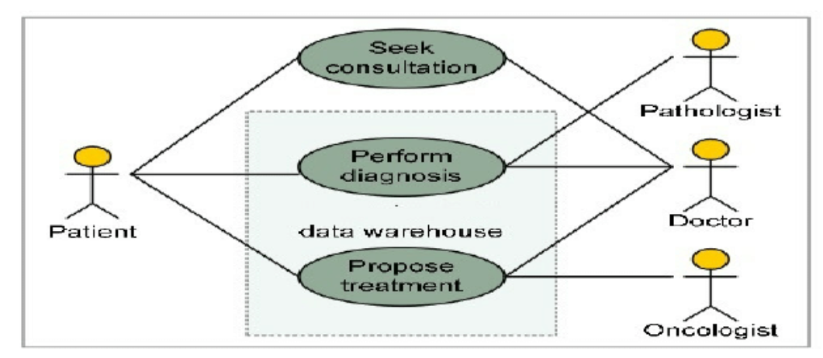

**A. USE CASE DIAGRAM:**

A use case diagram is a form of behavioural diagram specified by and produced from a use-case study in the Unified Modelling Language (UML). Its goal is to give a graphical overview of the functionality a system offers in terms of the actors, their objectives (expressed as use cases), and any dependencies among those use cases. A use case diagram's primary objective is to identify which system functions are carried out for which actor. The system's actors can be seen in their many roles. The use case diagram does not depict actor interaction. The system or use case boundaries may need to be reevaluated if this interaction is necessary for a coherent description of the desired behaviour. Alternatively, assumptions made for the use case could include actor interaction.

* Use Cases: A use case is represented by a horizontal ellipse and represents a series of behaviours that offer an agent with something of quantifiable value.
* Actors: A person, group, or external system that participates in one or more interactions with the system is referred to as an actor.
* System boundary boxes: The system boundary box, a rectangle denoting the system's scope, is drawn around the use cases. Everything inside the box denotes functionality that is under scope, whereas everything outside the box does not.

**B. CLASS DIAGRAM:**

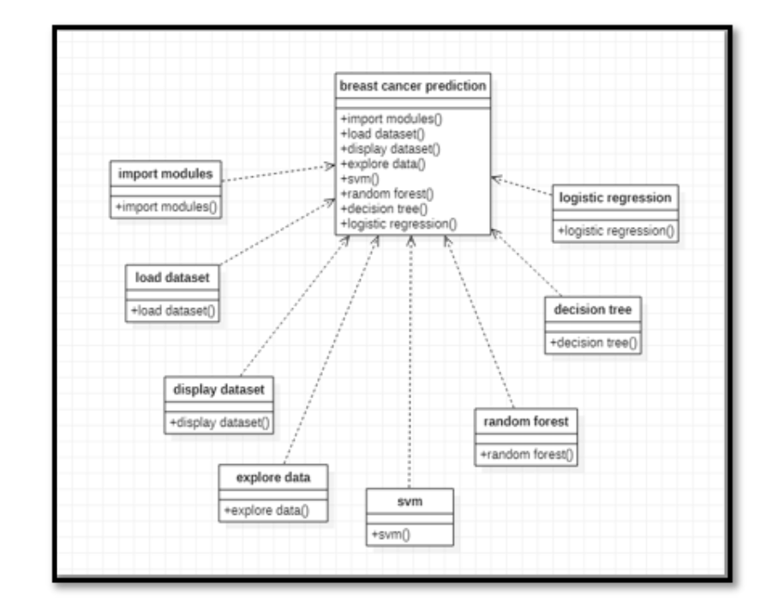

**C. ACTIVITY DIAGRAM:**

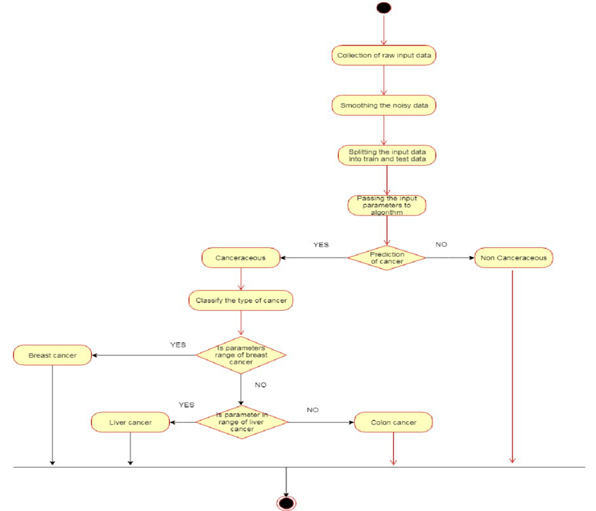

**D. SEQUENCE DIAGRAM:**

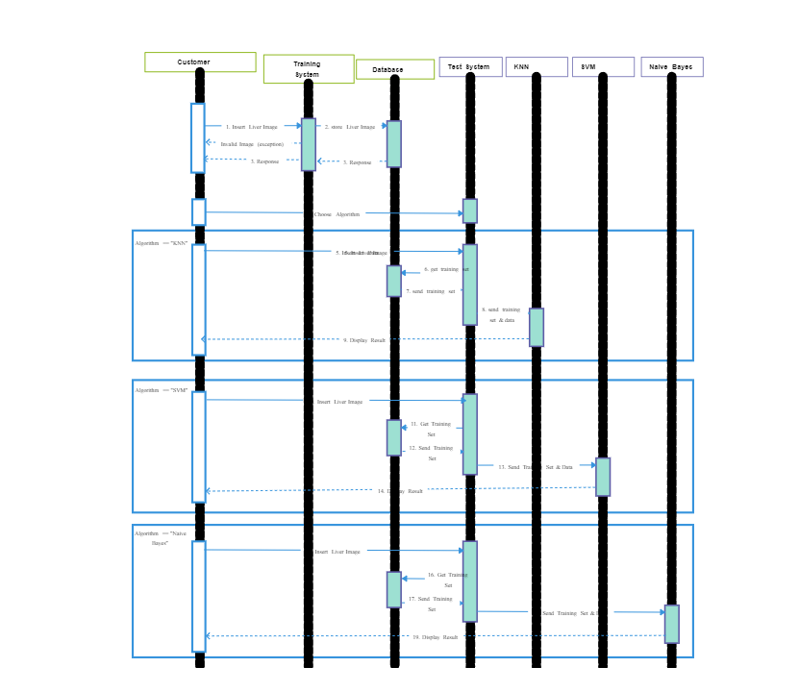

**E. FLOWCHART DIAGRAM:**

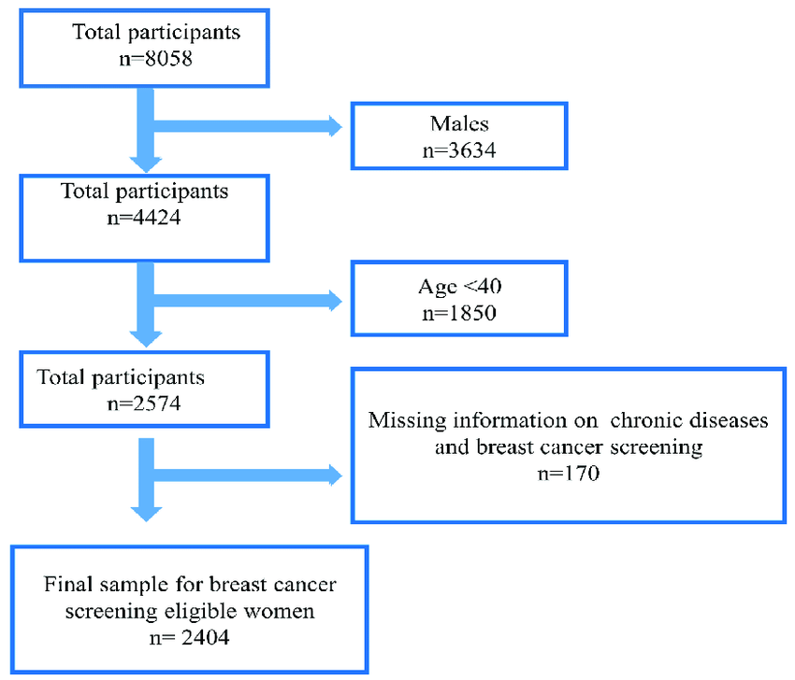

**F. DATA FLOW DIAGRAM:**

A data flow diagram (DFD) is a graphical representation of the "flow" of data through an information system. DFDs can also be used for the visualization of data processing (structured design). On a DFD, data items flow from an external data source or an internal data store to an internal data store or an external data sink, via an internal process. A DFD provides no information about the timing of processes, or about whether processes will operate in sequence or in parallel It is therefore quite different from a flowchart, which shows the flow of control through an algorithm, allowing a reader to determine what operations will be performed, in what order, and under what circumstances, but not what kinds of data will be input to and output from the system, nor where the data will come from and go to, nor where the data will be stored (all of which are shown on a DFD).

It is common practice to draw a context-level data flow diagram first, which shows the interaction between the system and external agents which act as data sources and data sinks. On the context diagram (also known as the 'Level 0 DFD') the system's interactions with the outside world are modelled purely in terms of data flows across the system boundary. The context diagram shows the entire sylam as a single process, and gives no clues as to its internal organization.

This context-level DFD is next "exploded", to produce a Level 1 DFD that shows some of the detail of the system being modelled. The Level 1 DFD shows how the system is divided into sub-systems (processes), each of which deals with one or more of the data flows to or from an external agent, and which together provide all of the functionality of the system as a whole. It also identifies internal data stores that must be present in order for the system to do its job, and shows the flow of data between the various parts of the system.

**G. STATE DIAGRAM:**

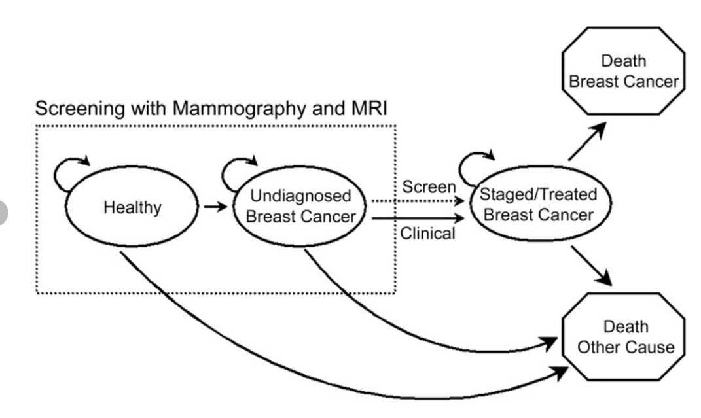

**G. ER DIAGRAM:**

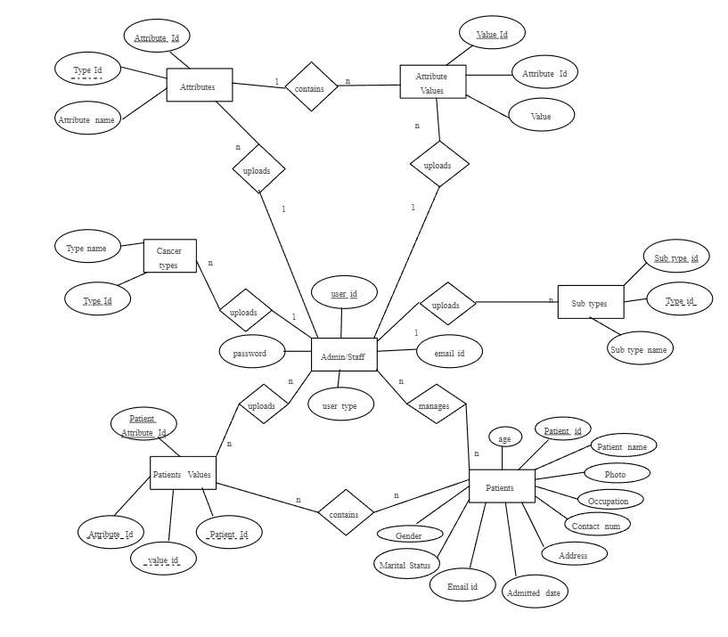

# OTHER SPECIFICATION

1. **Advantage**

1.Enhanced Accuracy and Sensitivity:

Machine learning models, when trained on comprehensive and diverse datasets, can exhibit high accuracy and sensitivity in detecting breast cancer.

2.Time-Efficient Diagnostics:

ML algorithms can analyze medical images swiftly, potentially reducing the time required for diagnosis compared to manual interpretation.

3.Consistency and Reduced Bias:

ML models can provide consistent evaluations, minimizing the impact of subjective human biases often encountered in interpretation.

4.Integration with Existing Diagnostic Practices:

These models can complement existing diagnostic practices, assisting radiologists in their evaluations and decision-making processes.

5.Potential for Early Detection:

ML-based systems have the potential to identify subtle patterns indicative of early-stage breast abnormalities, aiding in timely interventions**.**

### **Limitations**

1.Reliance on Training Data Quality:

The performance of ML models heavily depends on the quality, diversity, and representativeness of the training data. Inadequate or biased data can result in compromised model performance.

2.Interpretability Challenges:

ML models, especially complex ones like neural networks, might lack interpretability, making it difficult to understand how specific features contribute to predictions, thereby complicating error identification and correction.

3.Potential Overfitting:

Models might overfit the training data, capturing noise and leading to decreased generalization when applied to new, unseen data.

4.Complexity in Handling Multiple Lesions:

Detecting multiple lesions within a single image can be challenging for ML models, potentially leading to oversight or misinterpretation.

5.Regulatory Compliance and Ethical Concerns:

Complying with healthcare regulations and ensuring ethical usage of patient data in training ML models is a critical concern.

### **Application:**

1.Assisted Diagnosis for Radiologists:

ML models can aid radiologists in making more accurate and prompt diagnostic decisions, potentially reducing the burden of interpretation.

2.Screening and Early Detection:

ML-based systems can be used for large-scale screening programs, facilitating early detection of potential abnormalities in mammograms.

3.Risk Assessment and Treatment Planning:

Predictive models can assist in evaluating individual patient risk factors and aiding in personalized treatment planning.

4.Clinical Decision Support Systems:

Implementing ML-based decision support systems in healthcare settings can provide recommendations to medical practitioners based on image analysis.

5.Research and Development:

ML models can support researchers by analyzing vast datasets to uncover patterns, contributing to the understanding of breast cancer and potential treatment strategies.

6.Telemedicine and Remote Diagnostics:

ML-driven diagnostic tools can support remote consultations and diagnostics, particularly in areas with limited access to specialized medical expertise.

# CONCLUSION AND FUTURE WORK

In conclusion, the field of breast cancer detection has seen incredible advancements through the integration of machine learning and deep learning techniques. Researchers have explored various methodologies, from traditional machine learning to cutting-edge deep learning architectures, in a quest to enhance the accuracy and efficiency of breast cancer detection. These techniques, including CNN architectures, transfer learning frameworks, and ensemble methods, have shown great promise in distinguishing between normal and abnormal breast tissues in medical imaging like mammograms.

However, there are ongoing challenges that need further attention. Improving the quality and quantity of training data remains crucial for these models to perform optimally. Additionally, ensuring these models can capture higher-level aspects of breast cancer beyond temporal dependencies is an area requiring more exploration. Controlling the model's output to meet specific criteria and improving interpretability are also key challenges. Addressing these limitations will involve refining the models, exploring new features, and enhancing the interpretability of deep learning algorithms.

Future work in breast cancer detection using machine learning involves refining existing models and exploring hybrid approaches that combine the strengths of different techniques. Research efforts will focus on gathering more diverse and comprehensive datasets to train these models. Additionally, interpretability and control mechanisms within these models will be improved, enabling better understanding and trust among medical practitioners. Further integration of these models into clinical settings will involve rigorous testing, validation, and adherence to safety and ethical standards. The ultimate goal is to create more accurate, reliable, and accessible tools that aid in early breast cancer detection, improving patient outcomes and healthcare practices.

# REFERENCES

# [1] Breast Cancer Mammograms Classification Using Deep Neural Network and Entropy-Controlled Whale Optimization Algorithm[Saliha Zahoor](https://pubmed.ncbi.nlm.nih.gov/?term=Zahoor%20S%5BAuthor%5D),1,* [Umar Shoaib](https://pubmed.ncbi.nlm.nih.gov/?term=Shoaib%20U%5BAuthor%5D),1

# [2] A Novel Hybrid K-Means and GMM Machine Learning Model for Breast CancerDetection [P. Esther Jebarani](https://ieeexplore.ieee.org/author/37089017486); [N. Umadevi](https://ieeexplore.ieee.org/author/37086753769); [Hien Dang](https://ieeexplore.ieee.org/author/37088580735); [Marc Pomplun](https://ieeexplore.ieee.org/author/37269541000)

# [3] Breast Cancer Detection and Diagnosis Using Mammographic Data: Systematic Review [Syed Jamal Safdar Gardezi](https://www.jmir.org/search?term=Syed%20Jamal%20Safdar%20Gardezi&type=author&precise=true);  [Baiying Lei](https://www.jmir.org/search?term=Baiying%20Lei&type=author&precise=true);   [Ahmed Elazab 1](https://www.jmir.org/search?term=Ahmed%20Elazab&type=author&precise=true);

# [4] Breast Cancer Detection using Machine Learning Approaches Sri Hari Nallamala, Pragnyaban Mishra, Suvarna Vani Koneru

# [5] An anatomization on breast cancer detection and diagnosis employing multi-layer perceptron neural network (MLP) and Convolutional neural network (CNN)Author links open overlay panelMeha Desai a, Manan Shah b

# [6] A Comparative Analysis of Nonlinear Machine Learning Algorithms for Breast Cancer Detection; Ali Al Bataineh

# [7] Machine Learning Classification Techniques for Breast Cancer DiagnosisDavid A. Omondiagbe1, Shanmugam Veeramani1 and Amandeep S. Sidhu2Published under licence by IOP Publishing Ltd

[8] Breast cancer detection using artificial intelligence techniques: A systematic literature review Author links open overlay panelAli Bou Nassif, Manar Abu Talib, Qassim Nasir, Yaman Afadar, Omar Elgendy

[9] Breast cancer detection using deep learning: Datasets, methods, and challenges aheadAuthor links open overlay panelNusrat Mohi ud din a, Rayees Ahmad Dar a, Muzafar Rasool b, Assif Assad a

[10] An Automatic Detection of Breast Cancer Diagnosis and Prognosis Based on Machine Learning Using Ensemble of Classifiers USMAN NASEEM 1 , JUNAID RASHID 2 , LIAQAT ALI3 , JUNGEUN KIM 2,4 , QAZI EMAD UL HAQ 5 , MAZHAR JAVED AWAN 6 , AND MUHAMMAD IMRAN 7

# [11] Intelligent Hybrid Deep Learning Model for Breast Cancer Detection <https://www.mdpi.com/2079-9292/11/17/2767>

# [12] Predicting Breast Cancer from Risk Factors Using SVM and Extra-Trees-Based Feature Selection Method Ganjar Alfian , Muhammad Syafrudin ,* , Imam Fahrurrozi , Norma Latif Fitriyani , Fransiskus Tatas Dwi Atmaji , Tri Widodo , Nurul Bahiyah , Filip Benes 7 and Jongtae Rhee 8

# [13] BM-Net: CNN-Based MobileNet-V3 and Bilinear Structure for Breast Cancer Detection in Whole Slide Images Jin Huang 1,†, Liye Mei 1,† , Mengping Long 1,2,†, Yiqiang Liu 2 , Wei Sun 2 , Xiaoxiao Li 1 , Hui Shen 3 , Fuling Zhou 3 , Xiaolan Ruan 4 , Du Wang 1 , Shu Wang 5 , Taobo Hu 1,5,* and Cheng Lei 1,*

# [14] Automated Breast Cancer Detection Models Based on Transfer Learning Madallah Alruwaili * and Walaa Gouda

# [15] BreaCNet: A high-accuracy breast thermogram classifier based on mobile convolutional neural network Roslidar Roslidar1,2,3 , Mohd Syaryadhi2 , Khairun Saddami2 , Biswajeet Pradhan4,5,6 , Fitri Arnia2,3 , Maimun Syukri7 and Khairul Munadi2,3,8,*