

**BRACT’S, Vishwakarma Institute of Information Technology, Pune-48**

**Department of Computer Engineering**

**Submitted By**

|  |  |  |  |
| --- | --- | --- | --- |
| **Sr No** | **Name** | **Roll No.** | **PRN No.** |
| **1** | **Ketan Choudhari** | **323016** | **22110060** |
| **2** | **Aniket Dhoke** | **323018** | **22110835** |
| **3** | **Ahilya Mote** | **323046** | **22110787** |
| **4** | **Pooja Vishwakarma** | **323064** | **22110402** |

**Guided By**

**Prof Dr Nitin Sakhare**

**Software Requirements Specification (SRS)**

**Breast Cancer Detection System**

**1. Introduction**

Indian Railway Catering and Tourism Corporation (IRCTC) is a subsidiary of theIndian

Railways that handles the catering, tourism and online ticketing operations of the Indian

railways, with around 5,50,000 to 6,00,000 bookings every day is the world's second

busiest and highest of 15 to 16 lakh tickets every day. Its tagline is "Lifeline of the

nation

Indian Railway Catering and Tourism Corporation (IRCTC) is a subsidiary of theIndian

Railways that handles the catering, tourism and online ticketing operations of the Indian

railways, with around 5,50,000 to 6,00,000 bookings every day is the world's second

busiest and highest of 15 to 16 lakh tickets every day. Its tagline is "Lifeline of the

nation

Indian Railway Catering and Tourism Corporation (IRCTC) is a subsidiary of theIndian

Railways that handles the catering, tourism and online ticketing operations of the Indian

railways, with around 5,50,000 to 6,00,000 bookings every day is the world's second

busiest and highest of 15 to 16 lakh tickets every day. Its tagline is "Lifeline of the

nation

Indian Railway Catering and Tourism Corporation (IRCTC) is a subsidiary of theIndian

Railways that handles the catering, tourism and online ticketing operations of the Indian

railways, with around 5,50,000 to 6,00,000 bookings every day is the world's second

busiest and highest of 15 to 16 lakh tickets every day. Its tagline is "Lifeline of the

nation

Indian Railway Catering and Tourism Corporation (IRCTC) is a subsidiary of theIndian

Railways that handles the catering, tourism and online ticketing operations of the Indian

railways, with around 5,50,000 to 6,00,000 bookings every day is the world's second

busiest and highest of 15 to 16 lakh tickets every day. Its tagline is "Lifeline of the

nation

Indian Railway Catering and Tourism Corporation (IRCTC) is a subsidiary of theIndian

Railways that handles the catering, tourism and online ticketing operations of the Indian

railways, with around 5,50,000 to 6,00,000 bookings every day is the world's second

busiest and highest of 15 to 16 lakh tickets every day. Its tagline is "Lifeline of the

nation

Indian Railway Catering and Tourism Corporation (IRCTC) is a subsidiary of theIndian

Railways that handles the catering, tourism and online ticketing operations of the Indian

railways, with around 5,50,000 to 6,00,000 bookings every day is the world's second

busiest and highest of 15 to 16 lakh tickets every day. Its tagline is "Lifeline of the

nation

Indian Railway Catering and Tourism Corporation (IRCTC) is a subsidiary of theIndian

Railways that handles the catering, tourism and online ticketing operations of the Indian

railways, with around 5,50,000 to 6,00,000 bookings every day is the world's second

busiest and highest of 15 to 16 lakh tickets every day. Its tagline is "Lifeline of the

nation

* 1. **Purpose**

The purpose of this Software Requirements Specification (SRS) is to provide a detailed description of the Breast Cancer Detection System. This document outlines the functional and non-functional requirements, scope, and limitations of the system to guide the development team and stakeholders.

**1.2 Scope**

The Breast Cancer Detection System is designed to assist healthcare professionals in the early and accurate detection of breast cancer through the analysis of medical imaging data. The system aims to leverage advanced technologies, including image processing and machine learning, to enhance the efficiency and reliability of breast cancer diagnosis.

**1.3 Glossary**

This should define all technical terms and abbreviations used in the document.

|  |  |
| --- | --- |
| Term | Definition |
| SRS | Software Requirements Specification |
| ML | Machine Learning |
| GUI | Graphical user Interface |
| DICOM | Digital Imaging and communications in Medicine |
| API | Application Programming Interface |

**1.4 Overview**

The subsequent sections of this document provide a comprehensive overview of the Breast Cancer Detection System, including the system's features, functionality, constraints, and assumptions. The document serves as a foundation for the development, testing, and deployment of the system.

**2. System Description**

**2.1 System Overview**

The Breast Cancer Detection System is a sophisticated software application that integrates with medical imaging devices to analyze mammograms and other relevant imaging data. The system employs machine learning algorithms to assist healthcare professionals in identifying potential indicators of breast cancer with high accuracy.

A. Product Perspective

The system had the following issues prior to automation:

● The current system is largely manual, requiring a lot of paper work and

calculation, and as a result may be inaccurate. As a result, data

maintenance is now inconsistent and inaccurate.

● Data that is only saved on paper is susceptible to loss, theft, and

destruction from natural disasters like fire and flooding.

● Customers and airline employees are inconvenienced by the current

system's slowness and time requirements.

● It is challenging to update, delete, add, or view the data because of its

manual nature.

● Since the number of passengers has significantly increased, it is incredibly

difficult to preserve and retrieve detailed passenger records.

● A railway has numerous offices all over the world. When there is no

connection between these offices, coordination and communication are

hampered.

● Therefore, the following are the suggested changes to the train reservation

system:

● The computerization of the reservation system will lighten the

administrative workload of the airline crew by reducing the amount of

paper-work.

● All calculations are done by the machine. Error chances are therefore zero.

● It is simple to access the passenger, reservation, and cancellation list and

make any necessary additions, deletions, or updates.

● Unauthorized access is avoided because to the user-ID validation offered

by the system.

B. Project Functions

Most booking agents will use this technique, regardless of their level of computer

expertise. This software's ability to be reasonably easy to use is a key feature.

This project's scope includes the following:

● Search: This feature enables the traveler's preferred "Departure city" and

"Arrival city" to be used by the booking agent to look for trains that are

available between the two travel cities. The system asks the agent for

information such as the departure and arrival cities, the date of departure,

the preferred time slot, and the number of passengers at first. The list of

trains that are available with various airlines between the defined cities on

the given day and time is then displayed.

● Selection: Using this function, a train can be chosen from the list that is

displayed. The train's complete details are displayed:

➢Train Number

➢Date, time and place of Departure

➢Date, time and place of arrival

➢Train duration

➢Fare per head

➢Number of stops: 0,1,2,..

● Review: The software prompts for train reservation if there are seats

available. The data about the train is displayed. The whole ticket,

including taxes, is displayed, and the flight information is examined.

● Traveller Information: It requests information on each passenger who is

scheduled to travel, including name, address, phone number, and email

address.

● Payment: The reservation maker's varied payment card information must

be entered by the agent.

● Cancellation: The system also enables cancellation of an existing

reservation by the user. This function logs the details of a traveller who

has asked to have his or her ticket cancelled. It contains records for the

train number, confirmation number, name, departure date, and fare

deducted.

C. User Characteristics

● Education level: The system's users must at the very least be fluent in

English.

● Technical proficiency: The user should feel at ease utilizing general-

purpose computer software.

* + 1. **Features**

1. **Data Input**: Accepts medical imaging data in DICOM format from various imaging devices.
2. **Preprocessing**: Implements image preprocessing techniques for enhancing image quality.
3. **Machine Learning Algorithms**: Integrates and trains machine learning models for breast cancer detection.
4. **User Interface**: Develops an intuitive GUI for healthcare professionals to interact with the system.
5. **Reporting:** Generates detailed reports based on the analysis results, providing insights to aid diagnosis.
6. **Security**: Implements robust security measures to ensure patient data confidentiality.
7. **Performance:** Processes images efficiently to support real-time analysis.

**2.2.2 Constraints**

* Compliance with healthcare data privacy regulations.
* Accuracy of breast cancer detection is dependent on the quality of input images.

**2.2.3 Assumptions:**

* Secure network for data transfer.
* Adequate hardware resources to support computational requirements.

**3. Functional Requirements**

**3.1 Performance Requirement**

**System Response Time for Image Processing:**

**High Priority:**

* The Breast Cancer Detection System should process medical imaging data with minimal latency to provide timely results for healthcare professionals.
* Response time for image processing should be optimized to ensure a seamless and efficient user experience.

**Accuracy of Breast Cancer Detection Algorithm:**

**High Priority:**

* The primary objective of the system is to achieve a high level of accuracy in breast cancer detection.
* Machine learning algorithms employed for detection must undergo rigorous training and validation to ensure reliable results.

**Security Measures Response Time:**

**Medium Priority:**

* While maintaining a high level of security is crucial, the response time for security measures, such as user authentication and data encryption, should be reasonable.
* Balancing security with system responsiveness is essential to avoid unnecessary delays in user interactions.

**3.2 Design Constraints**

**Compliance with DICOM Standards for Medical Imaging Data:**

* The system must adhere to the Digital Imaging and Communications in Medicine (DICOM) standards for the storage and exchange of medical imaging data.
* This constraint ensures interoperability with various medical imaging devices and systems that follow DICOM standards.

**Integration with Existing Hospital Information Systems:**

* The Breast Cancer Detection System should seamlessly integrate with existing hospital information systems (HIS).
* Integration with HIS enables the exchange of patient data, medical histories, and diagnostic results, providing a comprehensive view for healthcare professionals.

**3.3 Hardware Requirements**

**Minimum and Preferred Hardware Specifications:**

**Minimum Hardware Specifications:**

* Processor: Dual-core, minimum clock speed.
* RAM: Minimum required for image processing.
* Storage: Adequate space for storing image datasets and system files.

**Preferred Hardware Specifications:**

* Processor: Quad-core or higher.
* RAM: Recommended for optimal performance.
* Storage: SSD for faster data access.

**3.4 Software Requirements**

For software development, a window-based or MAC operating system

with DOS capability is a prerequisite. FrontPage, Windows XP, and

dumps are necessary. The systems must be connected by LAN, and an

internet connection is required.

**Necessary Software Components and Versions:**

* Operating System: Compatible with major operating systems (Windows, Linux, etc.).
* Database Management System: Integration with a database system for storing and retrieving patient data.
* Machine Learning Framework: Utilization of a specific machine learning framework (e.g., TensorFlow, PyTorch).
* Imaging Software: Integration with imaging software for DICOM file handling.

**3.5 Other Requirements**

Software should satisfy following requirements as well: -

● Security

● Portability

● Correctness

● Efficiency

● Flexibility

● Testability

● Reusability

Software should satisfy following requirements as well:-

* Security
* Portability
* Correctness
* Efficiency
* Flexibility
* Testability
* Reusability\

**4. Non-Functional Requirements**

**4.1 Security**

* Encryption of patient data: High priority.
* Access controls for user authentication: High priority.

**4.2 Reliability**

* System availability: High priority.
* Backup and recovery procedures: Medium priority.

**4.3 Availability**

* The system should be available 24/7.

**4.4 Maintainability**

* Codebase modularity: Medium priority.
* Documentation for system maintenance: Medium priority.

**4.5 Supportability**

* Clear and well-documented supporting modules and source code.

**5. PROJECT DOCUMENTATION:**

**Different types of documentation, including use case diagrams, class diagrams, activity diagrams, sequence diagrams, flowchart diagrams, data flow diagrams, state diagrams, and entity-relationship diagrams.**

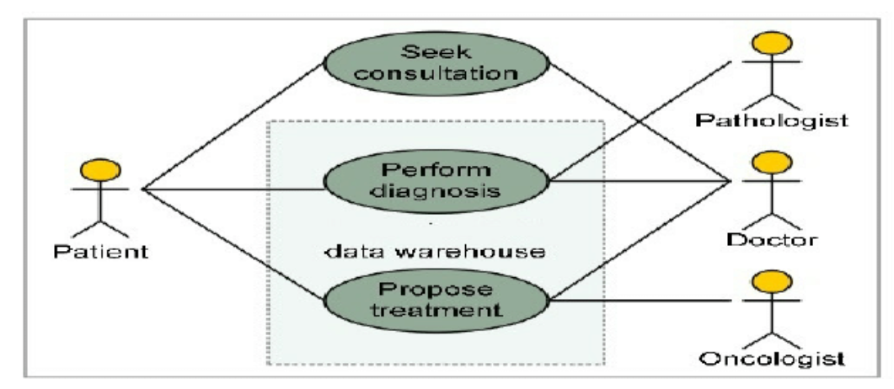

**A. USE CASE DIAGRAM:**

A use case diagram is a form of behavioural diagram specified by and produced from a use-case study in the Unified Modelling Language (UML). Its goal is to give a graphical overview of the functionality a system offers in terms of the actors, their objectives (expressed as use cases), and any dependencies among those use cases. A use case diagram's primary objective is to identify which system functions are carried out for which actor. The system's actors can be seen in their many roles. The use case diagram does not depict actor interaction. The system or use case boundaries may need to be reevaluated if this interaction is necessary for a coherent description of the desired behaviour. Alternatively, assumptions made for the use case could include actor interaction.

* Use Cases: A use case is represented by a horizontal ellipse and represents a series of behaviours that offer an agent with something of quantifiable value.
* Actors: A person, group, or external system that participates in one or more interactions with the system is referred to as an actor.
* System boundary boxes: The system boundary box, a rectangle denoting the system's scope, is drawn around the use cases. Everything inside the box denotes functionality that is under scope, whereas everything outside the box does not.

**B. CLASS DIAGRAM:**

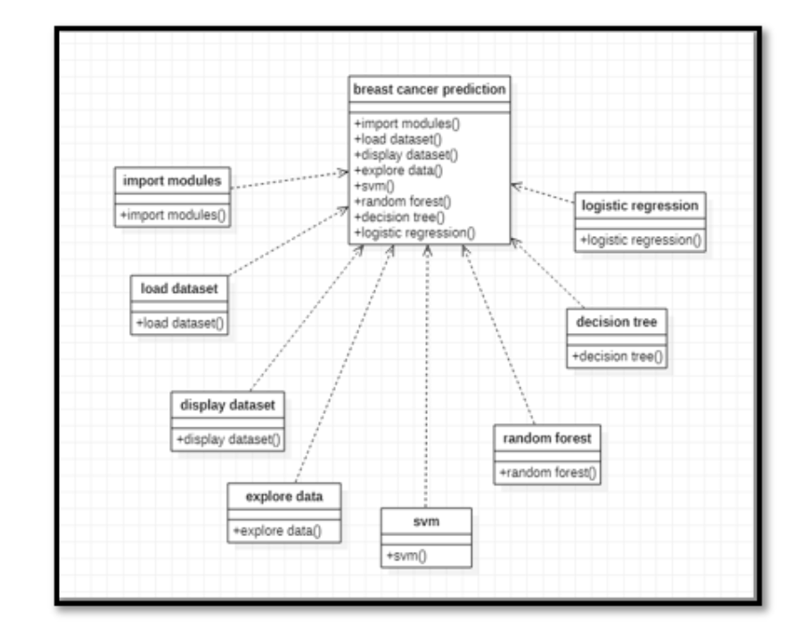

**C. ACTIVITY DIAGRAM:**

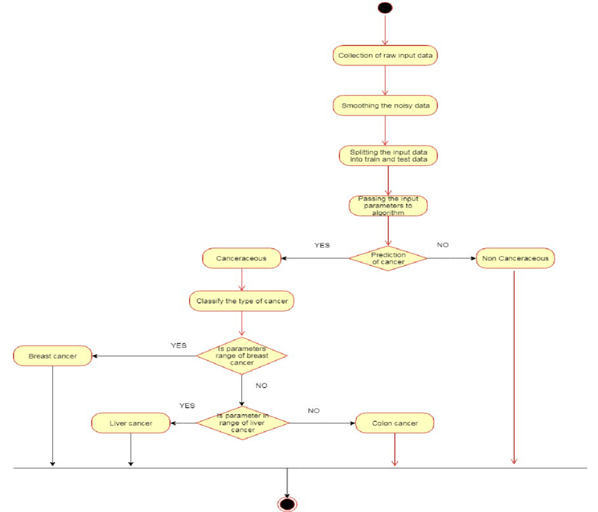

**D. SEQUENCE DIAGRAM:**

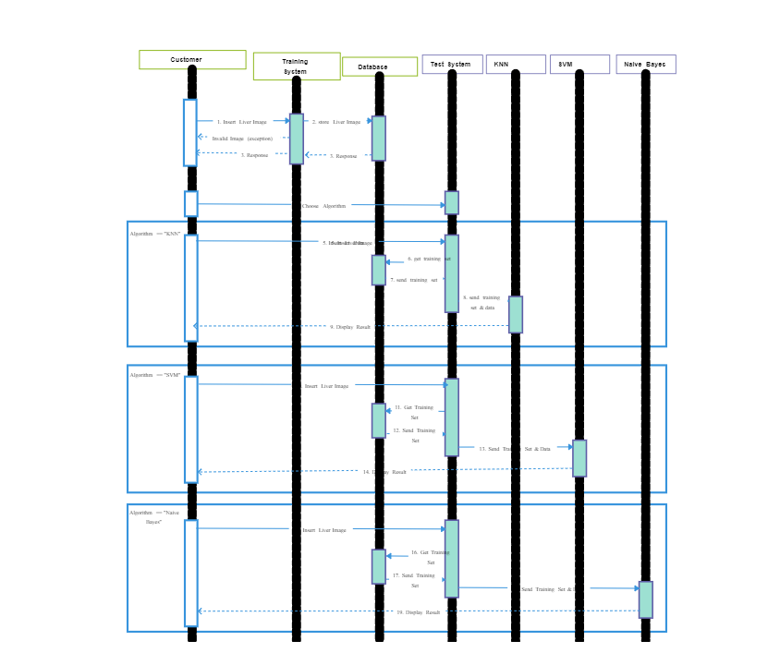

**E. FLOWCHART DIAGRAM:**

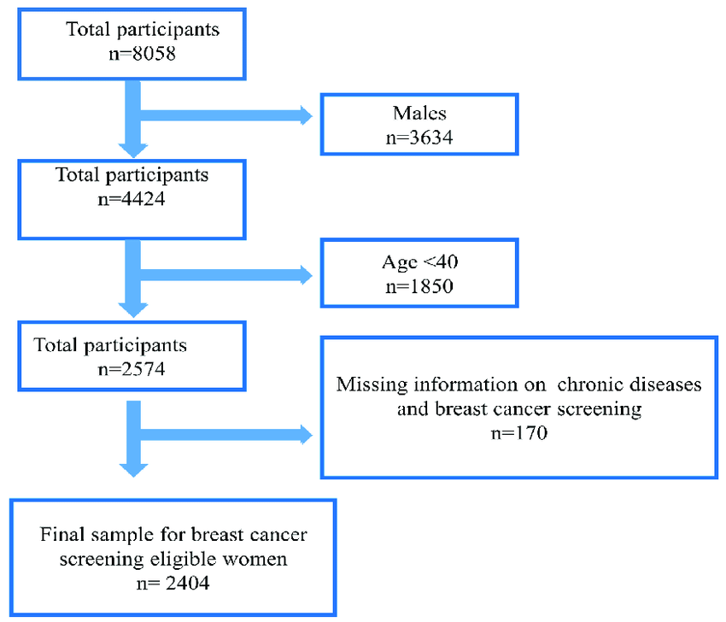

**F. DATA FLOW DIAGRAM:**

A data flow diagram (DFD) is a graphical representation of the "flow" of data through an information system. DFDs can also be used for the visualization of data processing (structured design). On a DFD, data items flow from an external data source or an internal data store to an internal data store or an external data sink, via an internal process. A DFD provides no information about the timing of processes, or about whether processes will operate in sequence or in parallel It is therefore quite different from a flowchart, which shows the flow of control through an algorithm, allowing a reader to determine what operations will be performed, in what order, and under what circumstances, but not what kinds of data will be input to and output from the system, nor where the data will come from and go to, nor where the data will be stored (all of which are shown on a DFD).

It is common practice to draw a context-level data flow diagram first, which shows the interaction between the system and external agents which act as data sources and data sinks. On the context diagram (also known as the 'Level 0 DFD') the system's interactions with the outside world are modelled purely in terms of data flows across the system boundary. The context diagram shows the entire sylam as a single process, and gives no clues as to its internal organization.

This context-level DFD is next "exploded", to produce a Level 1 DFD that shows some of the detail of the system being modelled. The Level 1 DFD shows how the system is divided into sub-systems (processes), each of which deals with one or more of the data flows to or from an external agent, and which together provide all of the functionality of the system as a whole. It also identifies internal data stores that must be present in order for the system to do its job, and shows the flow of data between the various parts of the system.

**G. STATE DIAGRAM:**

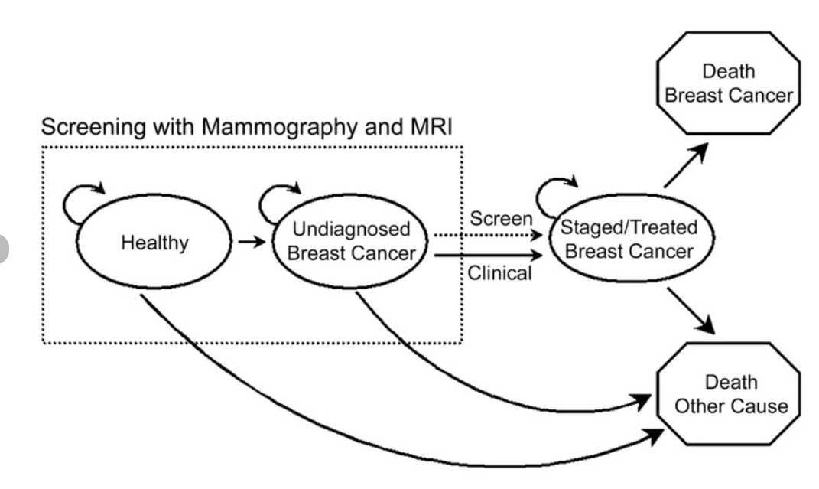

**G. ER DIAGRAM:**

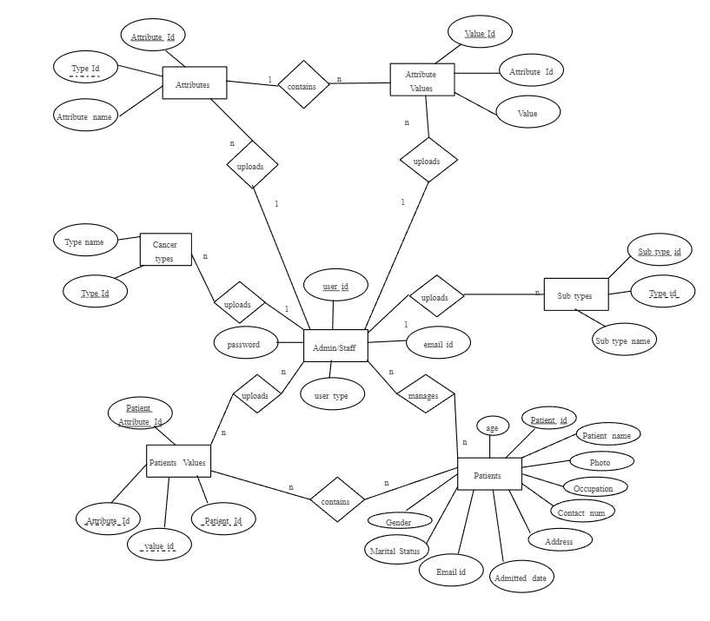

**6. Constraints**

* Compliance with healthcare regulations and standards.
* Integration with payment gateways following industry security standards.

**7. Assumptions and Dependencies**

* Timely and Accurate Data
* Stable internet connectivity
* Payment gateway integration
* User Authenticity (valid information)
* Security infrastructure: to ensure confidentiality and integrity of user data
* Maintenance and Support
* User Awareness about system’s features and functionalities.

**8. Glossary**

* This SRS document serves as a comprehensive guide for the development and deployment of the Breast Cancer Detection System. It outlines the purpose, scope, features, requirements, constraints, and assumptions to ensure a clear understanding among stakeholders and the development team**.**

|  |  |
| --- | --- |
| Term | Definition |
| SRS | Software Requirements Specification |
| ML | Machine Learning |
| GUI | Graphical user Interface |
| DICOM | Digital Imaging and communications in Medicine |
| API | Application Programming Interface |