PRODUCT REQUIREMENTS DOCUMENT
Sales Process Automation Tool with MIS Dashboard
Bajato Lights LLP | Version 1.0 | November 2023
Document Owner | Product Manager
Department | Sales, Operations, Production, Senior Management
Version | 1.0 – Initial Release
Date | November 2023
Status | Approved for Development
Confidentiality | Internal Use Only

1. Executive Summary
Bajato Lights LLP currently relies on a fragmented, manual workflow for its end-to-end sales documentation process. Sales executives independently author Quotations, Order Reviews, and Proforma Invoices in varied formats—causing delays, missing information, inconsistent communication, and reactive production scheduling.

This Product Requirements Document defines the scope, functional requirements, user stories, and success metrics for the Sales Process Automation Tool—a centralized digital platform that standardizes all sales documentation, automates cross-functional communication, and delivers automated MIS reporting to senior leadership.

2. Problem Statement

2.1 Current-State Pain Points
Pain Point | Impact
Manual document creation | Inconsistent formats, missing fields, repeated rework
No standardized template | Every customer gets a different document structure
Slow customer response time | Risk of losing deals to faster competitors
Unstructured query tracking | Follow-ups missed; no visibility on open queries
Late production notifications | Production cannot plan ahead; scheduling delays
Manual MIS reporting | Senior leadership lacks timely, reliable sales visibility

3. Goals & Objectives
# | Objective | Metric | Target
1 | Standardize all sales documentation | Template compliance | 100%
2 | Accelerate customer response time | Avg. response time reduction | 60% faster
3 | Eliminate missing/incorrect data | Error rate per document | ≤ 10% of baseline
4 | Enable proactive production planning | Order-to-production notification lag | < 1 hour
5 | Automate leadership MIS reporting | Manual report preparation time | 0 hours
6 | Increase sales team productivity | Time saved on document prep | 40% uplift

4. Scope

4.1 In Scope
- Standardized templates for Quotation, Order Review, and Proforma Invoice
- Customer query tracking module with reply-window management
- Automated order notification to Flow Management System on order confirmation
- MIS Dashboard built in Google Data Studio
- Automated weekly email delivery to senior management, Sales Manager, and Operations

4.2 Out of Scope (Phase 2)
- ERP / CRM integration
- Mobile application interface
- AI-driven pricing recommendations
- E-signature workflow

5. User Personas
Persona | Role | Primary Need | Key Pain Today
Sales Executive | Day-to-day user | Fast, accurate document creation | Manual rework & formatting
Sales Manager | Supervisor | Consistent team output | No visibility on team queues
Operations / Production | Downstream consumer | Early order visibility | Late, incomplete order info
Senior Leadership | Decision-maker | Weekly sales performance insights | Delayed, manual MIS reports

6. Functional Requirements

FR-01 Customer Query & Response Tracker
- Log all inbound customer enquiries with timestamps and source channel.
- Assign configurable reply windows per query (24 hrs / 48 hrs / custom).
- Visually highlight overdue queries with color-coded alerts.
- Status lifecycle: New → In Progress → Sent → Closed.
- Allow comments and internal notes per query record.

FR-02 Standardized Templates Engine
- Provide pre-designed, locked templates for Quotation, Order Review, and Proforma Invoice.
- Auto-populate customer master data and recurring fields.
- Enforce mandatory-field validation before submission or export.
- Maintain Bajato Lights LLP brand consistency across all documents.

FR-03 Quotation Generation Module
- Capture: customer name, item description, quantity, unit price, payment terms, lead time, and validity date.
- Auto-generate documents in PDF and Excel formats.
- Maintain a version history log for audit and comparison.

FR-04 Order Review Module
- Auto-fetch approved quotation data to pre-populate fields.
- Validate all mandatory fields before order finalization.
- On finalization, push order details to Flow Management System automatically.

FR-05 Proforma Invoice Module
- Pre-populate all data from the finalized Order Review.
- Allow minor adjustments (e.g., delivery address, payment schedule) prior to approval.
- Lock all fields after approval to prevent unauthorized modification.

FR-06 Flow Management System Integration
- On Order Review finalization, push structured order payload to Flow Management API.
- Trigger automated push notification / email to the Production team.
- Production dashboard displays upcoming confirmed orders for scheduling.

FR-07 MIS Dashboard (Google Data Studio)
- Sales performance summary (weekly, monthly, quarterly).
- Enquiry volume trend and source breakdown.
- Open vs. closed query ratio.
- Quotation-to-order conversion funnel.
- Pending Order Reviews with aging.
- Production readiness and pipeline insights.

FR-08 Automated Weekly Email Report
- Schedule: Every Saturday at 08:00 AM IST (configurable).
- Content: PDF snapshot of MIS Dashboard + weekly activity summary.
- Recipients: Senior Management, Sales Manager, Operations Team.
- System must trigger without any manual intervention.

7. Interface Preview — UI Wireframe
The screens below illustrate the proposed interface design for the Sales Process Automation Tool. These wireframes represent the Customer Query Tracker module—the primary daily-use screen for the Sales Team—and serve as a reference for development and stakeholder alignment.

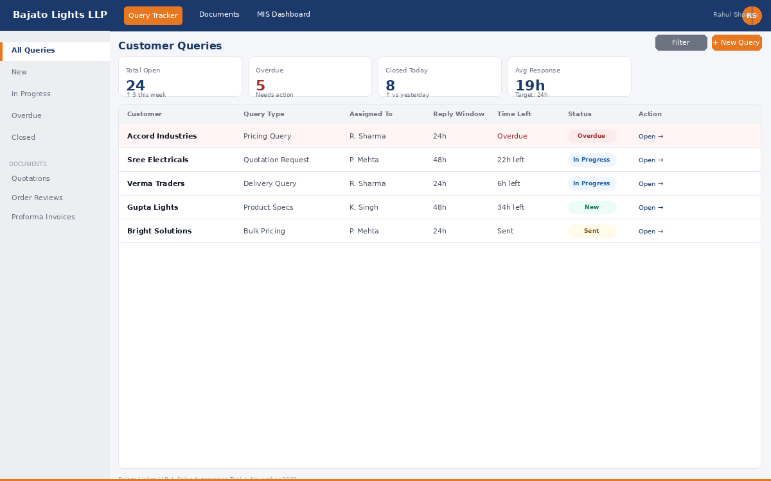
Figure 7.1 | Customer Query Tracker — Main Dashboard View
Displays real-time query status, overdue alerts (red highlight), reply-window countdown, and one-click access to open queries. Metric cards at the top surface actionable KPIs at a glance.

7.1 Key UI Elements Shown
UI Element | Description
Top Navigation Bar | Global nav with module switching (Query Tracker / Documents / MIS Dashboard) and user avatar.
Left Sidebar | Context-sensitive menu for filtering queries by status; collapses to icon-only on smaller screens.
Metric Cards (4-up) | Live KPI tiles: Total Open, Overdue, Closed Today, Avg Response Time. Color-coded for instant health check.
Query Table | Tabular view of all customer queries with columns for type, assignee, reply window, and aging. Sortable and filterable.
Status Badges | Color-coded pills: Overdue (red), In Progress (blue), New (green), Sent (amber). Provides at-a-glance status.
+ New Query Button | Orange CTA button consistent with brand color; opens a slide-over form to log a new customer enquiry.

Additional wireframes for the Quotation, Order Review, Proforma Invoice, MIS Dashboard, and Flow Management Integration screens are available in the separate Wireframe Reference Document (v1.0, November 2023).

8. Non-Functional Requirements
Category | Requirement
Performance | Document generation must complete within 5 seconds.
Reliability | System uptime SLA of ≥ 99.5% during business hours.
Security | Role-based access control; only authorized users may finalize or lock documents.
Scalability | Support up to 500 documents/month without degradation.
Usability | Sales executives should require < 30 min of onboarding to use core features.
Data Integrity | All finalized documents must be immutable and audit-logged.
Integration | Flow Management API must receive order payload within 60 seconds of finalization.

9. User Stories & Acceptance Criteria

US-01 Quotation Creation (Sales Executive)
As a Sales Executive, I want to create a standardized quotation quickly so that I can respond to customer enquiries faster and accurately.

# | Acceptance Criterion
AC1 | Template auto-fills all standard customer and company fields on creation.
AC2 | System blocks submission if any mandatory field is empty, with an inline error message.
AC3 | Exported PDF/Excel matches the approved template format without layout defects.
AC4 | Version history is updated on every edit and is accessible to the Sales Manager.

US-02 Document Standardization (Sales Manager)
As a Sales Manager, I want all team-generated documents to follow a uniform format so that our output is professional and consistent across all customers.

# | Acceptance Criterion
AC1 | No user can modify the template structure; only designated admins can update templates.
AC2 | All output documents display identical layout, fonts, and branding regardless of the creator.

US-03 Proactive Production Planning (Operations / Production)
As a Production User, I want automatic order updates the moment an order is confirmed so that I can begin scheduling and resource planning immediately.

# | Acceptance Criterion
AC1 | Order details are pushed to Flow Management within 60 seconds of Order Review finalization.
AC2 | Push notification / email is sent to the Production team simultaneously.
AC3 | All order fields (item, quantity, delivery date, terms) sync correctly and completely.

US-04 Automated MIS Reporting (Senior Leadership)
As a Senior Leader, I want a weekly sales MIS report delivered to my inbox automatically every Saturday so that I have reliable visibility without requesting it manually.

# | Acceptance Criterion
AC1 | Email is sent every Saturday at 08:00 AM IST without any manual trigger.
AC2 | Dashboard data reflects actuals as of Friday EOD; no stale data.
AC3 | Email includes both a PDF snapshot and a live dashboard link.

US-05 Query Tracking (Sales Executive)
As a Sales Executive, I want a query tracker so that no customer enquiry is missed or responded to beyond the agreed reply window.

# | Acceptance Criterion
AC1 | Overdue queries are visually flagged (red highlight) in the tracker view.
AC2 | Status can be updated inline; comments and timestamps are captured automatically.
AC3 | Manager can view all team queries sorted by status, age, and assignee.

10. Success Metrics & KPIs
KPI | Baseline | Target (Post-Launch)
Average customer query response time | ~48 hours | ~19 hours (60% reduction)
Document error / missing-field rate | High (ad-hoc) | ≤ 10% of pre-tool baseline
Sales executive time on document prep | ~3 hrs/day | ~1.8 hrs/day (40% reduction)
Production notification lag | Manual; often hours | < 60 seconds (automated)
MIS report preparation time | ~2 hrs/week manual | 0 hours (fully automated)
Leadership dashboard availability | Weekly manual PDF | Real-time, always-on

11. Assumptions & Dependencies

11.1 Assumptions
- All sales team members have reliable internet access and browser-based device access.
- Customer master data is available and reasonably up-to-date for auto-population.
- Flow Management System exposes a stable API or webhook endpoint for order ingestion.
- Google Data Studio access is available to the designated admin and report recipients.

11.2 Dependencies
- Flow Management System API documentation and sandbox access.
- Google Workspace account for Data Studio and automated email (Google Apps Script / Workspace).
- IT / System Admin for initial user provisioning and role assignment.
- Approved brand guidelines and document templates from the Sales Manager.

12. Risks & Mitigations
Risk | Severity | Mitigation
Flow Management API is unavailable or undocumented | High | Obtain API specs in Week 1; build mock integration for parallel testing.
Low user adoption by sales team | Medium | Conduct training workshops; champion-led rollout; collect feedback loop.
Data inconsistency from customer master | Medium | Data cleansing sprint prior to go-live; validation rules at entry.
Email scheduler failure on Saturdays | Low | Automated retry logic + failure alert to IT admin.

13. High-Level Timeline
Phase | Duration | Key Deliverables
Discovery & Design | Nov Wk 1–2 | Finalized PRD, wireframes, template designs approved
Development – Core Modules | Nov Wk 3–4 | Query Tracker, Templates Engine, Quotation Module live in staging
Development – Integrations | Dec Wk 1–2 | Order Review, Proforma Invoice, Flow Management integration
MIS & Automation | Dec Wk 3 | Data Studio dashboard, weekly email scheduler deployed
UAT & Training | Dec Wk 4 | User acceptance testing, bug fixes, team training sessions
Go-Live | Jan 2024 Wk 1 | Production launch, hypercare support window

14. Glossary & Appendix

14.1 Glossary
Term | Definition
PRD | Product Requirements Document — defines what the product must do.
MIS | Management Information System — aggregated reporting for leadership decisions.
Flow Management | Internal production scheduling and operations management system at Bajato Lights LLP.
Proforma Invoice | A preliminary invoice issued before final billing to confirm order terms.
UAT | User Acceptance Testing — end-user validation before production deployment.
FR | Functional Requirement — a capability the system must provide.
US | User Story — a short description of a feature from the end-user perspective.
AC | Acceptance Criterion — the condition that must be met for a user story to be complete.

14.2 Document Revision History
Version | Date | Author | Change Summary
1.0 | Nov 2023 | Product Manager | Initial release for stakeholder review and sign-off
1.1 | Nov 2023 | Product Manager | Section 7 added: Interface Preview with UI wireframe screenshot

