20 Oct 2021

AUGMENTED REALITY(NATIVE) SAMPLE APPLICATION (1.0.1)

Details

Overview

Augmented Reality is changing the way real world information is augmented with virtual 3D content that enables delivering rich and amazing experiences to the users. AR also simultaneously provides a great degree of information. This enables rendering of real world information and presenting it in an interactive way, where virtual elements can become part of the real world, extending the real world into virtual world.

With capabilities ranging from Real-time Image Recognition and Tracking, SLAM(Simultaneous localization and Mapping) and virtual 3D Models in AR scenes that enables you in creating powerful interfaces and rich feedback loops in products customization. This revolutionizes the way rich content can be delivered.

This application is based on ARRenderer widget. The widget is added dynamically to the form and is used for scanning surfaces and adding objects.

* **Supported Platforms**
  + Native iOS and Android - Using ARRenderer widget
  + iPhone, Android Phone, iPad, Android tablet

**Notes** :

1. Volt MX Iris v 9.2.3
2. XCode v 11.3 , iOS v 13.0
3. Android v 7.0

How To:

# **Getting Started with AR SAMPLE APPLICATION**

Select the AR project

Open VoltMX Iris. From menu bar click on Project -> New Project. You can see the below screen. Click on Sample Apps and then click Next button.

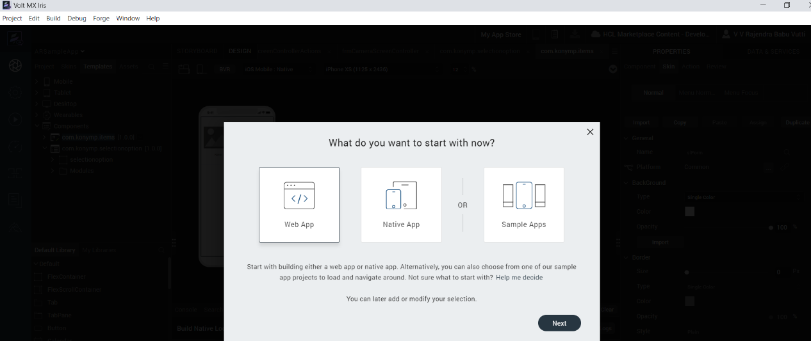

Select Augmented Reality App and then click on Choose button.

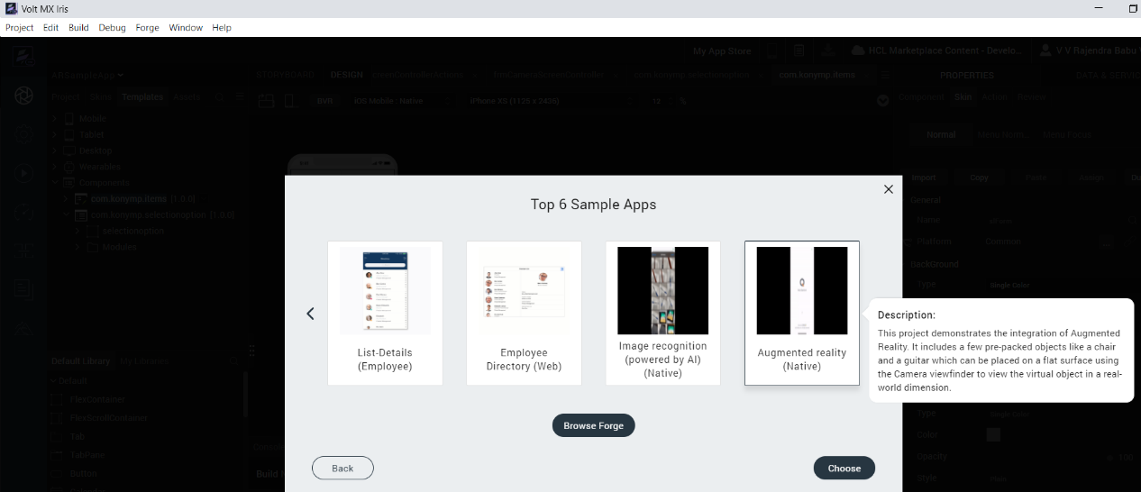

From the **Project** explorer, go to **Mobile**, expand **Forms**, and then verify whether the **frmDashboard, frmCameraScreen** is successfully imported to the existing application

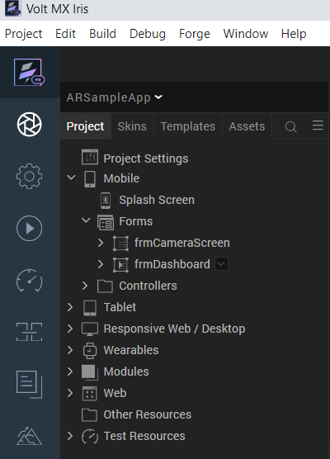

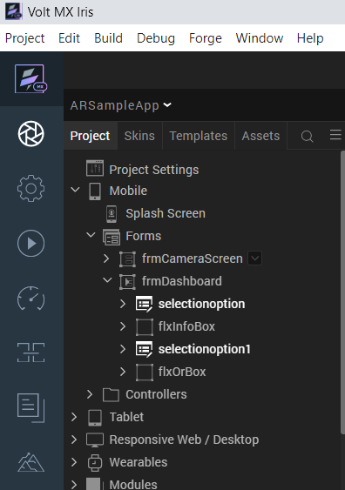

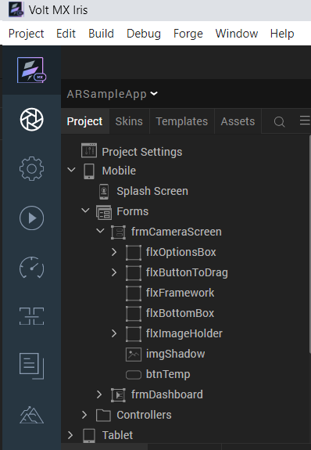

Go to **Templates**, expand **Components** and then verify whether the components are successfully imported to the existing application.

Build the App

From menu bar, go to **Build** and then select **Build Native Local**.

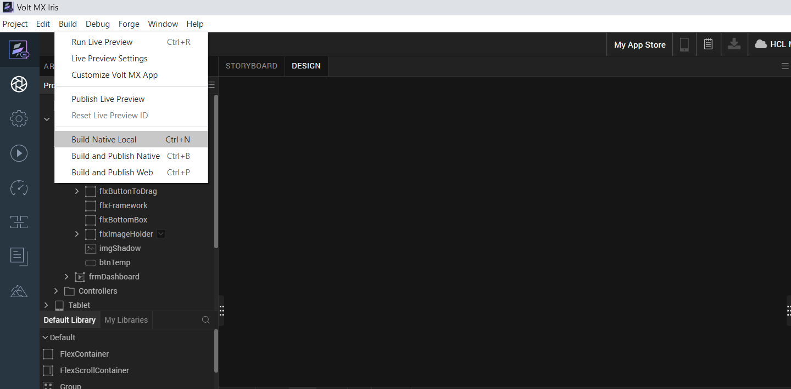

For **Mobile**, select **Android** and **iOS**. Click **Build**.

After the build is successful, run the app on your mobile device

Application Flow

The landing page for the app is as follows

Click on Scan and so The AR Renderer will ask the camera permissions as shown in below.

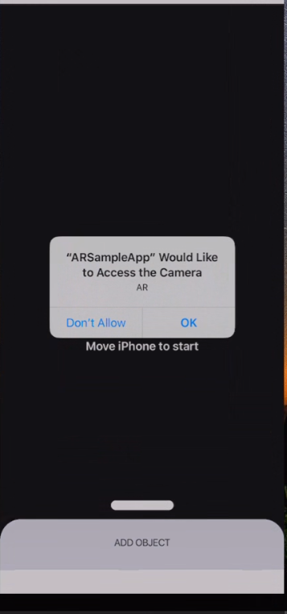

Once click on OK then it will starts searching for a plane surface.

Then add an object and you will see the selected object as show in the following screen shots.

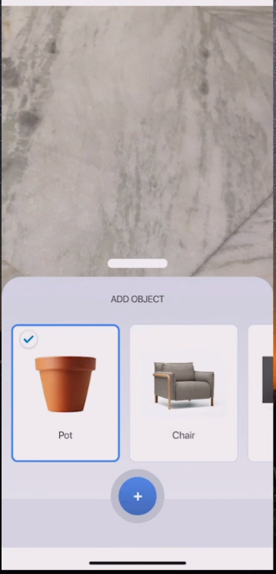

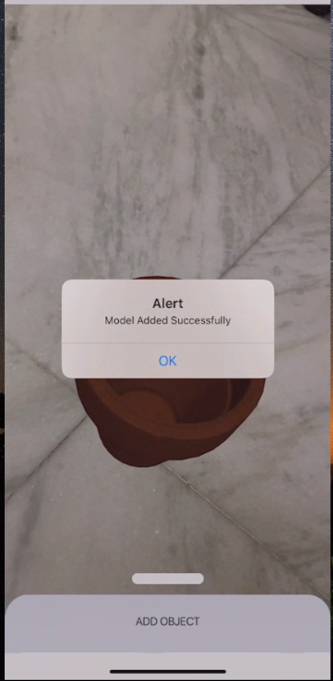

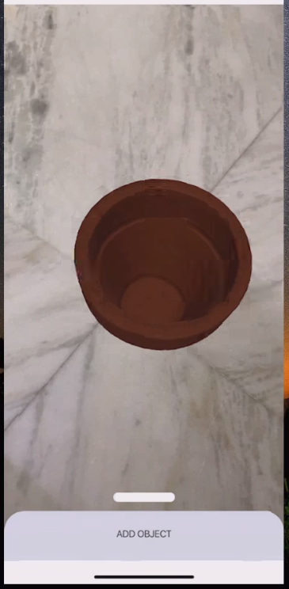

Select another object from list of objects and can see 3d view as shown in below images.

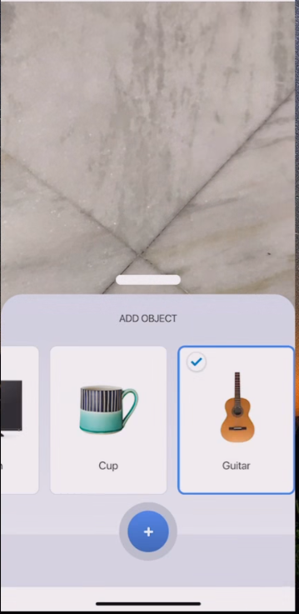

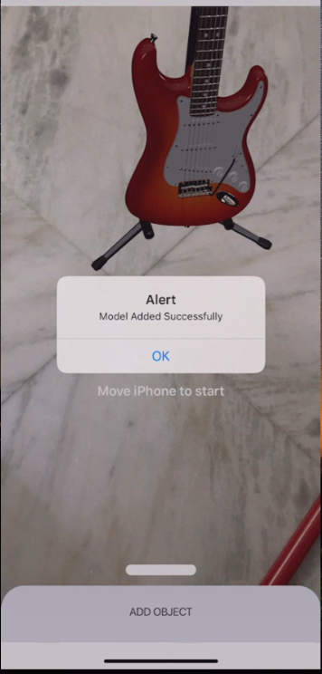

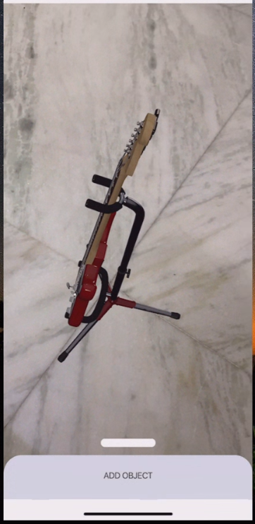

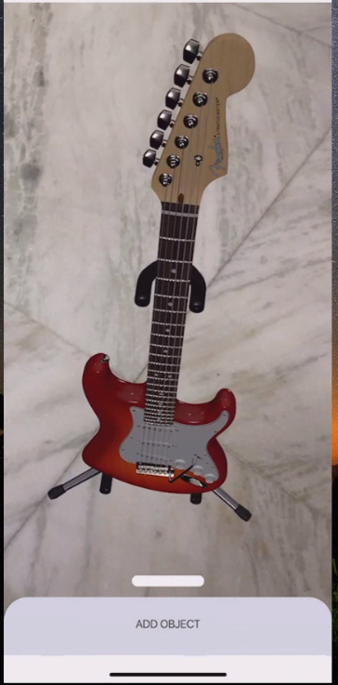

**Note:** For Android, the image is displaying very small and when moving the camera closely then the image is displaying in big size.