## ****HandsMen Threads Salesforce Project Report****

### ****Intern Details:****

**Name:** Pooja Soni

**Location:** Bhopal, Madhya Pradesh

**College:** Lakshmi Narain College of Technology

**Platform:** Salesforce Virtual Internship by SmartBridge

### ****Project Title:****

**HandsMen Threads Salesforce Project**

### ****Use Case Overview:****

HandsMen Threads, a forward-thinking organization in the fashion industry, aimed to streamline data operations and improve customer relationships through Salesforce. The objective was to develop a robust system that enables seamless business process automation, ensures data quality, and enhances overall operational efficiency.

### ****Core Functionalities Implemented:****

**Custom Data Model:**

1. Created custom objects:

* HandsMen\_Customer\_\_c
* HandsMen\_Order\_\_c
* HandsMen\_Product\_\_c
* Inventory\_\_c
* Marketing\_Campaign\_\_c

1. Defined relationships using Lookup and Master-Detail fields.

**Data Quality & UI Validation**

* Used validation rules and required fields to maintain integrity from the UI.
* Implemented formula fields like FullName\_\_c and Stock\_Status\_\_c.

**Lightning App Builder**

* Created a custom Lightning App with tabs for each object.
* Customized record pages for improved user experience.

**Screen Flows**

* Built guided flows for data entry, especially for creating new customers and orders.
* Example: Flow for capturing new order details linked to customer records.

**Record-Triggered Flows**

* Sent Order Confirmation emails automatically when new orders are placed.
* Triggered Loyalty Status updates based on Total\_Purchases\_\_c.

**Scheduled Flow: Loyalty Status Update**

* Runs daily at midnight.
* Updates loyalty status to:

Gold if Total\_Purchases\_\_c > 1000

Silver if 500–1000

Bronze if <500

**Email Templates & Alerts**

* Created:

Order Confirmation Email

Low Stock Alert

Loyalty Program Email

* Used HTML templates with Classic Letterheads.
* Set up email alerts for order confirmation and inventory low-stock notifications.

**Inventory Monitoring**

* Formula field Stock\_Status\_\_c on Inventory\_\_c to show stock availability.
* Triggered email alert to Inventory Manager if Stock\_Quantity\_\_c < 5.

**Asynchronous Apex**

* Developed a Batch Apex job (InventoryBatchJob) scheduled using

CopyEdit

Apex

System.schedule('Daily Inventory Sync', '0 0 0 \* \* ?', new InventoryBatchJob());

* Handles bulk updates of inventory and financials.

**GitHub Deployment**

* Pushed complete project metadata and screenshots to GitHub:

[GitHub Repository](https://github.com/Poojacoding/HandsMen-Threads-Salesforce-Project" \t "_new)

* Includes project source files, README, and demo video link.

### ****Skills & Tools Used:****

**Salesforce Platform**

**Screen & Record-Triggered Flows**

**Apex & Batch Apex**

**Data Modeling**

**Validation Rules & Formula Fields**

**Lightning App Builder**

**Git & GitHub**

**Email Templates & Alerts**

### ****Learning Outcomes:****

Through this project, I learned to:

* Design and model real-world business scenarios using Salesforce.
* Automate repetitive tasks through flows and Apex.
* Use declarative tools to build scalable applications.
* Push and manage Salesforce metadata using GitHub.
* Communicate with customers via automated emails.

### ****Attachments:****

**Screenshots:** Showcasing objects, flows, templates, records.

**Demo Video:** Uploaded on SkillWallet platform.

**GitHub:** Contains the metadata, flows, code, and assets.

### ****ScreenShots:****

**Custom Objects:**

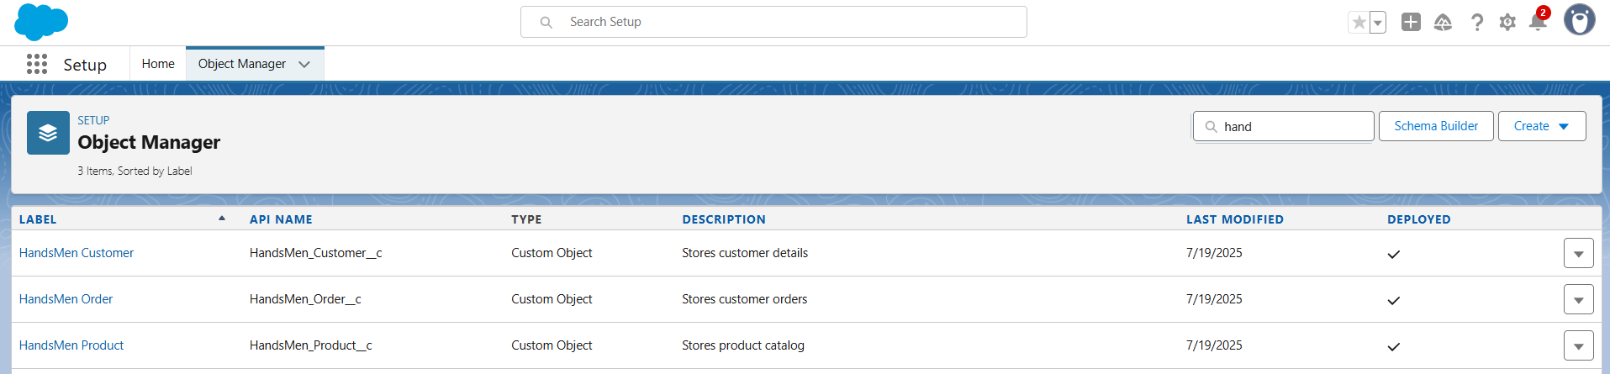

**HandsMen Threads App:**

### 

**Custom Tabs:**

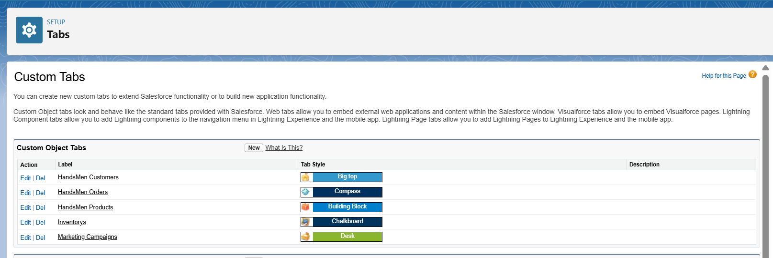

**HandsMen Customer Fields:**

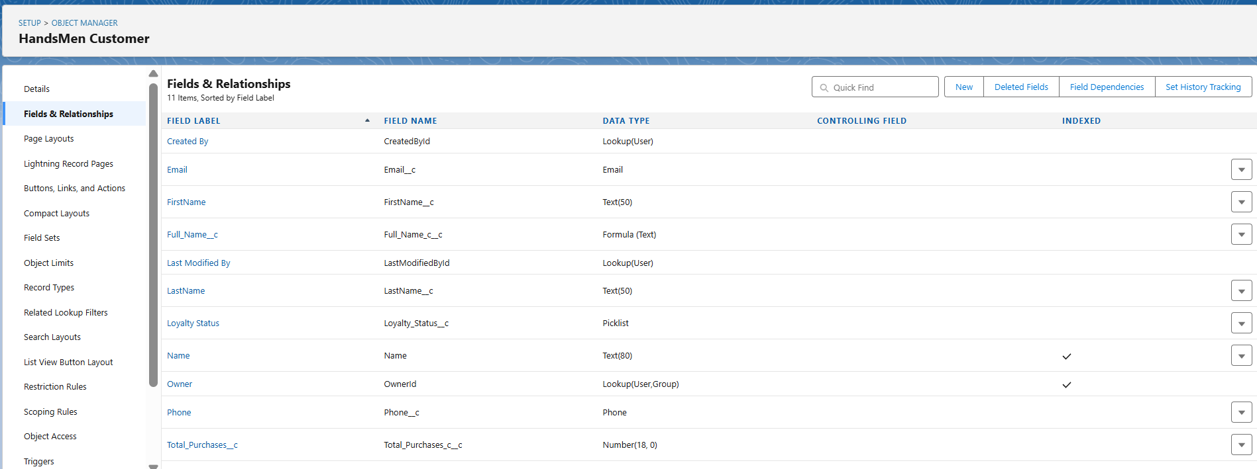

**HandsMen Order Fields:**

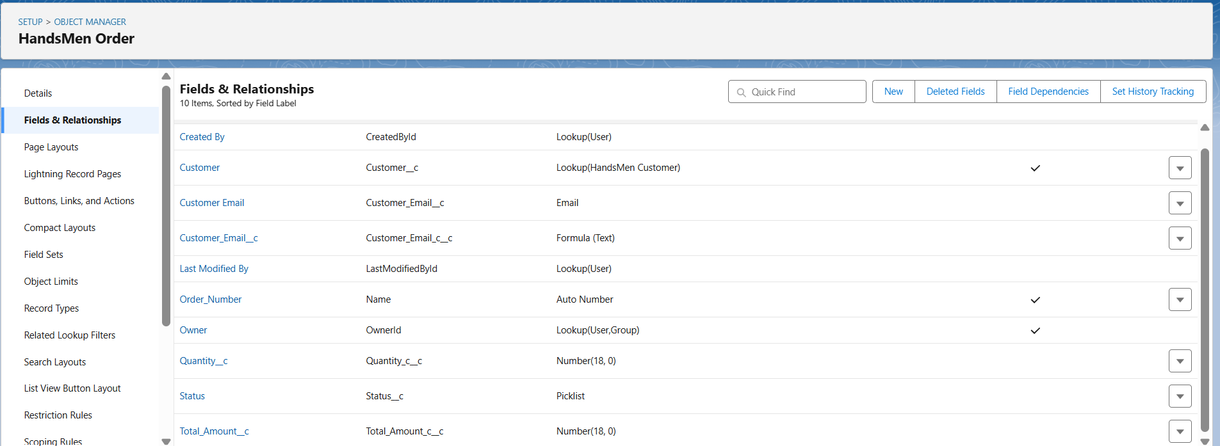

**HandsMen Product Fields:**

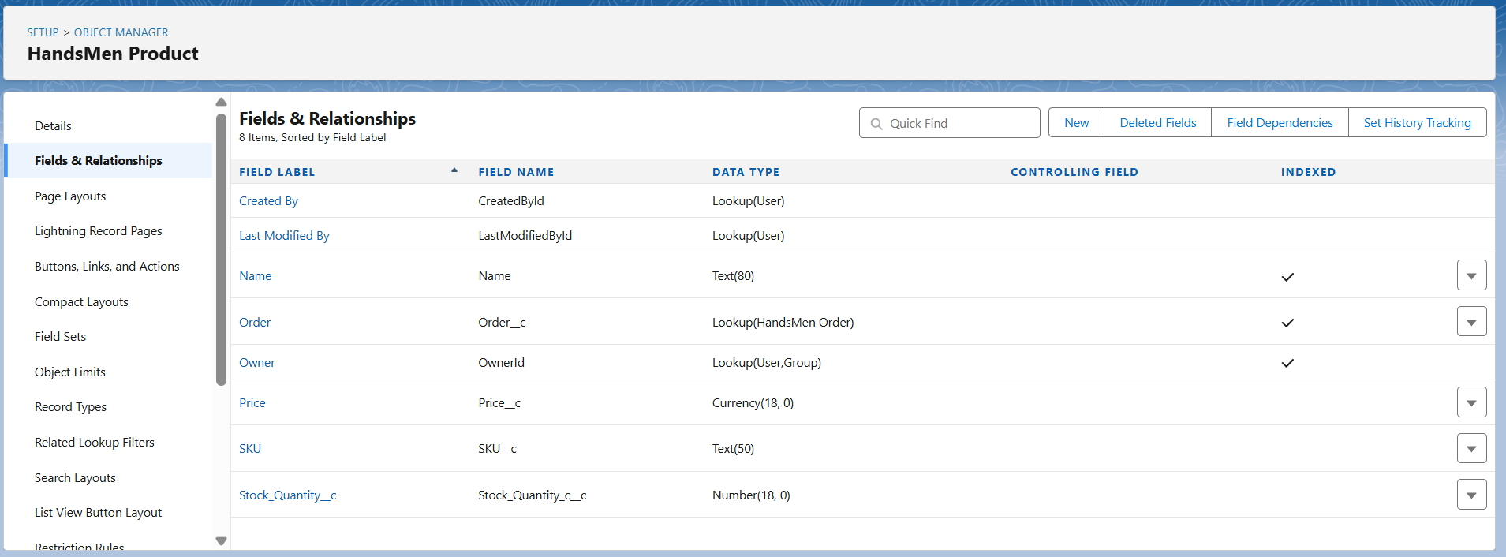

**Inventory Fields:**

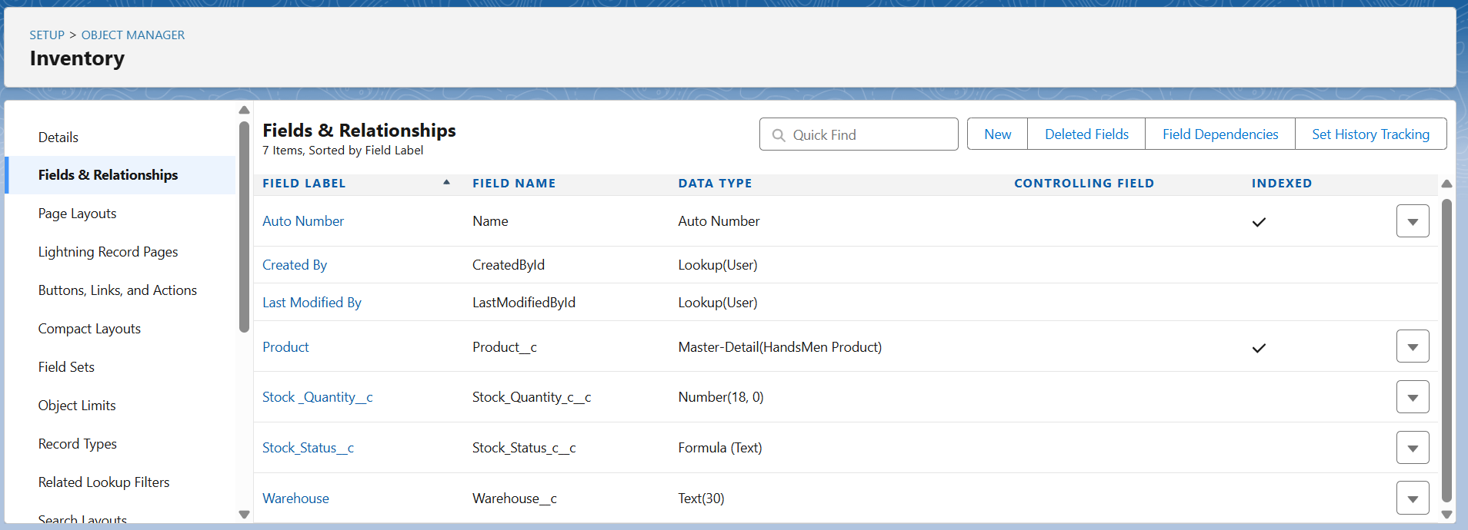

**Marketing Campaign Fields:**

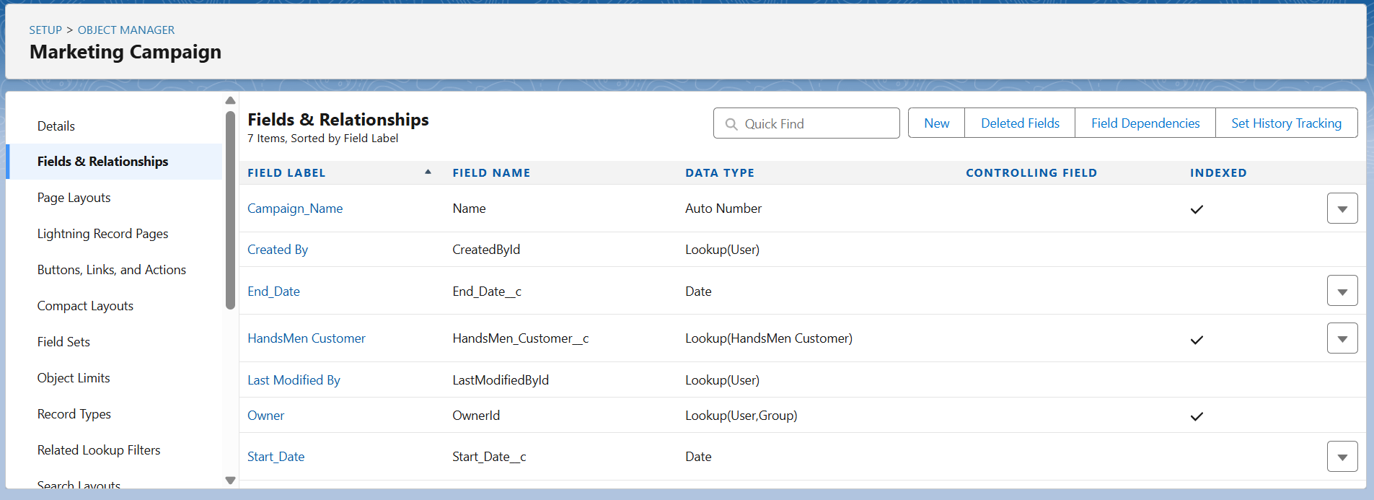

**Order Confirmation Flow:**

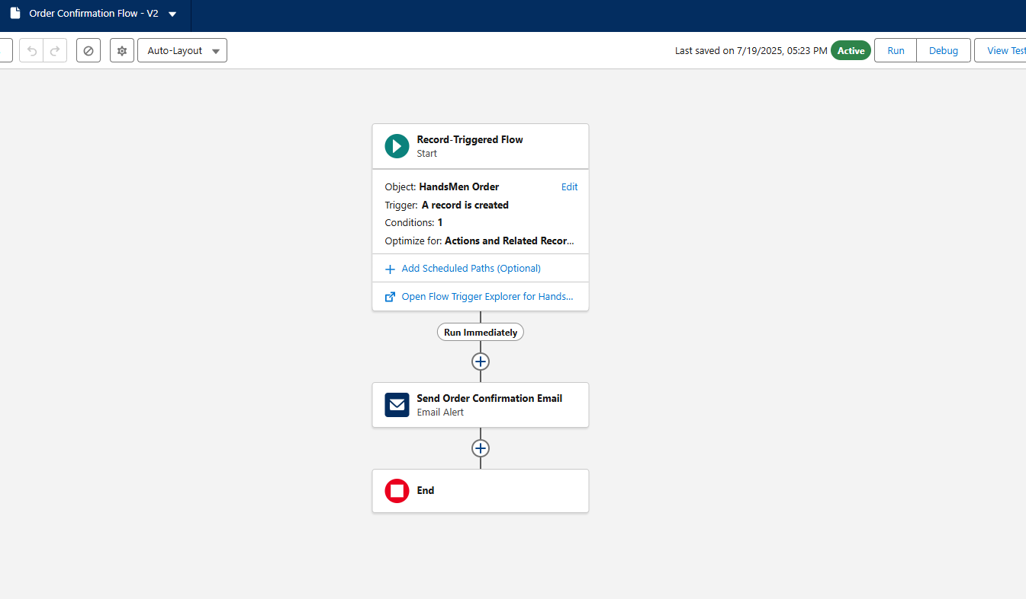

**Loyalty Status Update Flow:**

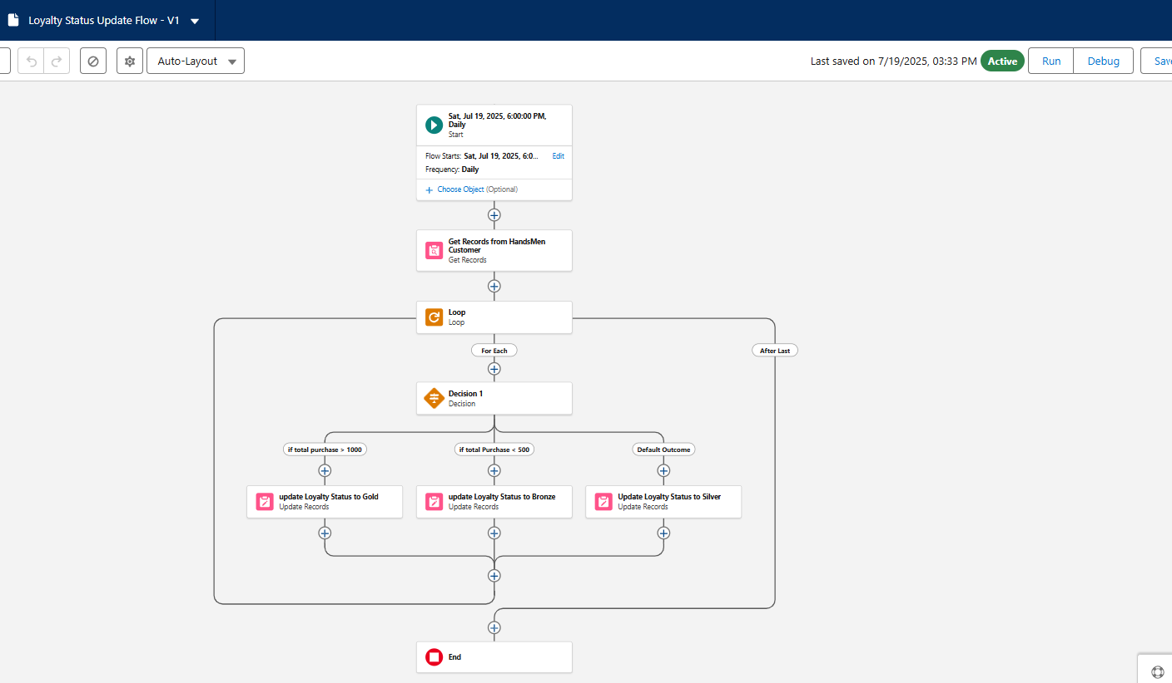

**Order Trigger Handler Apex Class:**

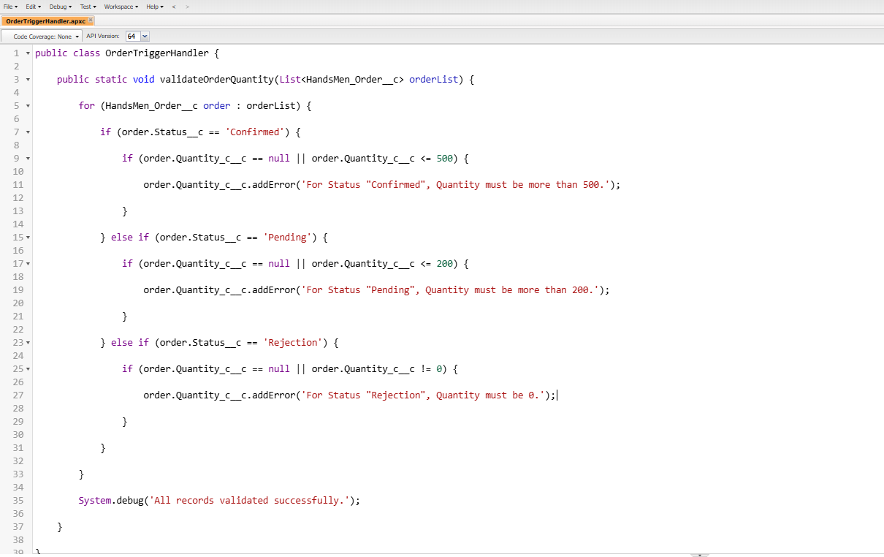

**Inventory Batch Job Apex Class:**

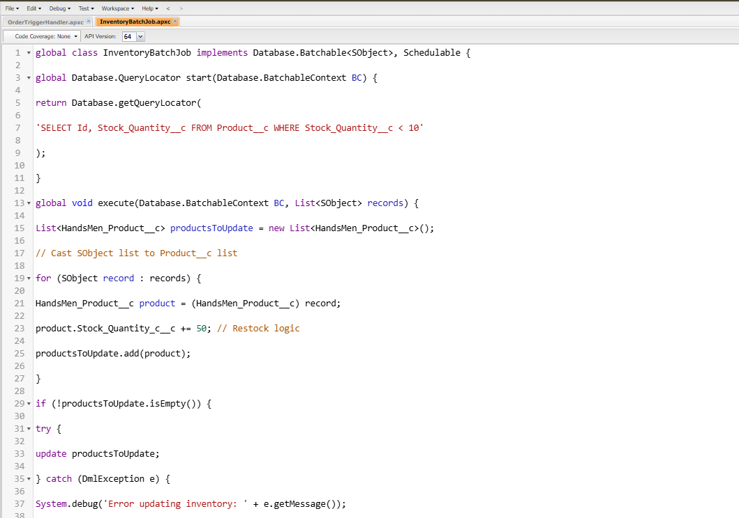

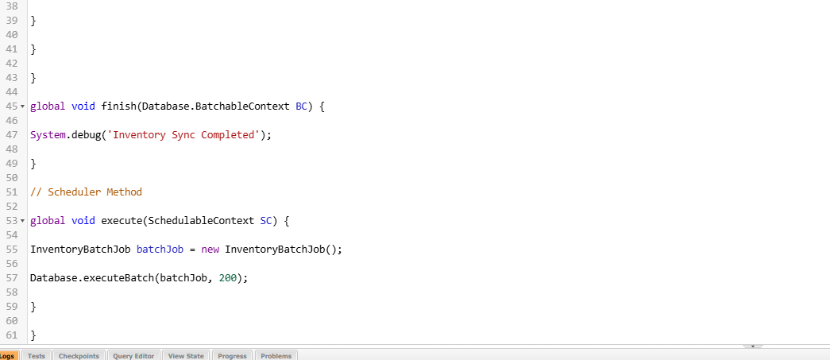

**Order Trigger:**

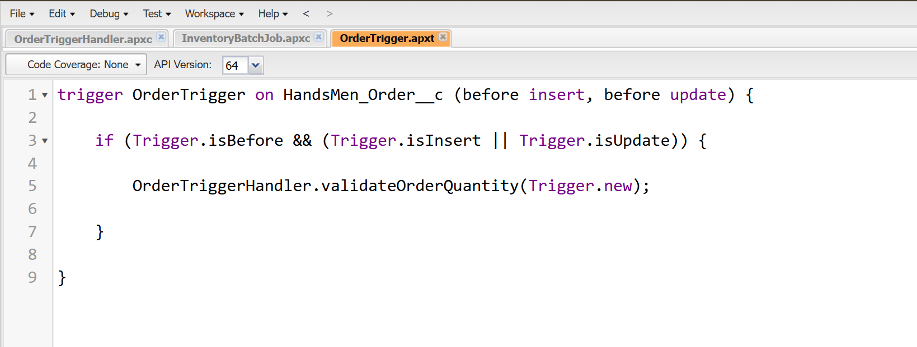

### ****Conclusion:****

This project gave me valuable insight into end-to-end Salesforce development—from UI-driven automation to backend data processing using Apex. It reflects how Salesforce can be tailored for industry-specific use cases like fashion retail and inventory management.

I’m grateful for the opportunity provided by SmartBridge and Salesforce and proud to have implemented a complete working solution.