mk Insights pro

Reference Guide

**MK Insights Pro**

Insights Pro is a web based application to effortlessly monitor and track agent-customer interactions that include calls/emails/chat. Supervisors and managers can easily get unique scorecards created to measure adherence and track business intelligence critical to their businesses. Contact center supervisors also get the opportunity to give online feedback to all the interaction audits completed. This console has unique features of customizable dashboards, trending reports, audit summary reports and more to help manage agent/team/vendor performance and identify new training opportunities.

**Key Features – MK Insights Pro:**

1. Full automated calls/chat/email evaluation
2. Enterprise performance dashboard
3. Dedicated consoles for QA managers and Call Center managers
4. Support for all types of QA forms -
5. Variable scales
6. Variable weights
7. Unlimited attributes
8. Attributes repository
9. Automated interaction upload process
10. Feedback console
11. Call Center roster management
12. Alert feature – This feature will only get triggered, when any call is marked as fatal error or zero tolerance
13. Data export to CSV
14. Call Embedding
15. Fully functional admin console
16. Extensive and customized reporting

**Evaluation Console**

There are two ways for data interactions using MK Insights Pro:

1. The evaluator can simply evaluate the data by directly using the form links provided on the console and in this method there is no process of uploading the data roster and assignment to the evaluators.
2. The evaluator can evaluate the data which are assigned to him by the supervisors. In this method roster uploading and assignment process must be done at the supervisor’s end before the calls are evaluated

This is the interaction console that provides information related to –

1. Total # of calls evaluated
2. Total # of calls not evaluated
3. Total # of mails evaluated
4. Total # of calls not evaluated

In order to fetch records, you need to select an option between evaluated or not evaluated, Interactive Type to be selected as calls or mails and lastly the Call Type as Inbound or Outbound.

Note: The option of selecting the Call Type will only be visible when Interactive Type is selected as “Calls”

***Edit Profile***: Under this tab you get an option to upload your profile pic and change your password

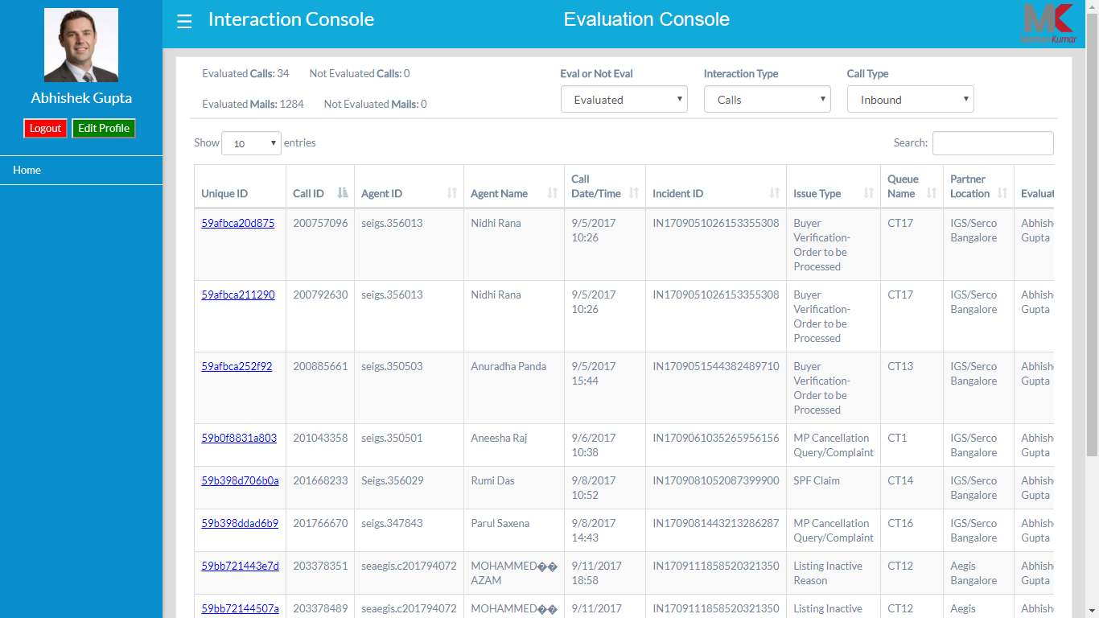

**QA Supervisor Console**

**Dashboard**: This is the first landing page and also termed as Supervisor Analyst Dashboard. You would be able to check the dashboard after selecting the filters. Please be informed that only the filters which are stated beneath are compulsory to be filled out, rest are optional. Also, by default, this console will have the information of the current month

1. Date Range
2. Evaluation Type
3. Form Type

After these filters are filled, click on the “Submit” button to fetch out the following reports:

1. Evaluation Count (in #): This will show the total number of evaluation completed by the evaluators for each agents
2. Average Evaluation Scores (in %): You would be able to check the average evaluation scores of all those calls which are evaluated for all the agents

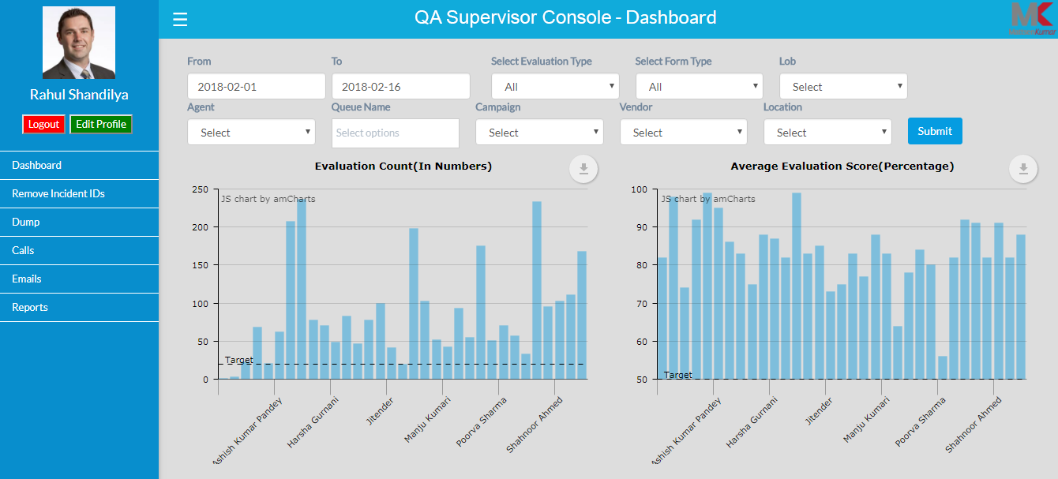

1. Evaluation Count (Date Wise): Get information related to the total number of calls evaluated on a daily basis
2. Average Evaluation Scores (Date Wise): You can check the average evaluation scores of all those calls evaluated for all agents on a daily basis

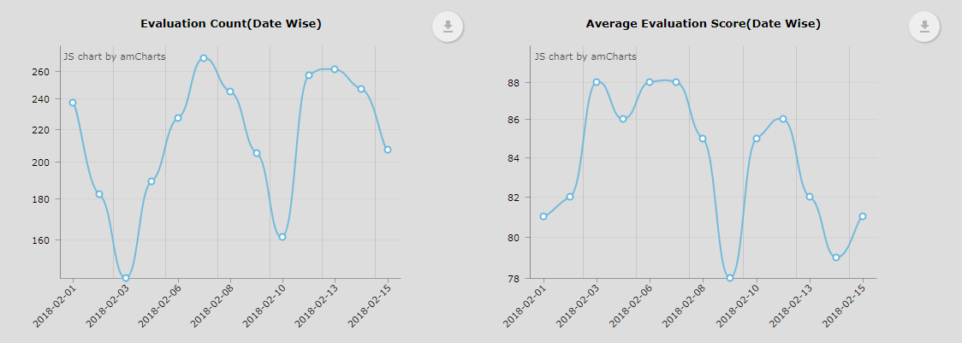

1. Date Wise Evaluation and Fatal Percentage: You will be able to see all the evaluated call along with the Fatal or autofail percentage on a daily basis

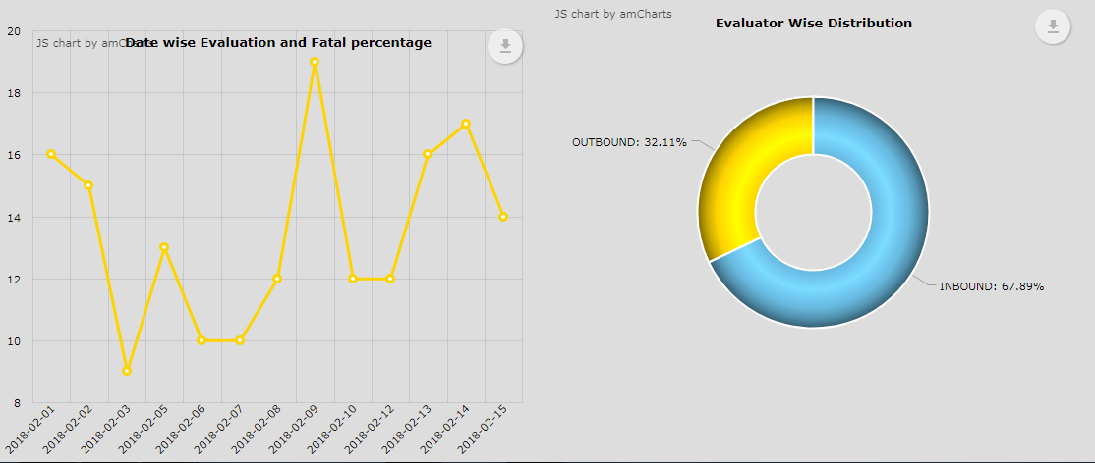

**Remove Incident IDs**: This section is used to unassign all the assign calls or evaluations in bulk. You can select the data type from the dropdown as (Call or Email)

Remember – only the .CSV format file is allowed to get uploaded to perform this action.

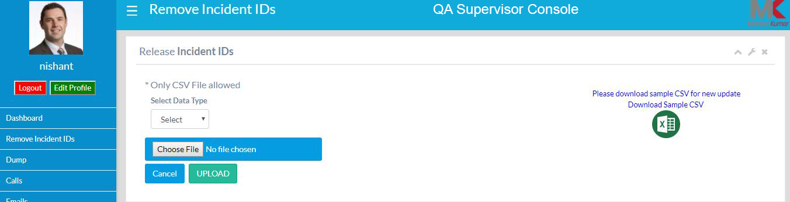

**Data Dump**: Now you can get the dump by simply filling the essential filters like –

1. Type of Evaluation
2. Type of Dump
3. By selecting the Date Range or Roster Date

Optional filters are also there which can also be filled like, LOB, Campaign, Vendor, Location, and Agent ID



**Calls**:

1. ***Call Bulk Upload***: Here you can upload the raw data related to the Calls or Roster. The only format which is allowed is .CSV format

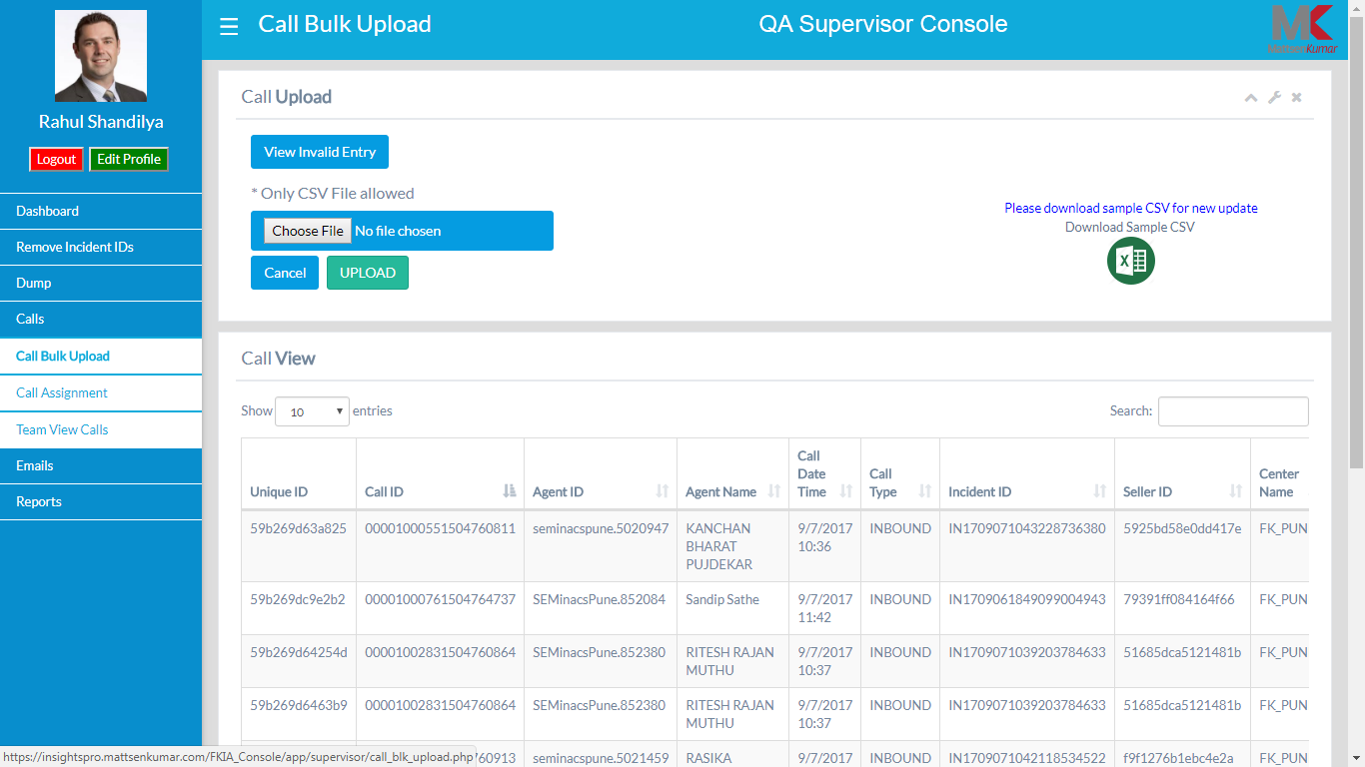

1. ***Call Assignment***:

* You can assign calls to evaluators on the basis of Roster data or Date range where you also need to select the Queue name and Agent ID
* You can also fill value as how many record you would want to fetch under latest record per agent field
* You have an option to select the multiple unique ids and assign them to any listed evaluator
* You also get the search button to search for any unique IDs

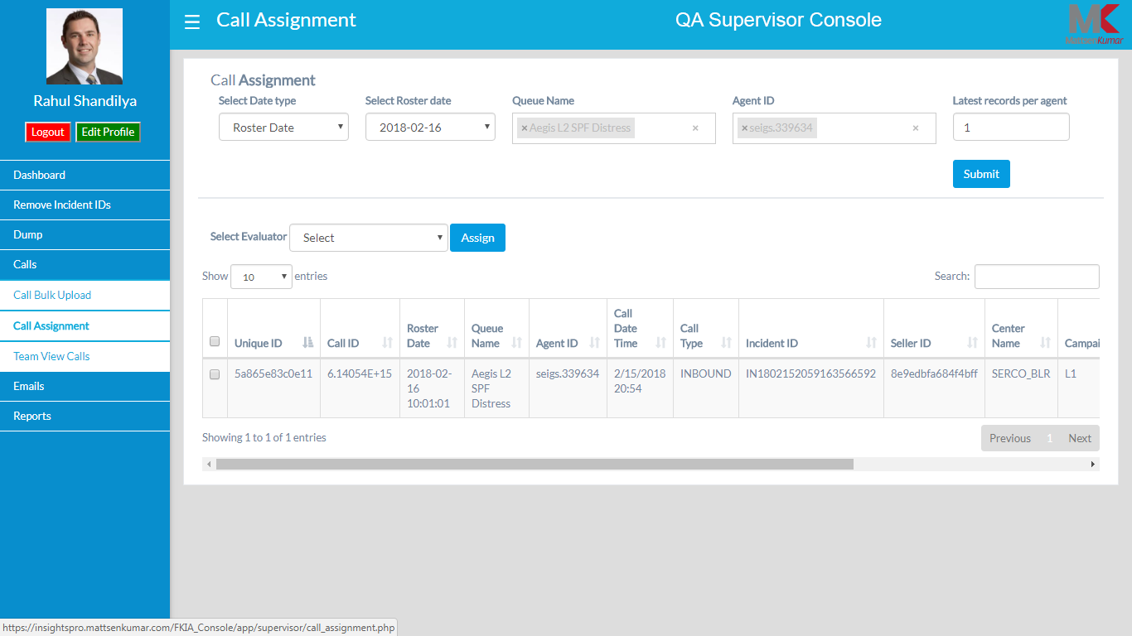

1. ***Team View Calls***:

* You would require to select the filter as the date range, Form name, evaluator, LOB, Campaign, Vendor, Location and Queue name
* After the filtering process is done, you get an information regarding the total number of Calls assigned, Evaluated and Not Evaluated by the evaluator in the list
* You have an option to copy, print or download csv file by clicking on any of the tabs respectively
* Search option on the console is there for any customize search

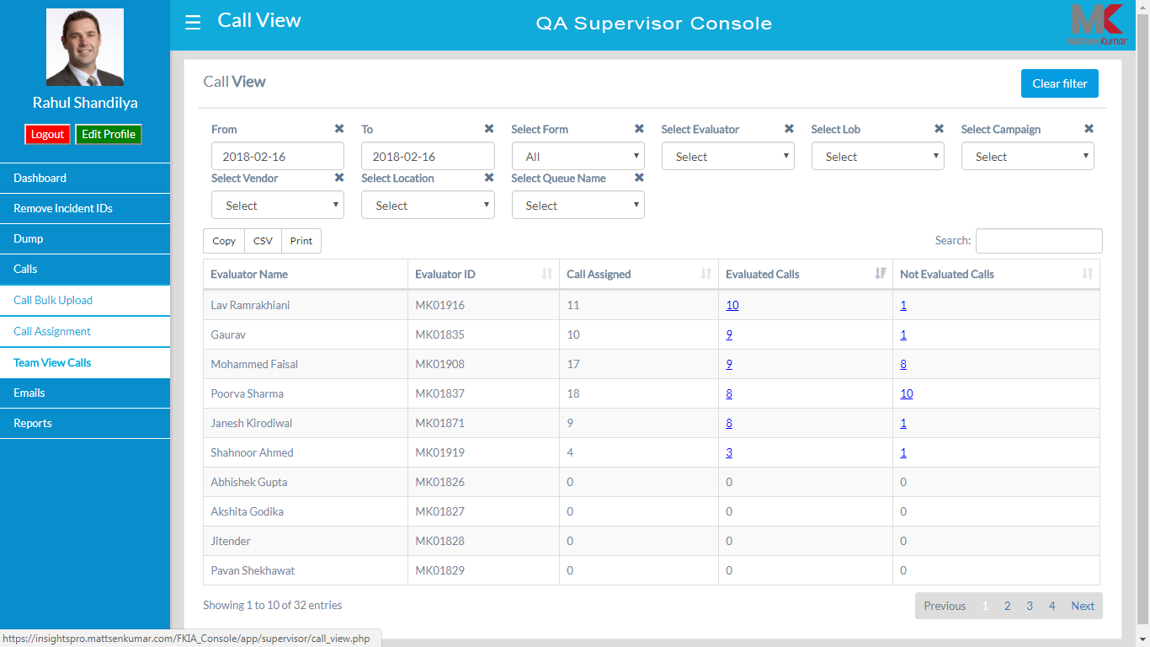

**Emails**:

1. ***Email Bulk Upload***: Here you can upload the raw data related to the Mails or Roster. The only format which is allowed is .CSV format

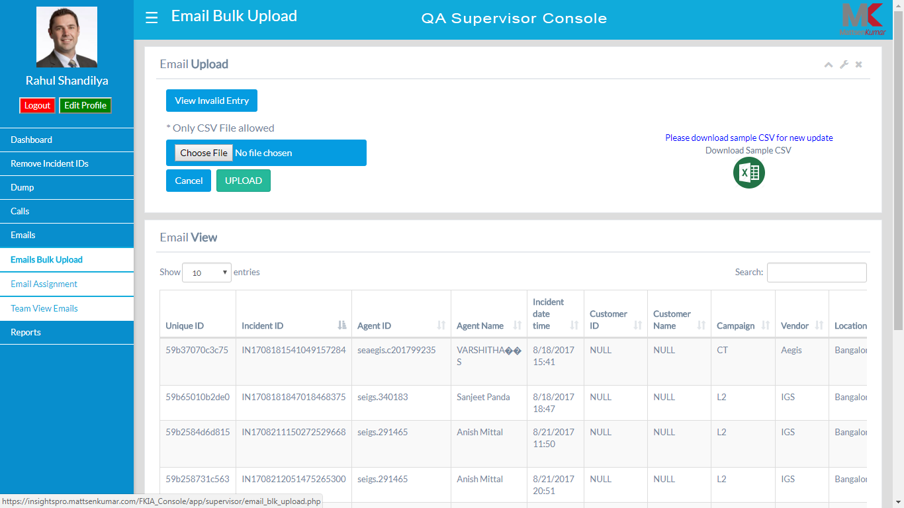

1. ***Email Assignment***:

* You can assign calls to evaluators on the basis of Roster data or Date range where you also need to select the Queue name and Agent ID.
* You can also fill value as how many record you would want to fetch under latest record per agent field.
* You have an option to select the multiple unique id and assign it to any listed evaluator
* Search option on the console is there for any customize search

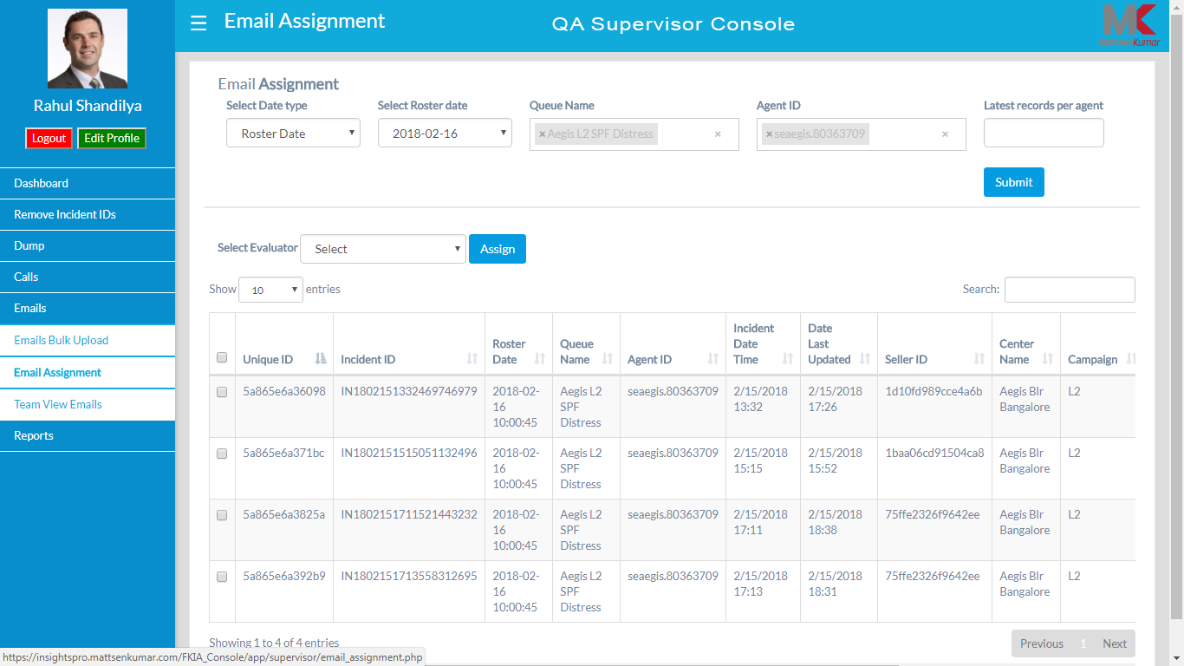

1. ***Team View Emails***:

* You would require to select the filter as the date range, Form name, evaluator, LOB, Campaign, Vendor, Location and Queue name
* After the filtering process is done, you get an information regarding the total number of Emails assigned, Evaluated and Not Evaluated by the evaluator in the list
* You have an option to copy, print or download csv file by clicking on any of the tabs respectively
* You Search option on the console is there for any customize search

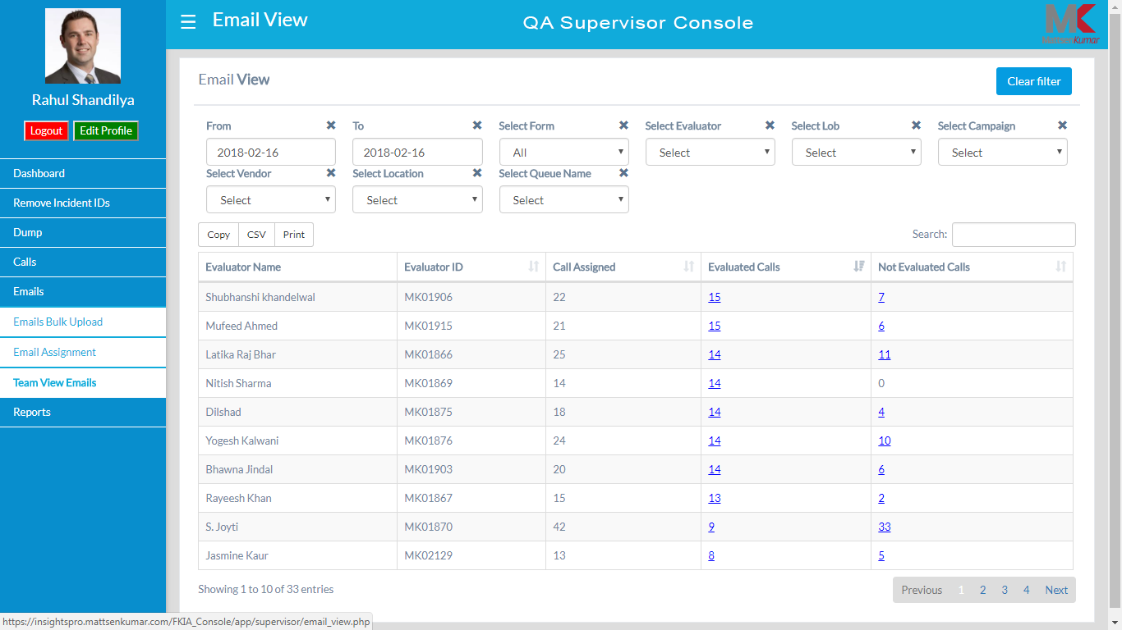

**Reports**:

1. ***Interaction Analyst Trending***:

* You would require to select the date range, type of form (calls/mails), form name as an essential filters, however, there are other optional filters available to select like evaluator, LOB, campaign, vendor, location, queue name
* After the filters are selected, you can check for the weekly trend of the reports like – how many evaluations have be done, total number of evaluators, AHT, and average evaluation scores

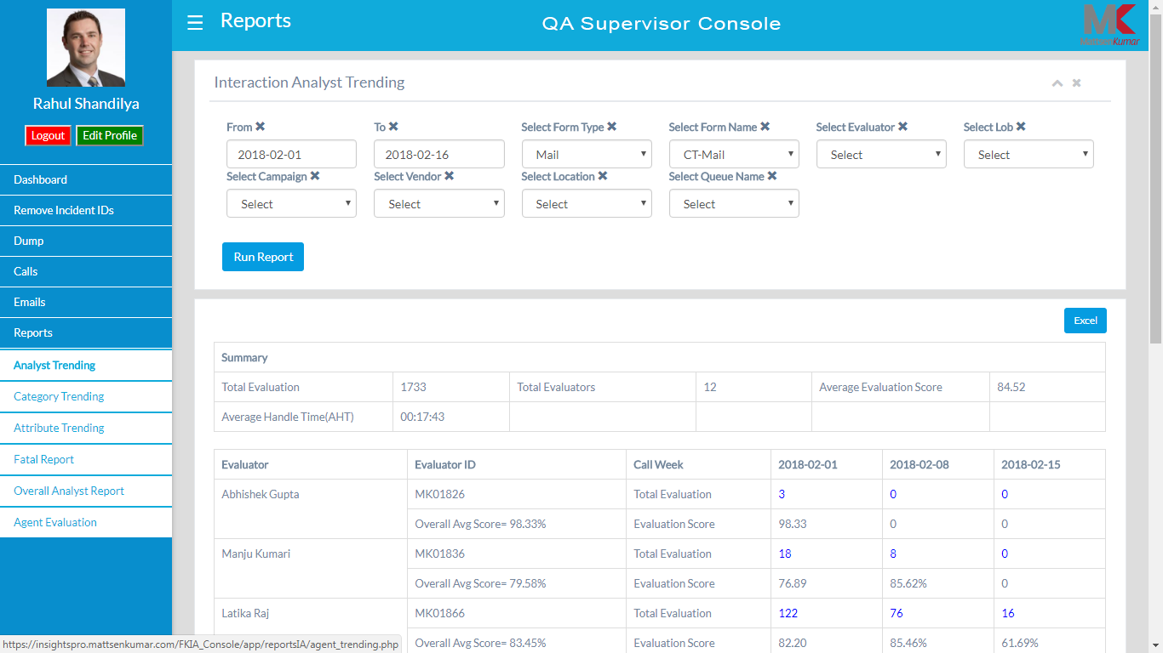

1. ***Category Trending***:

* Fetch a category trending report after you have filled all the filters like date range, type of form (calls/mails), form name as an essential filters, however, there are other optional filters available to select like evaluator, LOB, campaign, vendor, location, queue name
* These categories are the ones which are listed in the evaluation sheet. The report will portray individual category weightage in the percentage format

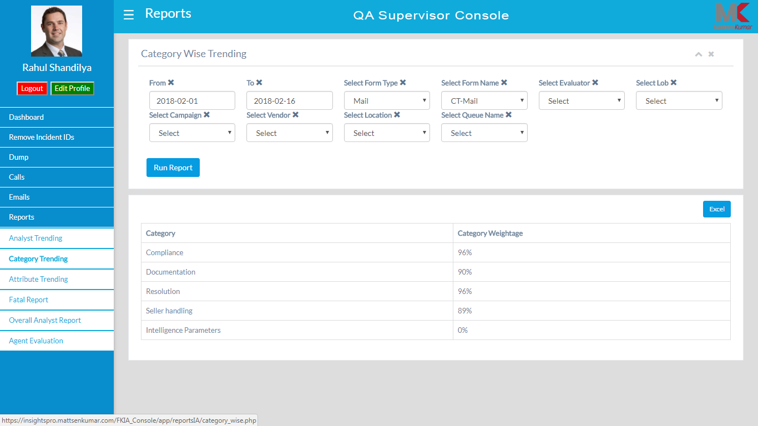

1. ***Attribute Trending***:

* To get this report you need to fill all the filters like date range, type of form (calls/mails), form name as an essential filters, however, there are other optional filters available to select like evaluator, LOB, campaign, vendor, location, queue name
* The report comprises of Category, Attribute, Attribute Answer, Attribute Count and last but not the least percentage of Attribute weightage score

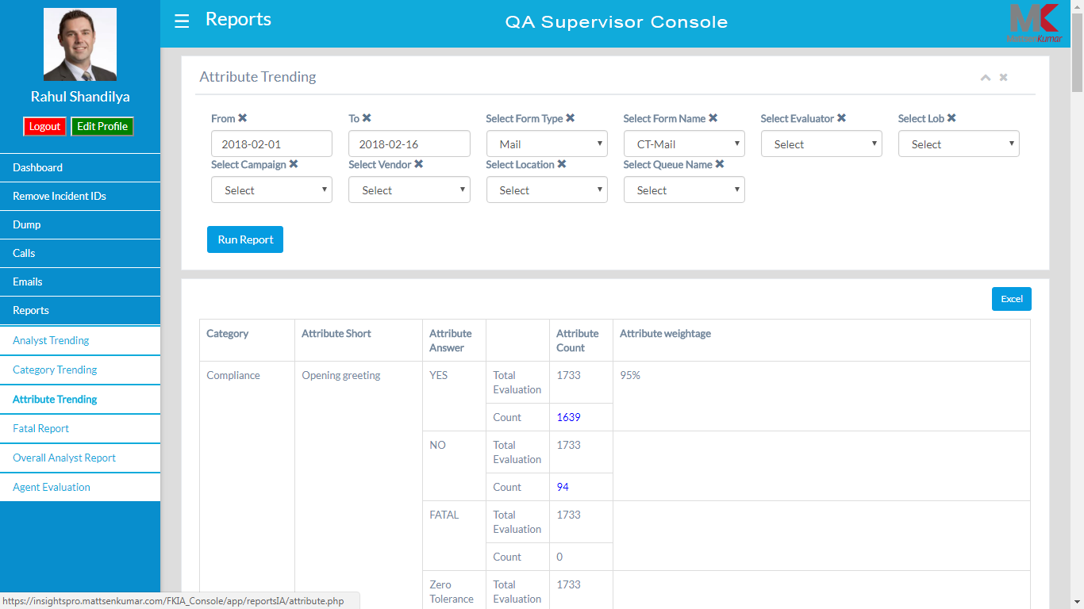

1. ***Fatal Trending***:

* This section will provide you the total number of Fatal count between the date range and partner location selected in the filter along with the form, evaluator, queue name
* You can also download the data in the excel format

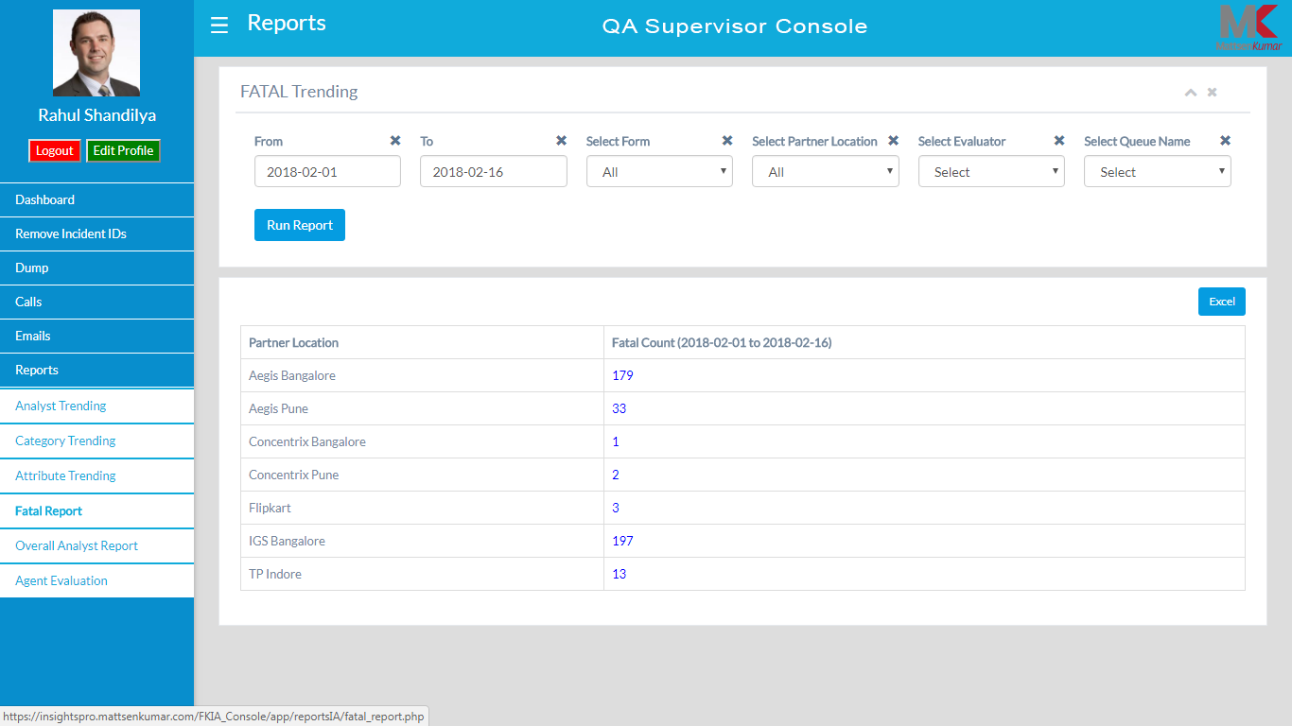

1. ***Overall Analyst Report***:

* To gather the summary you need to fill all the filters like date range, type of form (calls/mails), form name as an essential filters, however, there are other optional filters available to select like evaluator, LOB, campaign, vendor, location, queue name
* The summary will display total number of evaluations completed within the specific date range, total evaluators, average evaluation score, average evaluation time, AHT, average call duration
* You can also download the data in the excel format

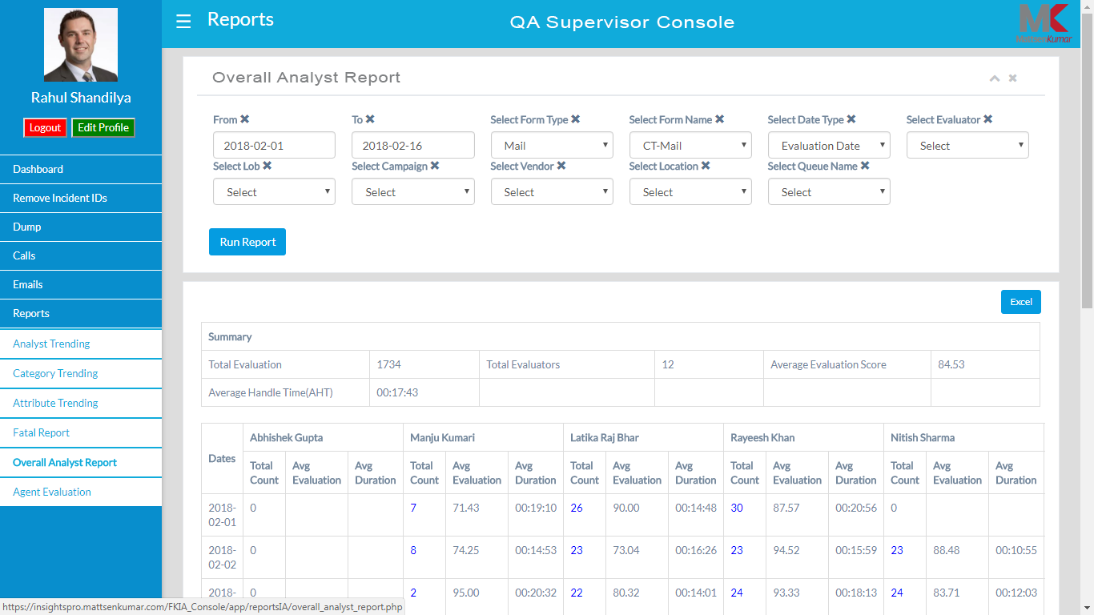

**Call Center Manager Console**

This domain is for the client end supervisor where all the agent level reports are accessible. All the report will only be fetched after filling out the filters like, date range, type of form (calls/mails), form name, vendor, location, campaign, LOB. Following are the reports which can be viewed.

1. ***Agent Evaluation Count***: This section will provide agent wise detail report like total number of evaluations completed by every agents

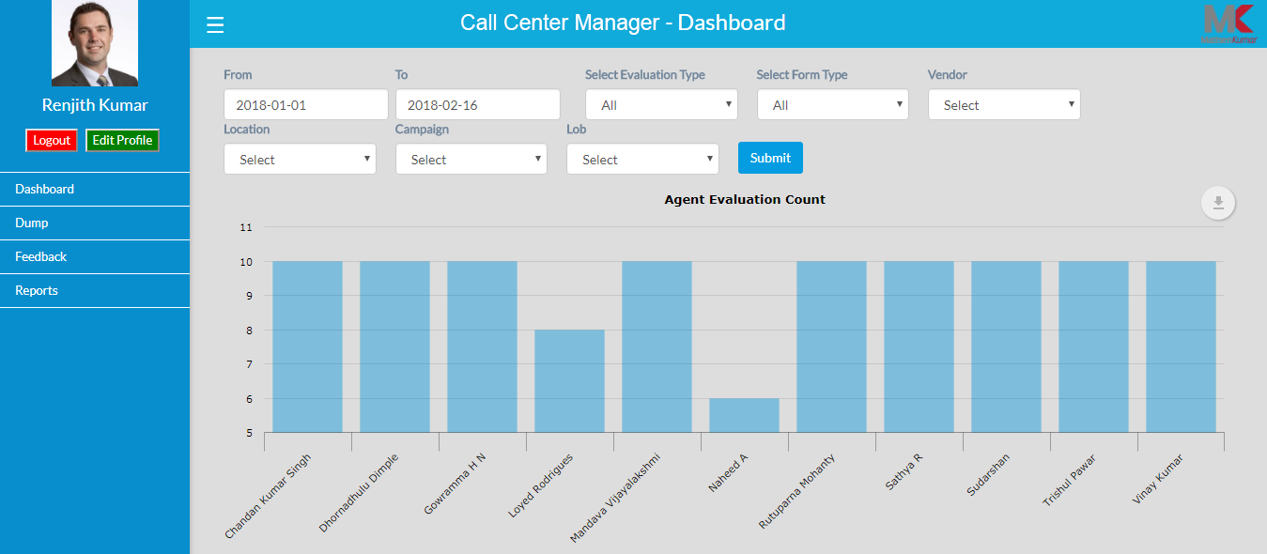

1. ***Agent Evaluation Score***: You can check the evaluation score of all the agents, where it has been considered that the threshold for all the agents would be 80%. Agents who have scored more than 80% are above the threshold and rest are considered as below threshold or outliers

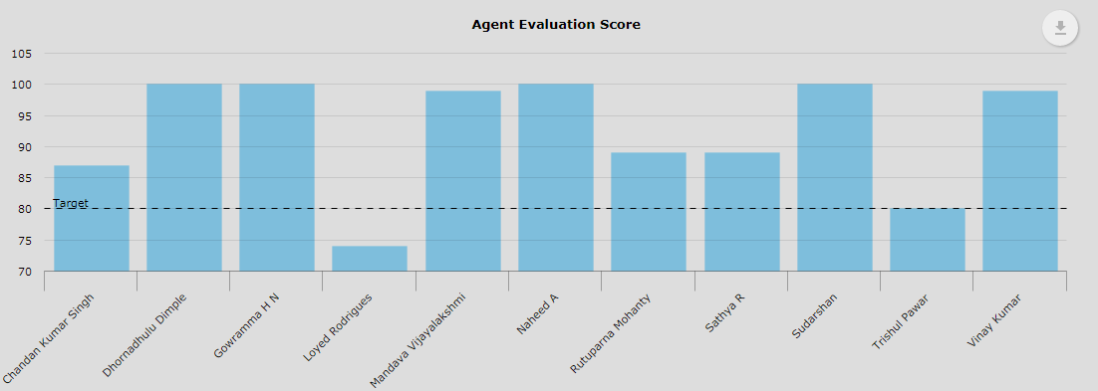

1. ***Total Evaluations vs Fatal (%) (Datewise)***: This graph will tell you the total number of evaluation done by each agents and the fatal percentage on a daily basis

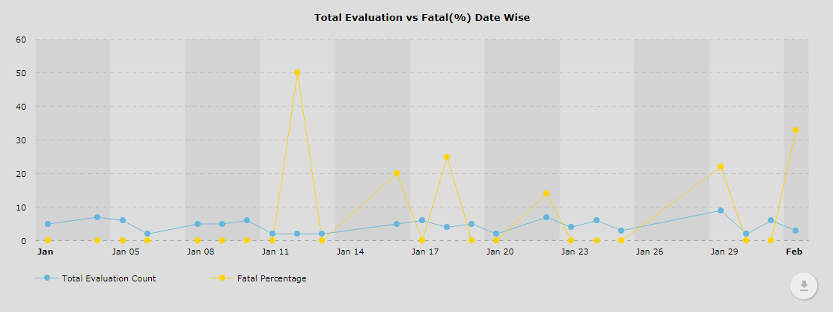

1. ***Total Evaluations vs Fatal Count (Date wise)***: You get information related to the total number of evaluation and the fatal percentage done by each agents on a daily basis

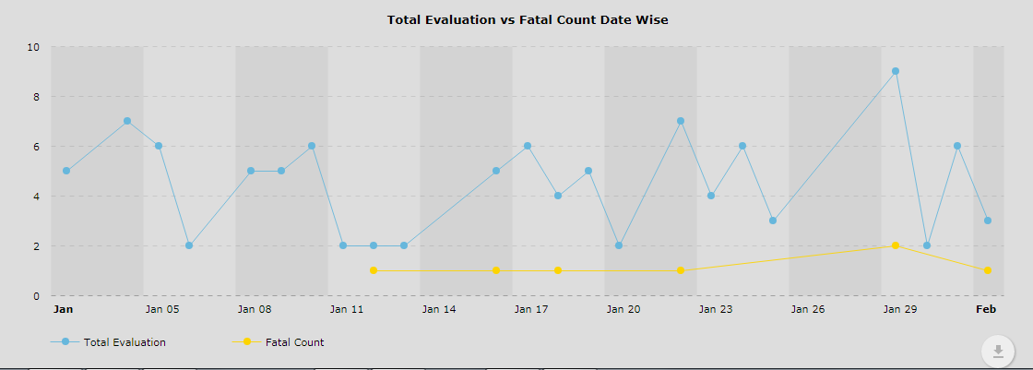

**Data Dump**

This console has filters which has to be filled in order to get a summary of all the calls which has already been audited of each agent. The data can be segregated by selecting the Date range or Roster date

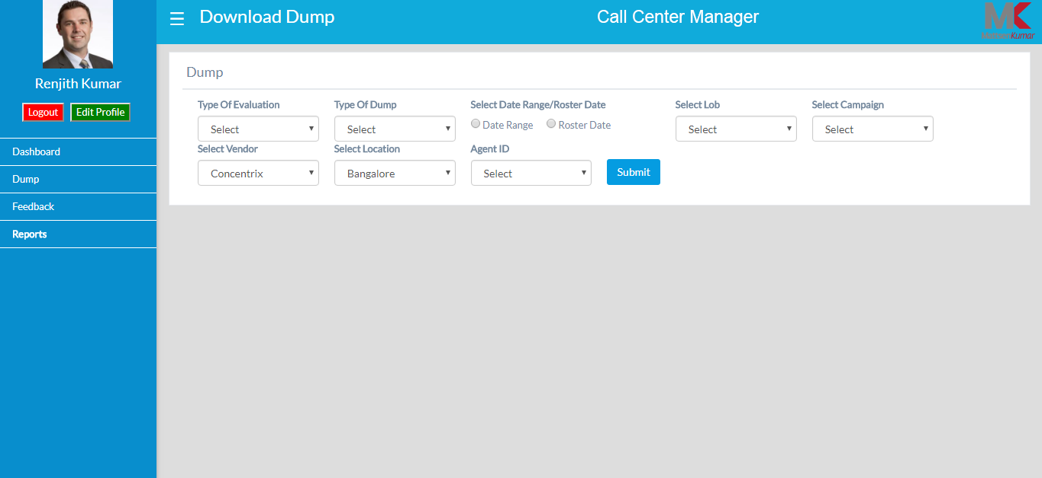

**Feedback**

After selecting all the filters, you would be able to see all total number of audit counts and Feedback count by each agent.

1. Once you see the total audit count, you can click on that number to get more information about the audits like, evaluator’s name, vendor, location, score.
2. You can also check if the feedback is given on any of the calls audited or not, under the feedback section
3. If you click on the unique id you will get the complete QA form marked by the agent. Also you will be able to see the attribute scores and category scores for each calls done by each come to know about the category scores, attribute scores of each agent

Note: you can further copy, download in csv format or print the report directly from that console

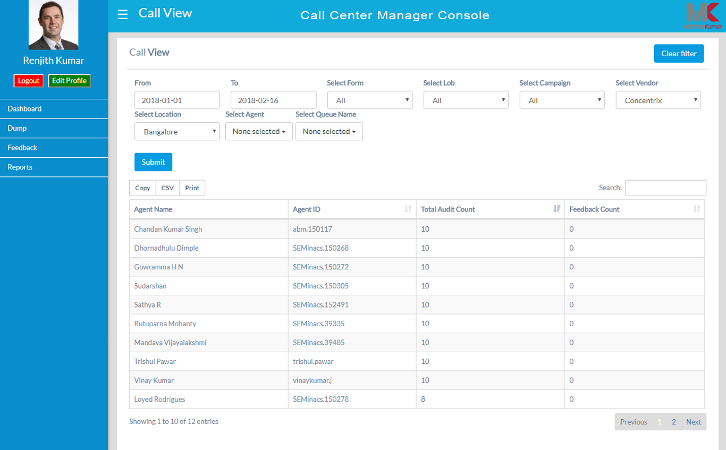

**Reports**:

1. ***Agent Trending***:

* You would require to select the date range, type of form (calls/mails), form name as an essential filters, however, there are other optional filters available to select like evaluator, LOB, campaign, vendor, location, queue name
* After the filters are selected, you can check for the weekly trend of the reports like – how many evaluations have be done for each agents, AHT, and average evaluation scores

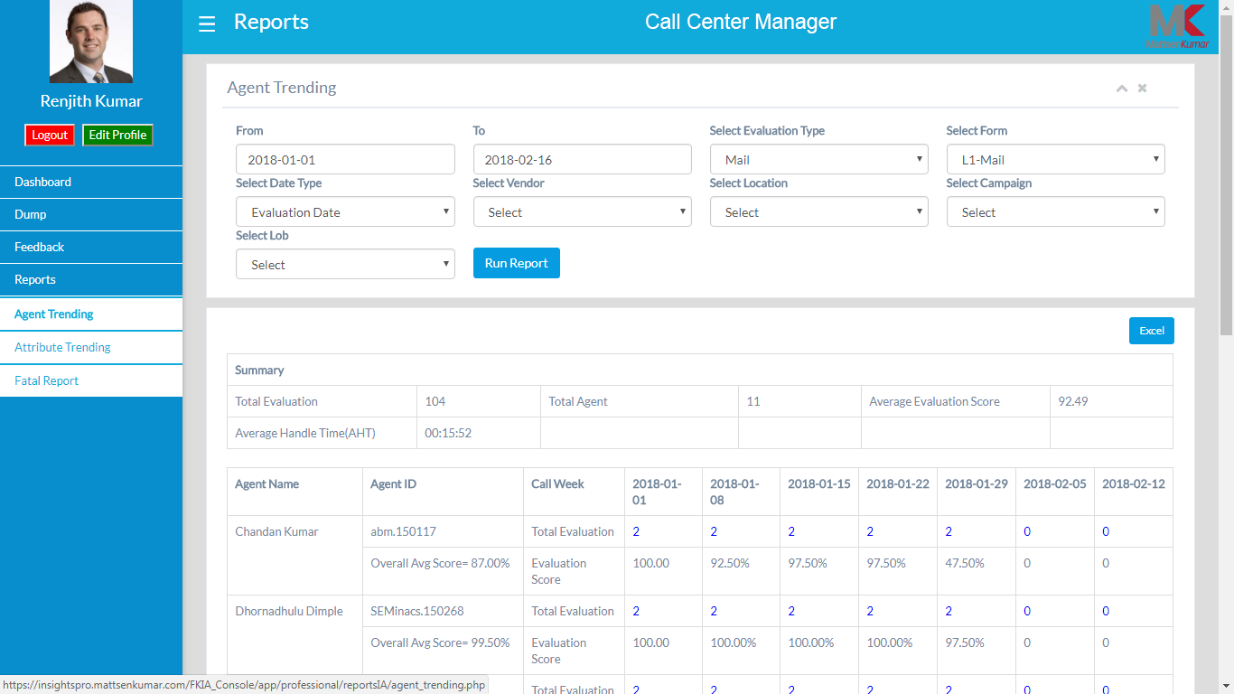

1. ***Attribute Trending***:

* To get this report you need to fill all the filters like date range, type of form (calls/mails), form name as an essential filters, however, there are other optional filters available to select like evaluator, LOB, campaign, vendor, location, queue name
* The report comprises of Category, Attribute, Attribute Answer, Attribute Count and total evaluation done on a weekly basis

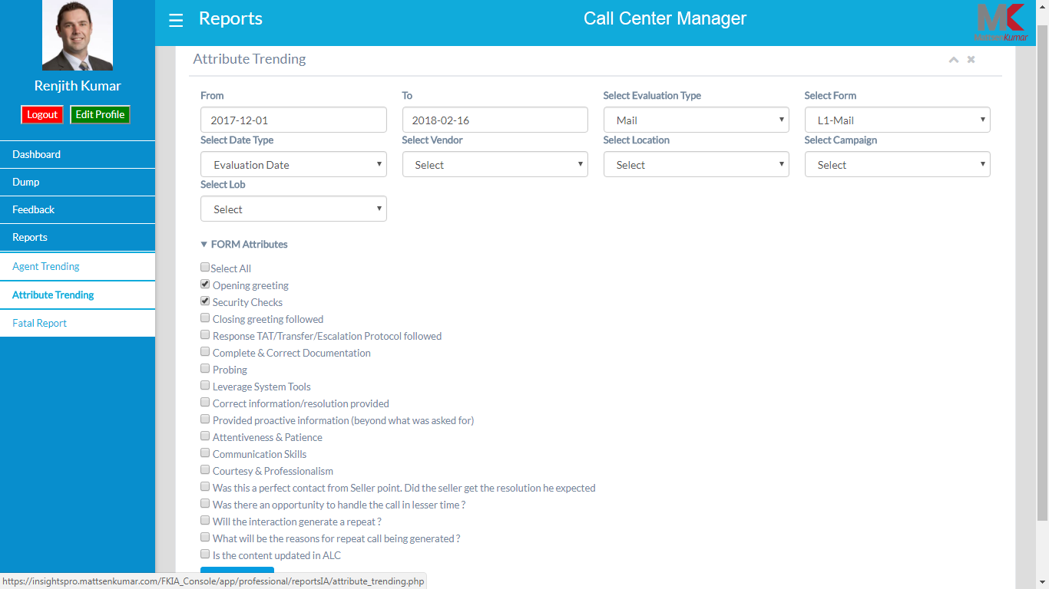

1. ***Fatal Trending***:

* This section will provide you the how many calls have been marked as Fatal by the evaluator. Unique Id in the report will make you see the form and attribute scores of each agent
* You can also download the data in the excel format

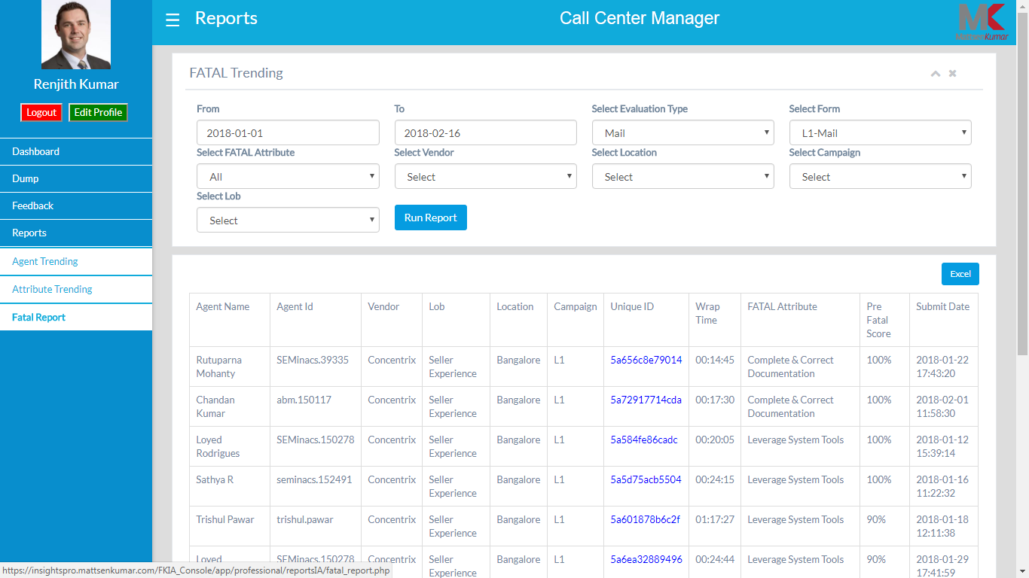

**Admin Console**

**Agent**:

* ***Agent Registration***: This console will allow agent registration one after the other according to the hierarchy. It is to keep in mind that the hierarchy is uploaded prior to register agent. Hierarchy will be in sequence like, LOB, Campaign, Queue Name, Vendor, Location, and Form Name

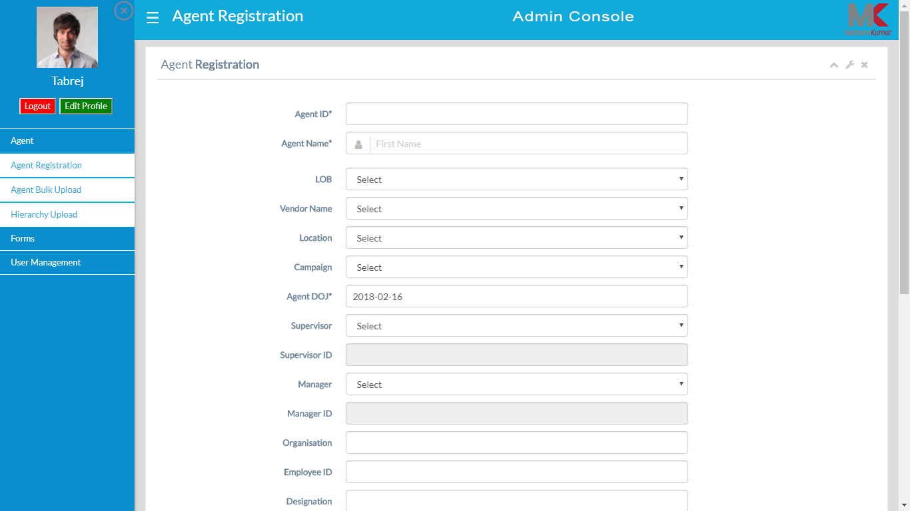

* ***Agent Bulk Upload***: You can upload the agent roster (in bulk as well) as per the hierarchy uploaded. If you want to view any invalid entry related to the agent, simply click on [Invalid Entry Button] and you will be able to see the details

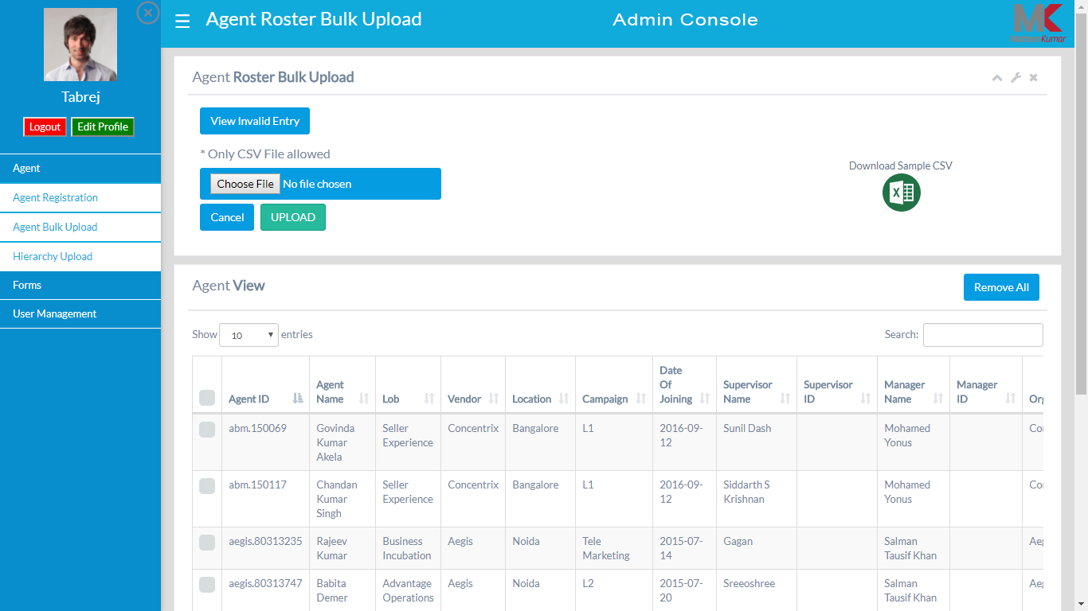

* ***Hierarchy Upload***: This section will have option to upload hierarchy in sequence like, LOB, Campaign, Queue Name, Vendor, Location, and Form Name. You can copy or print data as and when required

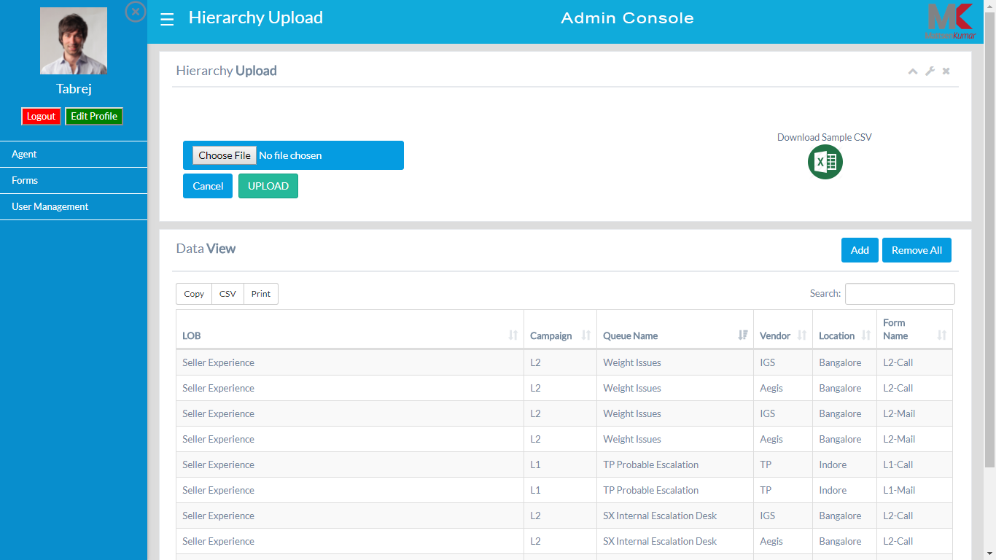

**Forms**:

* ***Form List***: This page will show number of forms embedded with insights pro console. You can also view Form Name, Version, and Number of Form Attributes. Form Link is a source to view complete form

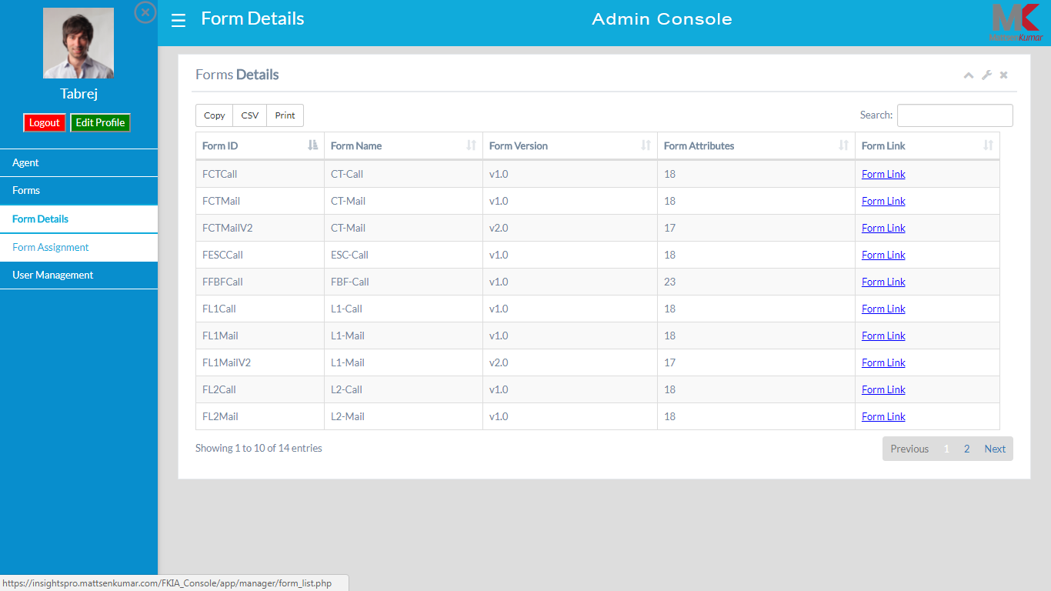

* ***Form Assignment***: You get an option to assign form by filling out the hierarchy fields like, LOB, Campaign, Queue Name, Vendor and Location

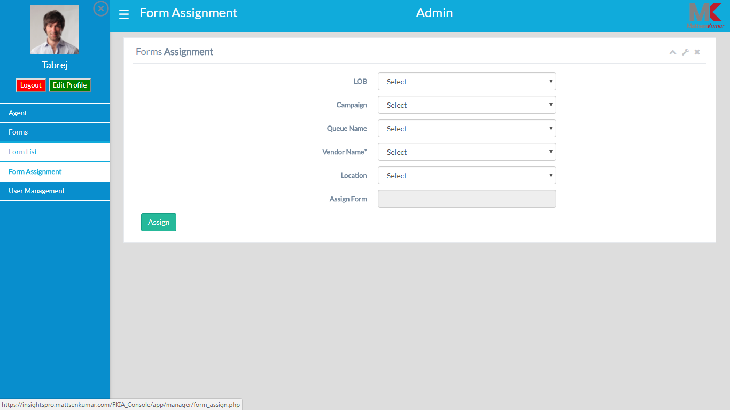

**User Management**:

* ***User Registration***: Here you can get your user registered by filling out various fields stated in the console

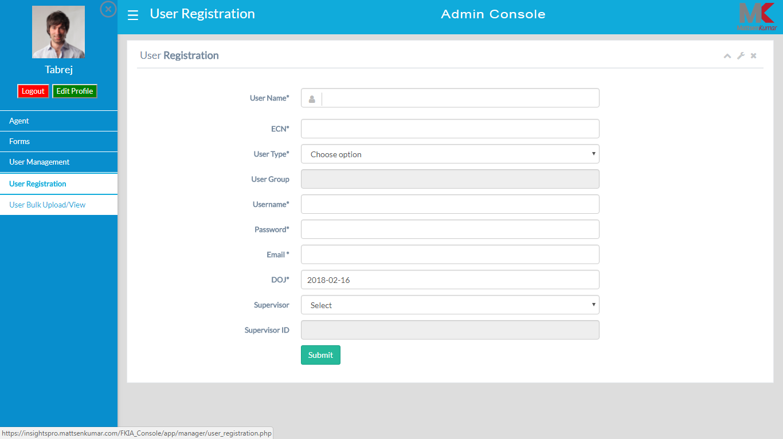

* ***User Bulk Upload/View***: In this you can upload users in bulk and view information like, supervisor id, employee code. You can also check the status of each user, whether it is active or inactive. There are options of making any kind of changes in the user profile also deleting the records

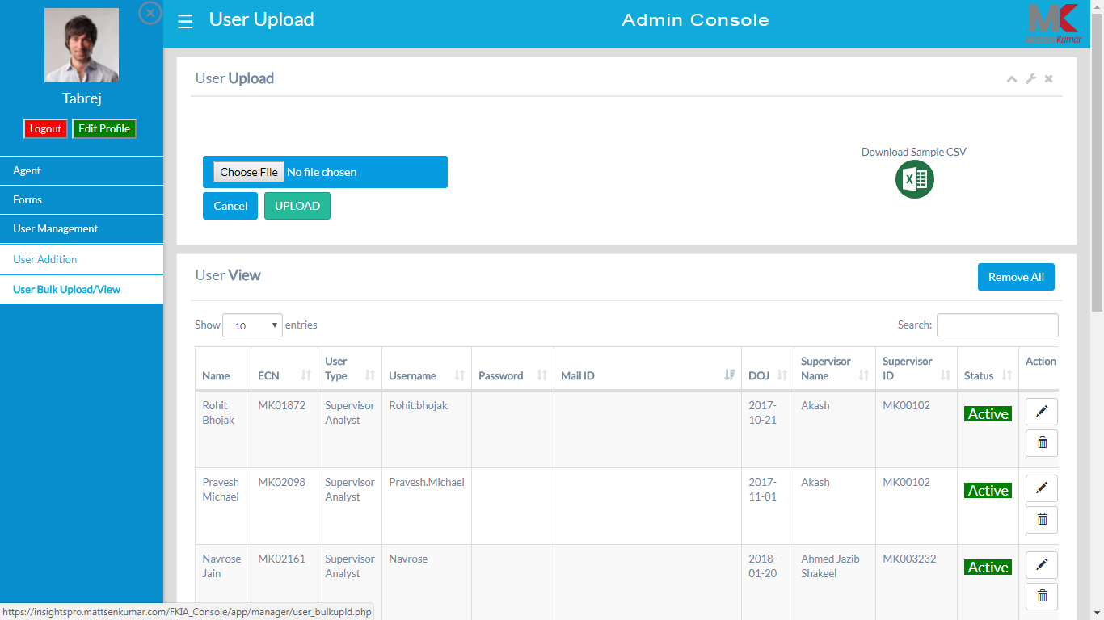

**Enterprise Console**

**Dashboard**: This is the first landing page. You would be able to check the dashboard after selecting the filters. Please be informed that only the filters which are stated beneath are compulsory to be filled out, rest are optional. Also, by default, this console will have the information of the overall evaluations done in MattsenKumar. You can change the view of the dashboard at client wise by simply selecting the Company type as “FK” (Flipkart)

1. Date Range
2. Evaluation Type
3. Form Type
4. Select Company Type

After these filters are filled, click on the “Submit” button to fetch out the following reports:

1. ***Evaluation Count Agent Wise (in #)***: This will show the overall total number of evaluation completed by the evaluators for each agent. You can also see the daily target for every agent (companywide)

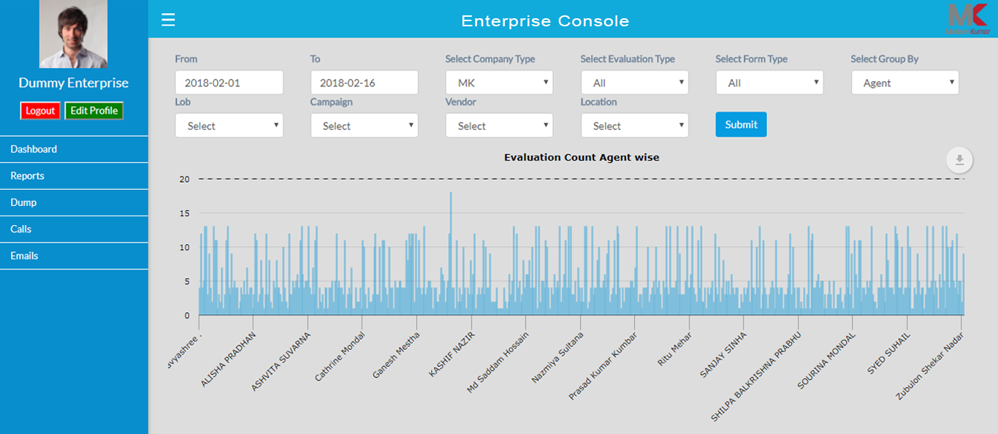

1. ***Evaluation Scores Agent Wise (in %)***: You would be able to check the overall evaluation scores of all those calls which are evaluated for all the agents

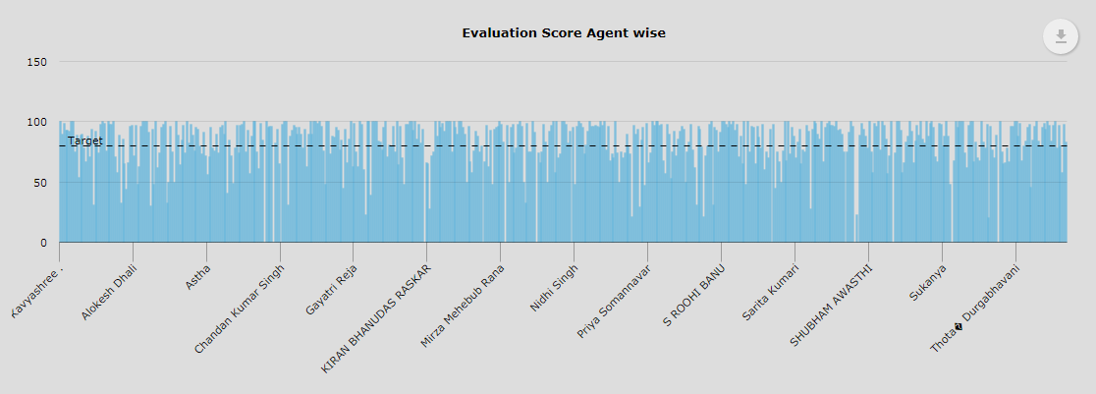

1. ***Date Wise Total Evaluation and Fatal Percentage***: You will be able to see all the company wide evaluated call along with the Fatal or autofail percentage on a daily basis

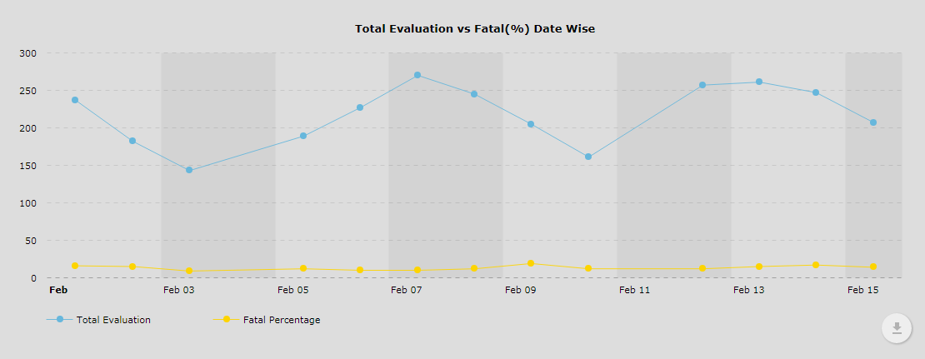

1. ***Evaluation Count and Fatal Count (Date Wise)***: Get information related to the overall total number of calls evaluated on a daily basis along with the complete count of Fatal errors

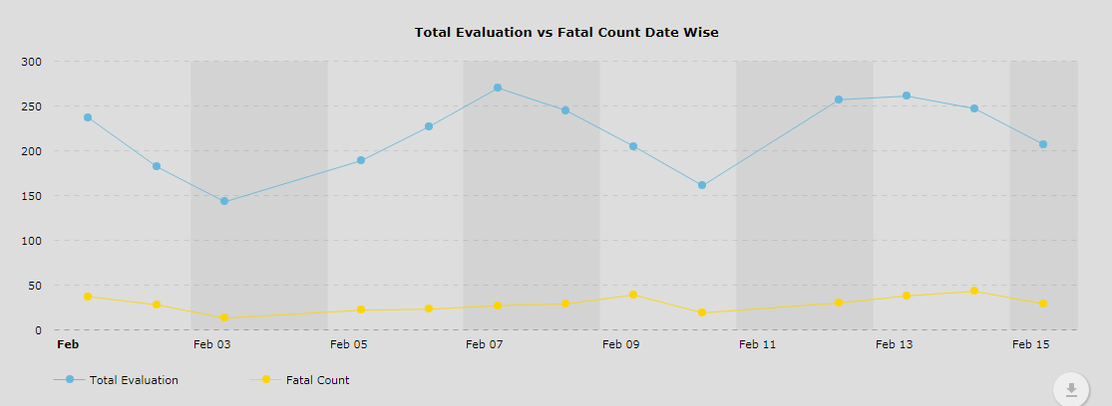

**Data Dump**: Now you can get the dump by simply filling the essential filters like –

1. Type of Evaluation
2. Type of Dump
3. By selecting the Date Range or Roster Date

Optional filters are also there which can also be filled like, LOB, Campaign, Vendor, Location, and Agent ID

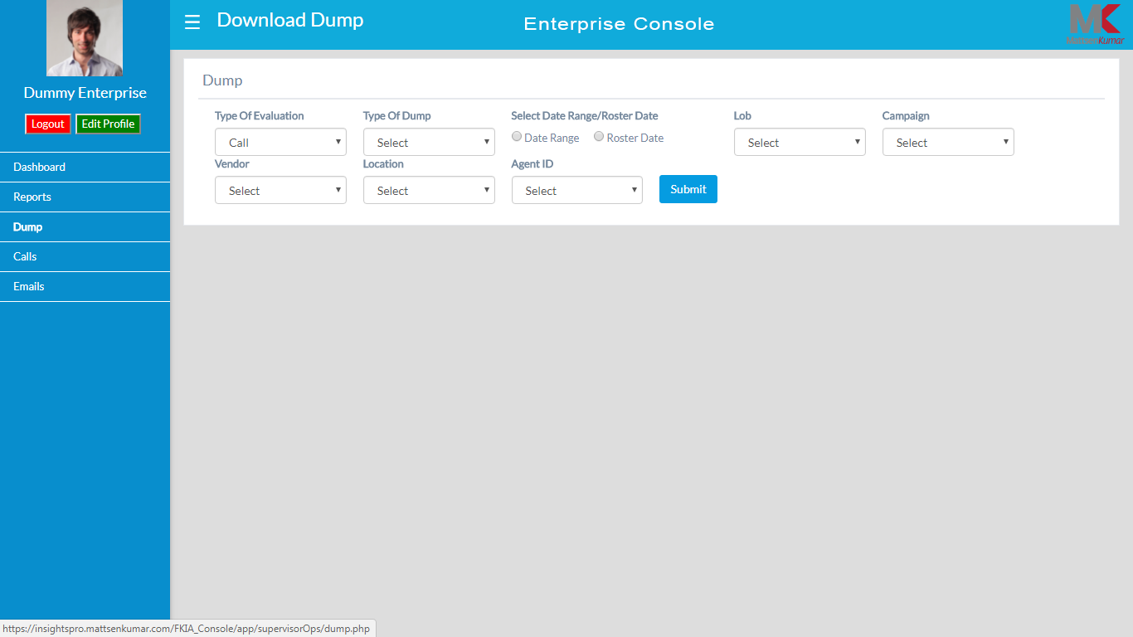

**Calls**:

1. ***Call Assignment***:

* You can now assign calls to evaluators on the basis of Roster data where you also need to select the LOB, Campaign, vendor, location and Agent ID for specific record
* You have an option to select the multiple unique ids and assign them to any listed evaluator
* Search option on the console is there for any customize search

1. ***View Calls***:

* Search option on the console is there to view overall calls assigned and complete evaluated and non-evaluated calls
* You have an option to copy, print or download csv file by clicking on any of the tabs respectively

**Emails**:

1. ***Email Assignment***:

* You can now assign calls to evaluators on the basis of Roster data where you also need to select the LOB, Campaign, vendor, location and Agent ID for specific record
* You have an option to select the multiple unique ids and assign them to any listed evaluator
* Search option on the console is there for any customize search

1. ***View Calls***:

* Search option on the console is there to view overall calls assigned and complete evaluated and non-evaluated calls
* You have an option to copy, print or download csv file by clicking on any of the tabs respectively

**Reports**:

1. ***Interaction Analyst Trending (Agent Trending)***:

* You would require to select the date range, type of form (calls/mails), form name, data type and company type as an essential filters, however, there are other optional filters available to select like evaluator, LOB, campaign, vendor, location, queue name
* After the filters are selected, you can check for the overall weekly trend of the reports like – how many evaluations have been done, total number of evaluators, AHT, and average evaluation scores

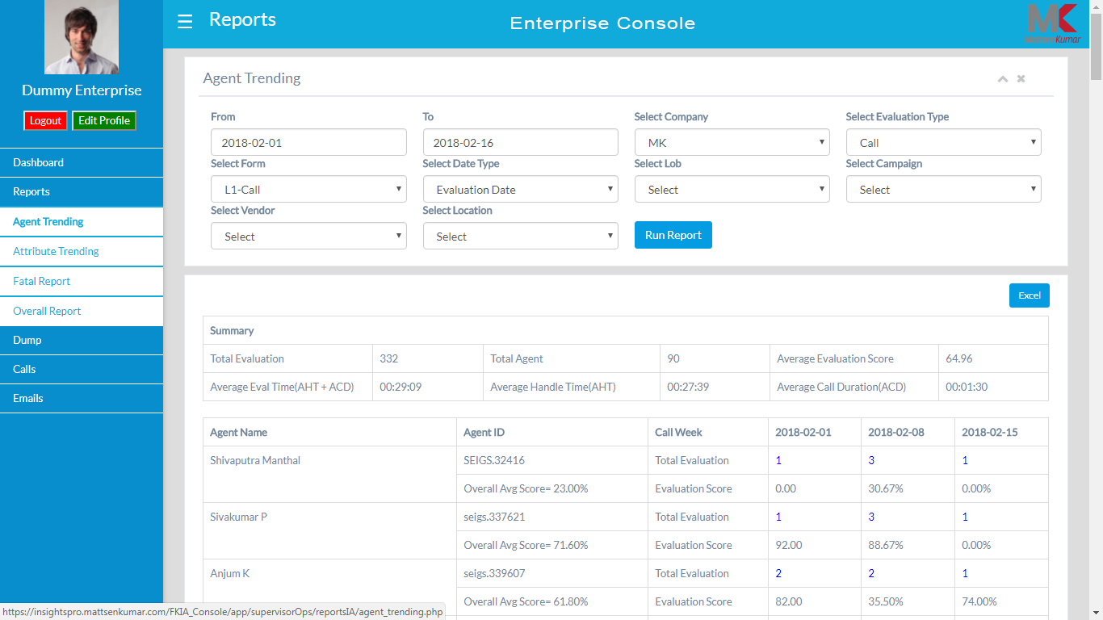

1. ***Attribute Trending***:

* To get this report you need to fill all the filters like date range, type of form (calls/mails), form name, data type and company type as an essential filters, however, there are other optional filters available to select like evaluator, LOB, campaign, vendor, location
* The report comprises of company wide Category, Attribute, Attribute Answer, Attribute Count and last but not the least percentage of Attribute weightage score

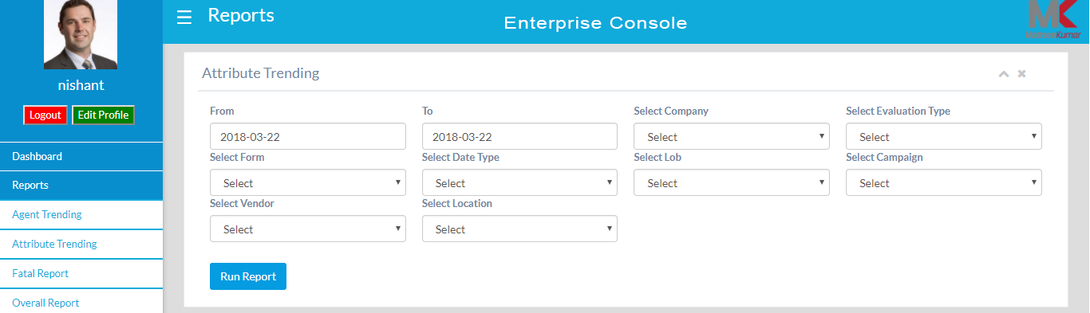

1. ***Fatal Report***:

* This section will provide you the overall total number of Fatal count between the date range and company type selected in the filter along with the fatal attribute, evaluation type and form name

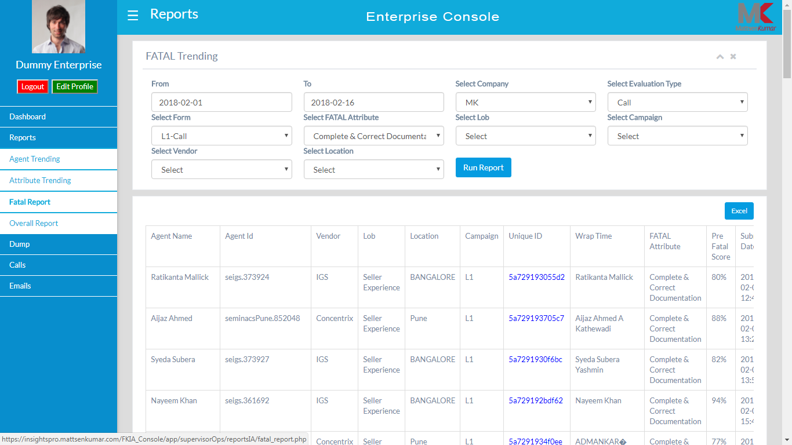

1. ***Overall Analyst Report***:

* To gather the company wide summary you need to fill all the filters like date range, select company, type of evaluation (calls/mails), form name and data type
* The summary will display overall total number of evaluations completed within the specific date range, total evaluators, average evaluation score, average evaluation time, AHT, average call duration. The report can also be sorted down as (LOB, Vendor, Campaign and Location) by selecting the group by option in the filter
* You can also download the data in the excel format

