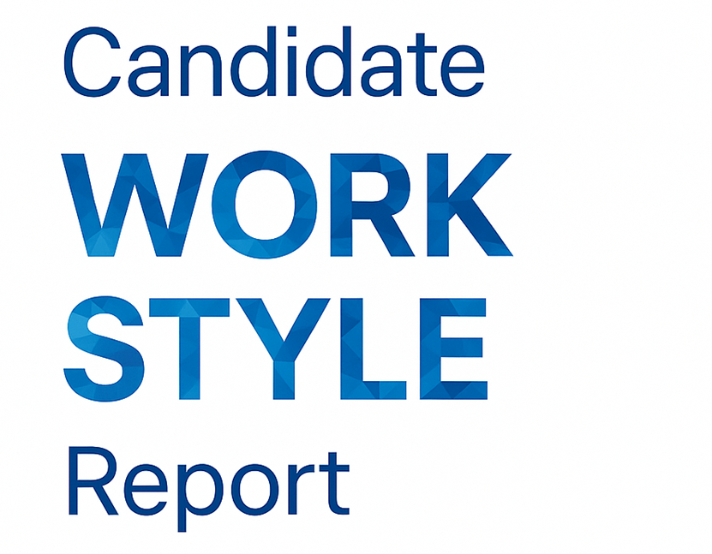

Prepared for:
{{Name}}
Role / Job Title:
{{Role}}
Date:
{{Date}}

Florida Maxima Corporation | © 2025
WHAT’S IN YOUR WORK STYLE REPORT?

SECTION | DESCRIPTION
1 | WELCOME
2 | EXECUTIVE SUMMARY
3 | PERSONALITY WORK ASSESSMENT
4 | THE TRIAD MODEL ROLE PROFILE
5 | SUMMARY & DEVELOPMENT RECOMMENDATIONS

- WELCOME

This section introduces the Work Style Report, which highlights how you think, act, and interact in professional settings. It helps you understand how your patterns influence communication, motivation, problem-solving, and collaboration, and how small, intentional shifts can elevate performance and teamwork. The goal of this report is self-awareness with purpose—to help you align your natural tendencies with the work environments, roles, and relationships that bring out your best. Grounded in behavioral science and practical workplace research, it provides a clear and actionable view of your working style.

PERSONALITY WORK ASSESSMENT

The Personality Work Assessment translates key psychological tendencies into practical, work-oriented insights. Each section highlights your Preferences/Typical Behavior and your Potential Needs, allowing you to anticipate what helps you perform at your best.
- Preferences / Typical Behavior – How you naturally operate when comfortable and engaged.
- Potential Needs/Blind Spots – The environmental conditions, feedback, or structure that sustain your motivation and effectiveness. These patterns reveal how your personality supports performance, communication, and decision-making, offering a lens for aligning personal style with organizational context and team dynamics.
This assessment evaluates both broad personality domains—such as Extraversion, Conscientiousness, and Emotional Stability—and the more specific sub-facets that sit beneath them. By combining these higher-level tendencies with granular behavioral nuances, it provides a more complete and finely tuned picture of how you typically operate at work.

THE TRIAD MODEL ROLE PROFILE

The Triad Model explores three foundational dimensions that shape how individuals approach work and relationships: 1. Task Orientation– The degree to which you prefer structure, organization, and focus on process and outcomes. 2. Sociability – How you connect, communicate, and collaborate with others in pursuit of shared goals. 3. Dominance – How you influence, assert, or take initiative to guide decisions and direction. Together, these dimensions create your Role Profile—a snapshot of your most natural way of contributing on a team. Your Triad results can clarify which roles or environments are most energizing for you, and where tension or misalignment may occur when conditions change. This profile becomes the foundation for understanding how you engage with others, lead projects, and adapt under varying workplace demands.

Executive Summary
{{Executive_Summary}}

Personality Work Assessment
[DOMAIN_CHART]
{{Domain_Section}}

TRIAD Model Role Profile Interpretation
This report interprets an individual's team role tendencies using the TRIAD Model (Driskell, Driskell, Burke, & Salas, 2017). The TRIAD Model defines three core behavioral dimensions—Task Orientation, Sociability, and Dominance—that collectively describe team role behavior.
{{TRIAD_Section}}

Summary & Recommendations
{{Recommendations_Section}}

