

DEPARTMENT OF COMPUTER SCIENCE
(Session: August – December 2017)

SUBJECT: DATA ANALYTICS
PROJECT REPORT ON
FORECASTING GLOBAL WARMING IN NEXT 10 YEARS USING

Submitted by

01FB15ECS083 D J POOJA

INDEX:
1. ABSTRACT
2. OBJECTIVE
3. INTRODUCTION
4. LITERATURE SURVEY
5. MODELLING
6. PRE-PROCESSING
7. PARAMETER ESTIMATION
8. FIT THE MODEL
9. DIAGNOSTIC CHECKING FOR ARIMA
10. FORECASTING
11. CODE
12. REFERENCES

1.ABSTRACT:
Is it true that the whole world is expressing a significant increase in the temperature? If yes, how fast is it increasing? Should we be worried of the increase in the global temperature in the upcoming years? So the main goal of my project is to answer these questions based on time series measuring the evolution of global temperature trying to fit in a model to give a prediction on global temperature in 10 years using software R.

After fitting in the ARIMA model, we get a positive that the global temperature is decreasing gradually in the next 10 years, which indicates that we needn’t have to worry too much about ‘Global warming’ for few more years!

Key words used:
Global warming, time series plot, acf and pacf, ARIMA models, AIC’s, diagnostic checking etc.

2.INTRODUCTION:
The data which I have chosen for my project collects the temperature time series during the time period of 1850-2015, which are derived from the global database. The data has been observed by CDIAC (Carbon dioxide Information Analysis Centre) and have been used in various other reports like IPCC.
Data resource link:
http://cdiac.ornl.gov/trends/temp/jonescru/jones.html
The data set has 170 rows and 14 columns. The Column header contains the 12 months and the last with the annual temperature.
Each row represents Year, starting from 1850-2015.
According to the data, the world experienced the temperature rise in 1990 and in 1997 reached the peak.

3.OBJECTIVE:
The reason I believe that this project is important is that global warming is a serious matter to our life. Analysing this land-surface temperature data set is a great way to study
Global warming, and predicting the future global temperature based on the data could help prevent the future disasters in advance.
So should we worry about the increase in temperature in the upcoming years?
In order to solve this question, I have used R to analyse the data and tried to fit in the model.

4.LITERATURE SURVEY

Global Warming and the problems of testing for trend in Time Series Data
-Wayne A. Woodward and H.L.Gray

Abstract:
In recent years a number of statistical tests have been proposed for testing the hypothesis that global warming occurring. The standard approach is to examine one or two of the more prominent global temperature datasets by letting Y=a+bt+E, where Y represents the temperature at time t and E represents the error from the trend line and to test the hypothesis that b=0. Several authors have applied these tests for trend to determine whether or not a significant long-term trend exists and conclude about the data. However, we show that certain ARIMA models may also be very reasonable models for these data due to random trend present.
This paper provide simulation evidence to show that the tests for the trend detect a deterministic trend in a relatively high percentage of realisation from a wide range of ARIMA models, including those obtained for the temperature series, for which it is improper to forecast a trend to continue over more than a very short time period.
The projections that the warming trend will extend into the future are largely based on factors such as build-up of greenhouse gases.

Comclusion remarks :

This paper has shown that although there is a major distinction between ARIMA models whose characteristics produce random trends and models of the from (1,1), this difference may be very difficult to ascertain from realisations of length approx. n=100. Several tests for trend to the Hansen and Lebedeff and the IPCC temperature series.
ARIMA models are possible model for these data. But simulation results indicate that application of these trend tests to realizations from ARIMA models fit to the temperature series results in the detection of a significant trend in would be inappropriate to forecast such a future trend in a high percentage of the realisations even though it would be inappropriate to forecast such a future.
According to the forecasting, it is observed that the temperature would decrease slightly and steadily.
Thus if temperature were behaving according to a “Correlation-based” model such as the ARIMA , then there is a high chance that a significant determination trend would be incorrectly inferred.
The projections that the warming trend will extend into the future are largely based on factors such as greenhouse gases.
References:
Abelson, Efficient utilization of non-numerical information in quantitative analysis: IEEE Trans. Autom Central 19,716-723.

5.MODELLING:
I checked the trend and seasonality based on the time series plot, ACF and PACF. Next, I used differencing at lag 1 in order to
get a stationary time series. Thus, I estimated the parameters based on the ACF and PACF of the differenced series. After suggesting eight possible models, I checked the smallest AICc as well as their invertiblity and casualty, which eliminated to three models as result. Though all of the three models passed the diagnostic checking, I choose ARIMA (2, 1, 2) according to the principle of parsimony.
Based on the model, my forecasting turned out a positive result, which I suggest we should not be too much worried about the increase in the temperature!
6.PREPROCESSING :
With the initial time series plot, the graph is not stationary due to upward increase in the global land-air temperature. The mean is -0.1050489 while the variance is 0.08117609. According to the graph there is a drastic change in the temperature in the year 1880, 1943, 1997 and 2015. Temperature reached the lowest point in 1870 and 1910.
Time series plot:
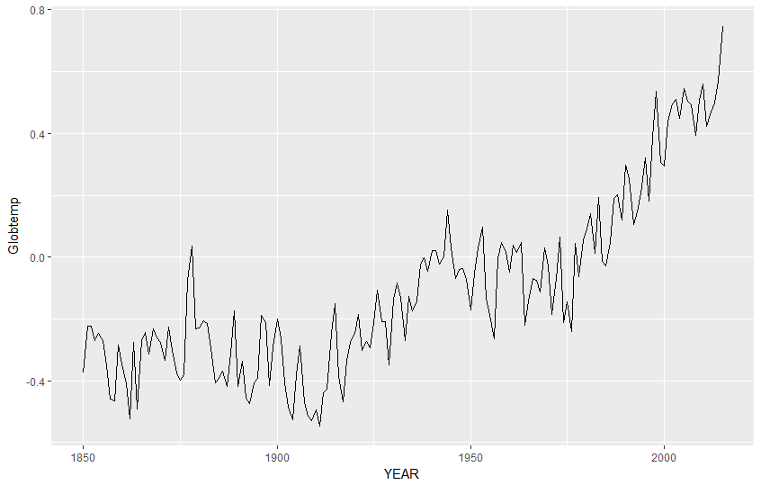
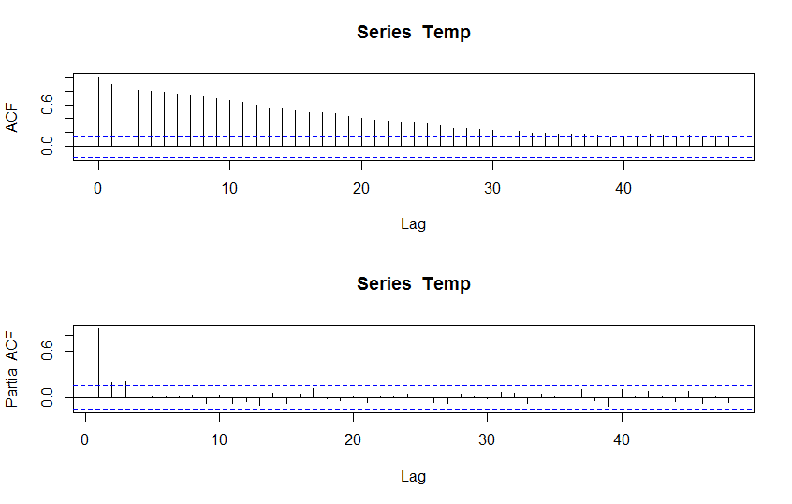
In the above Autocorrelation graph (acf), the slow decay of ACF point’s shows non-stationarity in the graph and in order to get a stationary series of graph, I have differentiated the data at lag 1 to remove the trend. Since there are negative values in the data, its easier differentiate rather than using transformation.

Stationary series:
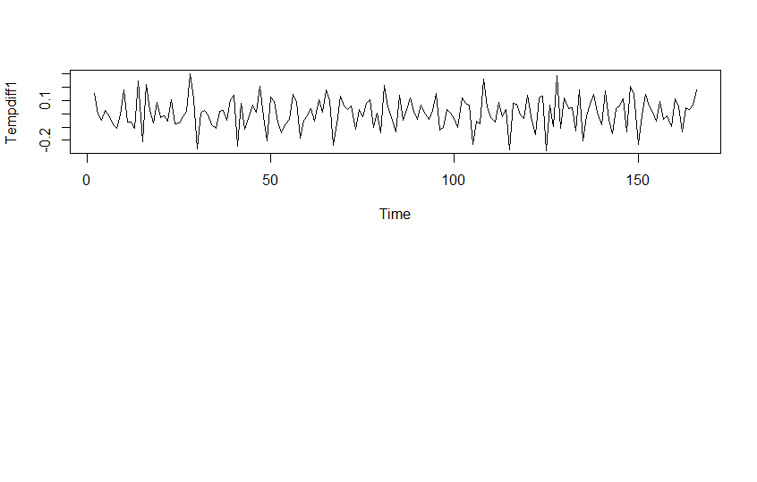

Stationary series for acf and pacf:

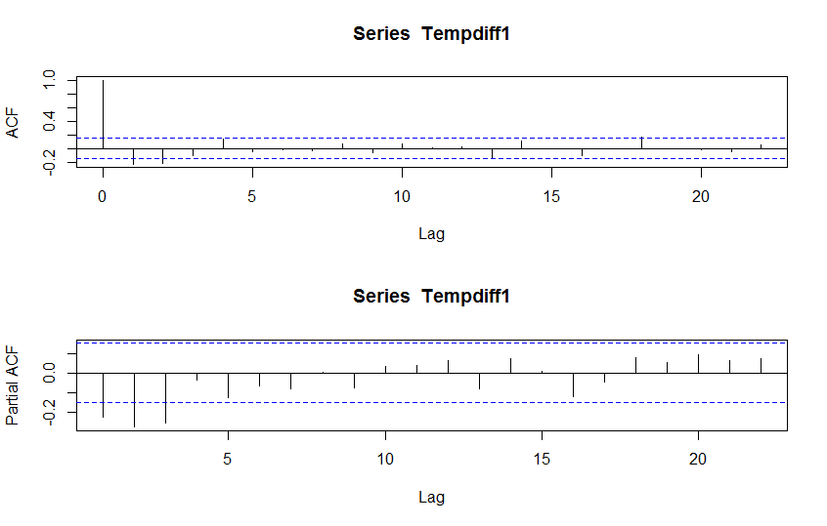

7.Parameter Estimation:
After differencing the time series at lag 1, the new times series plot appears to be stationary. The mean appears to be 0.00679393, which is approximately 0. While the variance decreased from 0.08117609 to 0.020457 . Also, the ACF shows no seasonality. Since both the ACF plot and PACF plot tails off quickly, it is possible to use ARIMA model here. According to the acf plot, the acf cuts off at lag 1 or lag 2, which indicates that Q could be equal to 1 or 2. According to the PACF plot, it cuts off at lag 1, 2, 3 which indicates that P could be 1, 2, 3.

The suggested models can be:
ARIMA (1,1,1)
ARIMA (1,1,2)
ARIMA (2,1,1)
ARIMA (2,1,2)
ARIMA (3,1,1)
ARIMA (3,1,2)
8.FIT THE MODEL:
In order to find the best model, I fit these models and then checked their AICc to find out the one with the smallest AICc.
AICc(fit1)
[1] -269.5687
> AICc(fit2)
[1] -269.6607
> AICc(fit3)
[1] -271.2477
> AICc(fit4)
[1] -269.5845
> AICc(fit5)
[1] -269.8915
> AICc(fit6)
[1] -270.746

After this,ARIMA(3,1,1),ARIMA(3,1,2) and ARIMA(2,1,2) appears to
be invertible and causal. Hence, the other models are eliminated.

9.Diagnostic checking for ARIMA(2,1,2) :

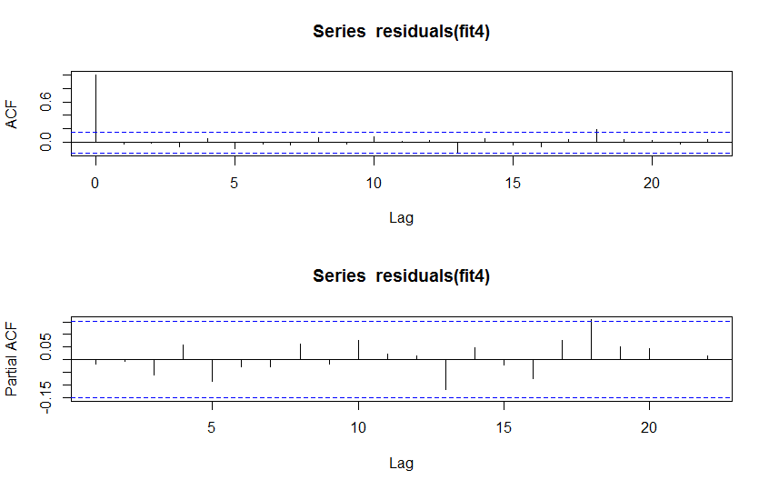
Fitted residuals into AR[0]. According to the plot, the model
Passed the diagnostic checking. Thus, this model could be
used for forecasting.
Sample mean is 0.014716; almost equal to zero
Sample variance is 0.0104887; almost equal to zero
No trend, no seasonality, no change of variance showed in
the diagrams.
P-values are larger than 0.05 and hence passed all the tests.
Residual plot :

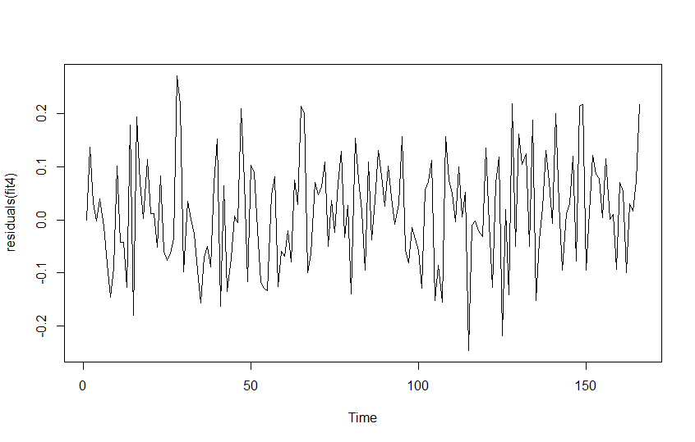

Diagnostics checking for ARIMA(3,1,1) :

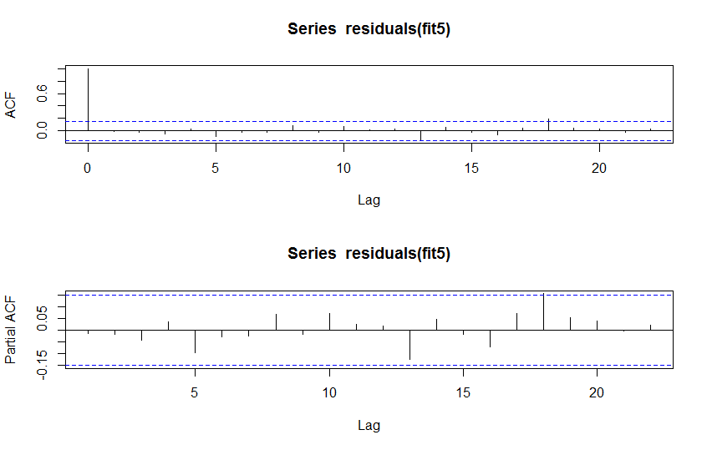

Mean is almost equal to zero: 0.0104
Variance is almost equal to zero: 0.0145
No trend, no seasonality, no change of variance showed in
the diagrams.
All acf and pacf residuals are in the confidence intervals and can
be counted zero.
p-values are larger than 0.05 and passed the test.
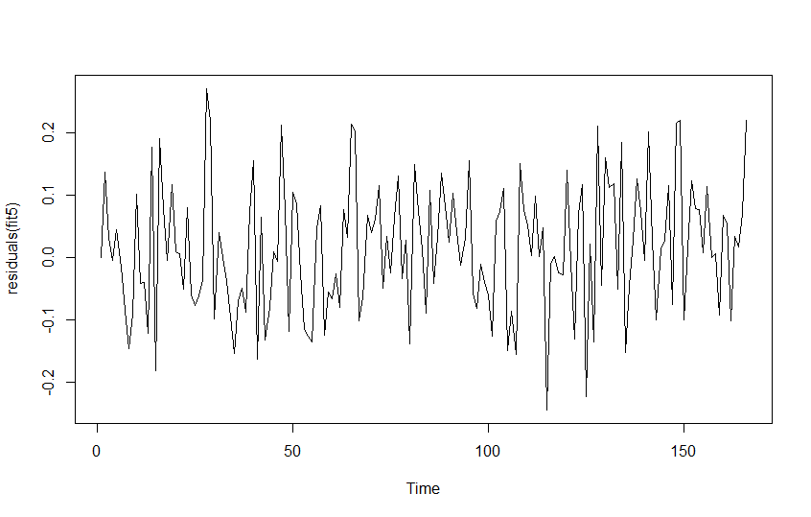
Diagnostics checking for ARIMA(3,1,2):
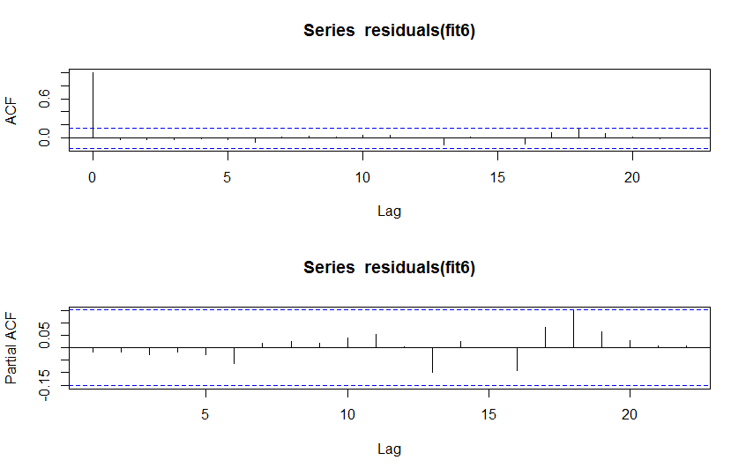
Mean is almost equal to zero: 0.010247
Variance is almost equal to zero: 0.014687
No trend, no seasonality, no change of variance showed in
the diagrams.
p-values are greater than 0.05 but all the models dint pass the test.

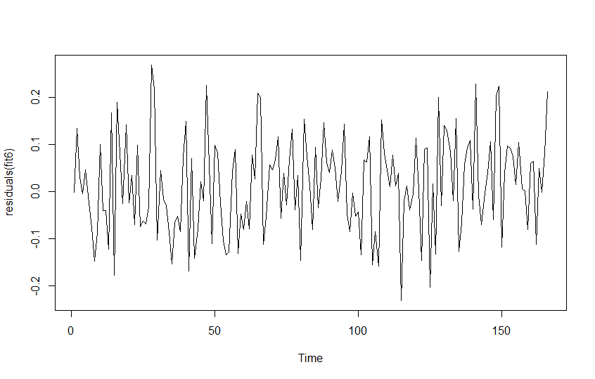
All of the three models passed diagnostic checking and are appropriate to use for forecasting. According to the principle of parsimony, I choose ARIMA(2,1,2) as the final model.

10.FORECASTING(CONCLUSION)
Based on the model, we can get the following predictions. In which the difference between the upper bond and the lower bond stands for the confidence interval, and the points indicate the predictions of global land-air temperature in the future ten years.
According to the forecasting, it is observed that the temperature would decrease slightly and steadily. Thus, we should not be worried too much about global warming in the future 10 years.

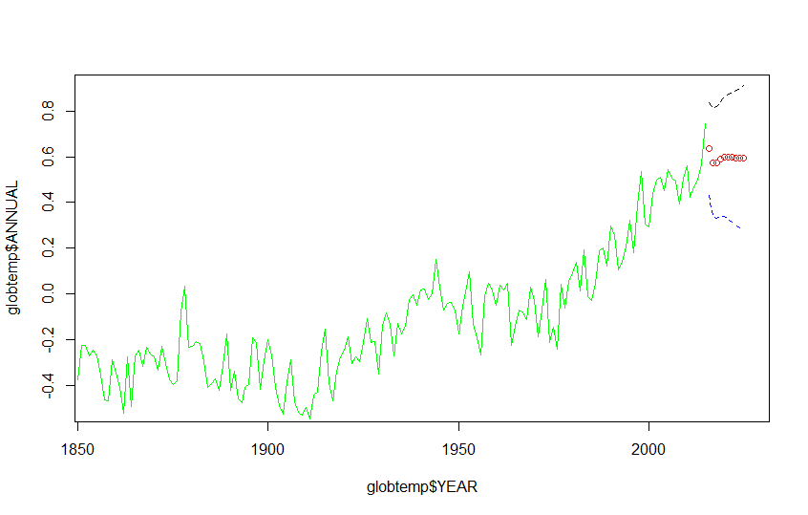

11.CODE

> globtemp<read.csv("C:/Users/Desktop/5thsem/globtemp.csv”)
> Temp = ts(globtemp[, c('ANNUAL')])
> globtemp$ANNUAL = ts(Temp)
> ggplot() + geom_line(data = globtemp, aes(x = YEAR, y = ANNUAL)) + ylab('Globtemp')
# According to the time series plot, it is not stationary

> var(Temp)
[1] 0.08117609
> mean(Temp)
[1] -0.1050843
> par(mfrow=c(2,1))
> acf(Temp,48)
> acf(Temp,type="partial",48)

#According to the acf plot, the acf tails off slowly which indicates non-stationary.
#First difference: Data is differenced at lag 1 in order to remove the trend.
> Tempdiff1=diff(Temp,1)
> ts.plot(Tempdiff1)
> var(Tempdiif1)
[1] 0.020457
> mean(Tempdiff1)
[1] 0.006793939
> par(mfrow=c(2,1))
> acf(Tempdiff1)
> pacf(Tempdiff1)

#fit models
> library(qpcR)
> library(forecast)
> fit1 = arima(Temp, order = c(1,1,1), method = "ML")
> fit2 = arima(Temp, order = c(1,1,2), method = "ML")
> fit3 = arima(Temp, order = c(2,1,1), method = "ML")
> fit4 = arima(Temp, order = c(2,1,2), method = "ML")
> fit5 = arima(Temp, order = c(3,1,1), method = "ML")
> fit6 = arima(Temp, order = c(3,1,2), method = "ML")
# Check the AICc
> AICc(fit1)
[1] -269.5687
> AICc(fit2)
[1] -269.6607
> AICc(fit3)
[1] -271.2477
> AICc(fit4)
[1] -269.5845
> AICc(fit5)
[1] -269.8915
> AICc(fit6)
[1] -270.746
# ARIMA(2,1,1) has the smallest AICc, ARIMA(1,1,1), ARIMA(1,1,2),
ARIMA(2,1,2), ARIMA(3,1,1) and ARIMA(3,1,2) have similar AICc.
#simulate models
> fit1

Call:
arima(x = Temp, order = c(1, 1, 1), method = "ML")

Coefficients:
ar1 ma1
0.3136 -0.7535
s.e. 0.1073 0.0654
sigma^2 estimated as 0.01099: log likelihood = 137.82, aic = -269.64
> fit2

Call:
arima(x = Temp, order = c(1, 1, 2), method = "ML")

Coefficients:
ar1 ma1 ma2
0.0250 -0.4311 -0.2173
s.e. 0.2233 0.2093 0.1262

sigma^2 estimated as 0.01084: log likelihood = 138.9, aic = -269.81
> fit3

Call:
arima(x = Temp, order = c(2, 1, 1), method = "ML")

Coefficients:
ar1 ar2 ma1
0.2537 -0.1815 -0.6551
s.e. 0.1214 0.0907 0.1021

sigma^2 estimated as 0.01074: log likelihood = 139.7, aic = -271.4
> fit4

Call:
arima(x = Temp, order = c(2, 1, 2), method = "ML")

Coefficients:
ar1 ar2 ma1 ma2
0.5325 -0.2838 -0.9409 0.2279
s.e. 0.5412 0.1743 0.5595 0.4156

sigma^2 estimated as 0.01071: log likelihood = 139.92, aic = -269.83

> fit5

Call:
arima(x = Temp, order = c(3, 1, 1), method = "ML")

Coefficients:
ar1 ar2 ar3 ma1
0.1361 -0.2075 -0.0996 -0.5459
s.e. 0.2168 0.1024 0.1182 0.2087

sigma^2 estimated as 0.01069: log likelihood = 140.07, aic = -270.14
> fit6

Call:
arima(x = Temp, order = c(3, 1, 2), method = "ML")

Coefficients:
ar1 ar2 ar3 ma1 ma2
-0.6812 0.0085 -0.2435 0.2917 -0.5576
s.e. 0.1407 0.1741 0.0910 0.1321 0.1254

sigma^2 estimated as 0.01049: log likelihood = 141.56, aic = -271.12

#diagnostic checking for ARIMA(2,2)
> plot(residuals(fit4))
> abline(h=0)
> par(mfrow=c(2,1))
> acf(residuals(fit4))
> pacf(residuals(fit4))
> mean(residuals(fit4))
[1] 0.014716
> var(residuals(fit4))
[1] 0.01048847
# all pvalues larger than 0.05
# The model passed diagnostic checking

#diagnostic checking for ARIMA(3,1)
> plot(residuals(fit5))
> abline(h=0)
> par(mfrow=c(2,1))
> acf(residuals(fit5))
> pacf(residuals(fit5))
> mean(residuals(fit5))
[1] 0.01453125
> var(residuals(fit5))
[1] 0.01047391
# all pvalues larger than 0.05
# The model passed diagnostic checking

#diagnostic checking for ARIMA(3,2)
> plot(residuals(fit6))
> abline(h=0)
> par(mfrow=c(2,1))
> acf(residuals(fit6))
> pacf(residuals(fit6))
> mean(residuals(fit6))
[1] 0.01465928
> var(residuals(fit6))
[1] 0.01027022

# Forecast next 10 observations of original time series
> library(forecast)
> pred <- predict(fit4, n.ahead = 10)
> pred.se<-pred$se
> plot(globtemp$ANNUAL~globtemp$YEAR, type="l", col="green", xlim=c(1856,2025),ylim=c(-0.5,0.9))
> points((2016:2025),pred$pred,col="red")
> lines(2016:2025,pred$pred+1.96*pred.se,lty=2, col="black")
> lines(2016:2025,pred$pred-1.96*pred.se,lty=2, col="blue")

12.REFERENECES :
Data resource link:
http://cdiac.ornl.gov/trends/temp/jonescru/jones.html

Other links:
http://www.sciencedirect.com/science/article/pii/S0925231201007020

http://www.sciencedirect.com/science/article/pii/S0001706X07001271

http://journals.ametsoc.org/doi/abs/10.1175/1520-0442(1993)006%3C0953:GWATPO%3E2.0.CO%3B2

https://link.springer.com/article/10.1007/s00376-012-1252-3

https://climate.nasa.gov/effects/

http://article.sapub.org/10.5923.j.statistics.20150505.08.html

Acknowledgement:
This project is data analysis project for fifth semester under the guidance of Sreekanth Prabhu Sir.

Thank you!

