SCREEN SHOTS

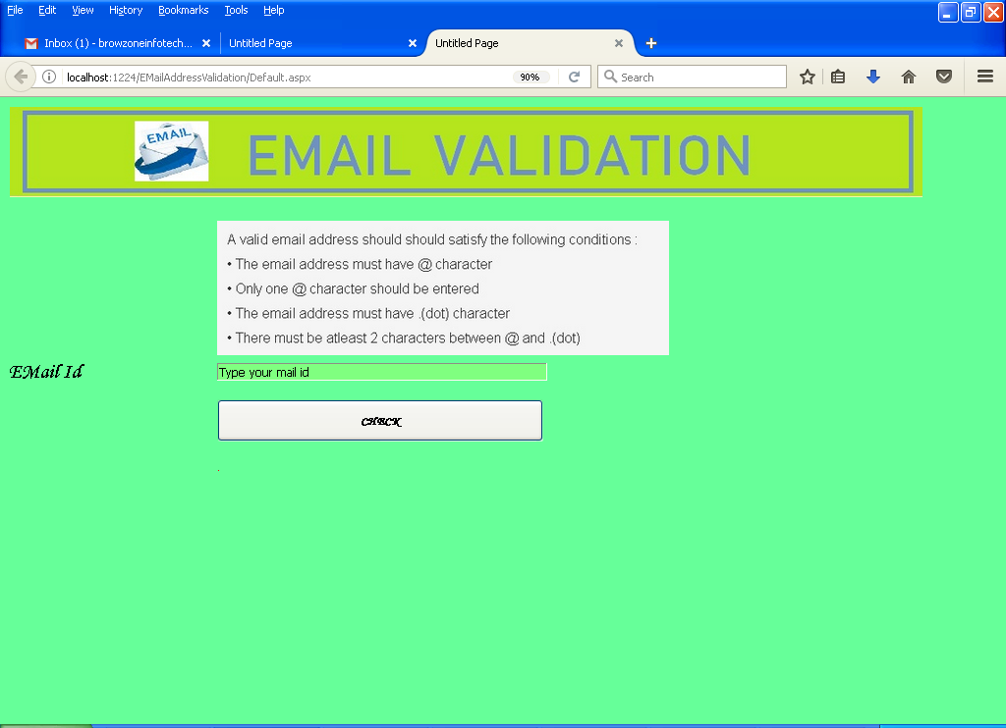

SAMPLE CODING

Partial Class _Default
Inherits System.Web.UI.Page

Protected Sub Button1_Click(ByVal sender As Object, ByVal e As System.EventArgs) Handles Button1.Click
Label2.Text = IsEmailValid(TextBox1.Text)
If Label2.Text = "False" Then
Label2.Text = "Invalid EMail id"
Else
Label2.Text = "Valid EMail id"
End If
End Sub
Public Function IsEmailValid(ByVal email As String) As Boolean
Dim chunks As String() = email.Split("@")
If chunks.Length() <> 2 Then Return False

If chunks(0).Length = 0 OrElse chunks(1).Length < 3 Then Return False

If Not chunks(1).Contains(".") Then Return False

If Not Char.IsLetter((chunks(0))(0)) Then Return False

For Each c As Char In email
If Not Char.IsLetter(c) AndAlso Not Char.IsNumber(c) AndAlso c <> "_" AndAlso c <> "." AndAlso c <> "@" Then Return False
Next

If email.Contains("..") OrElse email.Contains(".@") OrElse email.Contains("@.") OrElse email.Contains("._.") Then Return False

If email.EndsWith(".") Then Return False

'check 2 char before dot .
Dim pos1 As Integer = email.IndexOf("@")
Dim pos2 As Integer = email.IndexOf(".")
Dim posval As Integer = pos2 - pos1
If posval <= 2 Then
Return False
End If

'Finally
Return True

End Function

End Class

