### **Setup GUI in Ubuntu EC2 Instance and Access via Windows RDP**

### 

#### **1. Objective**

### The objective of this documentation is to provide a step-by-step guide to setting up a Graphical User Interface (GUI) on an Ubuntu EC2 instance and accessing it via Remote Desktop Protocol (RDP) from a Windows machine. This setup includes installing the necessary packages, configuring VNC, and enabling RDP access.

### 

#### **2. Architecture Flow**

### **Launch EC2 Instance:** Create an EC2 instance with Ubuntu**.**

### **Install GUI and VNC Server:** Install a desktop environment and VNC server on the instance.

### **Configure VNC Server:** Set up the VNC server for remote access.

### **Install and Configure XRDP:** Install XRDP to allow RDP connections from Windows.

### **Connect via RDP:** Access the GUI using RDP from a Windows machine.

### 

#### **3. Prerequisites**

### **AWS Account with access to create EC2 instances.**

### **Basic knowledge of using Linux terminal.**

### **An SSH client (e.g., PuTTY) to connect to the EC2 instance.**

### **A Windows machine with Remote Desktop Connection.**

### 

#### **4. Steps**

### **Step 1: Launch an Ubuntu EC2 Instance**

### **Go to the AWS Management Console.**

### **Navigate to EC2 and launch a new instance with Ubuntu as the operating system.**

### **Choose an instance type (e.g., t2.micro for the free tier).**

### **Configure security groups to allow SSH (port 22) and RDP (port 3389) access.**

### **Launch the instance and connect using SSH.**



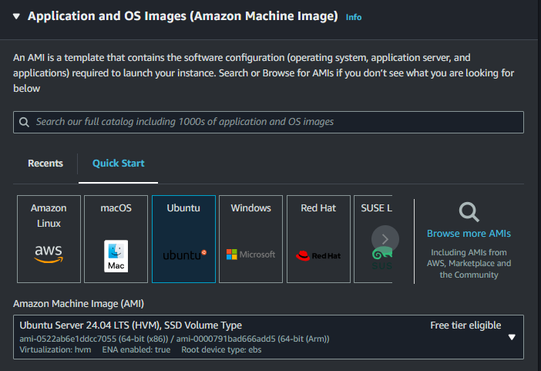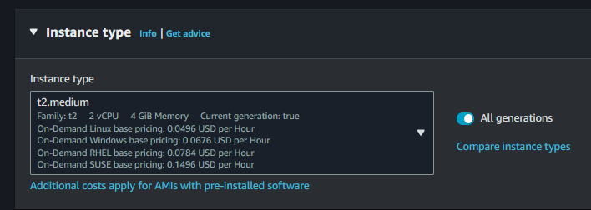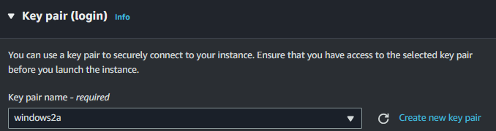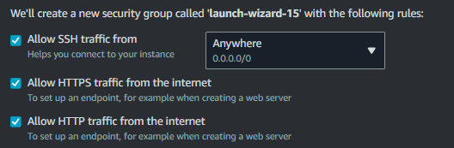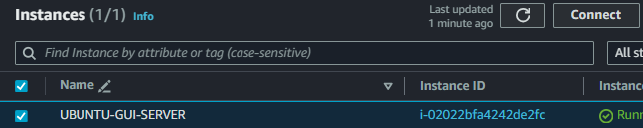

Open terminal

Run commands

1)sudo apt update -y

2) sudo apt upgrade -y

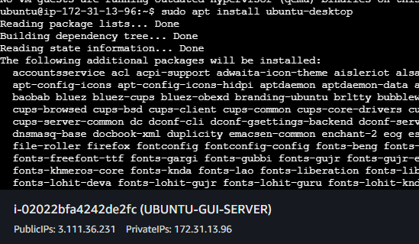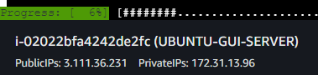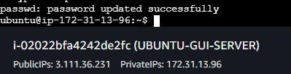

Must change the security group and add the rule rdp anywhere

#!/bin/bash

# Update the package list to ensure all packages are up-to-date

sudo apt update -y

# Upgrade all installed packages to their latest versions

sudo apt upgrade -y

# Install the full Ubuntu desktop environment

sudo apt install ubuntu-desktop -y

# Install TightVNC server for remote desktop access

sudo apt install tightvncserver -y

# Initialize the VNC server

Vncserver

New password: rootuser

Retype password:rootuser

# Install LXDE, a lightweight desktop environment

sudo apt install lxde -y

# Install XRDP to enable Remote Desktop Protocol (RDP) access

sudo apt install xrdp -y

# Set the password for the 'ubuntu' user

sudo passwd ubuntu

Set password :- rootuser

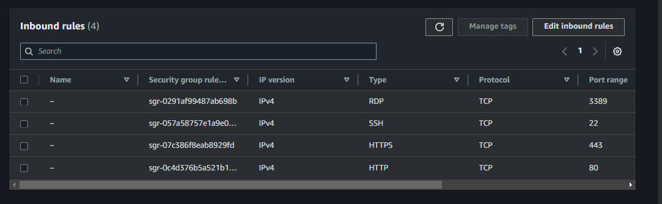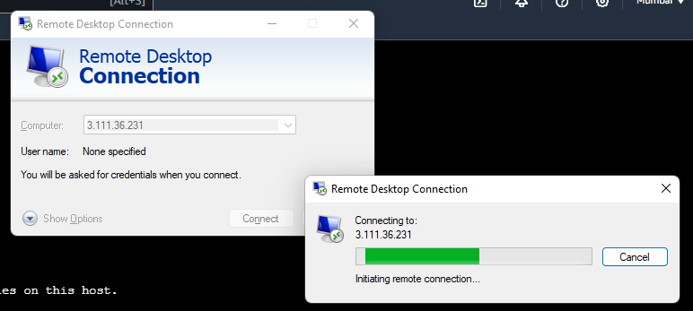

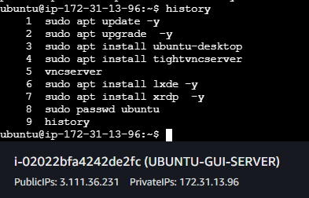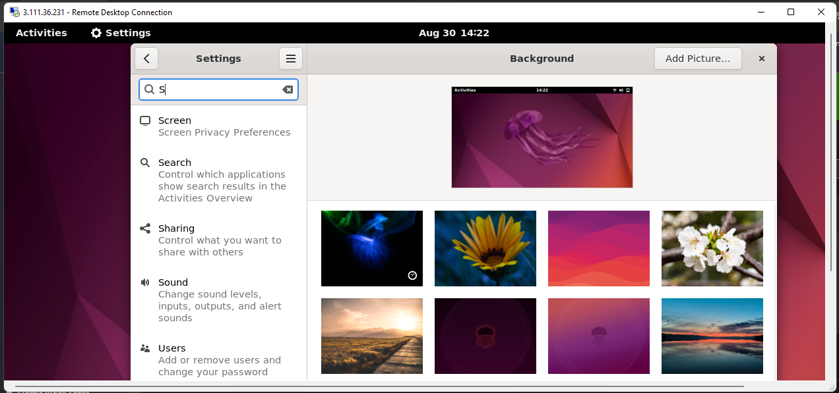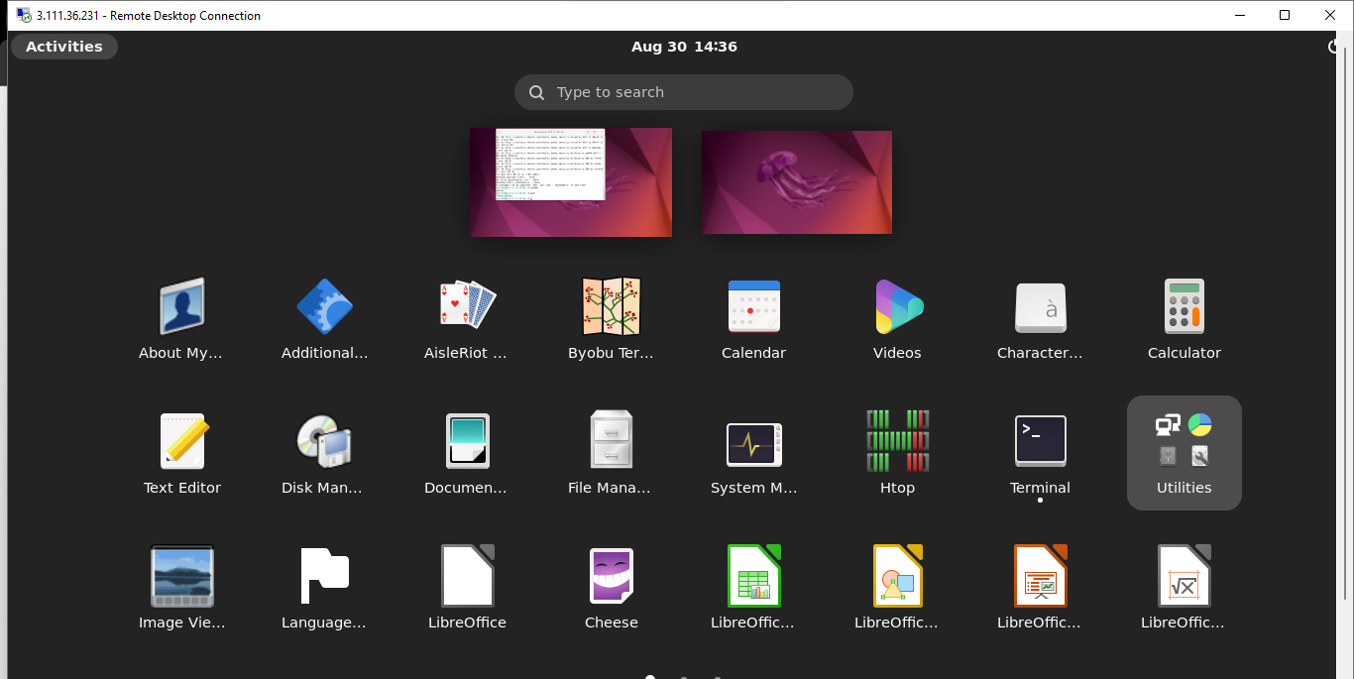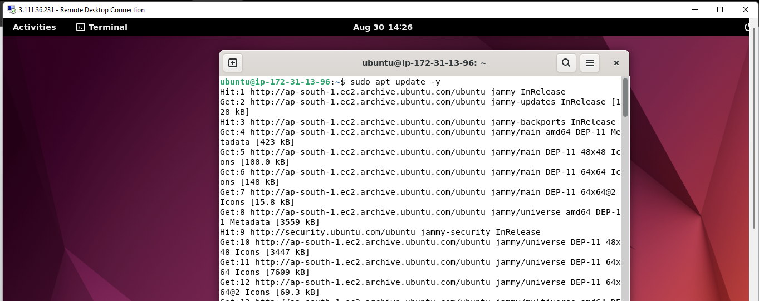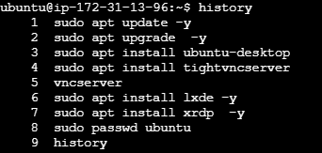

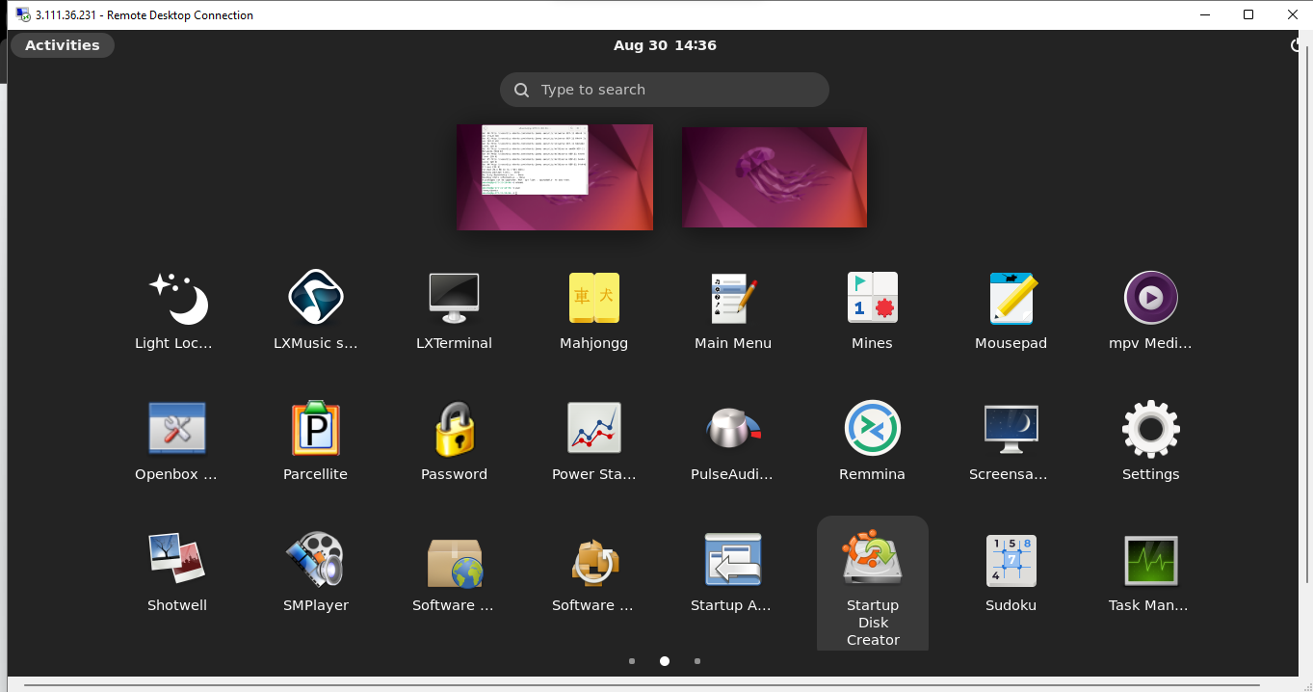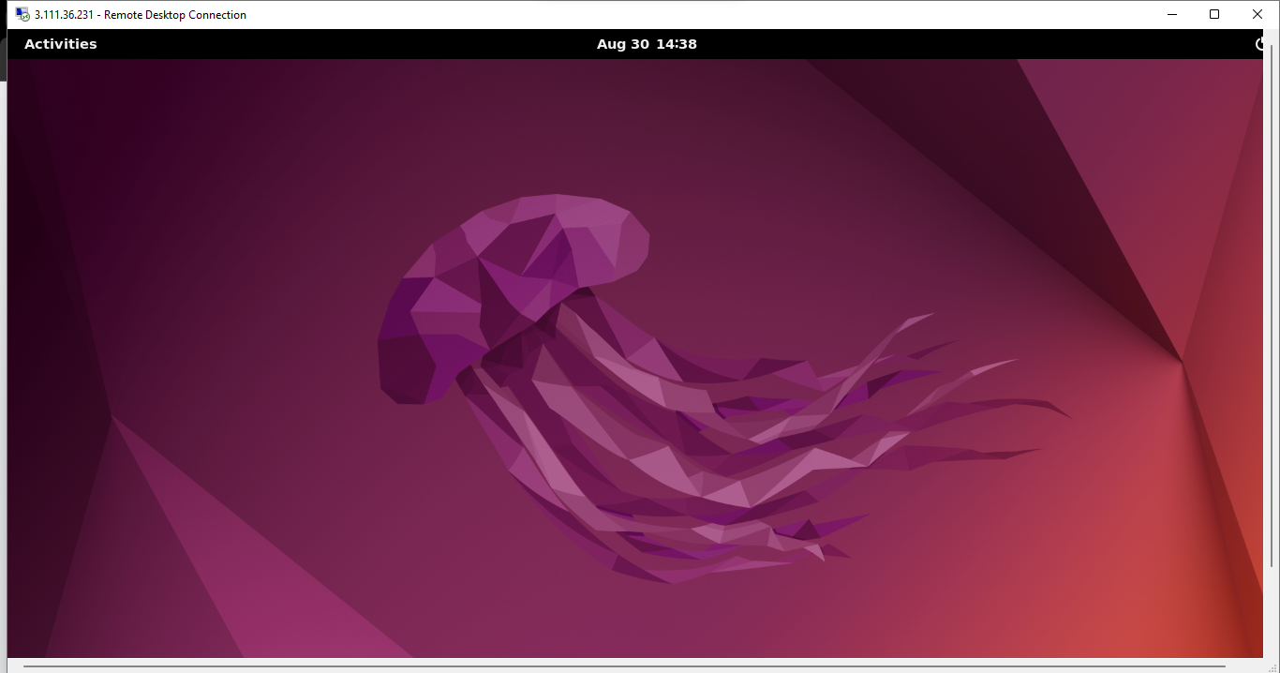

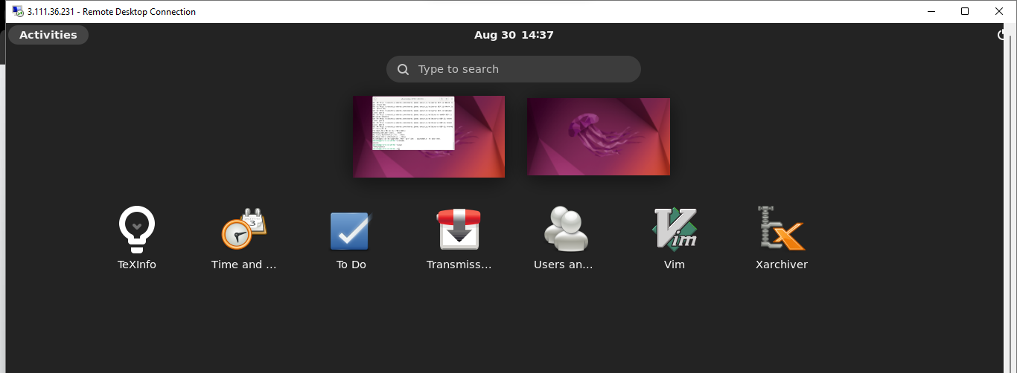

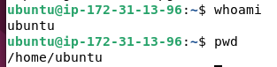

### **Operating System (OS)**

* **Definition**: The OS is the core software that manages hardware and software resources on a computer.
* **Examples**: Windows, macOS, Linux, Android.
* **Functions**:
  + Manages hardware resources like CPU, memory, and storage.
  + Provides a user interface (e.g., GUI, command line).
  + Facilitates communication between software and hardware.

### **Kernel**

* **Definition**: The kernel is the central part of an operating system, acting as a bridge between applications and the hardware.
* **Examples**: Linux kernel, Windows NT kernel.
* **Functions**:
  + Manages system resources (CPU, memory, I/O devices).
  + Controls process execution and task scheduling.
  + Handles system calls from applications.

### **Daemon**

* **Definition**: A daemon is a background process that runs continuously and performs system-related tasks.
* **Examples**:
  + httpd (Apache web server daemon).
  + sshd (Secure Shell daemon).
* **Functions**:
  + Handles requests for services like web hosting or remote login.
  + Operates without direct user interaction.

### **Applications**

* **Definition**: Applications are software programs designed to perform specific tasks for users.
* **Examples**:
  + Microsoft Word (word processing).
  + Google Chrome (web browsing).
* **Functions**:
  + Provide tools and interfaces for users to perform tasks.
  + Rely on the operating system for resource management.

### **Data Files**

* **Definition**: Data files store user or application data and are typically created and accessed by applications.
* **Examples**:
  + .txt files for text data.
  + .jpg files for images.
* **Functions**:
  + Store information that applications can read or write to.
  + Can be used for backups, sharing, or application input.

### **Configuration Files (Changeable)**

* **Definition**: Configuration files contain settings and parameters for software and can be modified to alter the behavior of applications or the OS.
* **Examples**:
  + httpd.conf for configuring an Apache web server.
  + .bashrc for customizing the Bash shell environment.

### **Commands Overview**

1. **sudo - Superuser Do**
   * **Description:** Executes commands as the superuser or another user.
   * **Usage:** sudo [command]
   * **Example:** sudo apt-get update
   * **Mini Description:** Grants administrative privileges to execute tasks that require root access.

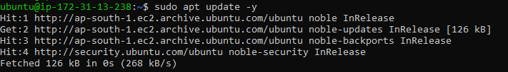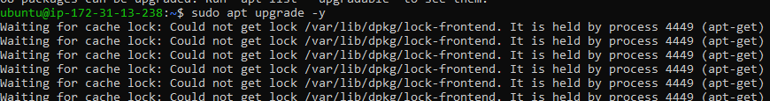

1. **apt-get - Package Handling Utility**
   * **Description:** Manages the installation, update, and removal of software packages.
   * **Usage:** sudo apt-get [option] [package]
   * **Example:** sudo apt-get install nginx

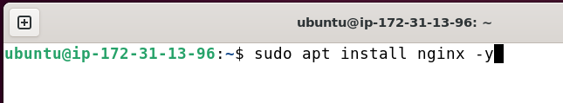

**Do enter 2 times**

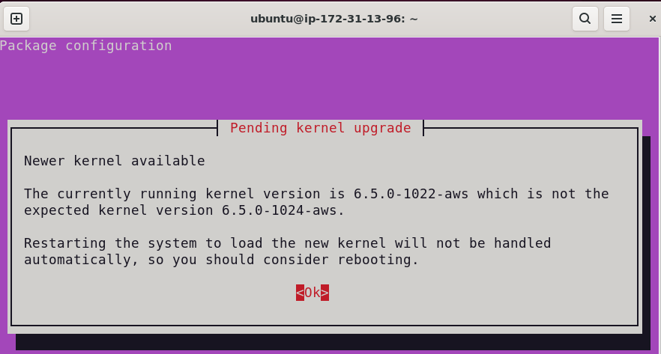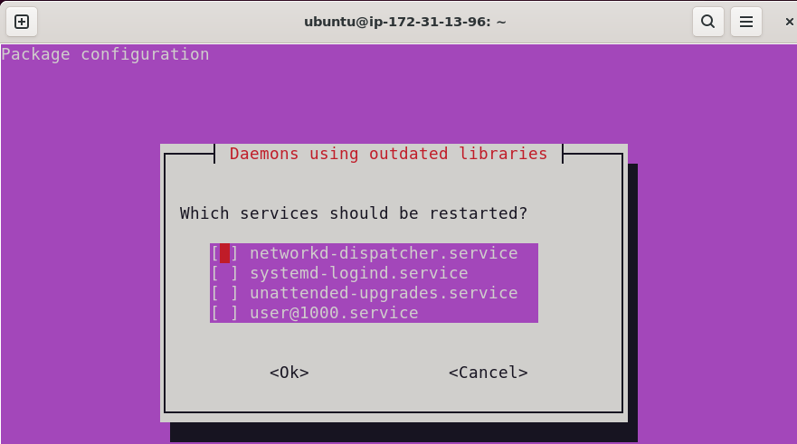

1. **ls - List Directory Contents**
   * **Description:** Lists files and directories in the current directory.
   * **Usage:** ls [options] [directory]
   * **Example:** ls -la

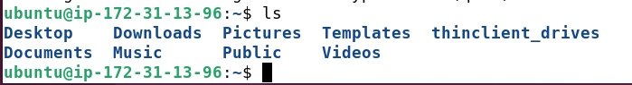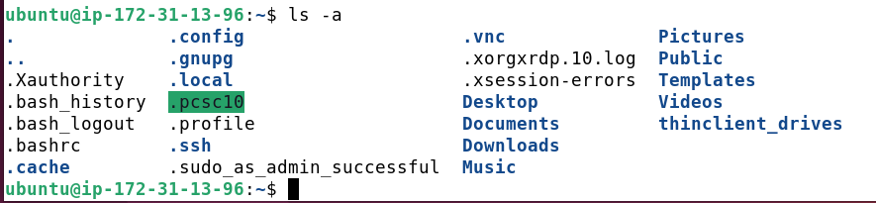

1. **cd - Change Directory**
   * **Description:** Changes the current directory to the specified path.
   * **Usage:** cd [directory]
   * **Example:** cd /var/www

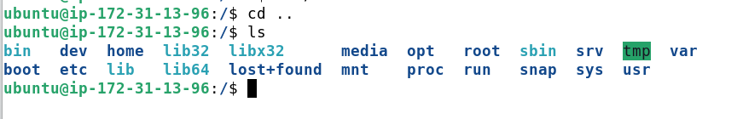

1. **pwd - Print Working Directory**
   * **Description:** Displays the current working directory.
   * **Usage:** pwd
   * **Example:** pwd

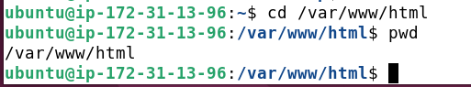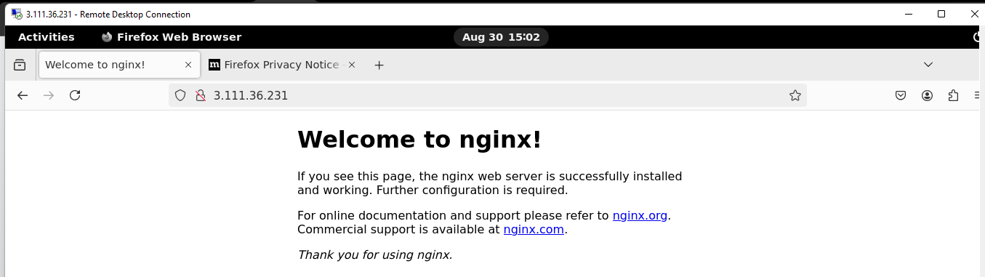

1. **touch - Create Empty Files**
   * **Description:** Creates a new empty file or updates the timestamp of an existing file.
   * **Usage:** touch [filename]
   * **Example:** touch index.html

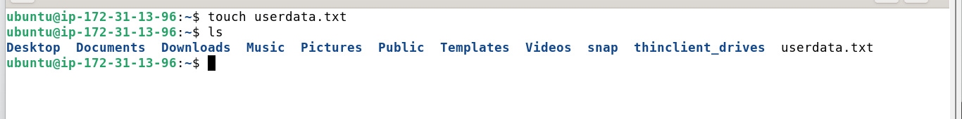

1. **mkdir - Make Directories**
   * **Description:** Creates a new directory.
   * **Usage:** mkdir [directory_name]
   * **Example:** mkdir my_project

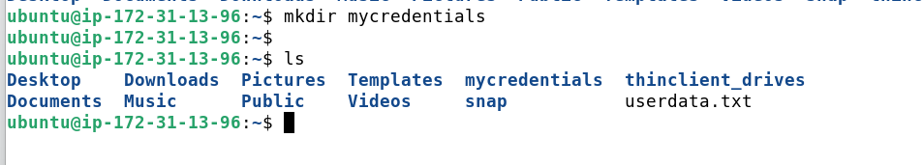

1. **rm - Remove Files or Directories**
   * **Description:** Deletes files or directories.
   * **Usage:** rm [options] [file/directory]
   * **Example:** rm -rf my_project
   * **Mini Description:** Removes files or directories permanently.
2. **cp - Copy Files or Directories**
   * **Description:** Copies files or directories from one location to another.
   * **Usage:** cp [source] [destination]
   * **Example:** cp index.html /var/www/html/

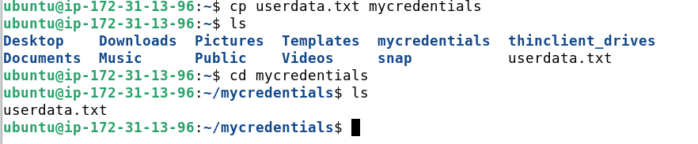

1. **mv - Move or Rename Files**
   * **Description:** Moves or renames files and directories.
   * **Usage:** mv [source] [destination]
   * **Example:** mv old_name.txt new_name.txt

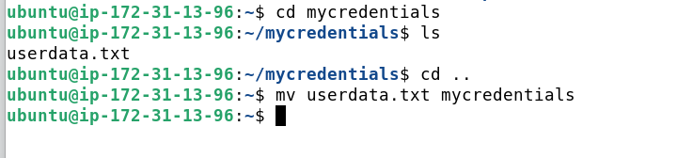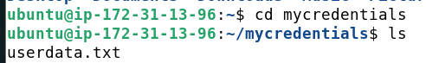

1. **chmod - Change File Permissions**
   * **Description:** Modifies file or directory permissions.
   * **Usage:** chmod [permissions] [file/directory]
   * **Example:** chmod 755 script.sh
   * **Mini Description:** Controls access to files and directories.
2. **chown - Change File Owner**
   * **Description:** Changes the ownership of a file or directory.
   * **Usage:** chown [owner][:group] [file/directory]
   * **Example:** sudo chown user:user /var/www/html
   * **Mini Description:** Assigns file ownership to specific users.
3. **cat - Concatenate and Display Files**
   * **Description:** Displays the content of a file.
   * **Usage:** cat [file]
   * **Example:** cat README.md

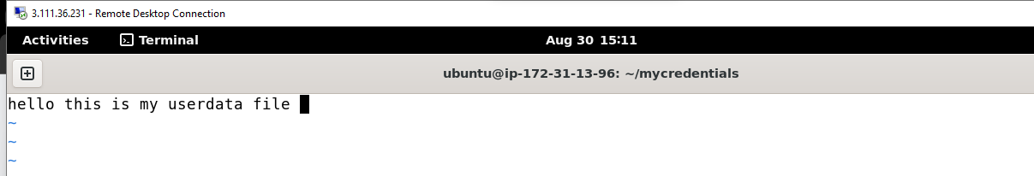**nano - Command Line Text Editor**

* + **Description:** Opens files in the nano text editor.
  + **Usage:** nano [file]
  + **Example:** nano config.txt
  + **Mini Description:** Edit text files directly from the command line.

1. **grep - Search Within Files**
   * **Description:** Searches for patterns within files.
   * **Usage:** grep [pattern] [file]
   * **Example:** grep "error" /var/log/syslog
   * **Mini Description:** Filters and searches through file contents.
2. **find - Search for Files**
   * **Description:** Searches for files in a directory hierarchy.
   * **Usage:** find [path] [options] [expression]
   * **Example:** find /var/www -name "*.html"
   * **Mini Description:** Locates files matching certain criteria.
3. **df - Disk Space Usage**
   * **Description:** Displays disk space usage.
   * **Usage:** df [options]
   * **Example:** df -h

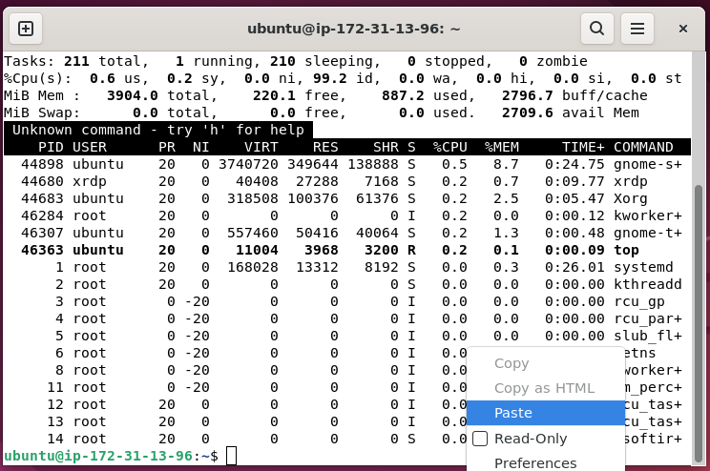

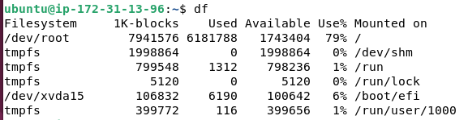

1. **du - Disk Usage**
   * **Description:** Shows disk usage of files and directories.
   * **Usage:** du [options] [file/directory]
   * **Example:** du -sh /var/www
   * **Mini Description:** Checks the size of directories and their contents.
2. **ps - Process Status**
   * **Description:** Displays information about running processes.
   * **Usage:** ps [options]
   * **Example:** ps aux

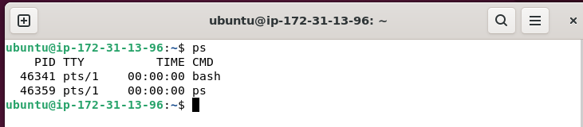

1. **kill - Terminate Processes**
   * **Description:** Sends a signal to terminate a process.
   * **Usage:** kill [PID]
   * **Example:** kill 1234
   * **Mini Description:** Stops a running process using its process ID.
2. **top - Real-Time Process Monitoring**
   * **Description:** Displays running processes in real-time.
   * **Usage:** top
   * **Example:** top

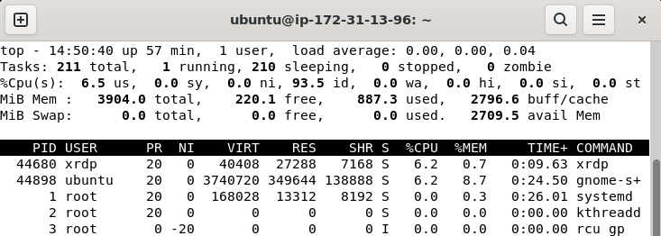

1. **htop - Interactive Process Viewer**
   * **Description:** Provides an interactive way to view and manage system processes.
   * **Usage:** htop
   * **Example:** htop
   * **Mini Description:** Enhanced version of top with an interactive interface.
2. **netstat - Network Statistics**
   * **Description:** Displays network connections, routing tables, interface statistics, masquerade connections, and multicast memberships.
   * **Usage:** netstat [options]
   * **Example:** netstat -tuln
   * **Mini Description:** Monitors network connections and listening ports.
3. **ifconfig - Network Interface Configuration**
   * **Description:** Configures or displays network interfaces.
   * **Usage:** ifconfig [interface]
   * **Example:** ifconfig eth0
   * **Mini Description:** Views or configures network interface settings.
4. **curl - Transfer Data from URLs**
   * **Description:** Transfers data from or to a server using supported protocols.
   * **Usage:** curl [options] [URL]
   * **Example:** curl http://example.com
   * **Mini Description:** Fetches data from web servers directly from the terminal.
5. **wget - Download Files from the Web**
   * **Description:** Retrieves files from web servers.
   * **Usage:** wget [options] [URL]
   * **Example:** wget https://example.com/file.zip
   * **Mini Description:** Downloads files from the internet to your local machine.
6. **tar - Archive Utility**
   * **Description:** Compresses or extracts files from an archive.
   * **Usage:** tar [options] [archive_file] [file/directory]
   * **Example:** tar -cvf archive.tar.gz /var/www
   * **Mini Description:** Creates or extracts archives.
7. **zip - Compress Files**
   * **Description:** Compresses files into a ZIP archive.
   * **Usage:** zip [archive_name] [file/directory]
   * **Example:** zip -r archive.zip my_project
   * **Mini Description:** Compresses multiple files or directories into a single archive.
8. **unzip - Extract ZIP Files**
   * **Description:** Extracts files from a ZIP archive.
   * **Usage:** unzip [archive_name.zip]
   * **Example:** unzip archive.zip
   * **Mini Description:** Extracts contents of ZIP archives.
9. **ssh - Secure Shell**
   * **Description:** Connects to a remote machine securely.
   * **Usage:** ssh [user@hostname]
   * **Example:** ssh user@192.168.1.10
   * **Mini Description:** Accesses remote servers via SSH for administration or file transfer.

### **3. Steps to Execute Commands**

1. **Open Terminal:** Access the command line by pressing Ctrl + Alt + T or searching for "Terminal" in your application menu.
2. **Execute Commands:** Type the desired command and press Enter.
3. **Use Sudo When Necessary:** If a command requires elevated privileges, prepend it with sudo.
4. **Check Outputs:** Review the command's output to ensure the operation was successful.
5. **Use Options and Flags:** Enhance commands with additional options to tailor their behavior.