|  |  |
| --- | --- |
| **Ex. No. 4** | **Design a Sign-In and Sign-Out Page with Navigation bar using CSS** |
| **Date of Exercise** | **23-1-2023** |
| **Webpage Host link** |  |

# Aim

# To develop a webpage using HTML5 tags and apply styles to the webpage using CSS properties and layouts like Normal flow and multicolumn layout.

# Description

* HTML: Hyper Text Markup Language is the code that is used to structure a webpage. We useHTML5 for the sake of this experiment.
* <! DOCTYPE HTML>: All HTML documents must start with this declaration. It informs the browser of the document type.
* <HTML>: Represents root of the document. It serves as a container for all other elements.
* <HEAD>: contains meta-info about the HTML page
* <TITLE>: specifies the title of the HTML page which is seen in the browser’s title bar.
* <BODY>: defines document’s body and is a container for all contents of the webpage that invisible.
* <P>: defines a paragraph
* <IMG>: used to embed an image into the webpage.
* <a>: used to go to a specific hyperlink destination. ‘href’ attribute defines the destination.
* <ul>, <li>: used to define an unordered list and each element of the list respectively.
* <TABLE>: used to create a table

CSS is used to, including the design, layout and variation in display for different devices and screen sizes.

CSS provides a set of styling properties and values. These properties can be applied the HTML tags using predefined CSS rules.

Selector {

Property1:value1;

Property2:value2:

Property3:value3;

}

* The <form> element is a container for different types of input elements, such as: text fields, checkboxes, radio buttons, submit buttons, etc.
* The HTML <form> element is used to create an HTML form for user input.
* <input type="text"> defines a single-line input field for text input.
* <label> tag defines a label for many form elements.
* The <input type="submit"> defines a button for submitting the form data to a form-handler.
* The action attribute defines the action to be performed when the form is submitted.
* The <button> element defines a clickable button
* The <fieldset> element is used to group related data in a form.
* <input type="password"> defines a password field.

# A navigation bar is basically a list of links, so using the <ul> and <li> elements make perfect sense.

# Program

<!DOCTYPE html>

<html>

<head>

<link rel="stylesheet" href="EX4_1036.css">

</head>

<body>

<ul>

<li><a href="#Home">Home</a></li>

<li><a href="#Products">Products</a></li>

<li><a href="#Services">Services</a></li>

<li><a href="#Contact Us">Contact Us</a></li>

</ul>

<br><br>

<table border="0">

<tr><td>

<div class="container">

<fieldset>

<h3 align="center">Sign In</h3>

<form>

<label id="Username">Username</label><br>

<input type="text" id="Username" placeholder="Enter Username/Email/Phone Number">

<br>

<lable id="Password">Password</lable><br>

<input type="password" id="Password" placeholder="Enter Password">

<br><br>

<input type="submit" value="Sign In">

</form>

</fieldset></td>

<br><br><td>

<div class="Signup">

<fieldset>

<h3 align="center">Sign Up</h3>

<form>

<label id="Name">Name</label><br>

<input type="text" id="Name" placeholder="Enter Name">

<br>

<label id="Email">Email</label><br>

<input type="text" id="Email" placeholder="Enter Email">

<br>

<label id="Password">Password</label><br>

<input type="password" id="Password" placeholder="Enter Password">

<br><br>

<input type="submit" value="Sign Up">

</form>

</fieldset></div></td></tr>

</div></table>

</body>

</html>

**CSS Code:**

/**{

background-image: url("img3.jpeg");

}*/

body{

background: url('img1.jpg');

}

ul {

list-style-type: none;

margin: 0;

padding: 0;

overflow: hidden;

background-color: rgb(141, 146, 224);

}

li {

float: left;

}

li:hover{

background-color:darkblue;

}

li a {

display: block;

color: white;

text-align: center;

padding: 14px 130px;

text-decoration: none;

}

.container {

left: 100px;

border: none;

border-radius: 25px;

float: left;

padding: 100px;

width: 400px;

position: relative;

/*text-align: center;*/

color: white;

}

.Signup{

left: 100px;

float: right;

padding: 70px;

width: 400px;

position: relative;

/*text-align: left;*/

color: white;

}

input[type=text],[type=password], select {

width: 100%;

padding: 12px 20px;

margin: 8px 0;

display: inline-block;

border: 1px solid #ccc;

border-radius: 4px;

box-sizing: border-box;

}

input[type=submit] {

width: 100%;

background-color: rgb(141, 146, 224);

color: rgb(10, 10, 10);

padding: 14px 20px;

margin: 8px 0;

border: none;

border-radius: 4px;

cursor: pointer;

}

# Output

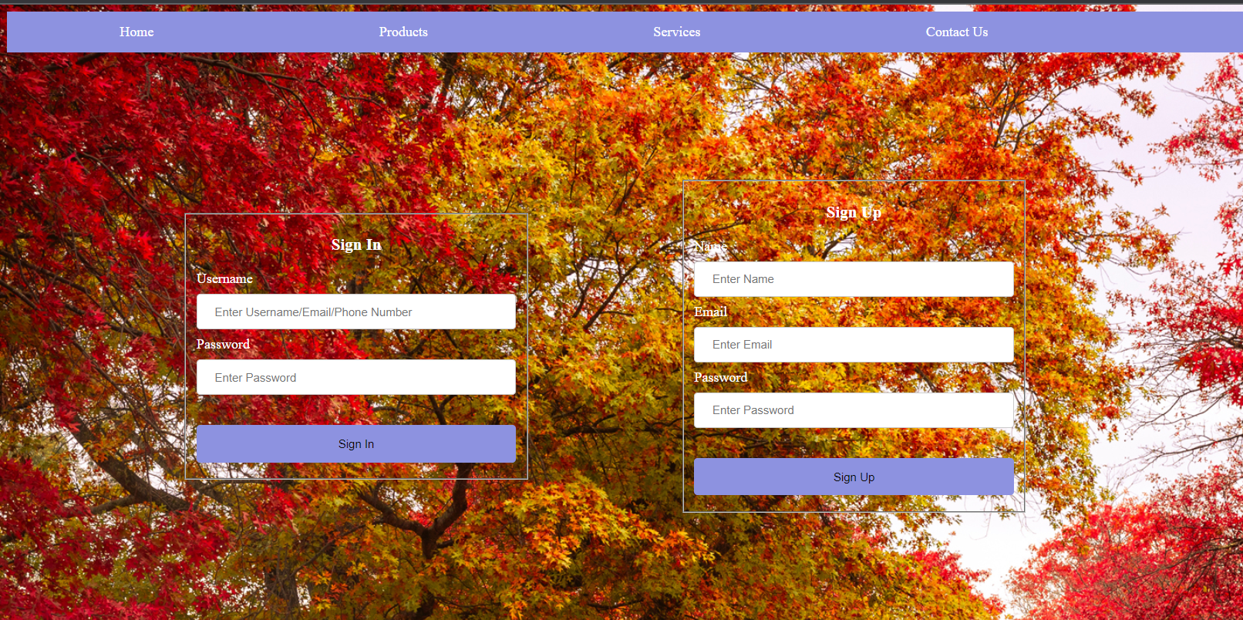

# Result

Thus a webpage has been created using HTML5 and CSS code and the output has been verified including the navigation bar.