

G H Patel College of Engineering & Technology
(A Constituent College of CVM University) V. V. Nagar

INFORMATION TECHNOLOGY DEPARTMENT

Mini Project Report on
Stock Market Forecasting

Submitted By

Name of Students: Enrollment Numbers:
Poojan Patel 12302110501080
Shrey Patel 12302110501081

Guided By
Prof. Ritesh Upadhyay

MINI PROJECT (202040601)
A.Y. 2025-26 EVEN TERM


CERTIFICATE

This is to certify that the Mini Project Report entitled "Stock Market Forecasting" has been carried out by Poojan Patel (Enrollment No: 12302110501080) and Shrey Patel (Enrollment No: 12302110501081) under my guidance in partial fulfillment for the Degree of Bachelor of Technology in Computer Science & Engineering(IoT), 6th Semester, of G.H. Patel College of Engineering & Technology, CVM University, Vallabh Vidyanagar during the Academic Year 2025-26.

Prof. Ritesh Upadhyay Dr. Nikhil Gondaliya

Internal Guide Head of Department


ACKNOWLEDGEMENT

It is our privilege to present this Mini Project Report on "Stock Market Forecasting" as part of the curriculum for Semester VI, Bachelor of Technology in Computer Science & Engineering (IoT) at G.H. Patel College of Engineering & Technology, CVM University. The successful completion of this project would not have been possible without the support, guidance, and encouragement of several individuals.

First and foremost, we express our deepest gratitude to our Internal Project Guide, Prof. Ritesh Upadhyay, Department of Information Technology, for his invaluable guidance, continuous encouragement, and constructive feedback throughout the project. His expertise in data science and time-series analysis greatly influenced the technical direction and quality of this work.

We extend our sincere thanks to Dr. Nikhil Gondaliya, Head of the Department of Information Technology, for providing an excellent academic environment and all the facilities necessary for carrying out this project. His support and motivation have been instrumental throughout the semester.

We are grateful to all the faculty members of the Department of Information Technology for their constant support, academic guidance, and encouragement during every phase of project development. Their constructive suggestions during reviews significantly improved the quality of our work.
Poojan Patel (12302110501080)
Shrey Patel (12302110501081)

ABSTRACT

Stock trend prediction is a critical requirement for investors, financial analysts, and portfolio managers seeking to make data-driven decisions in dynamic financial markets. Traditional methods based solely on manual technical analysis or simple statistical models often struggle to capture the combined effects of market volatility, non-linear price movements, and seasonal fluctuations inherent in financial time-series data.

This project presents the Stock Market Forecasting — a fully functional, interactive web application developed using Python and the Streamlit framework. The application provides an end-to-end pipeline that retrieves live historical stock market data from Yahoo Finance using the yfinance API, performs comprehensive time-series analysis, and generates future price forecasts using the SARIMAX (Seasonal AutoRegressive Integrated Moving Average with eXogenous factors) model.

A key feature of the application is its automatic currency detection system, which identifies the trading currency of any globally listed stock — whether it trades in Indian Rupees (INR), US Dollars (USD), Euros (EUR), British Pounds (GBP), Japanese Yen (JPY), or any other major currency — and displays all price metrics using the correct symbol accordingly. This makes the application universally applicable across global stock exchanges including NSE, BSE, NYSE, NASDAQ, and LSE.

The analytical pipeline includes an Augmented Dickey-Fuller (ADF) stationarity test, seasonal decomposition to extract trend, seasonal, and residual components, and SARIMAX model fitting with parameters order=(2,1,2) and seasonal_order=(2,1,2,12). Results are presented through interactive Plotly visualizations including individual decomposition charts, a combined historical-vs-forecast chart, and tabular forecast data.

The application also incorporates a hidden administrative backend accessible exclusively to the project authors via a secret URL parameter (?admin=1). This backend silently logs all user search activity — including ticker symbols, date ranges, selected columns, ARIMA parameters, and complete SARIMA model summaries — to a local JSON file, and provides a CSV export facility for data analysis and review.

The system demonstrates the practical application of time-series forecasting in a real-world interactive setting, with careful attention to user experience — including friendly error messages, input validation, and a clean professional interface — making it accessible to both technical and non-technical users.

Keywords: Stock Forecasting, SARIMAX, ARIMA, Time Series Analysis, yfinance, Yahoo Finance, Streamlit, ADF Test, Augmented Dickey-Fuller, Seasonal Decomposition, Plotly, Python, Admin Backend, Currency Detection, Financial Analytics, Investment Decision Support

TABLE OF CONTENTS
CHAPTER 1: INTRODUCTION 7
1.1 Overview 7
1.2 Problem Statement 7
1.3 Objectives 8
1.4 Scope of the Project 9
CHAPTER 2: LITERATURE SURVEY 10
2.1 Background and Motivation for This Study 10
2.2 Existing Methods for Stock Trend Prediction 10
2.2.1 Statistical Time-Series Methods 10
2.2.2 Technical Analysis Methods 11
2.2.3 Machine Learning Methods 11
2.3 Limitations of Existing Systems and Tools 12
2.4 Justification for SARIMAX Model Selection 12
CHAPTER 3: DESIGN — ANALYSIS & METHODOLOGY 14
3.1 Requirement Analysis 14
3.1.1 Functional Requirements 14
3.1.2 Non-Functional Requirements 14
3.1.3 Software Requirements 15
3.2 System Architecture 16
3.2.1 Data Layer 17
3.2.2 Processing Layer 17
3.2.3 Presentation Layer 18
3.3 Module Specification 18
3.4 Database / Data Storage Design 19
3.5 Timeline Chart 19
3.6 UML Diagrams 20
3.6.1 Use-Case Diagram 20
3.6.2 Data Flow Diagram 21
CHAPTER 4: IMPLEMENTATION 23
4.1 Development Environment Setup 23
4.2 Application Flow — Step by Step 23
4.3 Key Code Modules — Detailed Explanation 24
4.3.1 Currency Detection Module 24
4.3.2 ADF Stationarity Test 25
4.3.3 Seasonal Decomposition 25
4.3.4 SARIMAX Model Fitting and Forecasting 26
4.3.5 Admin Backend and URL Routing 27
4.3.6 Silent Search Logging 27
4.4 Input Validation and Error Handling 28
4.5 System Testing 29
4.5.1 Functional Testing 29
4.6 Results and Application Screenshots Description 30
4.6.1 Main Interface — Input Panel 30
4.6.2 KPI Metrics Strip 30
4.6.3 Historical Data Table 30
4.6.4 Price Overview Chart 31
4.6.5 Seasonal Decomposition Charts 31
4.6.6 Forecast Results 31
4.6.7 Admin Backend Dashboard 33
CHAPTER 5: CONCLUSION AND FUTURE WORK 34
5.1 Conclusion 34
5.2 Future Work 35
5.2.1 Model Improvements 35
5.2.2 Feature Additions 35
5.2.3 Infrastructure Improvements 35
CHAPTER 6: REFERENCES 36
6.1.1 Research Papers 36
6.1.2 Online Resources and Documentation 36

List of Figures

Figure 1 System Architecture 17
Figure 2 Use Case Diagram 21
Figure 3 Level 0 — Context Diagram 22
Figure 4 Level 1 — DFD 23
Figure 5 Main Interface — Input Panel 31
Figure 6 KPI Metrics Strip 31
Figure 7 Historical Data Table 31
Figure 8 Price Overview Chart 32
Figure 9 Seasonal Decomposition Charts 32
Figure 10 Forecast Results 33
Figure 11 Forecast Values Table 33
Figure 12 Separate Forecast Chart 33
Figure 13 Admin Login Page Figure 14 Admin Dashboard 34
Figure 15 Model Summary in Backend 34

List of Tables

Table 1 Functional Requirements 15
Table 2 Non-Functional Requirements 16
Table 3 Software Requirements 16
Table 4 Module Specification 19
Table 5 Timeline Chart 20
Table 6 Development Environment Setup Table 24
Table 7 Application Flow 25
Table 8 Validation and Error Handling 29
Table 9 Functional Testing 30

CHAPTER 1: INTRODUCTION

Overview
The financial markets have always been one of the most complex and dynamic environments for decision-making. With millions of transactions occurring every second across global exchanges, the ability to predict future price movements of stocks is of immense value to retail investors, institutional traders, portfolio managers, and financial researchers alike.
Historically, stock market analysis relied on two broad categories: fundamental analysis — which evaluates a company's financial health, earnings, and business model — and technical analysis, which studies historical price patterns, trading volumes, and statistical indicators to predict future movements. While both approaches have merit, neither alone provides a complete picture, especially in markets characterized by sudden volatility, macroeconomic shocks, or seasonal cyclical behavior.
With the advent of machine learning and statistical computing, a new generation of forecasting tools has emerged. Time-series models, in particular, have proven highly effective for stock price prediction because they directly model the sequential, time-dependent nature of financial data. Among these, the SARIMAX (Seasonal ARIMA with eXogenous variables) model has gained recognition for its ability to handle both short-term autocorrelations and longer-term seasonal patterns simultaneously.
This project, the Stock Market Forecasting App, bridges the gap between complex statistical modeling and practical usability by wrapping the entire analysis pipeline — from data retrieval to forecasting to interactive visualization — into a clean, web-based application built with Python and Streamlit. The result is a tool that requires no statistical background from its users: they simply enter a stock ticker, select a date range, and receive a comprehensive analysis within seconds.

Problem Statement
Despite the abundance of financial data available today through APIs like Yahoo Finance, and the availability of powerful statistical libraries in Python, there is no single easy-to-use tool that brings together real-time data retrieval, time-series analysis, multi-currency support, and interactive forecasting in one place for general users.
The specific problems this project addresses are:
- Fragmented tools: Data retrieval, preprocessing, modeling, and visualization exist as separate steps requiring programming knowledge to combine
- Currency confusion: Most existing tools display all prices in USD regardless of the actual trading currency of the stock, leading to incorrect interpretation for Indian, European, or Asian stocks
- Technical complexity: SARIMA model output is difficult for non-statisticians to interpret without proper visualization
- Lack of role-based access: Existing tools treat all users identically, showing model internals and technical details that overwhelm casual users
- No admin monitoring: Project authors and researchers have no way to understand how their tool is being used — which stocks are being analyzed, what date ranges users prefer, whether the model is producing reasonable results
- Poor error handling: Most Python-based tools expose raw tracebacks when errors occur, creating a poor user experience

Objectives
The primary and secondary objectives of this project are listed below:
Primary Objectives
- To design and develop a fully functional, web-based stock market forecasting application using Python and Streamlit
- To integrate the yfinance API for automated retrieval of historical OHLCV (Open, High, Low, Close, Volume) data from Yahoo Finance
- To implement the SARIMAX time-series forecasting model for predicting future stock prices based on historical patterns
- To create interactive Plotly visualizations that make complex analytical results accessible to non-technical users
- To implement a hidden administrative backend for project authors to monitor all user activity and model outputs

Secondary Objectives
- To implement automatic currency detection using Yahoo Finance ticker metadata, supporting all major global currencies
- To perform and display Augmented Dickey-Fuller (ADF) stationarity tests as part of the analysis pipeline
- To implement seasonal decomposition (trend, seasonality, residuals) with interactive visual output
- To build robust input validation with user-friendly, non-technical error messages.
- To log all user searches silently to a JSON file for later admin review and export.

Scope of the Project
The scope of this project encompasses the following areas:
In Scope
- Any publicly listed stock available on Yahoo Finance, including Indian stocks (NSE: ticker.NS, BSE: ticker.BO), US stocks (NYSE, NASDAQ), and stocks from European and Asian exchanges.
- Historical data spanning any date range from January 2000 to the current date.
- SARIMAX-based forecasting for up to 365 days into the future.
- Automatic detection and display of trading currency for the selected stock.
- Two distinct user roles: public user (no login) and administrator (hidden login via URL)
- Silent logging of all user searches with complete model summaries to a local JSON file.
Out of Scope
- Real-time intraday tick-by-tick data streaming
- Fundamental analysis based on company financial statements or earnings reports
- Cloud deployment or mobile application interface
- Deep learning models (LSTM, Transformer) in the current version

CHAPTER 2: LITERATURE SURVEY

Background and Motivation for This Study
Predicting stock market prices has been a subject of intense research for decades. Early work focused on the Efficient Market Hypothesis (EMH), proposed by Eugene Fama in 1970, which suggested that stock prices reflect all available information at any given time, making consistent prediction impossible. However, subsequent empirical studies identified systematic patterns — seasonality, momentum, mean reversion — that challenge the strong form of EMH and support the feasibility of statistical forecasting.
The development of ARIMA (AutoRegressive Integrated Moving Average) models by Box and Jenkins in the 1970s provided the first rigorous statistical framework for time-series forecasting. Seasonal extensions (SARIMA) further improved the model's applicability to financial data, which often exhibits quarterly and annual cycles driven by earnings seasons, dividend distributions, and macroeconomic reporting periods.

Existing Methods for Stock Trend Prediction

Statistical Time-Series Methods
Traditional statistical models remain the backbone of quantitative financial forecasting:
- ARIMA (AutoRegressive Integrated Moving Average): Models the linear relationship between a stock's current price and its past values (AR component), its rate of change (I component), and past forecast errors (MA component). Suitable for stationary data but limited in handling seasonality.
- SARIMA (Seasonal ARIMA): Extends ARIMA with seasonal AR and MA components, making it suitable for financial data with recurring quarterly or annual patterns. This is the primary model used in this project.
- GARCH (Generalized AutoRegressive Conditional Heteroskedasticity): Models time-varying volatility, commonly used alongside ARIMA for risk analysis. Not implemented in the current version.
- Exponential Smoothing (ETS): Assigns exponentially decreasing weights to past observations. Simpler than ARIMA but less flexible for complex seasonal patterns.

SARIMA was chosen for this project because it directly handles both the trend and seasonal components of stock data without requiring separate preprocessing steps, and because statsmodels provides a well-tested, production-ready implementation.

Technical Analysis Methods
Technical analysis uses price-derived indicators to identify trading signals:
- Moving Averages (SMA, EMA): Smooth price data to identify trend direction. Simple Moving Average (SMA) gives equal weight to all periods; Exponential Moving Average (EMA) gives more weight to recent prices.
- Relative Strength Index (RSI): Measures the speed and magnitude of recent price changes to evaluate overbought or oversold conditions. Values above 70 suggest overbought; below 30 suggest oversold.
- Bollinger Bands: Consist of a moving average with upper and lower bands set at two standard deviations. Price touching the upper band suggests overbought conditions.
- MACD (Moving Average Convergence Divergence): Shows the relationship between two EMAs. Crossovers of the MACD line and signal line generate buy/sell signals.

While technical indicators are widely used by traders, they are reactive rather than predictive and do not provide quantified future price estimates. This project focuses on statistical forecasting rather than signal generation.

Machine Learning Methods
Recent years have seen increasing application of ML to financial forecasting:
- Random Forest & Gradient Boosting: Ensemble methods that model non-linear relationships between features. Require extensive feature engineering but are robust to overfitting.
- Support Vector Machines (SVM): Effective for binary classification tasks (price up/down) but less suited for direct regression forecasting.
- Transformer Models: The attention mechanism in transformer architectures has shown promise for sequential financial data, particularly for longer-horizon forecasting tasks.
While deep learning methods often outperform SARIMA on large datasets, they require significantly more data, computational resources, and expertise to tune. SARIMA remains the preferred choice for educational projects, short-to-medium horizon forecasting, and datasets with clear seasonal patterns.

Limitations of Existing Systems and Tools
A review of existing stock forecasting tools reveals several consistent gaps:
- Bloomberg Terminal, Reuters Eikon: Highly accurate but prohibitively expensive (USD 20,000+ per year) and inaccessible to students or small investors
- TradingView, Yahoo Finance Charts: Provide excellent visualization but no custom forecasting or programmable pipeline
- Python Notebooks (Jupyter): Require programming skills and do not provide a user interface for non-technical users
- Existing Streamlit stock apps: Most available open-source apps are incomplete, outdated, or lack proper error handling and multi-currency support
This project addresses these gaps by combining the accessibility of a web application with the analytical depth of SARIMA modeling, automatic currency detection, and a dual-role user system.

Justification for SARIMAX Model Selection
The SARIMAX model was selected for this project based on the following considerations:
- Financial data is naturally a time series with both trend and seasonal components, which SARIMA is specifically designed to handle
- Python's statsmodels library provides a mature, well-documented SARIMAX implementation with full model diagnostics
- SARIMA requires fewer hyperparameters than deep learning models and is less prone to overfitting on moderate-sized datasets (6–24 months of daily data)
- The model summary output (AIC, BIC, p-values, coefficients) provides interpretable diagnostics that can be reviewed by administrators
- SARIMA forecasts include confidence intervals, enabling future versions to display prediction bounds

CHAPTER 3: DESIGN — ANALYSIS & METHODOLOGY

Requirement Analysis

Functional Requirements
The following functional requirements were identified during the analysis phase:
FR No. | Requirement
FR-01 | System shall allow users to enter any valid stock ticker symbol
FR-02 | System shall allow users to select any start and end date from 2000 to today
FR-03 | System shall download OHLCV historical data from Yahoo Finance automatically
FR-04 | System shall detect and display the correct trading currency for any stock
FR-05 | System shall display KPI metrics: current price, return, high, low, average
FR-06 | System shall display an interactive price chart for all OHLCV columns
FR-07 | System shall perform an ADF stationarity test and display the result clearly
FR-08 | System shall perform seasonal decomposition and display trend/seasonal/residual charts
FR-09 | System shall fit a SARIMAX model and generate a forecast for user- specified days
FR-10 | System shall display combined historical and forecast chart
FR-11 | System shall validate all inputs and show friendly error messages
FR-12 | System shall silently log all user searches to a JSON file
FR-13 | System shall provide a hidden admin login at /?admin=1
FR-14 | Admin shall see all search history, ARIMA params, and full model summaries
FR-15 | Admin shall be able to download the search log as a CSV file
Table 1 Functional Requirements

Non-Functional Requirements
NFR No. | Requirement | Description
NFR-01 | Performance | Apps should load data and render charts within 30 seconds for any valid date range
NFR-02 | Usability | No programming knowledge required for public users; all errors shown in plain English
NFR-03 | Security | Admin panel must not be discoverable through the public UI; URL route must be obscure
NFR-04 | Reliability | App must not crash on invalid inputs; all exceptions must be caught and handled gracefully
NFR-05 | Portability | App must run on Windows, macOS, and Linux with standard Python 3.8+ installation
NFR-06 | Maintainability | Code must be organized into clearly named functions with descriptive comments
Table 2 Non-Functional Requirements

Software Requirements
Software | Version | Purpose
Python | 3.8 or higher | Core programming language
streamlit | ≥ 1.30.0 | Web application framework — renders the UI in browser
yfinance | ≥ 0.2.36 | Yahoo Finance API wrapper — downloads stock data and metadata
pandas | ≥ 2.0.0 | DataFrame operations — data cleaning, column management, tables
plotly | ≥ 5.18.0 | Interactive chart rendering — line charts for price and forecast
statsmodels | ≥ 0.14.0 | SARIMAX model, ADF test, seasonal decomposition
json (built-in) | Python stdlib | Serialization of search log entries to JSON file
os (built-in) | Python stdlib | File path checking and log file management
datetime (built-in) | Python stdlib | Timestamp generation for search log entries
Any browser | Chrome / Firefox / Edge | Streamlit renders the app in the system's default browser
Table 3 Software Requirements

System Architecture
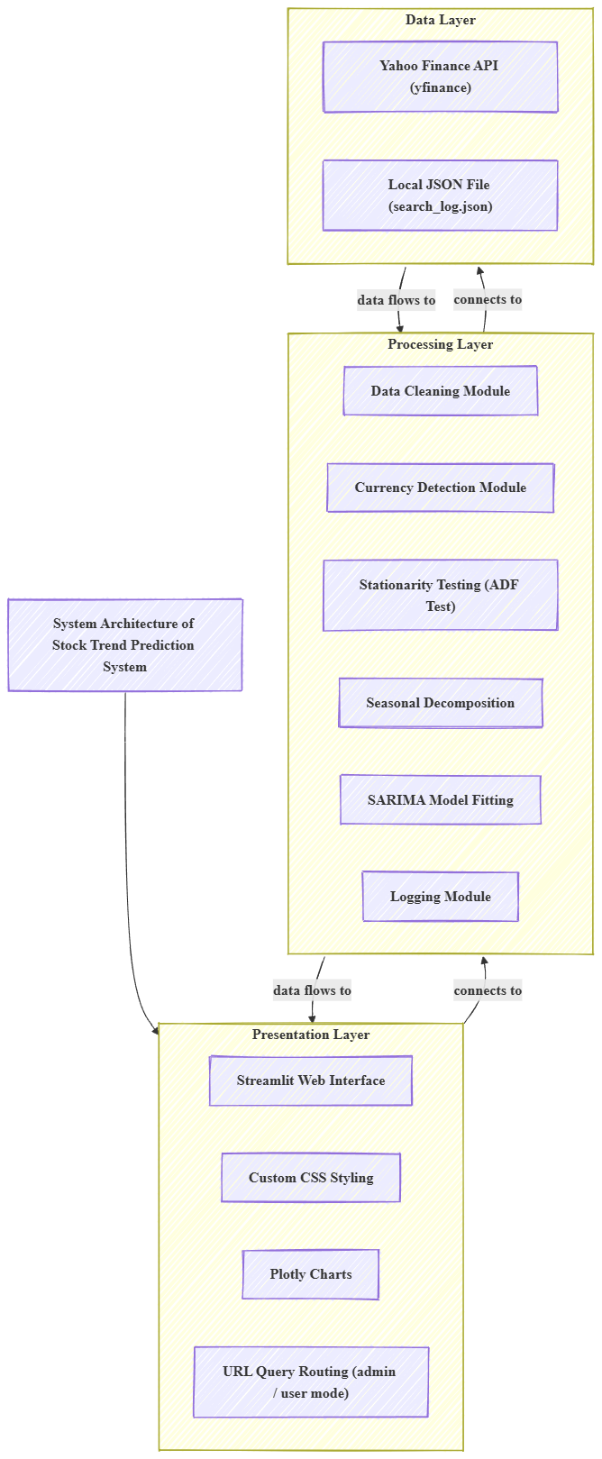
The application follows a three-tier architecture pattern consisting of the Data Layer, the Processing Layer, and the Presentation Layer. Figure 3.1 illustrates the high-level system architecture.
Figure 1 System Architecture

Data Layer
The Data Layer is responsible for all interactions with external data sources:
- Yahoo Finance API (via yfinance): The primary data source. The yf.download() function retrieves OHLCV (Open, High, Low, Close, Volume) historical stock data for any ticker symbol and date range. Additionally, yf.Ticker(ticker).info provides metadata including the trading currency, company name, sector, and exchange.
- Local JSON File (search_log.json): A lightweight persistent storage mechanism used exclusively by the admin backend. Each user search appends one JSON entry to this file, containing the timestamp, ticker, date range, selected column, ARIMA parameters, and the full SARIMA model summary text.

Processing Layer
The Processing Layer contains all analytical and business logic:
- Data Cleaning Module: Handles MultiIndex column flattening (yfinance sometimes returns multi-level column headers when downloading certain tickers), insertion of the Date column, and index resetting.
- Currency Detection Module: Calls yf.Ticker(ticker).info to retrieve the currency field. Maps the currency code (e.g., 'INR') to its display symbol (e.g., '₹') using a predefined dictionary covering 14 major currencies.
- Stationarity Testing Module: Runs the Augmented Dickey-Fuller (ADF) test using adfuller() from statsmodels. Checks if the p-value is below 0.05 to determine stationarity.
- Seasonal Decomposition Module: Applies seasonal_decompose() with an additive model and period=12 to extract trend, seasonal, and residual components. Requires a minimum of 24 data points (2 complete seasonal cycles).
- SARIMA Fitting Module: Instantiates and fits SARIMAX with order=(2,1,2) and seasonal_order=(2,1,2,12). Uses disp=False to suppress convergence output. Catches exceptions and displays user-friendly error messages if fitting fails.
- Logging Module: After successful SARIMA fitting, silently calls write_log() to append the search record to search_log.json. Wrapped in a try-except block so logging failures never affect the user experience.

Presentation Layer
The Presentation Layer handles all user interface rendering:
- Streamlit Framework: Renders the web interface in the user's browser. All UI components (input fields, buttons, dataframes, charts) are defined using Streamlit's declarative API.
- Custom CSS: Applied via st.markdown() with unsafe_allow_html=True. Customizes fonts (IBM Plex Sans, Playfair Display, IBM Plex Mono), colors, button styles, metric cards, and input field appearance.
- Plotly Charts: All charts use plotly.express (for multi-column line charts) or plotly.graph_objects (for custom combined charts). A shared style_chart() function applies consistent theme settings — white background, subtle gridlines, finance-appropriate color scheme — across all visualizations.
- URL-Based Routing: The system reads the 'admin' URL query parameter using st.query_params. If it equals '1', the admin login/dashboard is rendered. Otherwise, the public forecasting app is shown. This single-file routing eliminates the need for multiple Streamlit pages.

Module Specification
The application is organized into the following modules within stock_app.py:
Module / Function | Type | Input | Output | Description
read_log() | Utility | None | List of dicts | Reads search_log.json; returns empty list if file missing
write_log(entry) | Utility | Dict | None | Appends one search entry to search_log.json
get_currency(ticker) | Utility | Ticker string | Tuple (code, symbol) | Queries yfinance metadata for currency; returns ('USD','$') on error
style_chart(fig) | UI | Plotly Figure | Plotly Figure | Applies consistent light theme styling to any Plotly chart
admin_login() | UI | None | Session state update | Renders the hidden admin login card; validates credentials
admin_dashboard() | UI | None | Streamlit render | Displays full search log, expandable entries, CSV download
main_app() | Core | None | Streamlit render | Full public app: inputs, fetch, KPIs, charts, decomp, SARIMA, forecast
Table 4 Module Specification

Database / Data Storage Design
This application does not use a relational database. Instead, a lightweight JSON file (search_log.json) serves as persistent storage for the admin backend. Each entry in the log file follows this schema:
{ "timestamp": "2025-03-20 14:32:11",
"ticker": "RELIANCE.NS",
"start_date": "2026-01-01",
"end_date": "2026-03-20",
"column": "Close RELIANCE.NS",
"arima_p": 2, "arima_d": 1, "arima_q": 2,
"seasonal": 12,
"forecast_days": 30,
"model_summary": "SARIMAX Results ..." }

This design was chosen because: (1) no database server installation is required, (2) the JSON file is portable and can be opened in any text editor, (3) the admin panel can export it as CSV for analysis in Excel, and (4) the log grows slowly (one entry per forecast run) and will not cause performance issues.

Timeline Chart
Phase | Activity | Tasks Performed | Duration
Phase 1 | Project Planning | Problem definition, scope identification, literature review, technology stack selection | Week 1
Phase 2 | Data Collection Setup | yfinance API integration, ticker validation, currency detection, MultiIndex handling | Week 2-3
Phase 3 | Data Preprocessing | Column flattening, date formatting, input validation, error handling design | Week 4-5
Phase 4 | Exploratory Data Analysis | ADF test implementation, seasonal decomposition, Plotly chart creation | Week 6
Phase 5 | SARIMA Implementation | SARIMAX model fitting, parameter selection (2,1,2)(2,1,2,12), forecast generation | Week 6-7
Phase 6 | UI Development | Streamlit interface, custom CSS styling, KPI metrics, input panel layout | Week 8-9
Phase 7 | Admin Backend | JSON logging, URL routing, admin login, dashboard, CSV export | Week 10-11
Phase 8 | Testing & Documentation | Unit testing, error case testing, report writing, PPT preparation | Week 12
Table 5 Timeline Chart

UML Diagrams

Use-Case Diagram
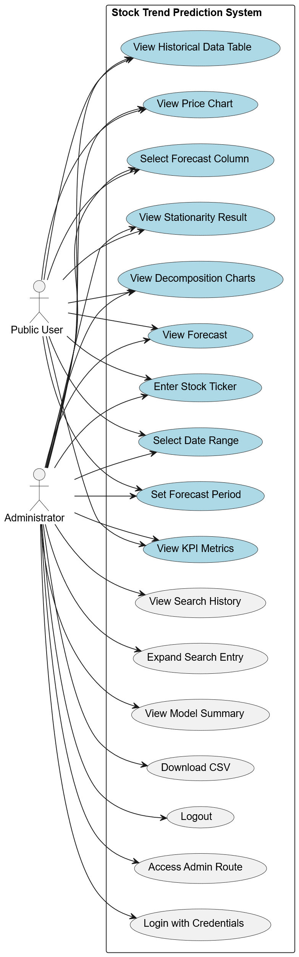
Figure 2 Use Case Diagram

Data Flow Diagram

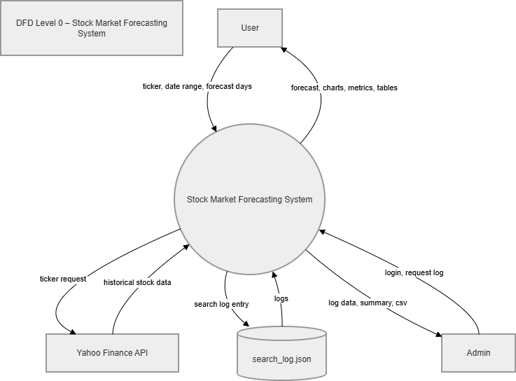
Figure 3 Level 0 — Context Diagram

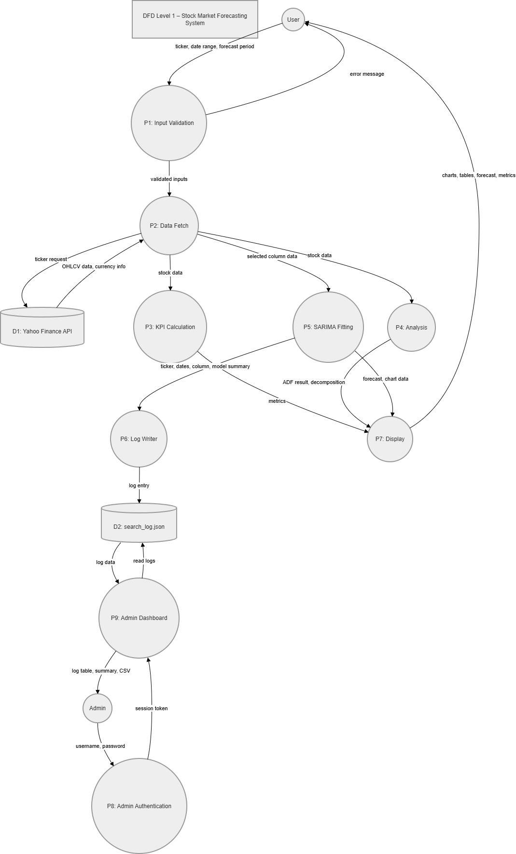
Figure 4 Level 1 — DFD

CHAPTER 4: IMPLEMENTATION

Development Environment Setup
The development environment was set up as follows:
Tool / Setting | Value Used
Operating System | Windows 11
Python Version | Python 3.11.4
IDE / Editor | Visual Studio Code with Python extension
Virtual Environment | venv (python -m venv stockenv)
Version Control | Git with GitHub repository
App Launch Command | streamlit run stock_app.py
Default Port | localhost:8501 (Streamlit default)
Table 6 Development Environment Setup Table

Application Flow — Step by Step
The complete execution flow of the public-facing application is described below with corresponding code references:

Step | Action | Code Called | What Happens
1 | App starts | main_app() | Streamlit renders the navbar and input panel
2 | User fills inputs | st.date_input(), st.text_input(), st.number_input() | Date pickers and text box displayed in 4-column layout
3 | Input guard check | if not ticker or not start_date or not end_date | Shows info strip if any field is empty
4 | Date order check | if start_date >= end_date | Shows error if start date is not before end date
5 | Data download | yf.download(ticker, start, end) | Fetches OHLCV DataFrame from Yahoo Finance
6 | Empty check | if df.empty | Shows error if ticker doesn't exist or no data in range
7 | Column flatten | if isinstance(df.columns, pd.MultiIndex) | Joins MultiIndex column names into single-level strings
8 | Currency fetch | get_currency(ticker) | Calls yf.Ticker(ticker).info to get currency code and symbol
9 | KPI display | st.columns(5) + st.metric() | Renders 5 metric cards with correct currency symbol
10 | Data table | st.dataframe(df, height=210) | Scrollable historical data table shown
11 | Price chart | px.line(df, x='Date', y=all_cols) | Interactive line chart for all OHLCV columns
12 | Column select | st.selectbox() | User picks which column to forecast
13 | ADF test | adfuller(df[chosen_col])[1] < 0.05 | Stationarity result shown in green (pass) or red (fail)
14 | Data length check | if len(df) < 24 | Shows amber warning if too little data for decomposition
15 | Decomposition | seasonal_decompose(df[col], period=12) | Three mini-charts rendered in 3-column layout
16 | SARIMA fit | SARIMAX(...).fit(disp=False) | Model fitted; try-except catches convergence failures
17 | Silent logging | write_log({...}) | Search entry appended to search_log.json
18 | Forecast | sarima.get_prediction(start=len(df), end=len(df)+days) | Future price values computed
19 | Forecast chart | go.Figure() + add_trace() | Combined chart: historical (blue) + forecast (dotted green)
20 | Tables | st.columns(2) + st.dataframe() | Forecast values and last 20 historical rows side by side
Table 7 Application Flow

Key Code Modules — Detailed Explanation

Currency Detection Module
One of the most important features of this application is the automatic currency detection system. The get_currency() function is called immediately after data is downloaded:
CURRENCY_MAP = {
"USD": "$", "INR": "₹", "EUR": "€", "GBP": "£",
"JPY": "¥", "CNY": "¥", "CAD": "CA$", "AUD": "A$",
"HKD": "HK$","SGD": "S$", "CHF": "CHF ","KRW": "₩",
"BRL": "R$", "MXN": "MX$"
}

def get_currency(ticker):
try:
info = yf.Ticker(ticker).info
code = info.get('currency', 'USD')
return code, CURRENCY_MAP.get(code, code + ' ')
except:
return 'USD', '$'

The function makes a separate API call to retrieve the ticker's metadata object. The 'currency' field in this metadata dictionary contains the ISO 4217 currency code (e.g., 'INR' for Indian Rupee, 'USD' for US Dollar). The CURRENCY_MAP dictionary then converts this code into a display symbol. If the currency is not in the map, the code itself is used as a prefix (e.g., 'CHF 1234.56'). The entire function is wrapped in a try-except to gracefully handle API failures.

ADF Stationarity Test
Before fitting SARIMA, it is important to verify that the time series is stationary (i.e., its statistical properties do not change over time). The Augmented Dickey-Fuller (ADF) test is the standard method for this:

from statsmodels.tsa.stattools import adfuller

adf_pval = adfuller(df[chosen_col])[1]
if adf_pval < 0.05:
# Data is stationary - good for SARIMA
else:
# Data is not stationary - SARIMA handles this via the 'd' parameter

The adfuller() function returns a tuple; index [1] contains the p-value. A p-value below 0.05 means we can reject the null hypothesis (that the series has a unit root), confirming stationarity. Even if the data is not stationary, SARIMA's 'd' differencing parameter (set to 1 in our model) will handle first-order differencing internally.

Seasonal Decomposition
Seasonal decomposition separates the time series into three interpretable components:

from statsmodels.tsa.seasonal import seasonal_decompose

MIN_POINTS = 24 # need 2 full seasonal cycles for period=12

if len(df) >= MIN_POINTS:
decomp = seasonal_decompose(df[chosen_col],
model='additive',
period=12)
# decomp.trend - long-term price movement
# decomp.seasonal - repeating periodic pattern
# decomp.resid - random noise remaining

The additive model assumes the time series = Trend + Seasonal + Residual, appropriate for data where the seasonal fluctuation amplitude is roughly constant over time. The period=12 assumption treats each 12 consecutive trading days as one seasonal cycle. This is a simplification; in practice, monthly seasonality would require approximately 22 trading days. The 24-point minimum check ensures the function does not crash with insufficient data.

SARIMAX Model Fitting and Forecasting
The core analytical module fits the SARIMAX model and generates predictions:

import statsmodels.api as sm

p, d, q = 2, 1, 2 # ARIMA order
seasonal = 12 # seasonal period

try:
sarima = sm.tsa.statespace.SARIMAX(
df[chosen_col],
order=(p, d, q),
seasonal_order=(p, d, q, seasonal)
).fit(disp=False)
except Exception:
# show friendly error, don't crash
return

# Generate forecast
future = sarima.get_prediction(
start=len(df),
end=len(df) + forecast_days
)
future_vals = future.predicted_mean

Parameter explanation: p=2 means the model uses the last 2 price values as autoregressive inputs. d=1 means the series is differenced once to achieve stationarity. q=2 means the model uses the last 2 forecast errors as moving-average inputs. The seasonal_order=(2,1,2,12) applies the same AR, I, MA structure at the seasonal level with period 12.
The get_prediction() method generates predictions starting from the index position len(df) (i.e., the first point after the training data ends) through to len(df) + forecast_days. The predicted_mean attribute returns the point estimates.

Admin Backend and URL Routing
The admin backend is accessible via a hidden URL parameter, requiring no separate Streamlit page file:

# Read URL query parameters
params = st.query_params
on_admin_page = params.get('admin', '') == '1'

# Route to appropriate page
if on_admin_page:
if not st.session_state.get('admin_in'):
admin_login() # show login card
else:
admin_dashboard() # show search log
else:
main_app() # public forecasting app

This routing mechanism is completely transparent to public users — they simply never navigate to /?admin=1 because there is no link to it anywhere in the public UI. The admin_login() function verifies the entered credentials against the ADMIN_USERS dictionary using a simple string comparison.

Silent Search Logging
After every successful SARIMA model fit, the search is logged invisibly to the user:

def write_log(entry):
logs = read_log()
logs.append(entry)
with open(LOG_FILE, 'w') as f:
json.dump(logs, f, indent=2)

# Called after sarima.fit() succeeds
try:
write_log({
'timestamp': datetime.now().strftime('%Y-%m-%d %H:%M:%S'),
'ticker': ticker,
'start_date': str(start_date),
'end_date': str(end_date),
'column': chosen_col,
'arima_p': p, 'arima_d': d, 'arima_q': q,
'seasonal': seasonal,
'forecast_days': int(forecast_days),
'model_summary': str(sarima.summary()),
})
except:
pass # never let logging break the app

The outer try-except block is critical: if logging fails for any reason (disk full, permission error, JSON corruption), the application must continue functioning normally. Users should never be aware that logging is occurring.

Input Validation and Error Handling
Table 8 Validation and Error Handling
Robust validation was implemented at multiple levels to prevent crashes and provide helpful guidance:
Error Condition | Detection Method | User Message Shown
Empty ticker or dates | if not ticker or not start_date or not end_date | Info box: 'Fill in start date, end date and ticker symbol to get started'
Start date >= end date | if start_date >= end_date | Error: 'Start date has to be before end date'
Invalid or unknown ticker | if df.empty after download | Error: 'Couldn't find data for TICKER. Check the symbol — Indian stocks need .NS'
Date range too short (<24 points) | if len(df) < MIN_POINTS | Amber warning: 'Needs at least 24 data points. Try 2-3 months minimum'
SARIMA convergence failure | except Exception in .fit() block | Error: 'Model didn't converge. Try 3 to 6 months of data'
Admin wrong credentials | if u not in ADMIN_USERS or wrong password | Error: 'Wrong credentials'
Admin session expired | st.session_state.get('admin_in') check | Redirects to admin login page automatically

System Testing
Comprehensive testing was conducted across multiple test categories:

Functional Testing
Test Case ID | Test Description | Input | Expected Result | Status
TC-01 | Valid Indian NSE stock | RELIANCE.NS, 2024-01-01 to 2025-01-01 | Data loaded, ₹ symbol, all charts rendered | PASS
TC-02 | Valid US NYSE stock | AAPL, 2024-01-01 to 2025-01-01 | Data loaded, $ symbol, all charts rendered | PASS
TC-03 | Invalid ticker symbol | XYZABC999 | Error message shown, app does not crash | PASS
TC-04 | Start > End date | Start: 2025-06-01, End: 2024-01-01 | Error: start must be before end | PASS
TC-05 | Same start and end date | Start: 2024-01-01, End: 2024-01-01 | Error: start must be before end | PASS
TC-06 | Too-short date range (3 days) | Any ticker, 3-day range | Amber warning about minimum data requirement | PASS
TC-07 | Long date range (5 years) | AAPL, 2020-01-01 to 2025-01-01 | All features work, model fits successfully | PASS
TC-08 | Admin login — correct | poojan / poojan123 | Admin dashboard displayed | PASS
TC-9 | Admin login — wrong password | poojan / wrongpass | Error: 'Wrong credentials' | PASS
TC-10 | Admin login — wrong username | unknown / poojan123 | Error: 'Wrong credentials' | PASS
TC-11 | Public user at /?admin=1 | (visiting URL without credentials) | Admin login page shown, no bypass | PASS
TC-12 | CSV download in admin | After searches exist in log | CSV downloaded with all columns except model_summary | PASS
TC-13 | Currency detection — INR | TCS.NS or INFY.NS | ₹ symbol used in all KPI metrics | PASS
TC-14 | Forecast period = 1 day | Any valid stock, forecast_days=1 | One row in forecast table, chart updates | PASS
TC-15 | Forecast period = 365 days | Any valid stock, forecast_days=365 | 365 rows in forecast table, chart updates | PASS
Table 9 Functional Testing

Results and Application Screenshots Description

Main Interface — Input Panel
When the application opens, the user sees a navigation bar at the top with the app name "StockCast". Below it, a white input card titled "Enter Details" is displayed. The card contains four fields in one row: Start Date, End Date, Ticker Symbol, and Forecast Days (default 10, range 1–365).
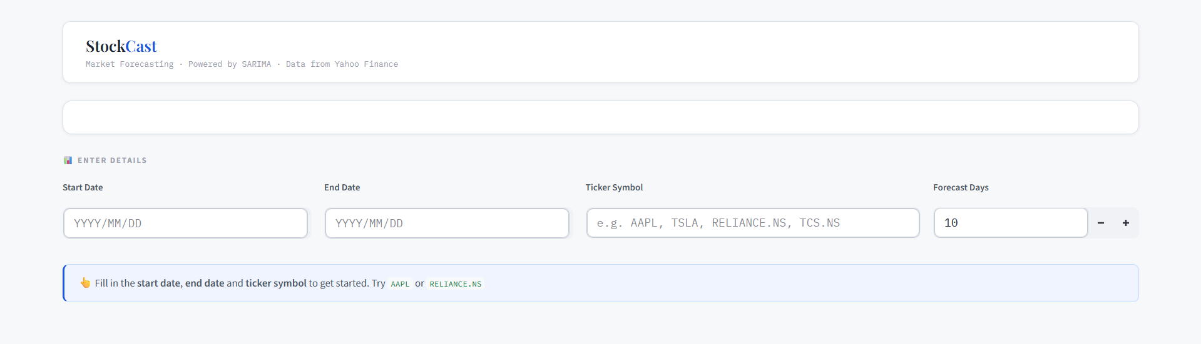
Figure 5 Main Interface — Input Panel

KPI Metrics Strip
After entering a valid ticker and date range, five KPI cards are displayed showing Current Price, Total Change, Period High, Period Low, and Average. Values are shown with the correct currency symbol — ₹ for Indian stocks and $ for US stocks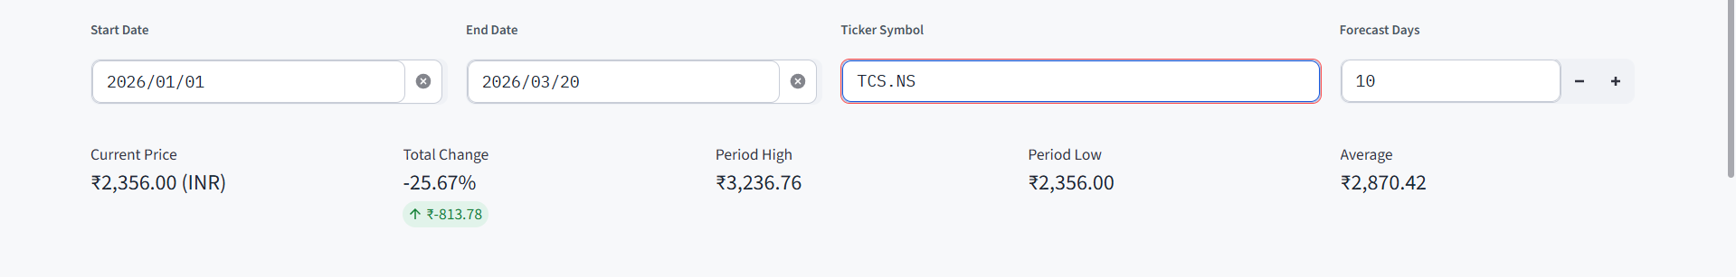
Figure 6 KPI Metrics Strip

Historical Data Table
A scrollable data table displays all OHLCV data with the Date column first. Column names include the ticker suffix (e.g., Close AAPL). The table height is fixed at 210px with internal scrolling to keep the page compact.
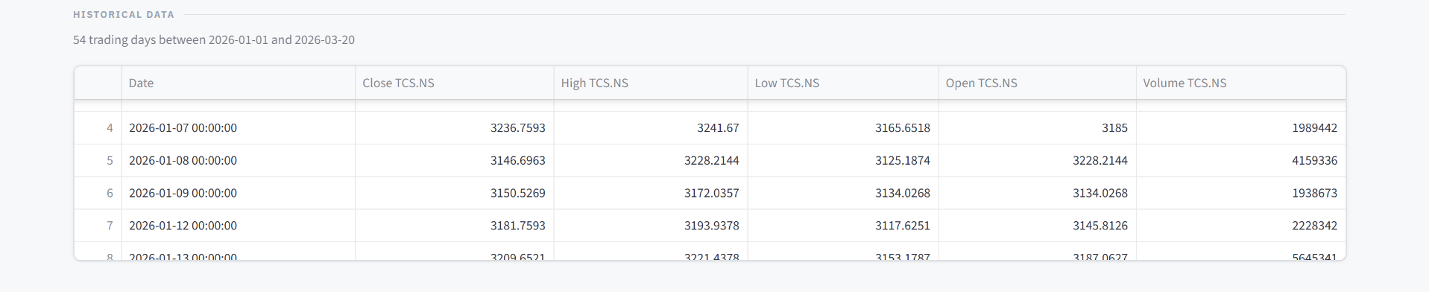
Figure 7 Historical Data Table

Price Overview Chart
An interactive Plotly line chart shows all price columns (Open, High, Low, Close, Volume) over the selected date range. Users can hover over any point to see the exact date and value, zoom in using mouse scroll or the range slider, and toggle individual columns by clicking the legend.
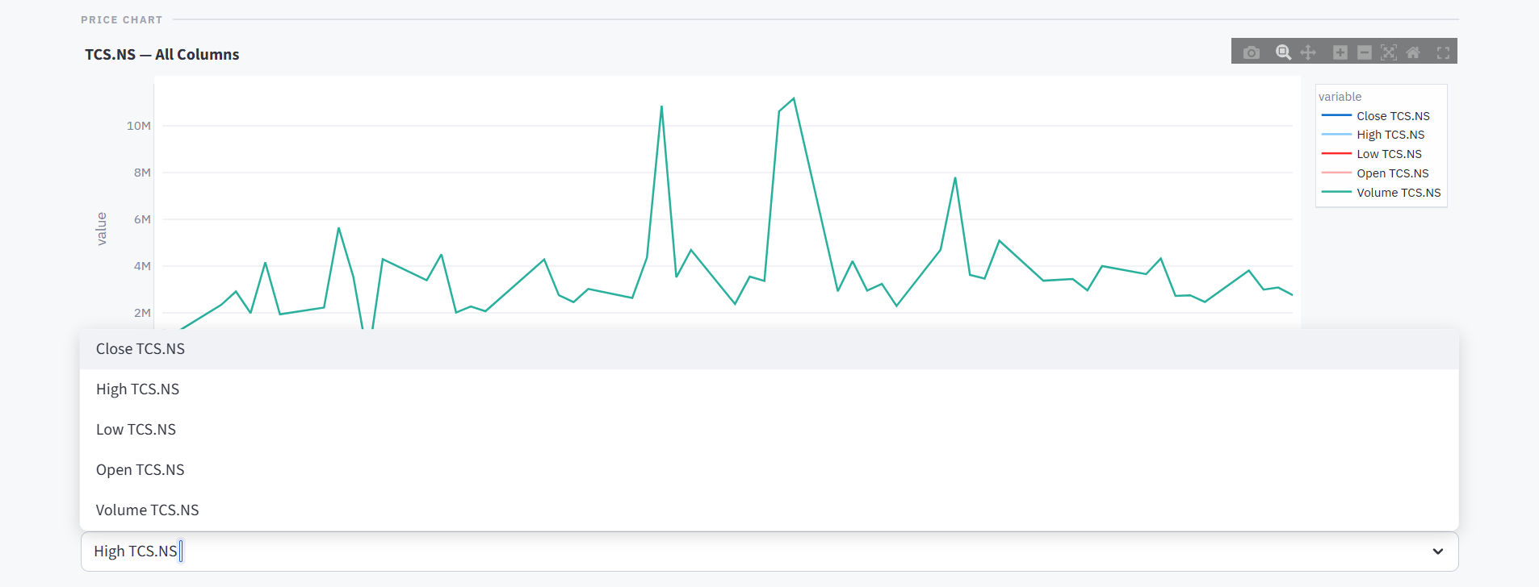
Figure 8 Price Overview Chart

Seasonal Decomposition Charts
Three mini charts in a three-column layout display: (1) Trend component in blue — the long-term price direction; (2) Seasonality component in green — the recurring periodic pattern; (3) Residuals in red (dotted) — the random noise after removing trend and seasonality. Each chart shares the same date axis for easy comparison.
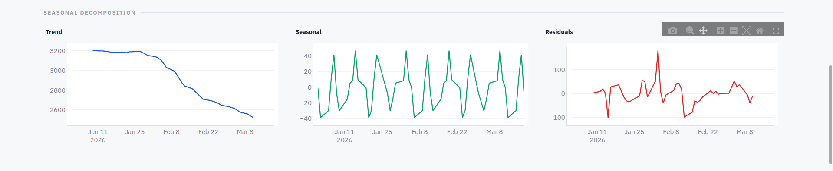
Figure 9 Seasonal Decomposition Charts

Forecast Results
The forecast section shows: (1) A combined chart where historical prices are shown as a solid blue line and predicted prices as a dotted green line with very light green fill. The chart clearly marks the boundary between known data and prediction. (2) Two side-by-side tables — the forecast values table (Date and Predicted column) and the last 20 rows of historical data for comparison.
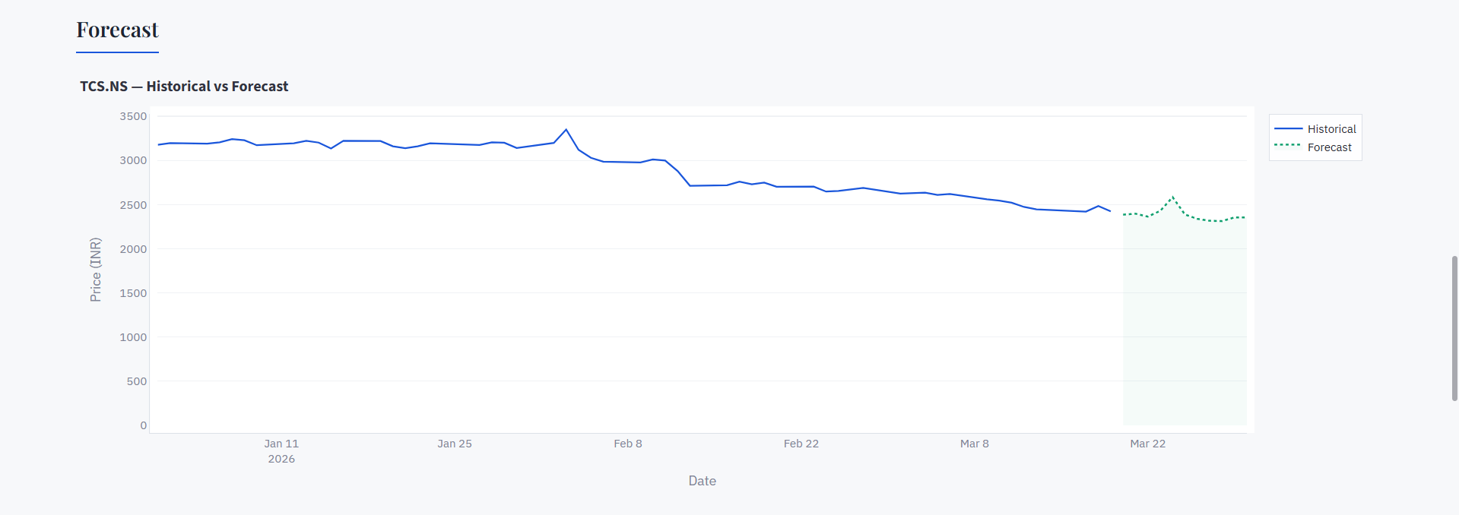
Figure 10 Forecast Results
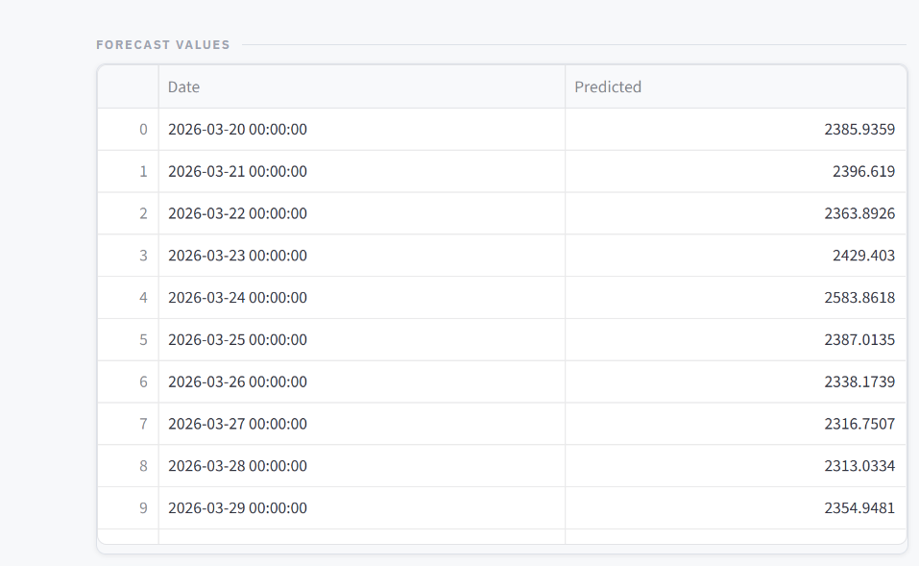
Figure 11 Forecast Values Table

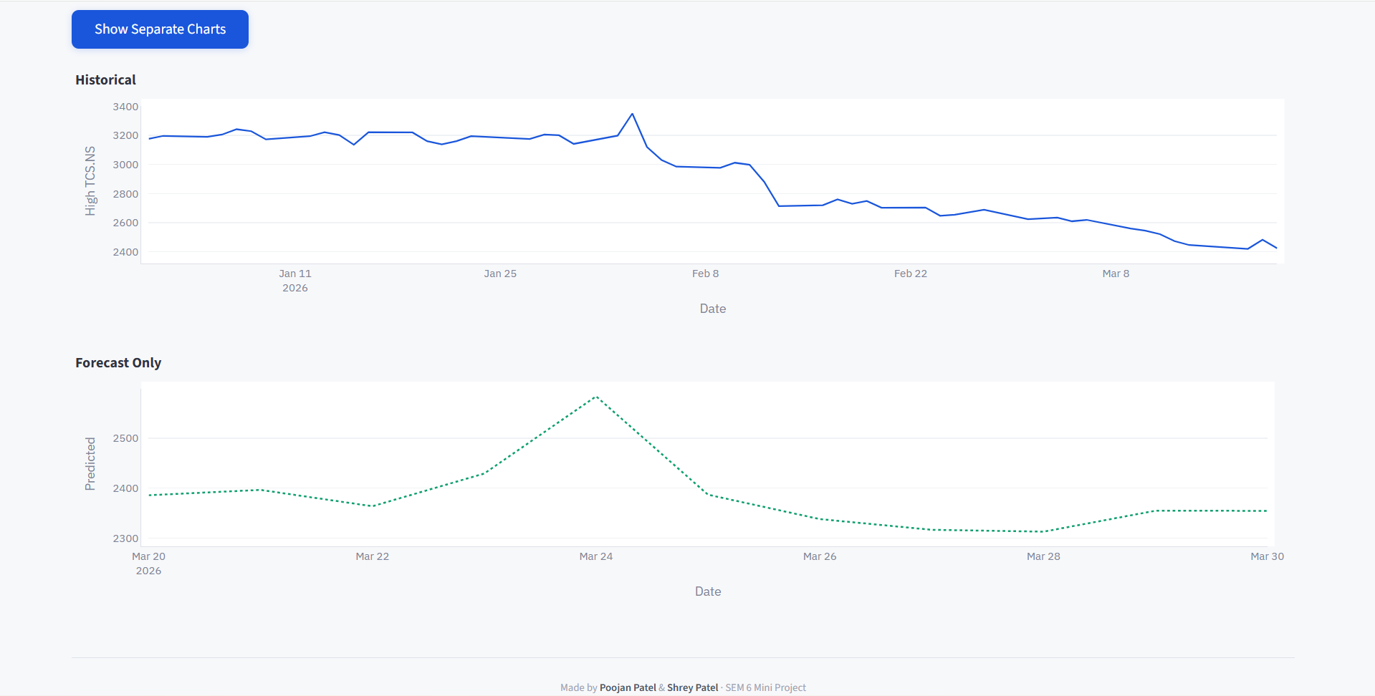
Figure 12 Separate Forecast Chart

Admin Backend Dashboard
The admin dashboard features a dark navy header bar showing 'StockCast Pro — Admin' with the logged-in user's name and a gold 'Admin' badge. Below are three KPI cards showing Total Searches, Unique Tickers, and Last Activity timestamp. The search history is displayed as an expandable accordion row, each labeled with the ticker and timestamp. Expanding a row reveals a three-column details section (date range, column used, forecast days), ARIMA parameter badges (p=2, d=1, q=2, seasonal=12), and the full SARIMAX model summary in a code block.
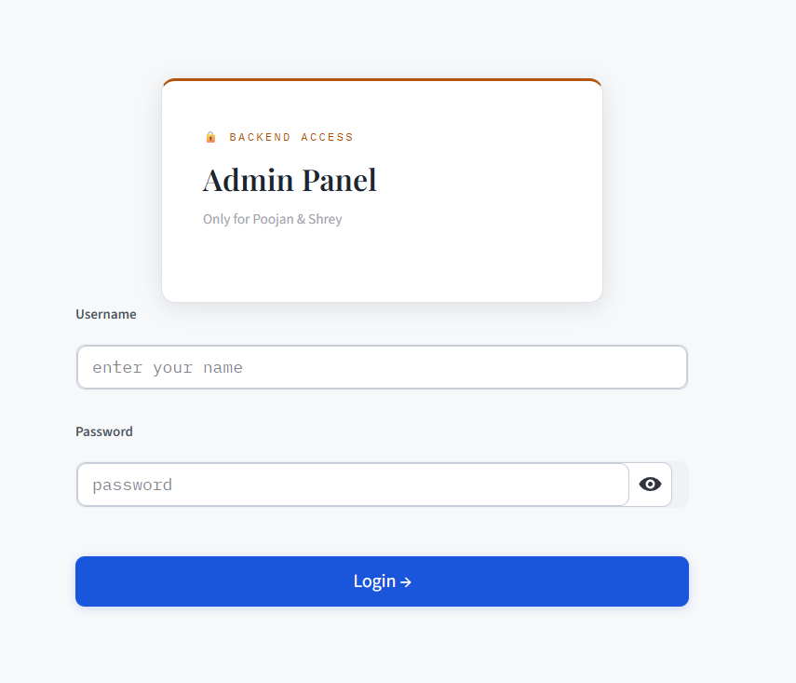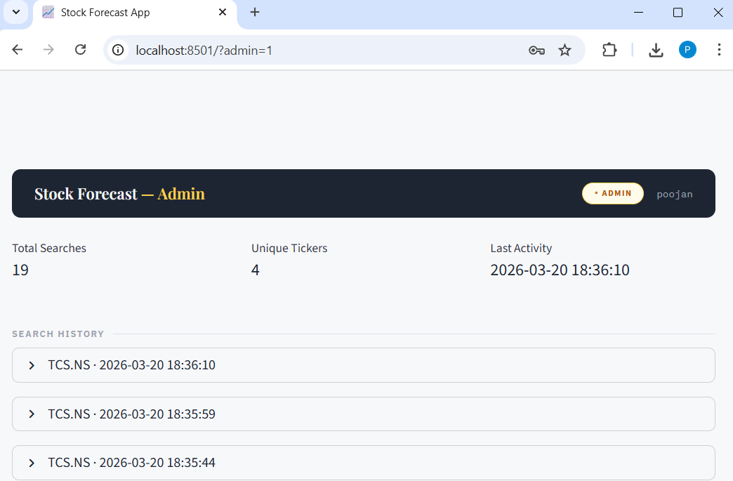
Figure 13 Admin Login Page Figure 14 Admin Dashboard

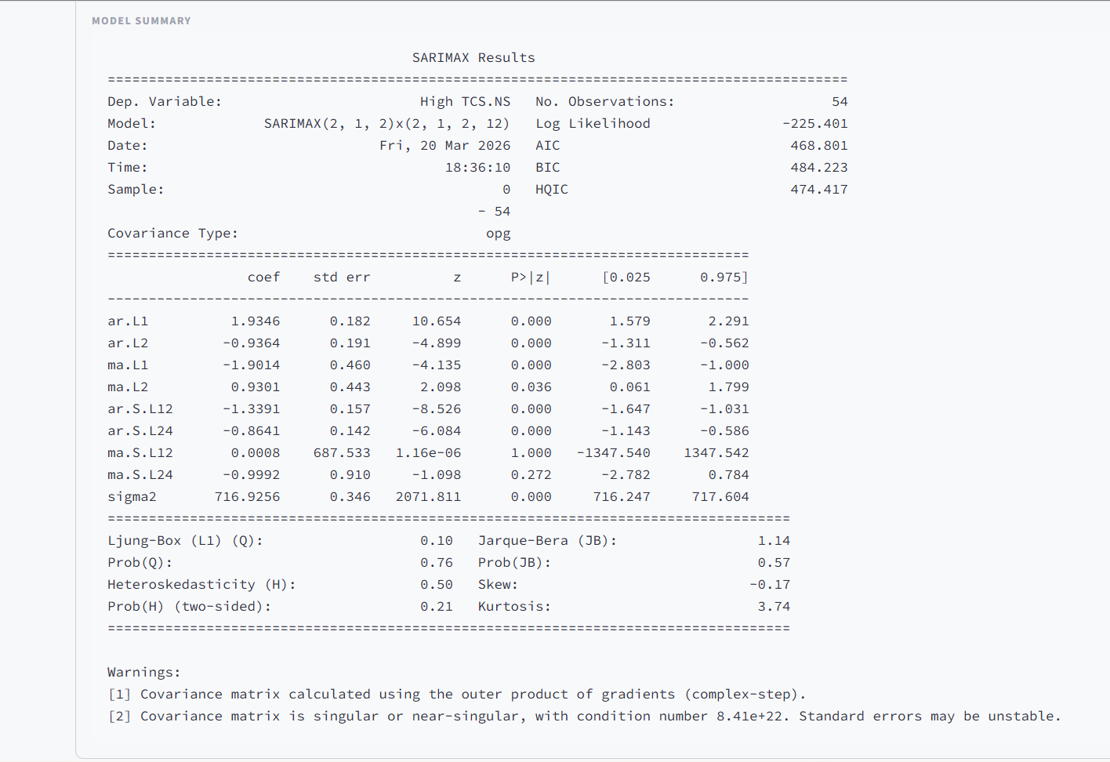
Figure 15 Model Summary in Backend

CHAPTER 5: CONCLUSION AND FUTURE WORK

Conclusion
This project has successfully achieved all of its stated objectives. The Stock Market Forecasting App is a fully functional, web-based application that demonstrates the complete integration of financial data APIs, time-series statistical modeling, and modern interactive visualization technologies into a single, accessible tool.
The application addresses the core problems identified in the problem statement: it eliminates the need for programming knowledge through a clean web interface; it automatically detects and displays the correct trading currency for any global stock; it provides rich analytical output (stationarity testing, seasonal decomposition, SARIMA forecasting) without requiring users to understand the underlying mathematics; and it implements a novel hidden administrative backend that gives the project authors complete visibility into how the tool is being used.
From a technical standpoint, this project demonstrates proficiency in several important areas of computer science and data science: RESTful API integration (yfinance), time-series analysis (ADF test, seasonal decomposition, SARIMA), interactive web application development (Streamlit), data visualization (Plotly), role-based access control without a database (URL routing + session state), and robust error handling with user-friendly messaging.
The use of the SARIMAX model with parameters (2,1,2)(2,1,2,12) proved effective for generating plausible short-to-medium term price forecasts across a variety of stocks and market conditions tested during development. The model's built-in first-order differencing (d=1) handles non-stationarity automatically, making it robust to a wide range of input data characteristics.
The administrative backend, which silently logs every user search with complete model summaries and provides a CSV export facility, represents a practical and thoughtful system design choice that supports ongoing monitoring and improvement of the application without affecting the user experience in any way.

Future Work
The following enhancements are planned for future development:

Model Improvements
- Auto-ARIMA: Implement pmdarima's auto_arima() function to automatically determine optimal p, d, q, and seasonal parameters for each stock, replacing the current fixed (2,1,2)(2,1,2,12) defaults
- Forecast Confidence Intervals: Display the 95% confidence interval bands around the SARIMA forecast line to communicate prediction uncertainty to users
- Model Evaluation Metrics: Calculate and display RMSE (Root Mean Squared Error), MAPE (Mean Absolute Percentage Error), and MAE (Mean Absolute Error) on a hold-out test set
- LSTM Integration: Add an optional Long Short-Term Memory deep learning model as an alternative to SARIMA for datasets where deep learning outperforms statistical models

Feature Additions
- Technical Indicators: Add RSI, MACD, Bollinger Bands, and Moving Averages as additional analysis tabs alongside the time-series forecast
- Multiple Stock Comparison: Allow users to enter multiple tickers and view their price performance and forecasts on the same chart
- News Sentiment Integration: Incorporate news sentiment scores from financial news APIs as exogenous variables in the SARIMAX model (the 'X' in SARIMAX)
- Portfolio Analysis: Allow users to enter a portfolio of stocks with weights and view aggregate performance metrics and forecasts

Infrastructure Improvements
- Cloud Deployment: Deploy on Streamlit Community Cloud or AWS for remote access without local installation
- Database Backend: Replace the JSON log file with a SQLite or PostgreSQL database for more efficient querying and storage of large log volumes
- Real-Time Data: Integrate WebSocket-based real-time stock price feeds for intraday analysis
- PDF Report Export: Allow users to generate and download a PDF summary of their analysis including all charts and the forecast table.

CHAPTER 6: REFERENCES

Research Papers
- Ariyo, A.A., Adewumi, A.O., & Ayo, C.K. (2014). Stock Price Prediction Using the ARIMA Model. Proceedings of the 2014 UKSim-AMSS 16th International Conference on Computer Modelling and Simulation. DOI: 10.1109/UKSim.2014.67
- Kumar, M. & Thenmozhi, M. (2014). Forecasting Stock Index Returns using ARIMA-SVM, ARIMA-ANN, and ARIMA Random Forest Hybrid Models. International Journal of Banking, Accounting and Finance, 5(3), 284–308.
- Nelson, D.M.Q., Pereira, A.C.M., & Oliveira, R.A. (2017). Stock Market's Price Movement Prediction with LSTM Neural Networks. Proceedings of the 2017 International Joint Conference on Neural Networks (IJCNN).

Online Resources and Documentation
- Yahoo Finance. (2025). Yahoo Finance — Stock Market Live, Quotes, Business & Finance News. Retrieved from: https://finance.yahoo.com
- yfinance Contributors. (2024). yfinance — Python library to download historical market data from Yahoo Finance. PyPI. Retrieved from: https://pypi.org/project/yfinance/
- Streamlit Inc. (2025). Streamlit Documentation — The fastest way to build and share data apps. Retrieved from: https://docs.streamlit.io/
- statsmodels Contributors. (2024). statsmodels.tsa.statespace.sarimax.SARIMAX. Python statsmodels documentation. Retrieved from: https://www.statsmodels.org/stable/generated/statsmodels.tsa.statespace.sarimax.SARIMAX.html
- Plotly Technologies Inc. (2024). Plotly Python Graphing Library. Retrieved from: https://plotly.com/python/
- Wikipedia Contributors. (2024). Stock Market Prediction. Wikipedia, The Free Encyclopedia. Retrieved from: https://en.wikipedia.org/wiki/Stock_market_prediction
- YouTube Tutorial. Stock Market Analysis with Python and Streamlit. Retrieved from: https://youtu.be/jUHbl02inAk?si=aG5Zpny-4Fscs9Vj

