s

This guide will demonstrate how to sign up for an Azure Dev Tools account using a Microsoft Account which is then validated using your DCMAIL / Durham College email account.

Microsoft Account

To sign in to this platform, you are required to use a personal Microsoft account (i.e. an account used to sign in to Microsoft websites and services which is not provided by Durham College). If you do not have one, you can create a Microsoft account or find out more information here: <http://bit.ly/msaccounts>

Once you have a personal Microsoft account, proceed with the directions below.

Obtaining Access to Project and Visio

1. Go to <http://azureforeducation.microsoft.com/devtools/>
2. Click on the **blue** **Sign-In** button. If you do not see the page below, please clear your web browser’s history.

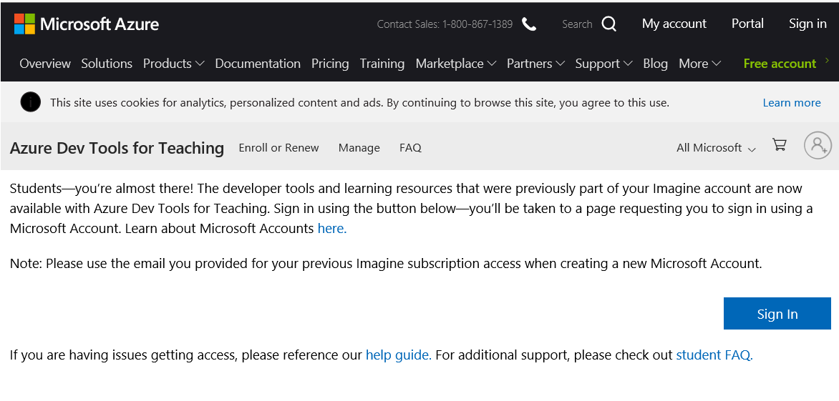

1. Sign in to the webpage using your personal Microsoft account.
2. You will be sent to the verification webpage (below)

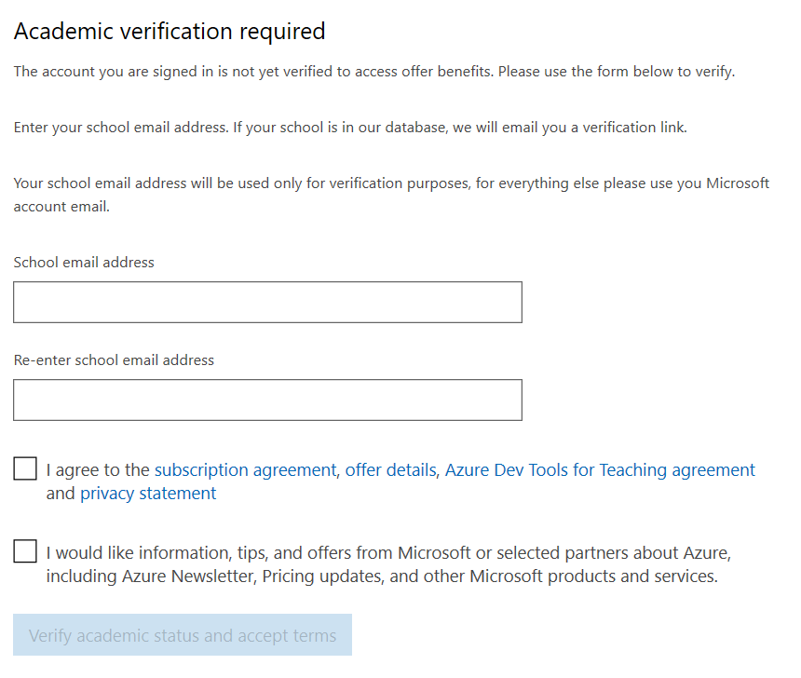

1. Enter your school email address (i.e. [firstname.lastname@dcmail.ca](mailto:firstname.lastname@dcmail.ca))
2. Check the ‘I agree to the subscription…” checkbox, then press the **Verify academic status and accept terms** button. You should see the notice below, prompting you to check your school issued email account.



1. Sign in to your school email ([www.dcmail.ca](http://www.dcmail.ca)) and find the verification email from ‘Microsoft Vetting Services’ which will look something like the email below

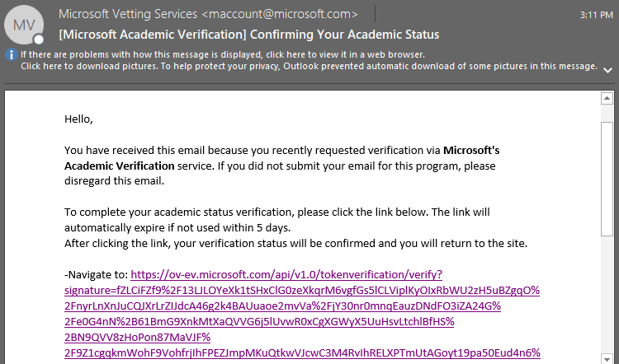

1. Click on the link in the email to verify your account. You should be directed to the webpage below – click on the checkbox next to “I agree to the subscription agreement…” and click ‘**Accept Terms’**

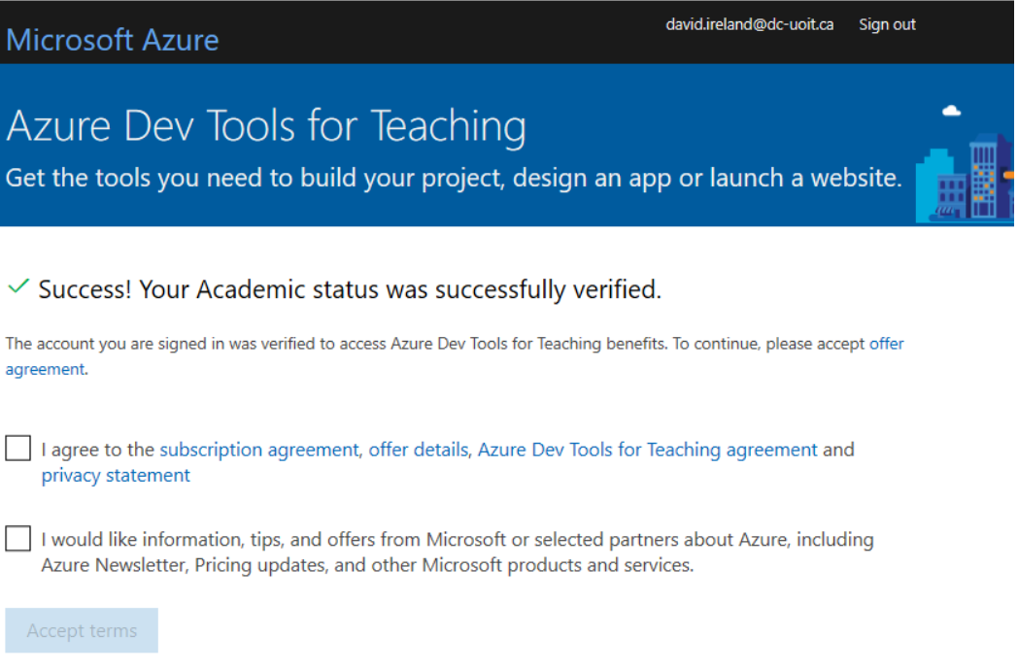

1. Sign out of this web page using the sign out button at the top right of the page. Close your

browser. You can now return to <http://azureforeducation.microsoft.com/devtools/>

1. Open a new browser window and navigate to <http://azureforeducation.microsoft.com/devtools/>
2. Click on ‘**Software’** and then search for the title you are looking for. (See image below)

