**DBMS ASSIGNMENT: 2**

**Name: Poojan Gandhi**

**Enroll No: AU1940125**

**Faculty: Shefali Naik**

* One txt file is also submitted.
* The txt file and this doc both contains data manipulation commands for all questions so we can refer any of them.
* This doc also have images of execution part for each question.
* The pdf (which is same as doc) is also submitted so that it will be more convenient to read.

# Bank Table creation and data insertion

create table branch(branch_name varchar(50) primary key,branch_city varchar(50),assets int);

create table account(account_number varchar(5) primary key ,branch_name varchar(50) references branch(branch_name),balance int);

create table loan(loan_number varchar(4) primary key ,branch_name varchar(50) references branch(branch_name),amount int);

create table customer(customer_name varchar(50) primary key,customer_street varchar(50),customer_city varchar(50));

create table borrower(customer_name varchar(50) references customer(customer_name),loan_number varchar(4) references loan(loan_number),primary key(customer_name,loan_number));

create table depositor(customer_name varchar(50) references customer(customer_name),account_number varchar(5) references account(account_number),primary key(customer_name,account_number));

**BRANCH TABLE**

INSERT INTO branch VALUES ('Brighton', 'Brooklyn', 7100000);

INSERT INTO branch VALUES ('Downtown', 'Brooklyn', 9000000);

INSERT INTO branch VALUES ('Mianus', 'Horseneck', 400000);

INSERT INTO branch VALUES ('North Town', 'Rye', 3700000);

INSERT INTO branch VALUES ('Perryridge', 'Horseneck', 1700000);

INSERT INTO branch VALUES ('Pownal', 'Bennington', 300000);

INSERT INTO branch VALUES ('Redwood', 'Palo Alto', 2100000);

INSERT INTO branch VALUES ('Round Hill', 'Horseneck', 8000000);

**LOAN TABLE**

INSERT INTO loan VALUES ('L-11', 'Round Hill', 900);

INSERT INTO loan VALUES ('L-14', 'Downtown', 1500);

INSERT INTO loan VALUES ('L-15', 'Perryridge', 1500);

INSERT INTO loan VALUES ('L-16', 'Perryridge', 1300);

INSERT INTO loan VALUES ('L-17', 'Downtown', 1000);

INSERT INTO loan VALUES ('L-23', 'Redwood', 2000);

INSERT INTO loan VALUES ('L-93', 'Mianus', 500);

**CUSTOMER TABLE**

INSERT INTO customer VALUES ('Adams', 'Spring', 'Pittsfield');

INSERT INTO customer VALUES ('Brooks', 'Senator', 'Brooklyn');

INSERT INTO customer VALUES ('Curry', 'North', 'Rye');

INSERT INTO customer VALUES ('Glenn', 'Sand Hill', 'Woodside');

INSERT INTO customer VALUES ('Green', 'Walnut', 'Stamford');

INSERT INTO customer VALUES ('Hayes', 'Main', 'Harrison');

INSERT INTO customer VALUES ('Johnson', 'Alma', 'Palo Alto');

INSERT INTO customer VALUES ('Jones', 'Main', 'Harrison');

INSERT INTO customer VALUES ('Lindsay', 'Park', 'Pittsfield');

INSERT INTO customer VALUES ('Smith', 'North', 'Rye');

INSERT INTO customer VALUES ('Turner', 'Putnam', 'Stamford');

INSERT INTO customer VALUES ('Williams', 'Nassau', 'Princeton');

**BORROWER TABLE**

INSERT INTO borrower VALUES ('Adams', 'L-16');

INSERT INTO borrower VALUES ('Curry', 'L-93');

INSERT INTO borrower VALUES ('Hayes', 'L-15');

INSERT INTO borrower VALUES ('Johnson', 'L-14');

INSERT INTO borrower VALUES ('Jones', 'L-17');

INSERT INTO borrower VALUES ('Smith', 'L-11');

INSERT INTO borrower VALUES ('Smith', 'L-23');

INSERT INTO borrower VALUES ('Williams', 'L-17');

**ACCOUNT TABLE**

INSERT INTO account VALUES ('A-101', 'Downtown', 500);

INSERT INTO account VALUES ('A-102', 'Perryridge', 400);

INSERT INTO account VALUES ('A-201', 'Brighton', 900);

INSERT INTO account VALUES ('A-215', 'Mianus', 700);

INSERT INTO account VALUES ('A-217', 'Brighton', 750);

INSERT INTO account VALUES ('A-222', 'Redwood', 700);

INSERT INTO account VALUES ('A-305', 'Round Hill', 350);

**DEPOSITOR TABLE**

INSERT INTO depositor VALUES ('Hayes', 'A-102');

INSERT INTO depositor VALUES ('Johnson', 'A-101');

INSERT INTO depositor VALUES ('Johnson', 'A-201');

INSERT INTO depositor VALUES ('Jones', 'A-217');

INSERT INTO depositor VALUES ('Lindsay', 'A-222');

INSERT INTO depositor VALUES ('Smith', 'A-215');

INSERT INTO depositor VALUES ('Turner', 'A-305');

# **1.** Create a procedure which will display loan details of borrowers in the following format.

**Procedure**

create or replace procedure borrowerDetailsA2Q1 as

totalLoanAmount int:=0;

cursor cur_borrower is select distinct customer_name from borrower;

rec_borrower cur_borrower%rowtype;

cursor cur_loanNumber(cname customer.customer_name%type) is select * from borrower where customer_name=cname;

rec_loanNumber cur_loanNumber%rowtype;

cursor cur_loan(ln loan.loan_number%type) is select * from loan where loan_number=ln;

rec_loan cur_loan%rowtype;

cursor cur_branchCity(bn branch.branch_name%type) is select branch_city from branch where branch_name=bn;

rec_branchCity cur_branchCity%rowtype;

begin

for rec_borrower in cur_borrower loop

totalLoanAmount:=0;

dbms_output.put_line('Borrower name: '||rec_borrower.customer_name);

dbms_output.put_line(' Loan No Branch Name Branch City Loan Amount');

for rec_loanNumber in cur_loanNumber(rec_borrower.customer_name) loop

for rec_loan in cur_loan(rec_loanNumber.loan_number) loop

--BRANCH_NAME IS PRIMAY KEY IN BRANCH THEREFORE IT IS UNIQUE

for rec_branchCity in cur_branchCity(rec_loan.branch_name) loop

dbms_output.put_line(' '||rec_loan.loan_number||' '||rec_loan.branch_name||' '||rec_branchCity.branch_city||' '|| rec_loan.amount);

end loop;

totalLoanAmount:=totalLoanAmount+rec_loan.amount;

end loop;

end loop;

if(totalLoanAmount!=0) then

dbms_output.put_line(' Total loan amount of borrower '||rec_borrower.customer_name||': '||totalLoanAmount||chr(10));

end if;

end loop;

end;

/

**Execution**

Execute borrowerDetailsA2Q1;

**IMAGE**

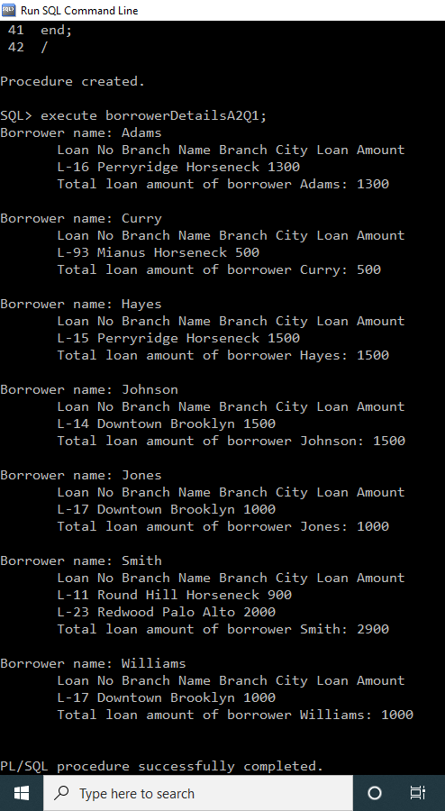

# **2.** Create a procedure which will display city-wise branch-wise loan details of borrowers in the following format.

**Procedure**

create or replace procedure city_with_branch_loan_details as

cityAmount int:=0;

branchAmount int:=0;

totalAmount int:=0;

cursor cur_city is select distinct branch_city from branch;

rec_city cur_city%rowtype;

cursor cur_branch(ct branch.branch_city%type) is select branch_name from branch where branch_city=ct;

rec_branch cur_branch%rowtype;

cursor cur_customer(bn branch.branch_name%type) is select b.customer_name,b.loan_number from borrower b,loan l where l.branch_name=bn and l.loan_number=b.loan_number;

rec_customer cur_customer%rowtype;

cursor cur_loanNumber(ln loan.loan_number%type) is select * from loan where loan_number=ln;

rec_loanNumber cur_loanNumber%rowtype;

begin

for rec_city in cur_city loop

dbms_output.put_line(rpad(' ',3)||'City : '|| rec_city.branch_city);

cityAmount:=0;

for rec_branch in cur_branch(rec_city.branch_city) loop

branchAmount:=0;

dbms_output.put_line(rpad(' ',7)||'Branch Name : '|| rec_branch.branch_name);

for rec_customer in cur_customer(rec_branch.branch_name) loop

dbms_output.put_line(rpad(' ',10)||'Borrower Name :'|| rec_customer.customer_name);

dbms_output.put_line(rpad(' ',13)||'Loan No Loan Amount');

for rec_loanNumber in cur_loanNumber(rec_customer.loan_number) loop

dbms_output.put_line(rpad(' ',13)||rec_loanNumber.loan_number||' ' || rec_loanNumber.amount);

branchAmount:= branchAmount+rec_loanNumber.amount;

end loop;

end loop;

dbms_output.put_line(rpad(' ',7)||'Total Loan Amount collected at the branch '||rec_branch.branch_name||': '|| branchAmount||chr(10));

cityAmount:=cityAmount+branchAmount;

end loop;

dbms_output.put_line(rpad(' ',3)||'Total Loan Amount collected in the City '||rec_city.branch_city||': '|| cityAmount||chr(10));

totalAmount:=totalAmount+cityAmount;

end loop;

dbms_output.put_line('Overall Total Amount :'||totalAmount||chr(10));

end;

/

**Execution**

execute city_with_branch_loan_details;

**Image**

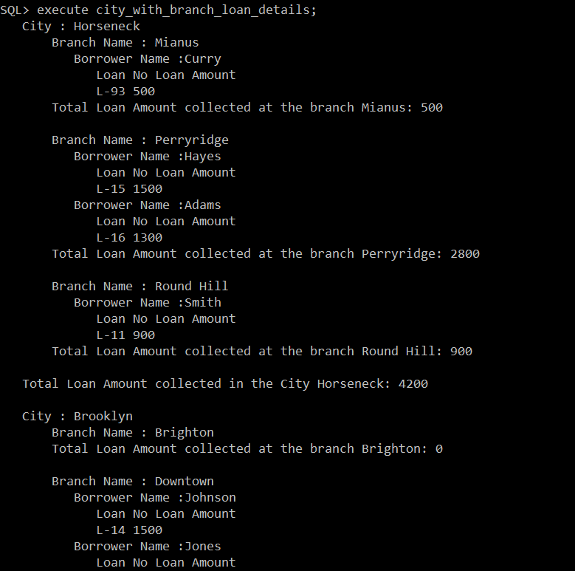

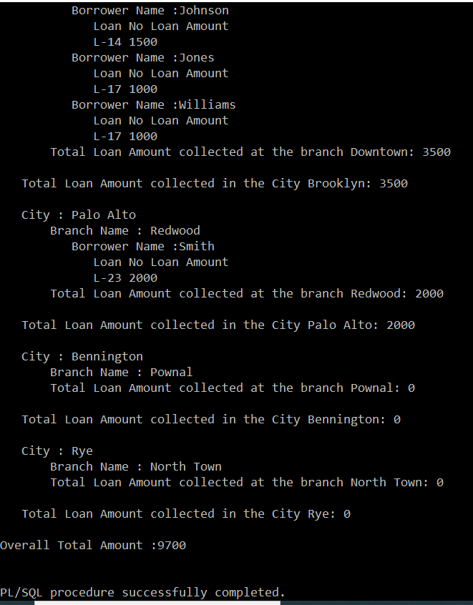

# **3.** Create a procedure with parameters city name and branch name. Display records of borrowers of that city and branch in the following format.

**Procedure**

create or replace procedure borrowerCBWiseA2Q3(ct branch.branch_city%type, bn branch.branch_name%type) as

cityAmount int:=0;

branchAmount int:=0;

cursor cur_customer is select b.customer_name,b.loan_number from borrower b,loan l where l.branch_name=bn and l.loan_number=b.loan_number;

rec_customer cur_customer%rowtype;

cursor cur_loanNumber(ln loan.loan_number%type) is select * from loan where loan_number=ln;

rec_loanNumber cur_loanNumber%rowtype;

begin

dbms_output.put_line(rpad(' ',3)||'City : '|| ct);

cityAmount:=0;

branchAmount:=0;

dbms_output.put_line(rpad(' ',7)||'Branch Name : '|| bn);

for rec_customer in cur_customer loop

dbms_output.put_line(rpad(' ',10)||'Borrower Name :'|| rec_customer.customer_name);

dbms_output.put_line(rpad(' ',13)||'Loan No Loan Amount');

for rec_loanNumber in cur_loanNumber(rec_customer.loan_number) loop

dbms_output.put_line(rpad(' ',13)||rec_loanNumber.loan_number||' ' || rec_loanNumber.amount);

branchAmount:= branchAmount+rec_loanNumber.amount;

end loop;

end loop;

dbms_output.put_line(rpad(' ',7)||'Total Loan Amount collected at the branch '||bn||': '|| branchAmount||chr(10));

cityAmount:=cityAmount+branchAmount;

dbms_output.put_line(rpad(' ',3)||'Total Loan Amount collected in the City '||ct||': '|| cityAmount||chr(10));

end;

/

**Execution**

execute borrowerCBWiseA2Q3('Horseneck','Perryridge');

**Image**

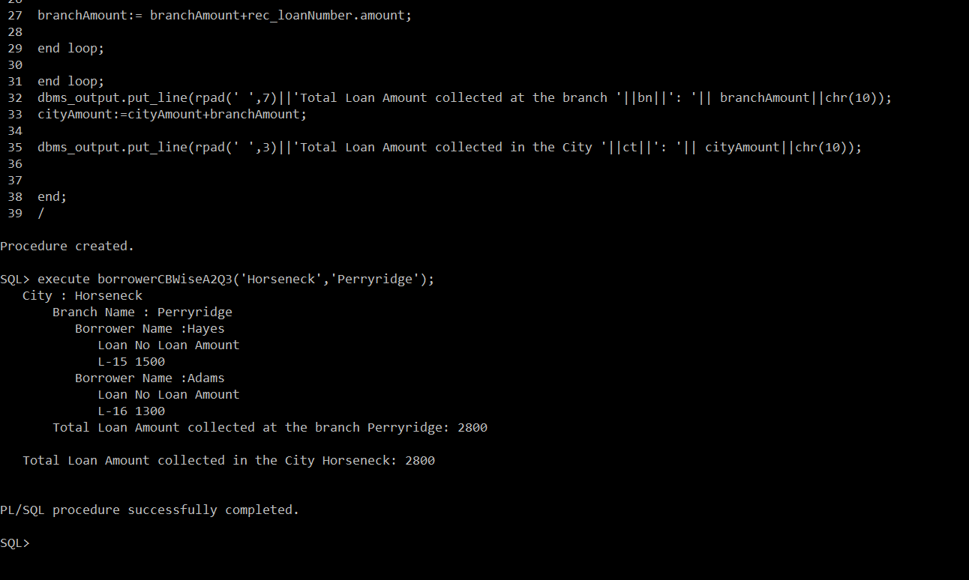

# **4.** Write a procedure to display details of the customers who are depositors as well as borrowers

**Procedure**

create or replace procedure customerBothBD_A2Q4 as

i int:=1;

cursor cur_BothBorroAndDepo is select distinct c.customer_name,c.customer_street,c.customer_city from customer c,borrower b,depositor d where c.customer_name=b.customer_name and c.customer_name=d.customer_name;

rec_BothBorroAndDepo cur_BothBorroAndDepo%rowtype;

begin

dbms_output.put_line('-------------------------------------------');

dbms_output.put_line('customer_name customer_street customer_city');

dbms_output.put_line('-------------------------------------------');

for rec_BothBorroAndDepo in cur_BothBorroAndDepo loop

--dbms_output.put_line(rec_BothBorroAndDepo.customer_name||' '||rec_BothBorroAndDepo.customer_street||' '||rec_BothBorroAndDepo.customer_city);

dbms_output.put_line(rpad(rec_BothBorroAndDepo.customer_name,10)||' '||rpad(rec_BothBorroAndDepo.customer_street,10)||' '||rpad(rec_BothBorroAndDepo.customer_city,10));

end loop;

end;

/

**Execution**

rpad(rec_BothBorroAndDepo.customer_name,10)||' '||rpad(rec_BothBorroAndDepo.customer_street,10)||' '||rpad(rec_BothBorroAndDepo.customer_city,10);

**Image**

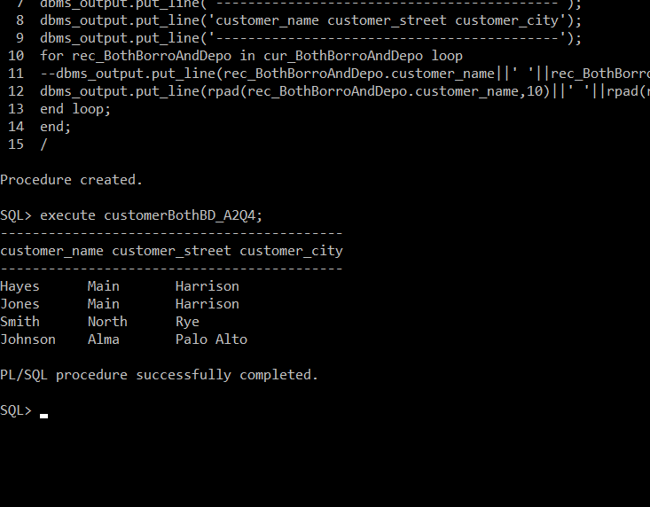

# **5.** Write a function with parameter branch name. Return total no. of customers of that branch.

**Procedure**

create or replace function totCustA2Q5(bn branch.branch_name%type) return int as

totalCustomer int:=0;

flag int:=0;

cursor cur_borrower is select distinct customer_name from borrower where borrower.loan_number in (select loan_number from loan where branch_name=bn );

rec_borrower cur_borrower%rowtype;

cursor cur_depositer is select distinct customer_name from depositor where depositor.account_number in (select account_number from account where branch_name=bn );

rec_depositor cur_depositer%rowtype;

begin

for rec_borrower in cur_borrower loop

totalCustomer:=totalCustomer+1;

end loop;

for rec_depositor in cur_depositer loop

flag:=0;

for rec_borrower in cur_borrower loop

if(rec_borrower.customer_name=rec_depositor.customer_name) then

flag:=1;

exit;

end if;

end loop;

if(flag!=1) then

totalCustomer:=totalCustomer+1;

end if;

end loop;

return totalCustomer;

end;

/

**Execution**

select totCustA2Q5('Downtown') TotalCustomer from dual;

select totCustA2Q5('Brighton') TotalCustomer from dual;

select totCustA2Q5('Round Hill') TotalCustomer from dual;

**Image**

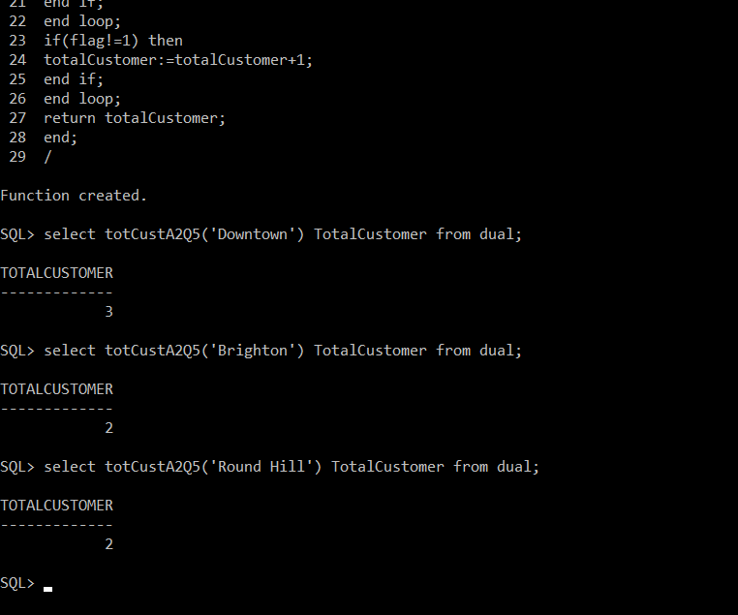

# **6.** Write a function with parameter city name. Return total no. of branches of that city.

**Procedure**

create or replace function totalBranchesA2Q6 (ct branch.branch_city%type) return int as

cursor cur_totalBranch is select count(branch_name) cnt from branch where branch_city=ct group by branch_city;

rec_totalBranch cur_totalBranch%rowtype;

begin

open cur_totalBranch;

fetch cur_totalBranch into rec_totalBranch;

return rec_totalBranch.cnt;

close cur_totalBranch;

end;

/

**Execution**

select totalBranchesA2Q6('Horseneck') TotalBranch from dual;

select totalBranchesA2Q6('Brooklyn') TotalBranch from dual;

**Image**

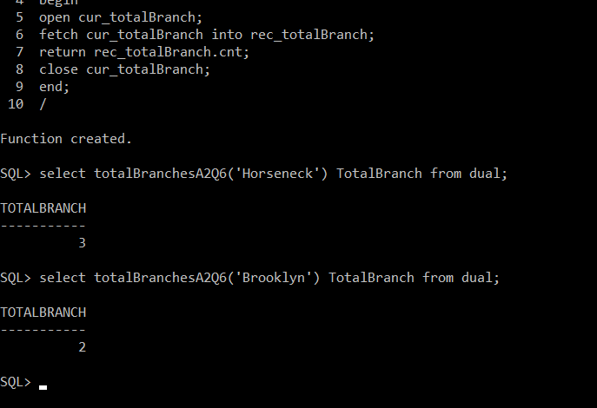

# 7. Write a function with parameter customer name. Return True if the customer lives in the city where he has account, else return false. Show message too.

**Procedure**

create or replace function custSameCityAsBranchA2Q7 (cn customer.customer_name%type) return boolean as

cursor cur_customer is select c.customer_name from customer c,depositor d,account a,branch b where c.customer_name=cn and c.customer_name=d.customer_name and d.account_number=a.account_number and a.branch_name=b.branch_name and c.customer_city=b.branch_city;

rec_customer cur_customer%rowtype;

flag boolean:=false;

begin

for rec_customer in cur_customer loop

flag:=true;

end loop;

return flag;

end;

/

**Execution**

--calling block

declare

name varchar(50):= '&name';

begin

if(custSameCityAsBranchA2Q7(name)) then

dbms_output.put_line('Customer has account in the city where she lives.');

else

dbms_output.put_line('Customer has account in the different city than where she lives');

end if;

end;

/

**Image**

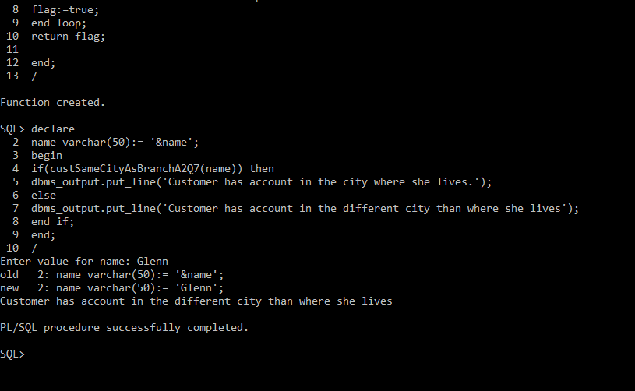

# 8. Write a trigger to check balance amount when user inserts or updates balance in accounts table. If balance < 200, don’t allow to insert/update the record and display appropriate error message.

**Procedure**

create or replace trigger chk_balanceA2Q8 before insert or update on account

for each row

begin

if(:new.balance<200) then

raise_application_error(-20002,'-----Please enter balance greater than 200-------');

end if;

end;

/

**Execution**

INSERT INTO account VALUES ('A-307', 'Round Hill', 150);

**Image**

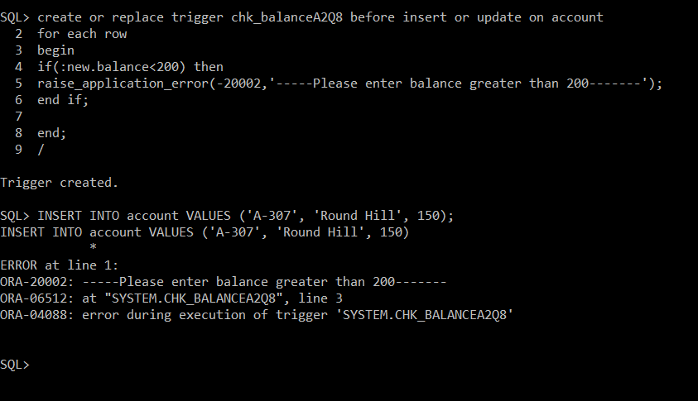

# 9. Create a table named city_assets with fields city_name and total_assets. Write a trigger which will insert/update a record in city_assets table when user inserts a new record in the branch table. city_assets table should contain total assets of each city. If the city is inserted for the first time in branch table, insert a new record for that city in the city_assets table. If the city which user is inserting in the branch table already exists in the city_assets table, update the amount in the city_assets table.

**Procedure**

**Make city_assets table**

create table city_assets(city_name varchar(50) primary key, total_assets int);

**Insert data**

Data can be found from select branch_city,sum(assets) from branch group by branch_city;

INSERT INTO city_assets values('Horseneck',10100000);

INSERT INTO city_assets values('Brooklyn',16100000);

INSERT INTO city_assets values('Palo Alto',2100000);

INSERT INTO city_assets values('Bennington',300000);

INSERT INTO city_assets values('Rye',3700000);

**Trigger**

create or replace trigger tr_city_assetsA2Q9 before insert on branch

for each row

declare

currentTotAssets int :=0;

flag int:=0;

cursor cur_city_assets is select * from city_assets;

rec_city_assets cur_city_assets%rowtype;

begin

for rec_city_assets in cur_city_assets loop

if(:new.branch_city=rec_city_assets.city_name) then

flag:=1;

currentTotAssets:=rec_city_assets.total_assets;

exit;

end if;

end loop;

if(flag=0) then

INSERT INTO city_assets values(:new.branch_city,:new.assets);

else

update city_assets set total_assets=currentTotAssets + :new.assets where city_name= :new.branch_city;

end if;

end;

/

**Execution**

INSERT INTO branch VALUES ('branch1', 'Ahmedabad', 4510000);

INSERT INTO branch VALUES ('branch2', 'Brooklyn',10090);

**Image**

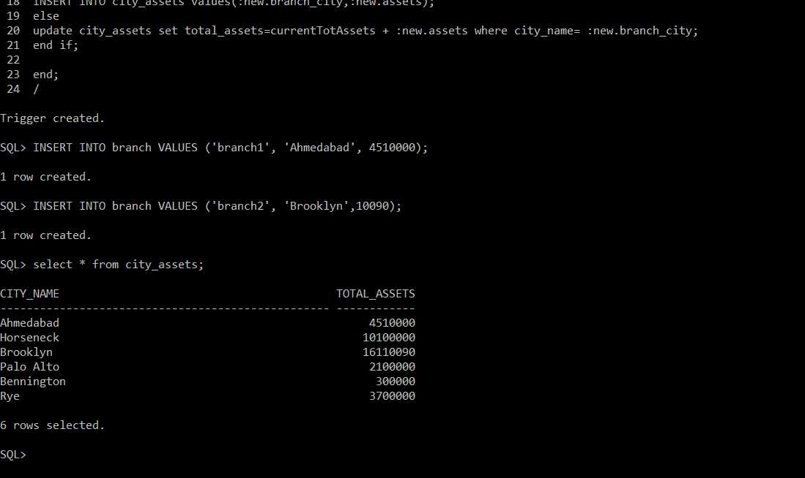

# 10. Write a trigger which will insert details of user, current date and time in a table named “trapped” after user made any changes(insert/delete/update) in the borrower table on -weekends and on weekdays between 10 pm to 6 am. The table trapped contains the fields user_name and date_time.

**Procedure**

**Make table trapped**

create table trapped(user_name varchar(10),dt timestamp);

**Trigger**

create or replace trigger tr_trappedA2Q10 after insert or delete or update on borrower

for each row

begin

if (to_char(sysdate,'dy')='sat' or to_char(sysdate,'dy')='sun' or to_number(to_char(sysdate,'HH24'))<6 or to_number(to_char(sysdate,'HH24'))>22) then

insert into trapped values(user, SYSTIMESTAMP);

end if;

end;

/

**Execution**

insert into loan values('Z-40', 'Redwood', 1234);

insert into customer values('Poojan', 'Bodakdev', 'Ahmedabad');

insert into borrower values('Poojan', 'Z-40');

select * from trapped;

**Image**

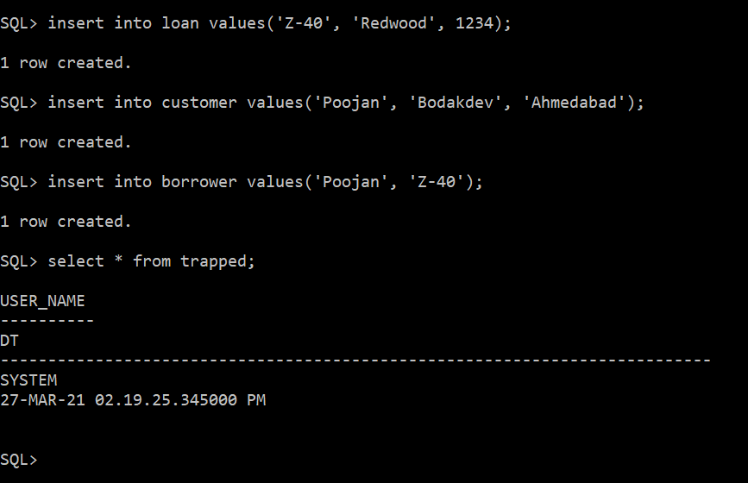

# 11. Write a trigger when any record is updated in the account table. When value of any field is updated, keep track of before and after values in the table “redolog_values” for each field of the account table. The redolog_values table contains the fields c_date, field_name, before_valueand after_value.

**Procedure**

**Make table redolog_values**

create table redolog_values(c_date date, field_name varchar(20), before_value varchar(50),after_value varchar(50));

**Trigger**

create or replace trigger tr_accntTrckA2Q11 after update on account

for each row

begin

if(:old.account_number != :new.account_number) then

INSERT INTO redolog_values VALUES(SYSDATE,'account_number',:old.account_number,:new.account_number);

end if;

if(:old.branch_name != :new.branch_name) then

INSERT INTO redolog_values VALUES(SYSDATE,'branch_name',:old.branch_name,:new.branch_name);

end if;

if(:old.balance != :new.balance) then

INSERT INTO redolog_values VALUES(SYSDATE,'balance',:old.balance,:new.balance);

end if;

end;

/

**Execution**

INSERT INTO account VALUES ('z-306', 'Round Hill', 100000);

update account set balance=350,account_number='Z-302' where account_number='z-306';

**(Here 2 values are updated balance and account_number)**

select c_date||' '||rpad(field_name,15)||' '||rpad(before_value,10)||' '||rpad(after_value,10) from redolog_values;

**Image**

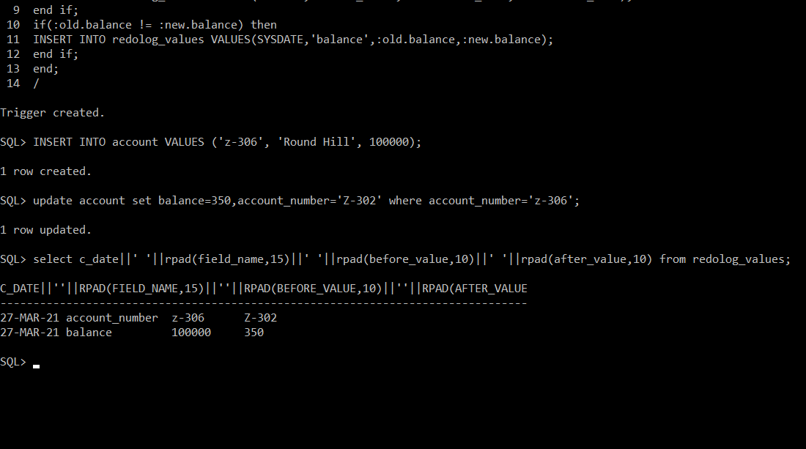

# 12. Write a trigger which will delete all child records from the borrower and depositor tables when customer record is deleted from the customer table.

**Procedure**

create or replace trigger tr_delectCustChilds before delete on customer

for each row

begin

delete from depositor where customer_name= :old.customer_name;

delete from borrower where customer_name= :old.customer_name;

end;

/

**Execution**

delete from customer where customer_name='Jones';

select customer_name from borrower;

select customer_name from depositor;

**Image**

